PROJECT 2
Splunk SIEM — Windows Security Monitoring
Evidence-Based Technical Documentation
This report documents the actual Splunk SIEM lab work completed using Windows Server 2022, Splunk Universal Forwarder, Splunk Enterprise, and VMware Workstation. The screenshots in this report are captured from the lab and are used as evidence of configuration, log ingestion, event investigation, and dashboard creation.
1. Project Overview
The objective of this project was to practice using Splunk as a SIEM in a Windows environment. A Windows Server 2022 Domain Controller, identified as DC01 / NKAD, generated Windows Security Events. Splunk Universal Forwarder collected the Security log and forwarded the events to Splunk Enterprise running on the host machine.
The project focused on authentication monitoring, SPL searches, investigation of Windows Event IDs, source-address analysis, privileged activity, and creation of a basic SOC monitoring dashboard.
2. Lab Environment
Windows Server 2022 (DC01 / NKAD) — Windows Security Event Log source
Splunk Universal Forwarder — log collection and forwarding
Splunk Enterprise — SIEM, search, analysis, and dashboard
VMware Workstation — virtual lab environment
TCP 9997 — Splunk receiving port
3. Splunk Installation and Service Validation
Splunk Enterprise was installed on the host machine and configured for the lab. The license and local server information were checked before continuing with log ingestion.
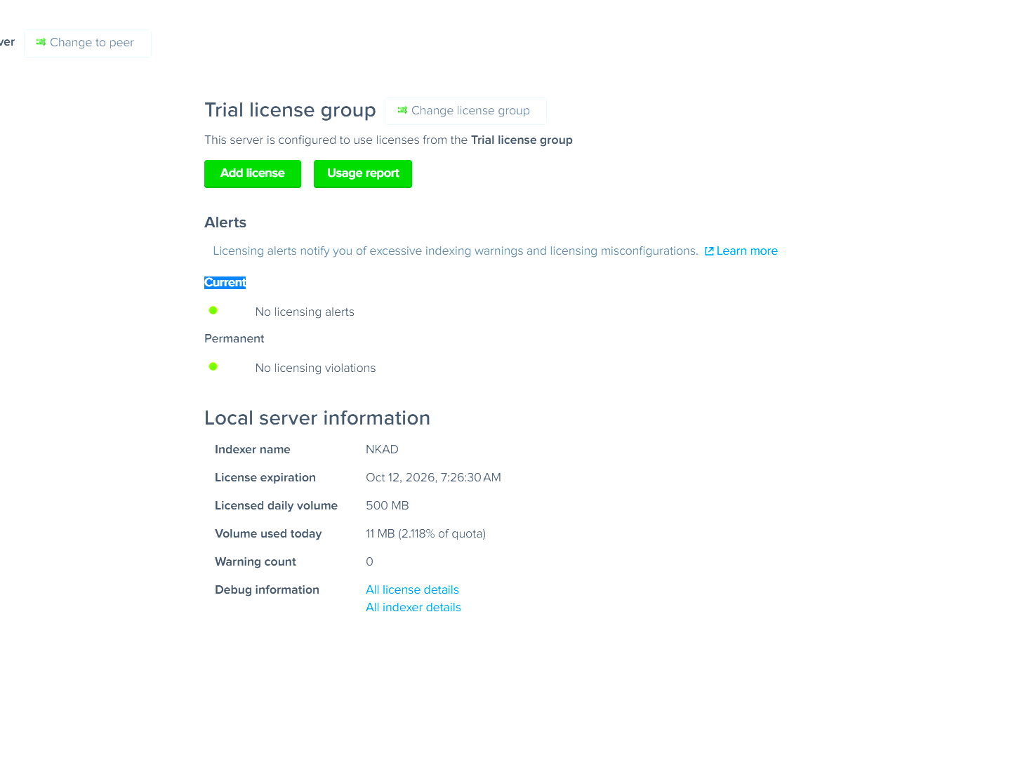
Figure 1 — Splunk Enterprise license and local server information.

4. Windows Security Log Collection
The Splunk Universal Forwarder was configured on the Windows Server to collect the Windows Security Event Log and forward it to the Splunk Enterprise host.
[WinEventLog://Security]
disabled = 0
index = main
start_from = oldest
current_only = 0
checkpointInterval = 5
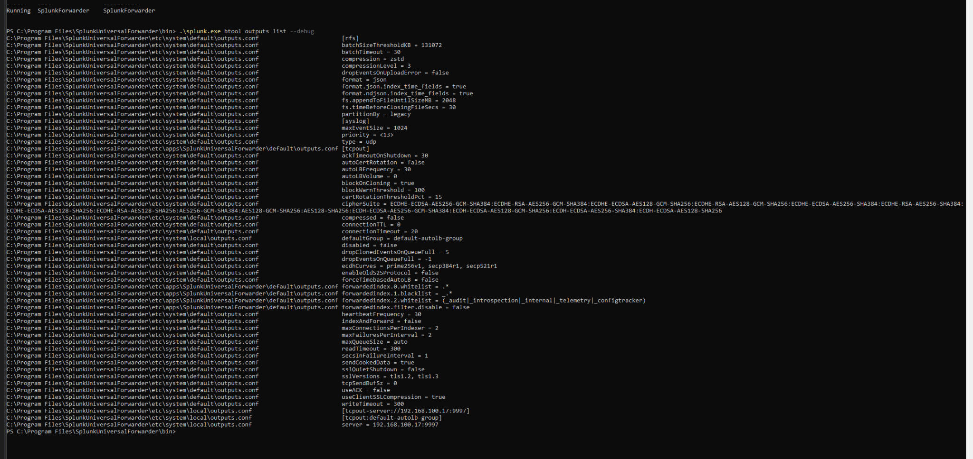
Figure 2 — Splunk Universal Forwarder configuration and forwarding settings.

5. Log Ingestion Verification
Windows Security events were successfully received by Splunk. Searches against host NKAD returned Windows Security events and exposed fields such as EventCode, Account_Name, Source_Network_Address, Logon_Type, and Failure_Reason.
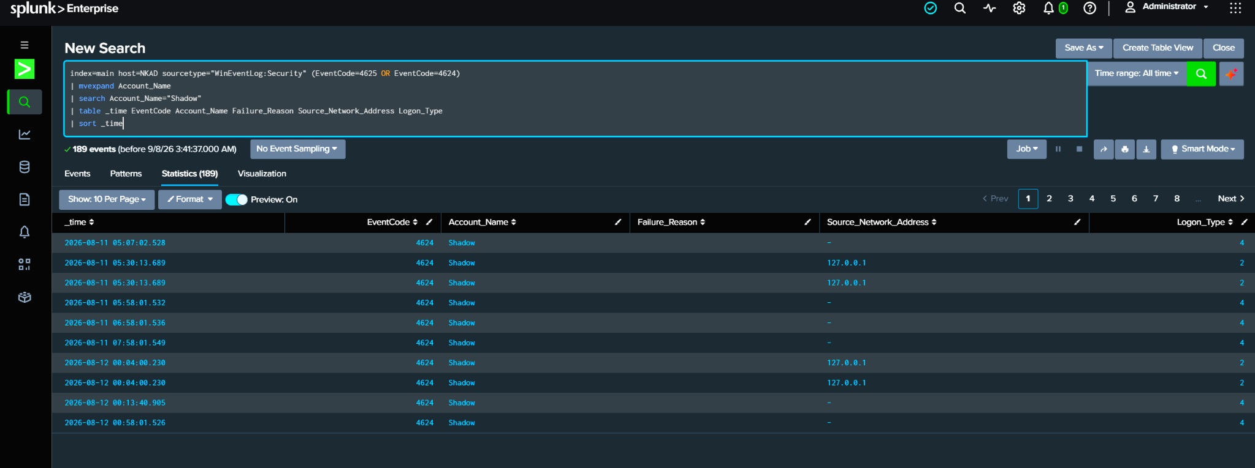
Figure 3 — Windows Security events returned in Splunk from host NKAD.

6. Successful Logon Investigation — Event ID 4624
Event ID 4624 was used to identify successful authentication activity.
index=main host=NKAD EventCode=4624
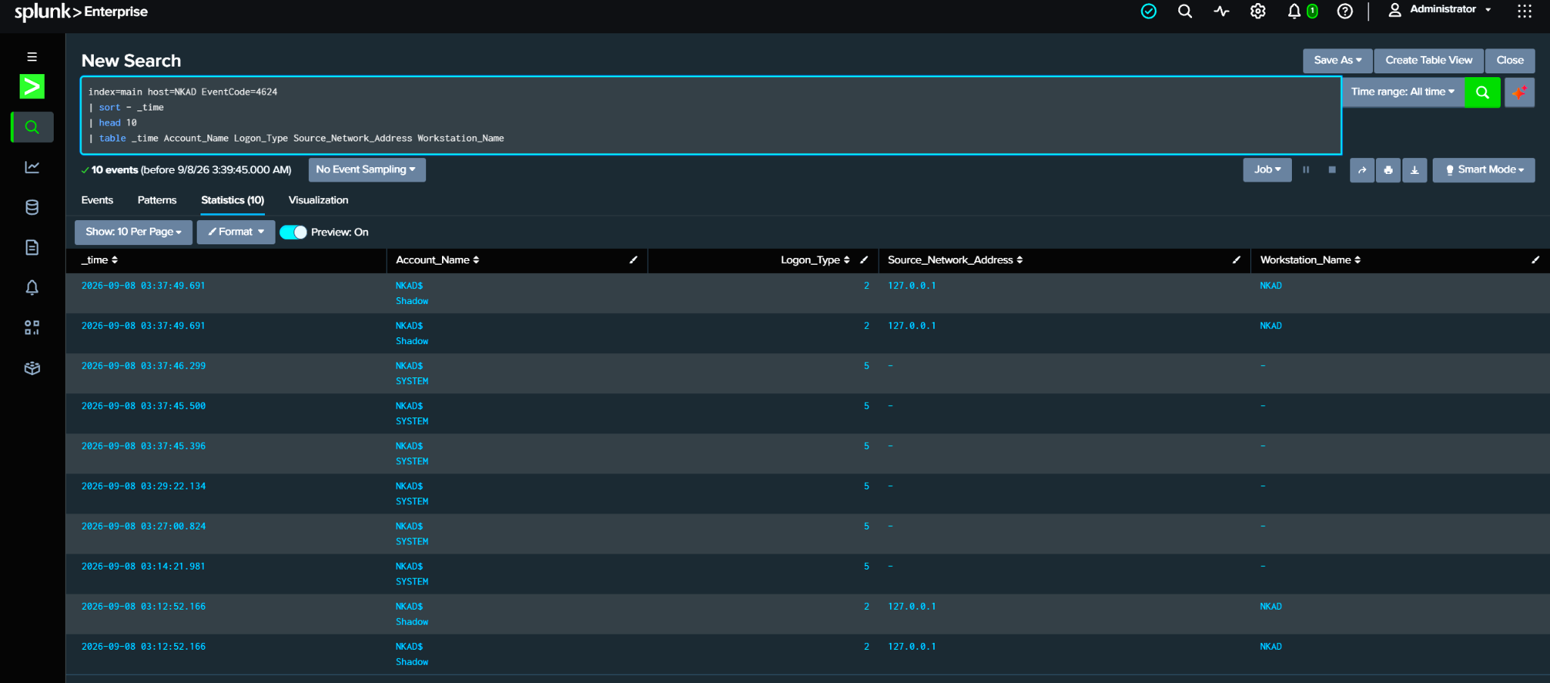
Figure 4 — Splunk search for Windows Event ID 4624.

7. Failed Logon Investigation — Event ID 4625
Event ID 4625 was used to investigate failed authentication attempts. A controlled failed-login test was generated in the lab so the resulting Windows Security event could be examined in Splunk.
index=main host=NKAD sourcetype="WinEventLog:Security" EventCode=4625
The investigated event showed the account Shadow, source address 127.0.0.1, Logon Type 2, and the failure reason Unknown user name or bad password. Because the source address was the local machine, the event was treated as intentional lab activity rather than a remote attack.
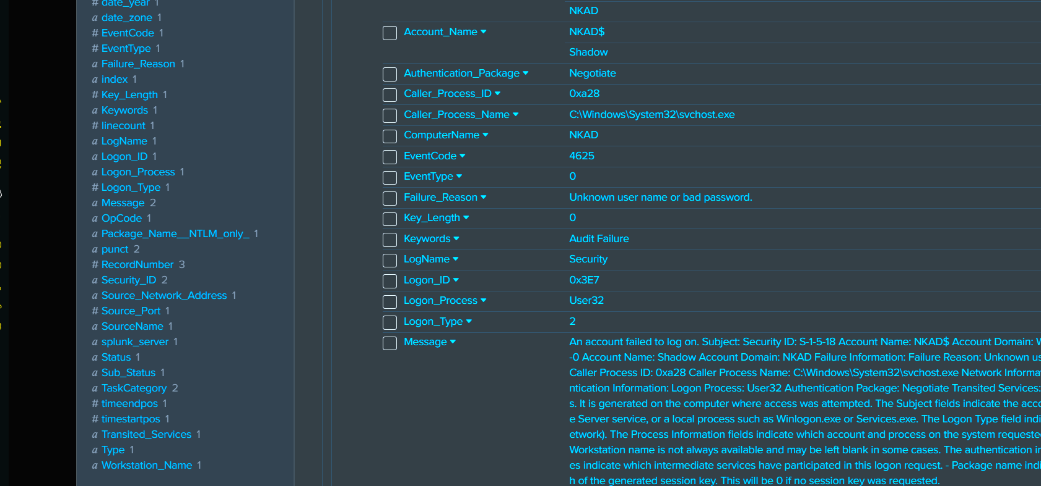
Figure 5 — Detailed Windows Event ID 4625 showing the failed authentication test.

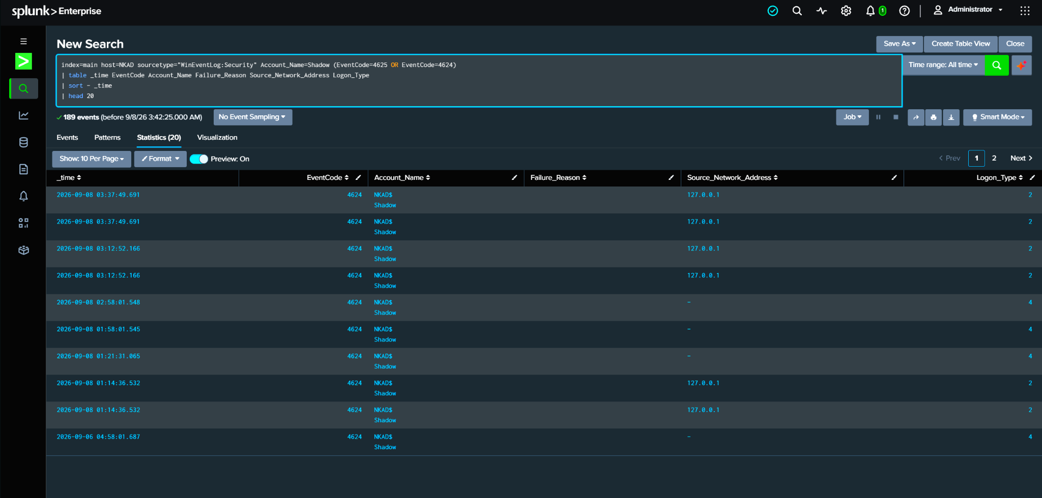
Figure 6 — Splunk results used to review source network address and failed authentication activity.

8. Authentication and Account Analysis
Additional SPL searches were used to group and review authentication activity by account and source information. This helped practice the type of filtering and correlation a SOC analyst would perform when investigating repeated authentication failures.
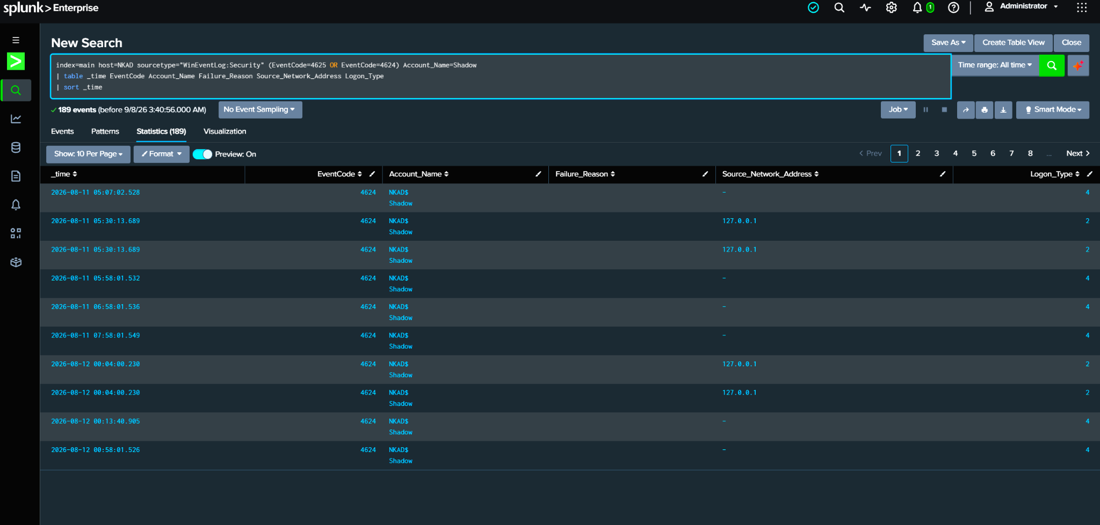
Figure 7 — Account and authentication fields displayed in Splunk.

9. Windows Security Events by EventCode
EventCode-based analysis was used to identify the types of Windows Security events present in the collected data. Events observed during the lab included successful logons (4624), failed logons (4625), privileged activity (4672), logoffs (4634), explicit credential use (4648), and other Windows security events.
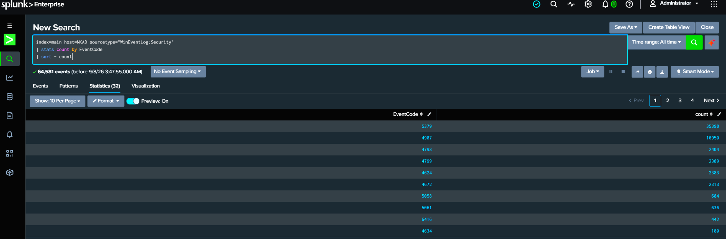
Figure 8 — Windows Security events grouped by EventCode.

10. Privileged Activity — Event ID 4672
Event ID 4672 was investigated as an indicator of special privileges assigned to a logon session.
index=main host=NKAD sourcetype="WinEventLog:Security" EventCode=4672
| stats count by Account_Name
| sort - count
The investigation returned activity including SYSTEM and Shadow. These results were used to practice identifying privileged activity. Event ID 4672 was treated as an investigation point and not automatically considered malicious.
11. SOC Dashboard
A dashboard named Splunk SOC Monitoring was created to provide a central view of the Windows security activity investigated during the project.
The dashboard contains four monitoring panels:
Failed Logons by Account and Source IP
Authentication Success vs Failure
Privileged Account Activity
Windows Security Events by EventCode
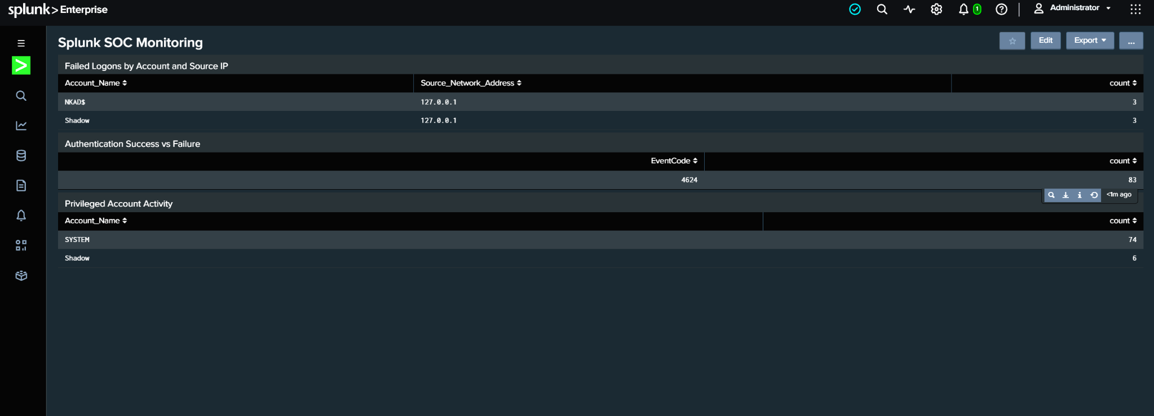
Figure 9 — Splunk SOC Monitoring dashboard during panel creation.

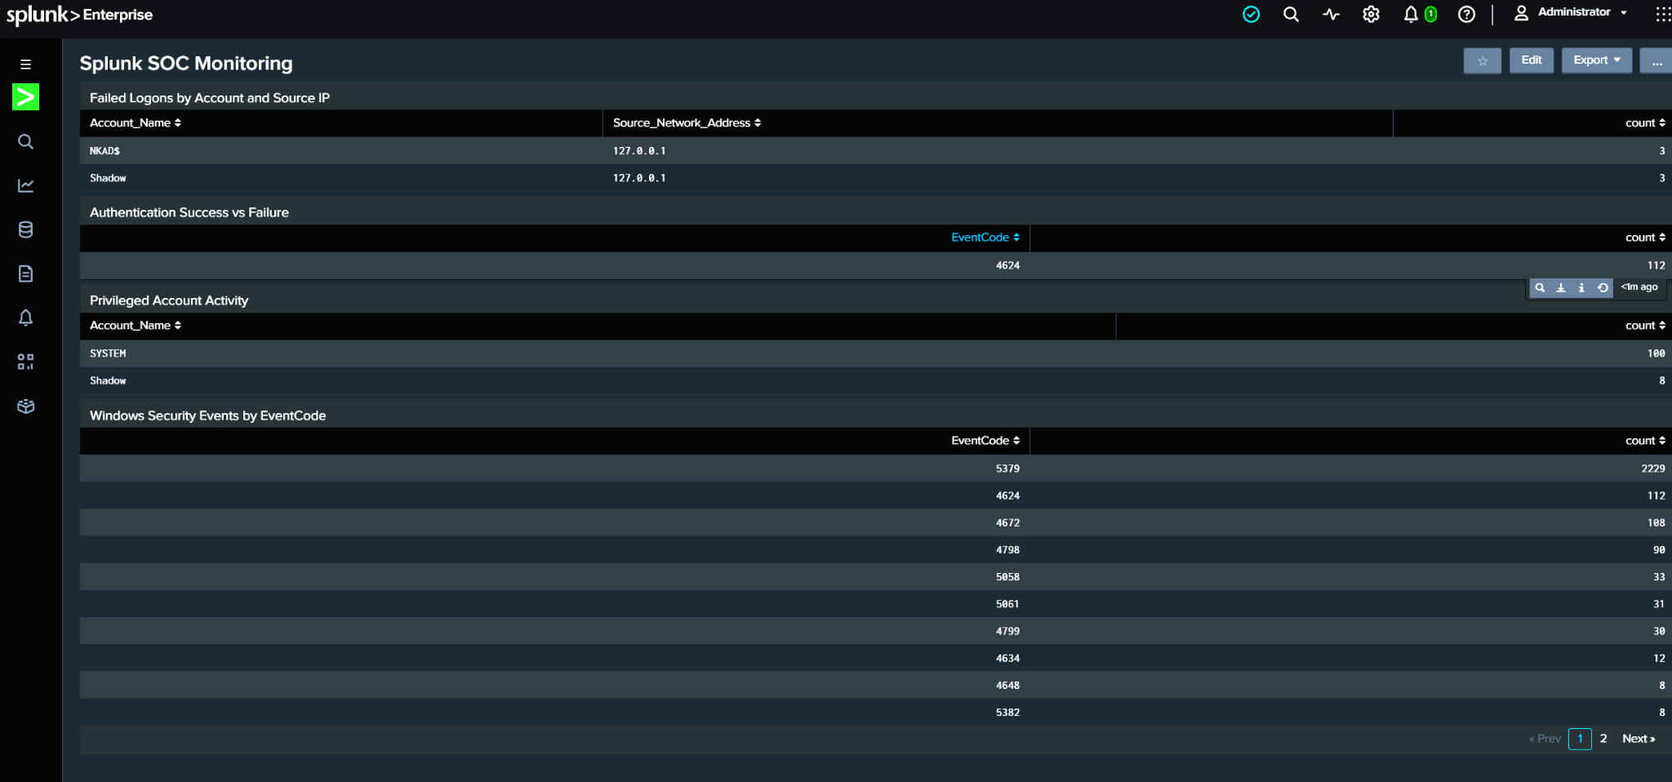
Figure 10 — Completed Splunk SOC Monitoring dashboard with the four monitoring panels.

12. Skills Practiced
Splunk SIEM fundamentals
SPL searching and filtering
Windows Security Event Logs
Authentication monitoring
Failed-logon investigation
Source IP investigation
Privileged activity monitoring
Security event analysis
SOC dashboard creation
Basic SOC investigation workflow

