Lab 2: Scheduling House Building Tasks Using Decision Optimization for Watson Studio Local

*January 22nd, 2018*

*Author: John Chaves john.chaves@us.ibm.com*

*Updated: Dec 2012, Nikolay Manchev*

**Table of contents**

Contents

Overview 1

Pre-requisites, access, and files 1

The Business Problem 1

Part 1: Set up a Project 2

Part 2: Loading Data 6

Part 3: Running the Model 7

Part 4: Creating a new Scenario 10

Bonus Section: Exporting the Model 12

# Overview

This Lab exercise will guide you on how to use the Decision Optimization add-on in creating planning scenarios on Watson Studio Local to efficiently assign construction tasks to workers of different skill levels. You will learn how to:

* Load data
* Create multiple planning scenarios
* Manipulate Objectives & Constraints

# Pre-requisites, access, and files

* Working knowledge of Watson Studio Local.
* Access to a Watson Studio Local cluster with the DODS add-on installed.
* Download and unzip this lab files:

<https://github.com/nmanchev/DSXBPEnablement/raw/master/DecisionOptimisation/house_data.zip>

After unzipping the file you should have access to three CSV files containing the data needed for this scenario.

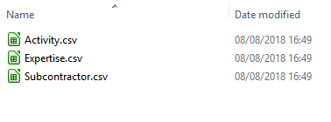

# The Business Problem

This is a problem of building five houses in different locations; the masonry, roofing, painting, etc. must be scheduled. Some tasks must necessarily take place before others and these requirements are expressed through precedence constraints.

There are three workers, and each worker has a given skill level for each task. Each task requires one worker; the worker assigned must have a non-null skill level for the task. A worker can be assigned to only one task at a time.

Each house has a completion deadline. The objective is to maximize the skill levels of the workers assigned to the tasks.

# Part 1: Set up a Project

In this section we will set up a Watson Studio Local Project. The Project is a high-level container where all assets are stored or referenced.

1. Login Watson Studio Local

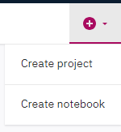  
NOTE: YOU CAN USE THE PROJECT CREATED IN LAB 4  
AND SKIP TO STEP 4.

1. (Optional) Once in the *Community* page, click on the little plus (+) sign on the top right of the screen and select *Create Project*. 🡪
2. Enter a project name (i.e. “Housebuilding_DODS”) and a brief description. Click *Create*.

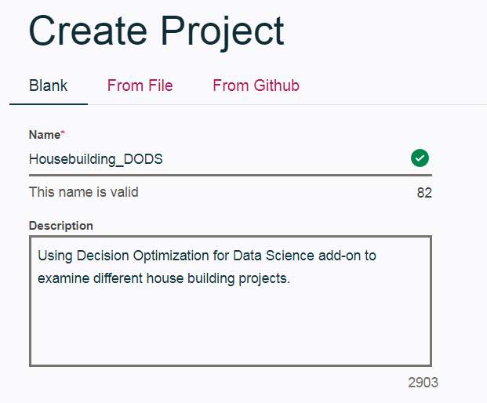

1. On the Project Dashboard click on the Plus sign and select "Add data set"

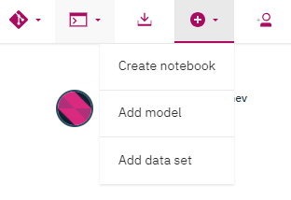

1. Click the "Select from your local file system" button.

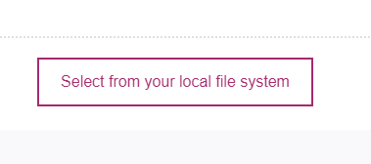

1. Navigate to where you have unzipped the house_data.zip archive, select all three CSV files and click "Open". The files get uploaded to your project and once the operation completes you should be able to see them in the Data Sets section.

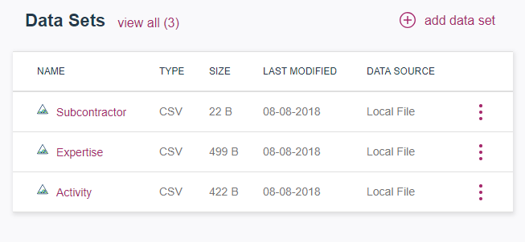

1. On the Project Dashboard, click again on the Plus sign at the top right side of the screen and *Add* a new Model.



1. Enter a Name and (optional) brief description. Select Decision Optimization as model type. Click *Create*

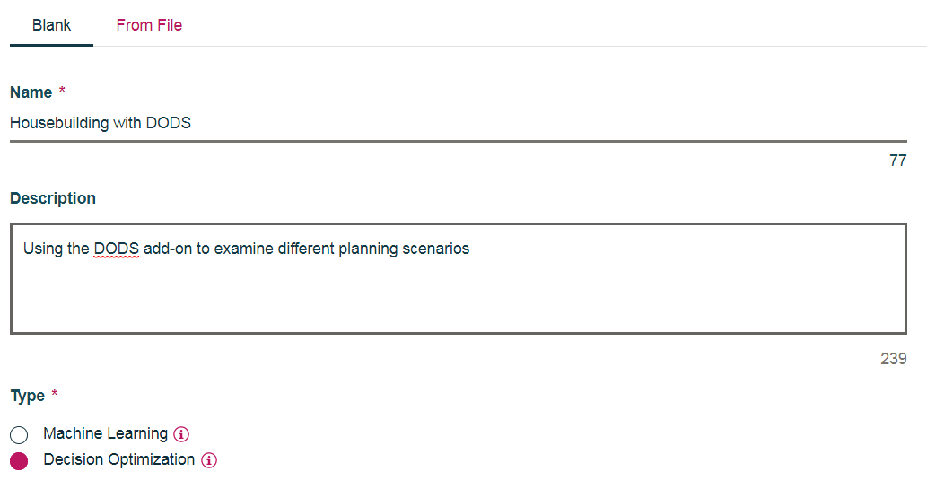

The workspace will display

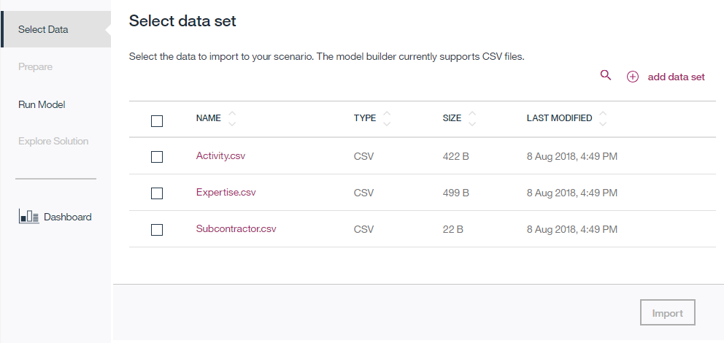

# Part 2: Loading Data

Let’s now select the required data. Select the check box next to each CSV file and click Import. The system will transfer you to the Prepare Input Data screen where you can browse and edit the input data.

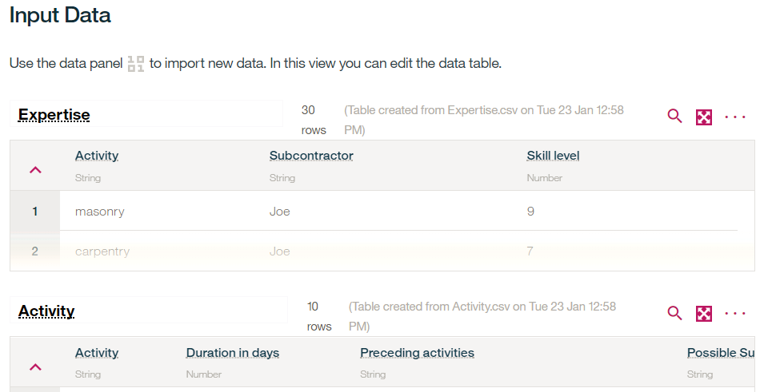

# Part 3: Running the Model

1. Click on Run Model to start formulating the model. Select Use Modeling Assistant and click OK. On the Model page, select “Scheduling”.

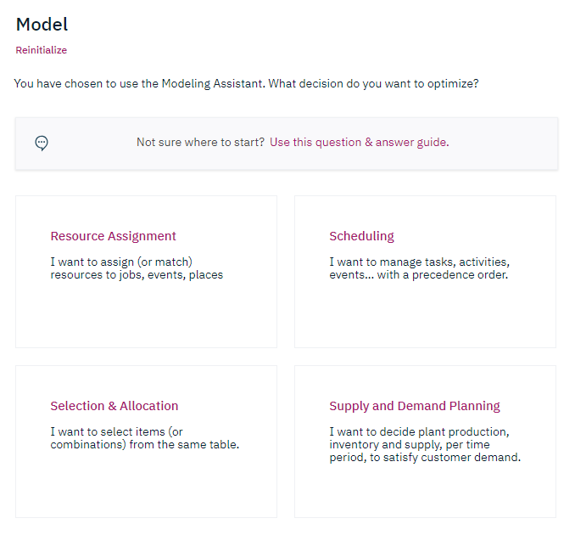

1. Now, let’s select the Tasks and Resources

* Map a task, choose: Activity
* Map a resource, choose: Subcontractor

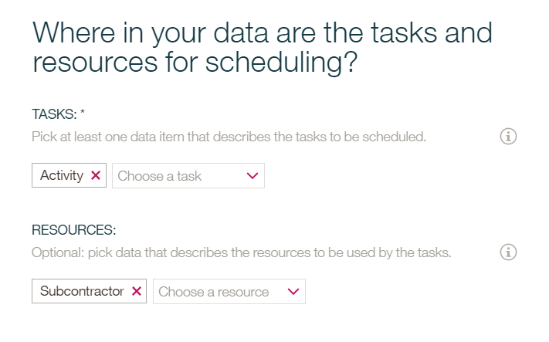

Click *Continue.*

1. Make sure to leave both boxes checked and click *Continue*

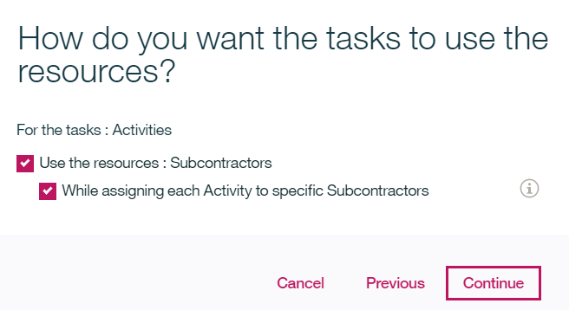

1. Click *Finish* to validate the intent.  
   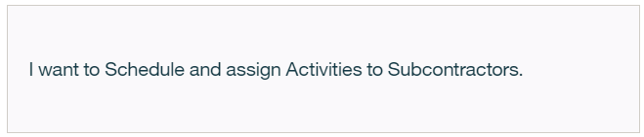
2. Take a few minutes to examine the *Model* page. Locate the Objectives & Constraints section on the left pane. Notice that some rules are preselected but others require completion (marked by a vertical red bar).

On this example, we’ll need to define a Start date and the Duration

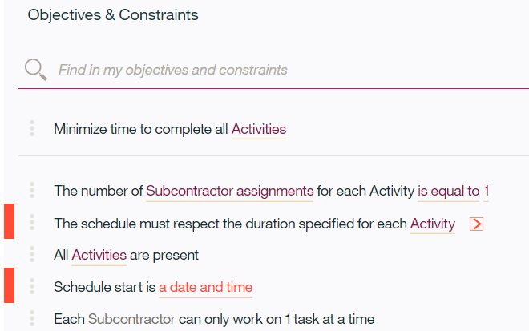

* 1. Click on the red arrow > to display the definition. Click on the default selection – Duration in days – to examine the other options. Keep “Duration in days” as the choice.

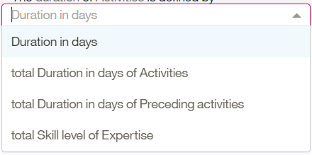

* 1. click the red <a start date> placeholder to select a start date.   
     Enter a new date as text, for example: 2018/08/01 or select a date from the proposed list. (i.e. today’s date).
  2. Click on to solve the model.
  3. Take a few minutes to examine the *Solution* page. Click on the expand icon  to zoom in the table.
  4. Select View Gantt Chart to view the construction schedule.
  5. Precedence constraints are not yet considered at this point (The moving task for example might not have been placed at the end).

# Part 4: Creating a new Scenario

Before we modify the original model, let’s create a new scenario so we can later compare the results.

1. Click on the  icon to display the Scenario panel. Click on the little down arrow and select “From the current one”. Confirm that you want to Create a duplicate scenario.
2. When the new Scenario displays, click on the three dots to display the menu. Rename the Scenario to Scenario2.
3. Select Run Model to display the model builder.
4. Let’s add precedence constraints.
   1. Under the *Suggestions* tab, type some Natural Language text, such as "*after preceding activities”* and click the refresh button to get suggestions.
   2. Look at suggestions and click on the plus sign  to add the constraint: "*Each Activity starts after the end of preceding activities"*
5. Adding a compatibility constraint
   1. Enter some Natural Language text such as “*subcontractor is included in possible subcontractors”*
   2. Use topic filtering and select “Compatibility”. 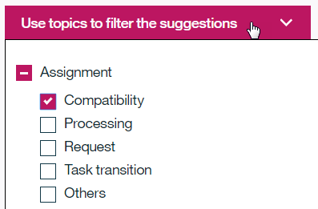
   3. Click on the Refresh icon to see the list of suggestions
   4. Add the constraint: " *For each Subcontractor to Activity assignment, Subcontractor is included in Possible Subcontractors of Activity*"
6. Add another objective
   1. Clear the Filter.
   2. Enter some Natural Language text such as “overall quality”
   3. add from suggestions "*Maximize overall quality of scheduling assignments according to < table of assignment value >”*
   4. Click on <table of assignment value> to edit it and select (or type) *Expertise*
   5. Click on the red arrow to expand the objective. Make selections as follows:

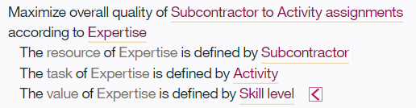

* 1. Your new objective is: *Maximize overall quality of scheduling assignments according to Expertise*

You can click "Run" to solve this new multi-objective model and wait for the end of solve. Refresh your browser and look at the updated Gantt chart.

**CONGRATULATIONS!**

**You have successfully completed the DODS Housebuilding Lab.**

# Bonus Section: Exporting the Model

Now that the model is built and trained, let’s export it to a Notebook and examine it closely.

1. If you closed DODS, make sure that you are still on the Housebuilding_DODS project and open the Housebuilding_DODS Model.  
   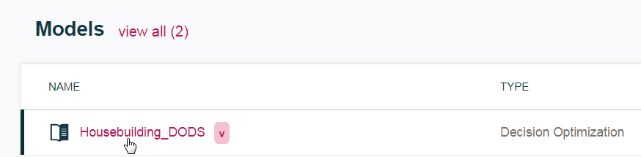
2. Open the Scenario Panel  , click on the 3 dots and select *Generate a Python Notebook from this scenario.* 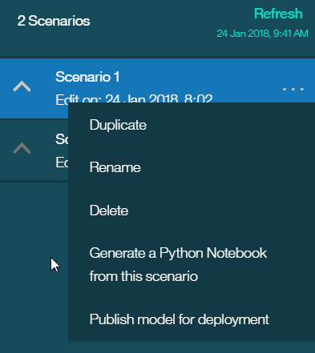
3. Name it “*Housebuilding_Generated_Notebook”* and Save it.
4. Return to the Project page by clicking on the navigation shortcut.

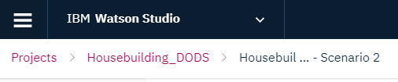

1. Click on Assets to view all the project’s components. Under the Notebooks section, click on the name of the notebook you just created.
2. Watson Studio Local will instantiate the Jupyter Notebook and display its contents.
3. Insert a new Markdown cell at the very top and enter a notebook title. Run the cell to see the result!

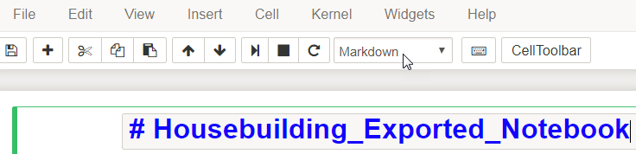

Run the notebook and confirm that you get similar results for your objective.

