# Introduction

This document provide a documentation of the application spo-cleaning-partners-app

# How to test the application

If you want to test it directly, we provided the war file on the git repository. You can retrieve it and deploy it on tomcat version 9.0 and use postman to fill your input and see the output. I provided the json collection too.

Here is an example:

* My application is deployed on tomcat :

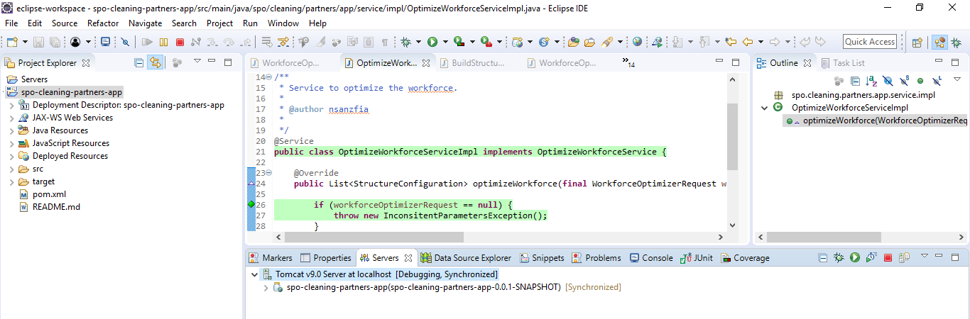

* Input in postman

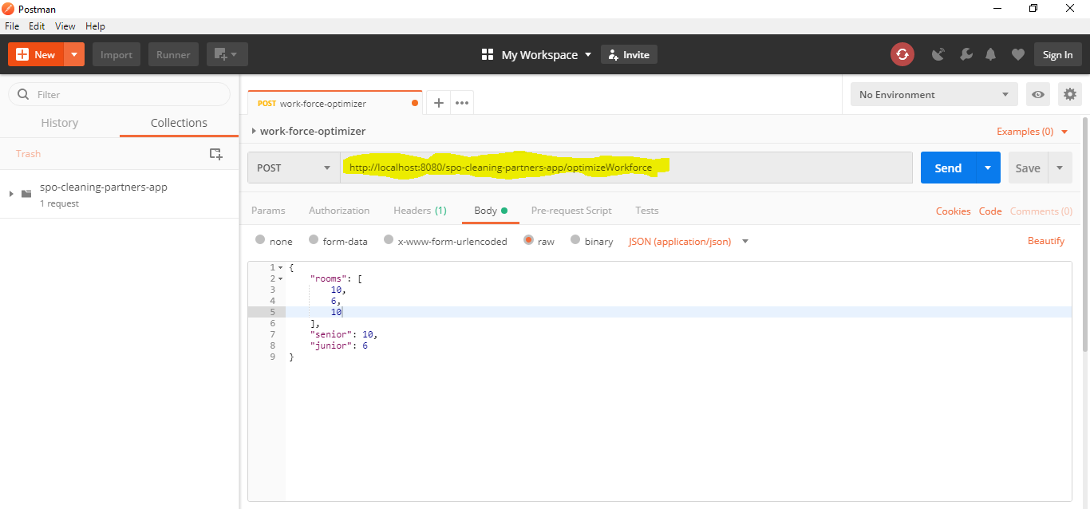

* Postman is a free tool that you can download on <https://www.getpostman.com/>.
* Once you downloaded it you click on file/import and add the json collection file which is in the root of the git repository
* When you click on send you can see the results below the input panel

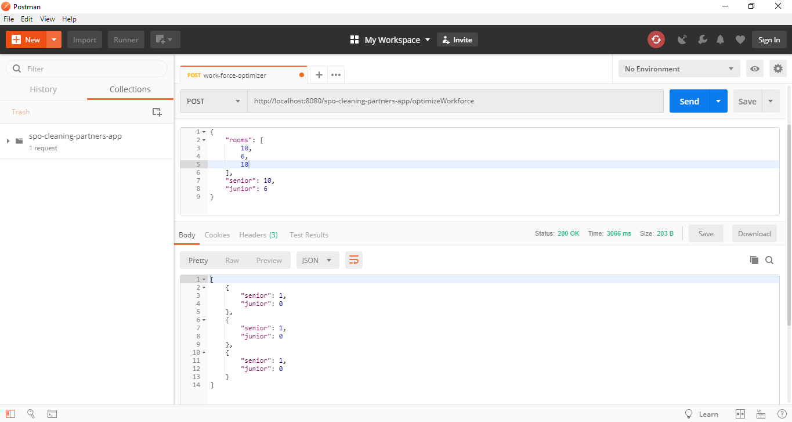

# Source code and usage of the application in dev mode

* All the configuration of the application have been commited.
* You get the code in your workspace, perform a clean install and a maven update
* You deploy the application on tomcat 9.0 and you can do some tests.
* Feel free to contact me if you need some explanations: fayabobo@gmail.com.