‘echo’ command in Linux

Declare a variable and echo its value. For example, Declare a variable of
x and assign its value=10.
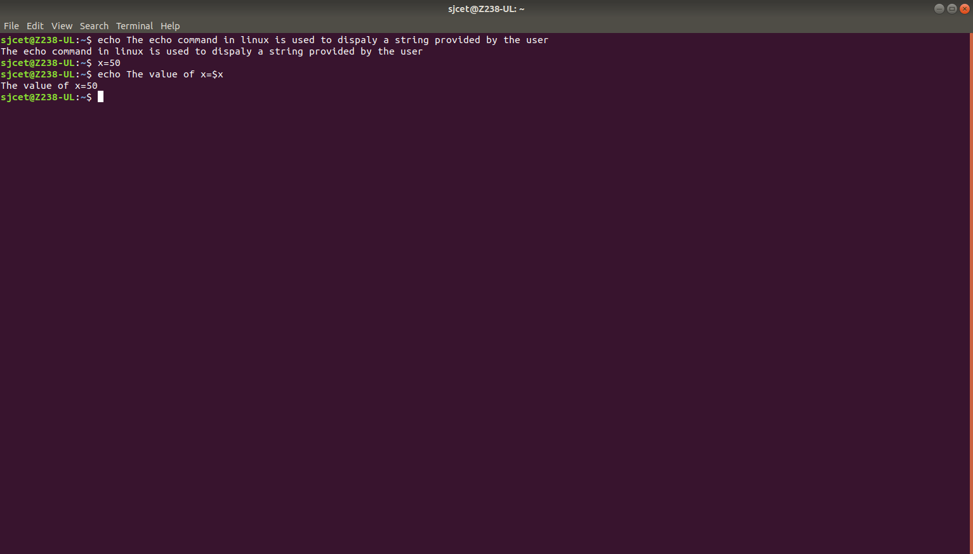

Using option ‘\b‘ – backspace with backslash interpretor ‘-e‘ which
removes all the spaces in between.
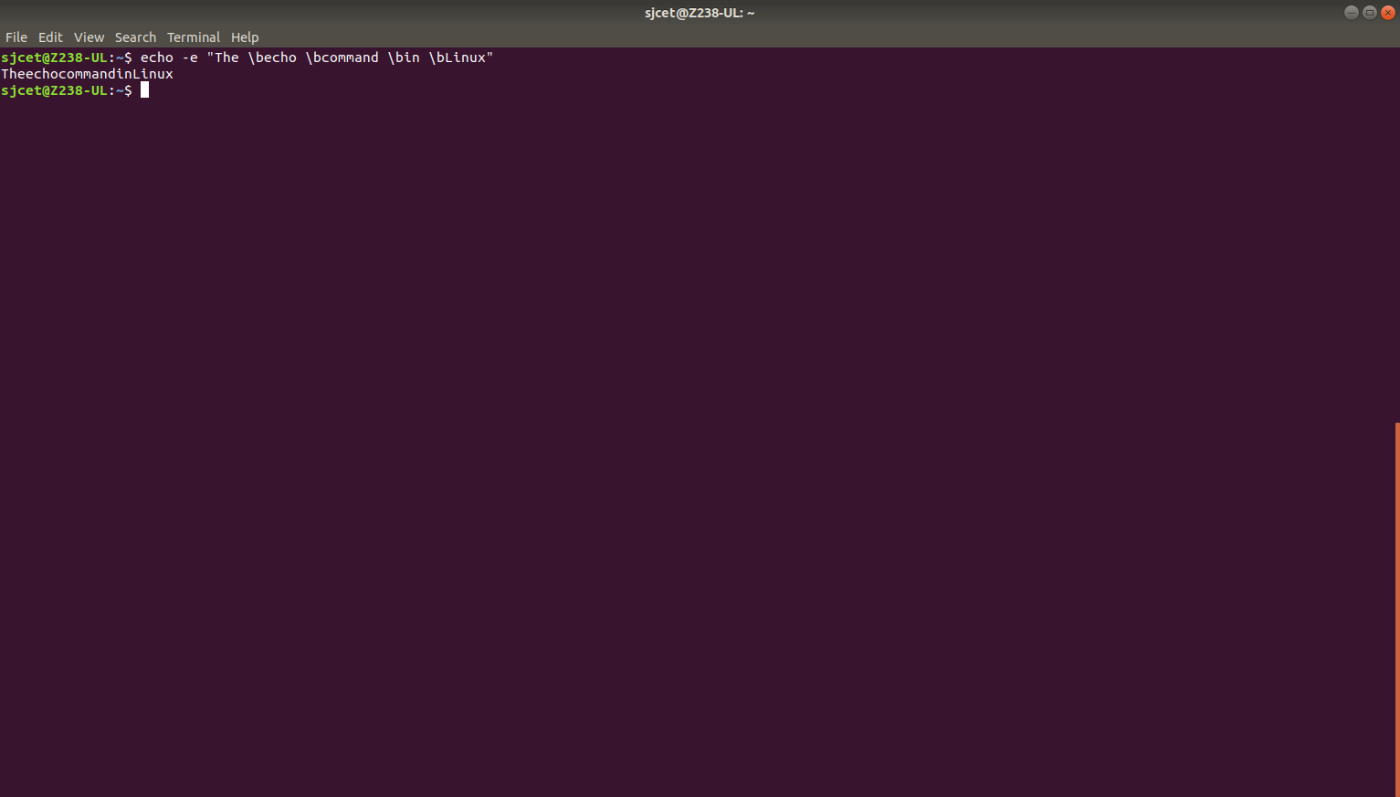

Using option ‘\n‘ – New line with backspace interpretor ‘-e‘ treats new
line from where it is used.

Using option ‘\t‘ – horizontal tab with backspace interpretor ‘-e‘ to
have horizontal tab spaces.

Using option ‘\v‘ – vertical tab with backspace interpretor ‘-e‘ to have
vertical tab spaces.

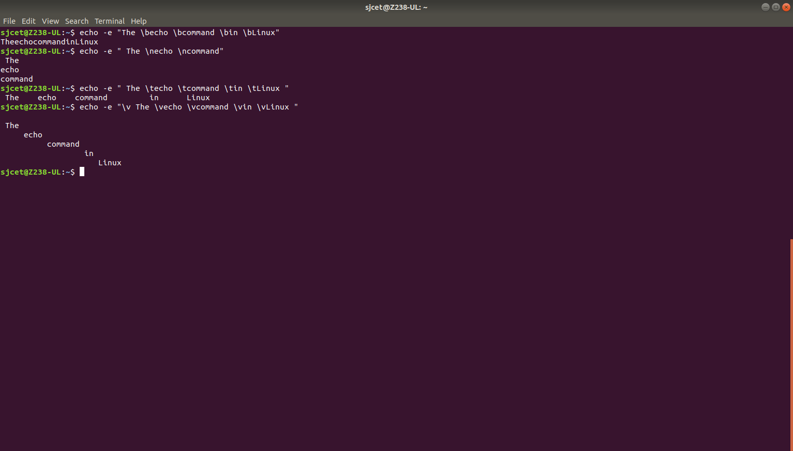

Using option ‘\r‘ – carriage return with backspace interpretor ‘-e‘ to have specified
carriage return in output.

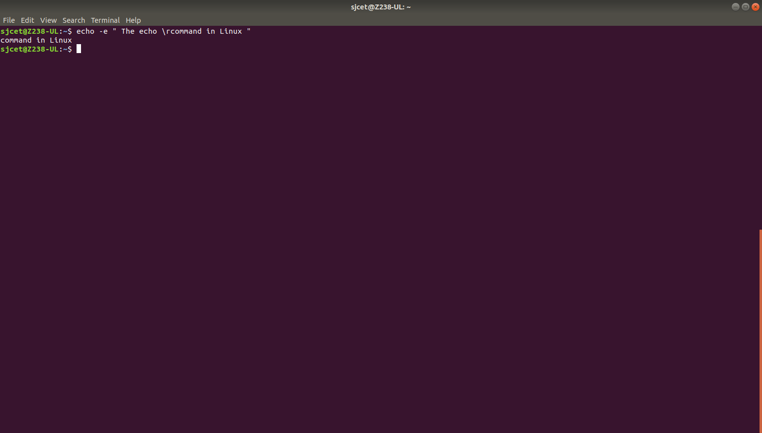

Read command

split the user input into different variables by adding multiple
arguments.
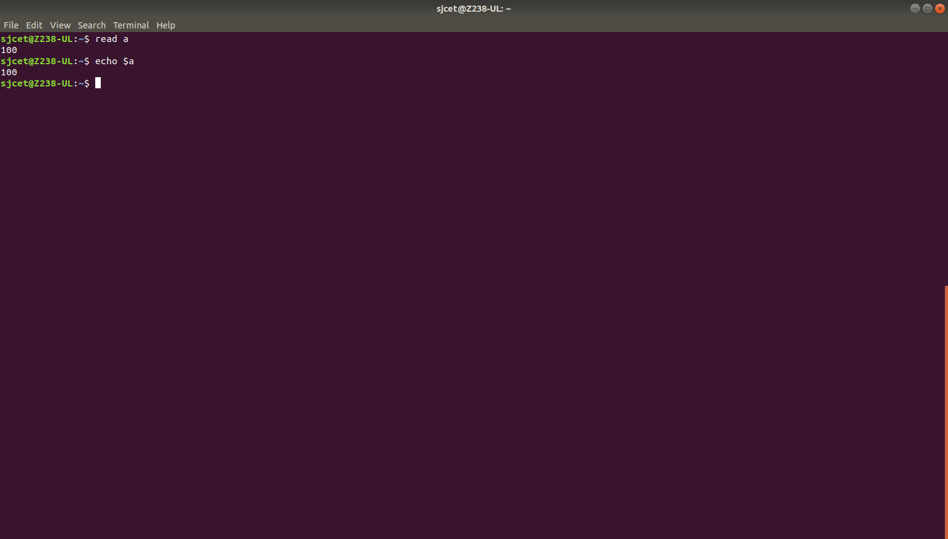
user input has more words than there are variables, the extra words are
assigned to the last provided variable:

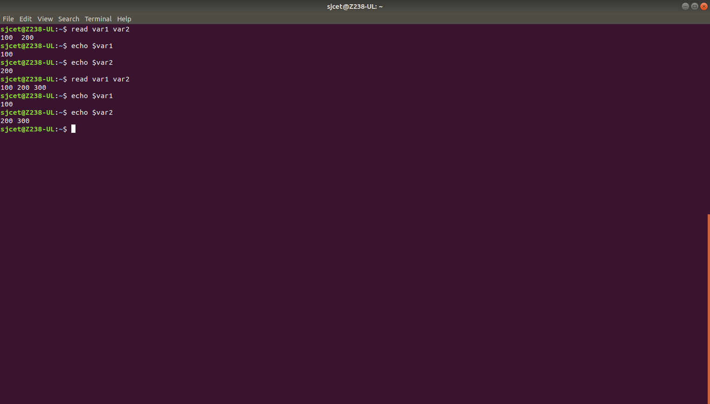
Piping

Piping takes the standard output from one command and parses it as standard input for
another process. Use echo and pipe the information to read for immediate parsing.

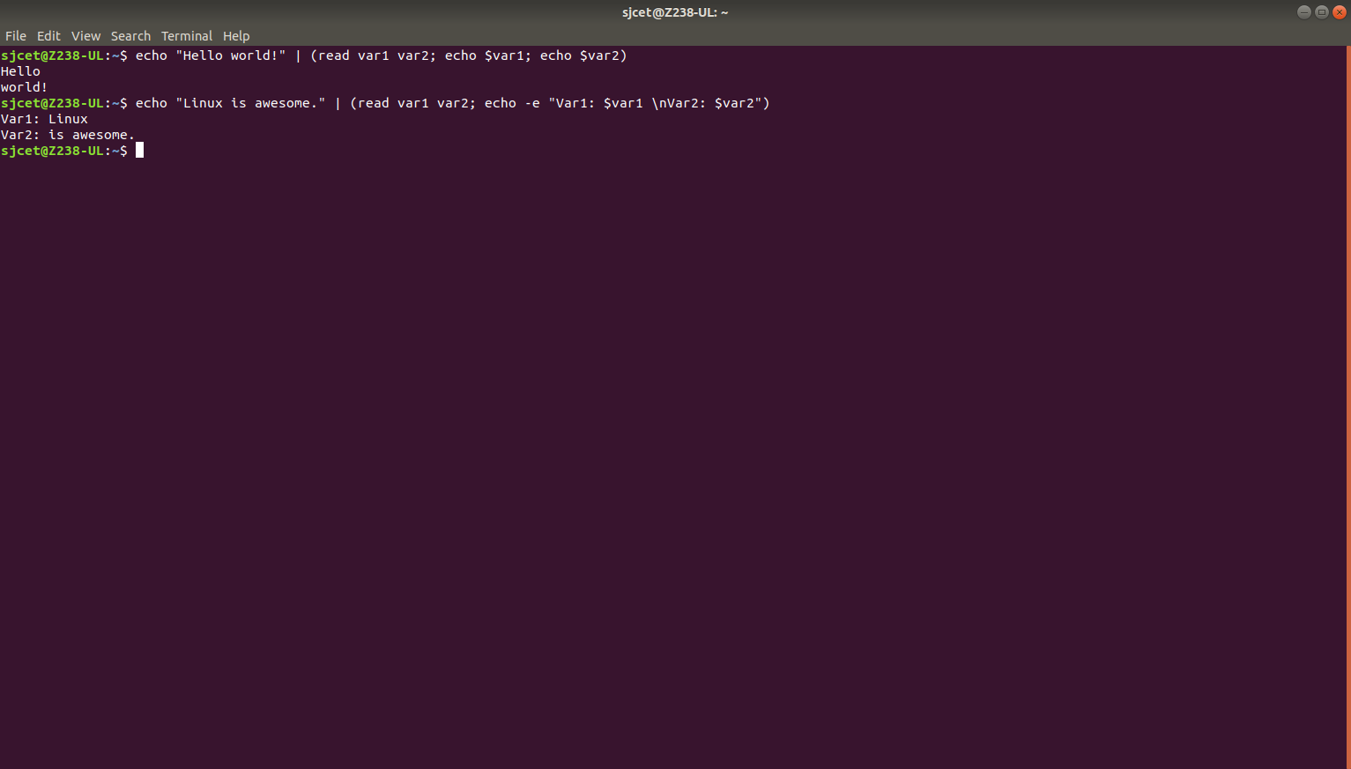

Changing the Delimiter

The default behavior of read is to split the line into words using one or more
spaces, tabs, and newline as delimiters. To use another character as a
delimiter, assign it to the IFS variable (Internal Field Separator).

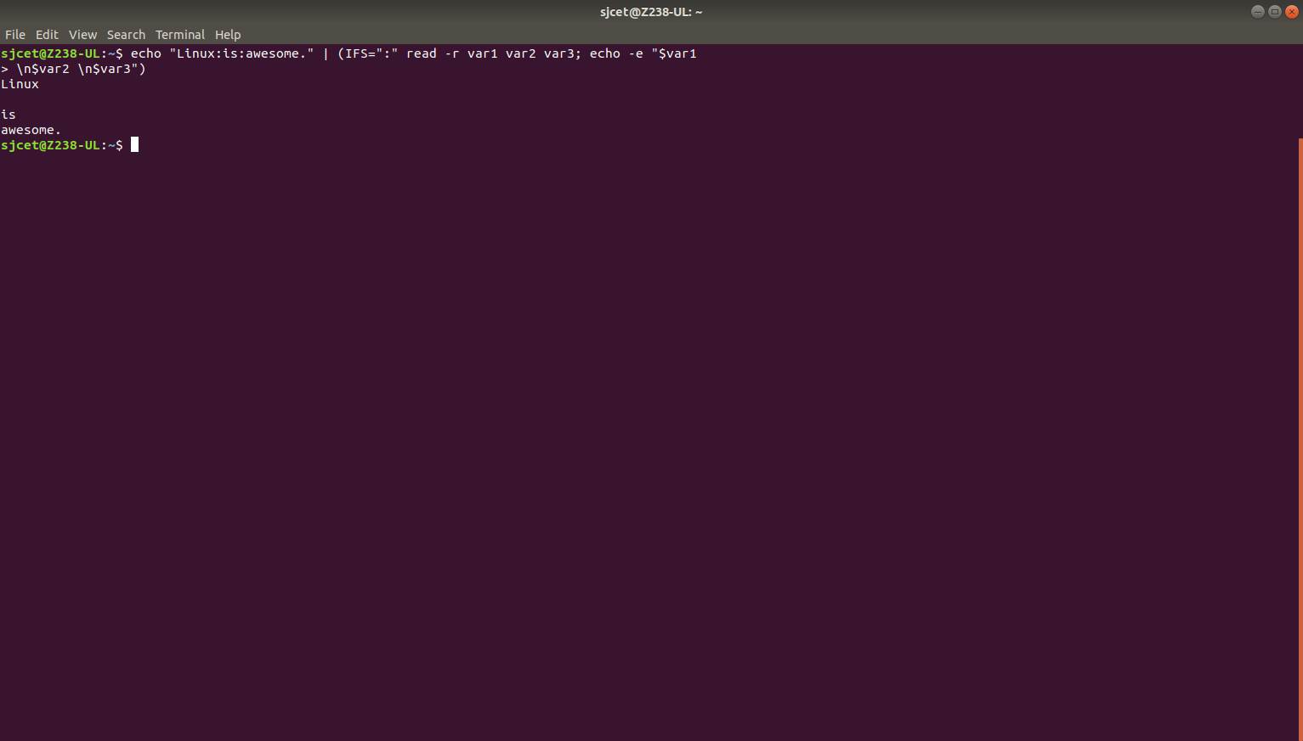

Assign the Words to Array

To assign the words to an array instead of variable names, invoke the
read command with the -a option:

