‘echo’ command in Linux

Declare a variable and echo its value. For example, Declare a variable of
x and assign its value=10.
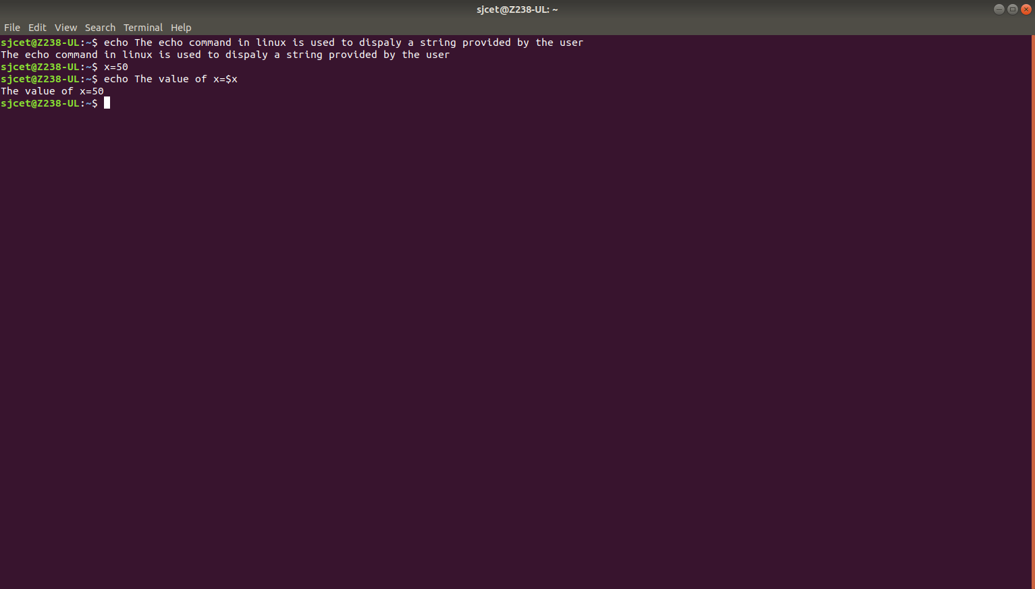

Using option ‘\b‘ – backspace with backslash interpretor ‘-e‘ which
removes all the spaces in between.
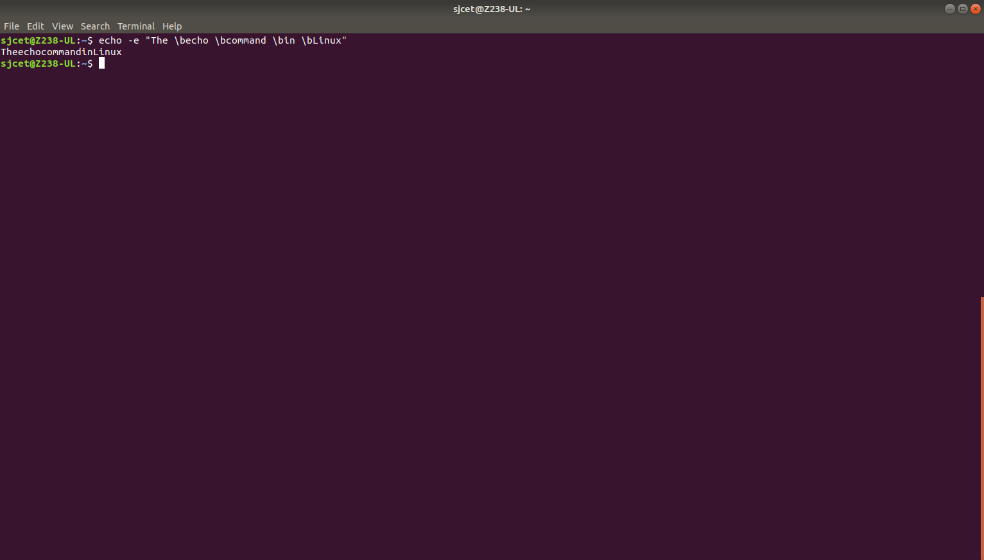

Using option ‘\n‘ – New line with backspace interpretor ‘-e‘ treats new
line from where it is used.

Using option ‘\t‘ – horizontal tab with backspace interpretor ‘-e‘ to
have horizontal tab spaces.

Using option ‘\v‘ – vertical tab with backspace interpretor ‘-e‘ to have
vertical tab spaces.

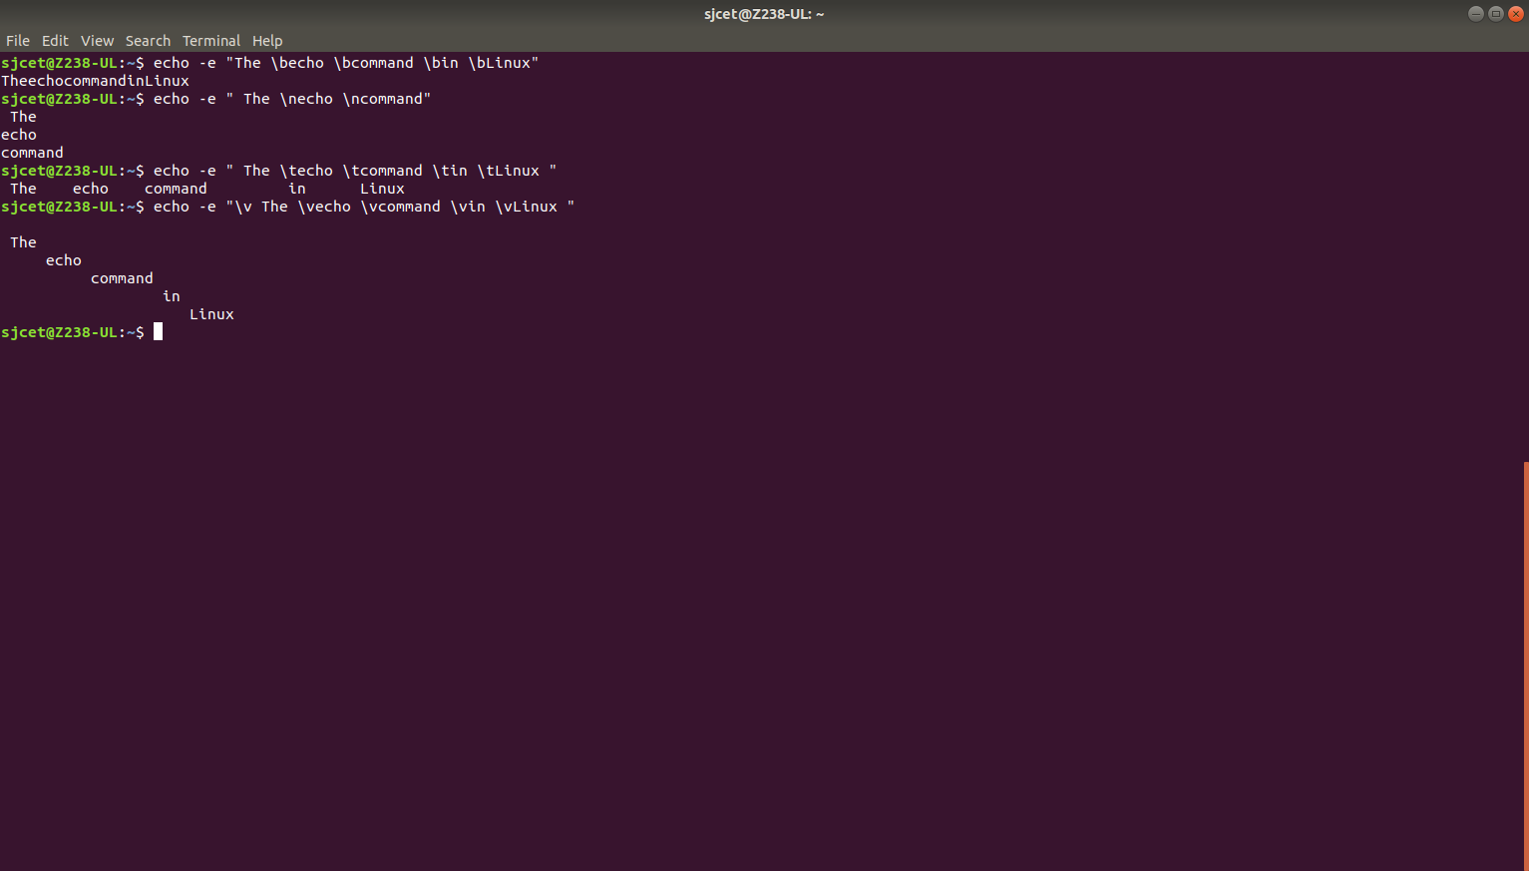

Using option ‘\r‘ – carriage return with backspace interpretor ‘-e‘ to have specified
carriage return in output.

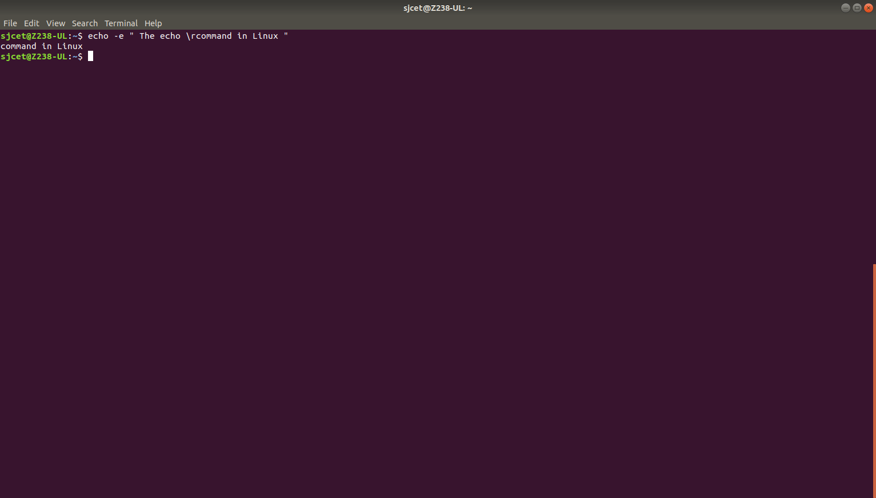

Read command

split the user input into different variables by adding multiple
arguments.
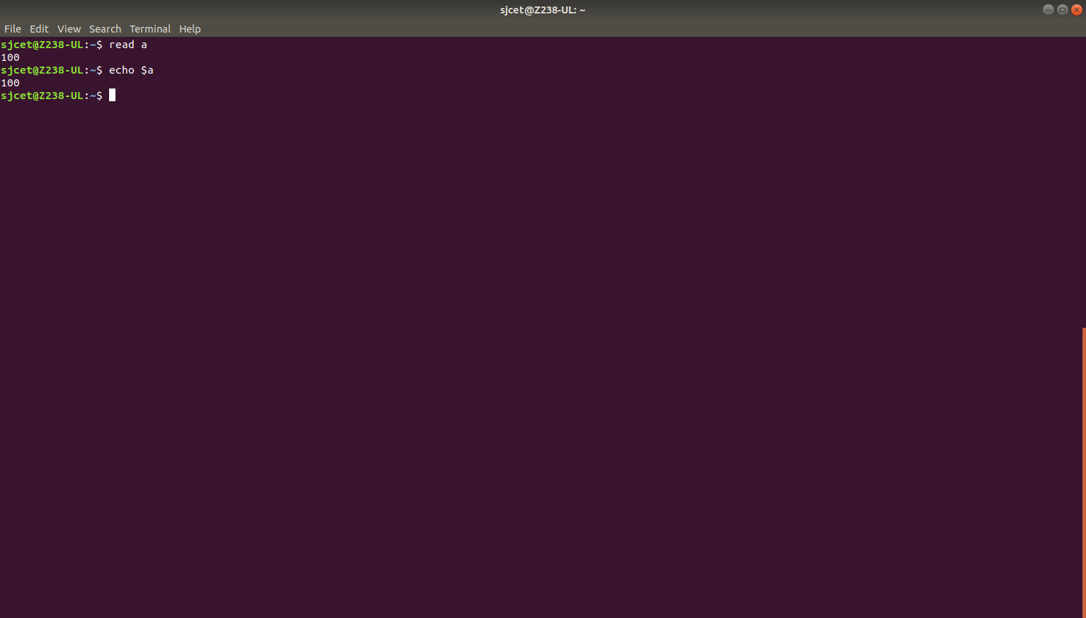
user input has more words than there are variables, the extra words are
assigned to the last provided variable:

