Waveform Buffers for LLRF Upgrade
  - J. Sebek January 21, 2026

Introduction
The current Low Level Radio Frequency (LLRF) system digitizes the amplitudes of eight detected RF signals at an approximately $1 \text{MSPS}$ rate. These signals are stored in circular buffers with a sample size of about $32 \text{kS}$ each. Averages of this data are read by the History buffers every $2 \text{s}$. In the event of an RF system fault, these buffers are frozen and the frozen data is written to files in the control system where further analysis can determine the cause of the fault.
The current system monitors 24 such signals. The new LLRF system will be based on two Dimtel LLRF9 chassis. These chassis will monitor the 18 most important signals. We need to build a chassis that will read the other six RF signal amplitudes as well as monitor some signals from the high voltage power supply (HVPS).

Data to be Acquired

RF Data
The amplitudes of the RF data need to be acquired. The RF signals that are currently monitored are:
- Klystron Output Forward Power
- Klystron Output Reflected Power
- Circulator Load Forward Power
- Circulator Load Reflected Power
- Klystron Drive Power
- Station Reference Power
- Waveguide Load 1 Forward Power
- Waveguide Load 1 Reflected Power
- Cavity A Forward Power
- Cavity A Reflected Power
- Cavity B Forward Power
- Cavity B Reflected Power
- Cavity A Probe Signal
- Cavity B Probe Signal
- Waveguide Load 2 Forward Power
- Waveguide Load 2 Reflected Power
- Cavity C Forward Power
- Cavity C Reflected Power
- Cavity D Forward Power
- Cavity D Reflected Power
- Cavity C Probe Signal
- Cavity D Probe Signal
- Waveguide Load 3 Forward Power
- Waveguide Load 3 Reflected Power

Explanation of the Loads
The purpose of the klystron is to provide RF power to the cavities. This power then creates fields in the cavities that accelerate the electron beam so that it can recover the energy it lost due to the synchrotron radiation it emitted during its last revolution around SPEAR.
The output of the klystron first passes through a device called a circulator. The circulator is an asymmetrical three port device. Its purpose is to isolate the three ports. All power into one port should go to only one other port. Power into port 1 should only exit port 2; power into port 2 should only exit port 3; power into port 3 should only exit port 1. The klystron, connected to port 1, can deliver power to the cavities, connected to port 2. Any power reflected back from the cavities will go to the circulator load, connected to port 3, and not back into the klystron.
Also, there are three two-way power dividers in the RF system that divide the power out of the circulator equally into the four cavities. These are known as “magic tees”. They are four port devices, but by symmetry considerations of the ports, in phase power from ports 2 and 3 only couples to port 1; out of phase power from these ports only couples to port 4. That is the magic. Magic tees are reciprocal devices. Therefore, one can input power to port 1 and have in-phase power out of ports 2 and 3, with none exiting port 4. The first magic tee divides the output power of the circulator into two. Then each magic tee in the second layer then divides that power into two again. Each output port feeds a cavity. As a result, each cavity gets ¼ of the klystron power.
One designs the layout of the magic tees and cavities such that the round trip distance from port 2 to its load differs from the round trip distance from port 3 to its load by ½ wavelength. Equal powers reflected back from the cavities then exit port 4 of the magic tee into a waveguide load.
The Circulator Load measures a combination of the signals from the klystron that the circulator does not properly direct to the cavities and the signal reflected back from the first Magic Tee. Waveguide Load 2 measures the sum of the reflected signals from Cavities A and B. Waveguide Load 3 measures the sum of the reflected signals from Cavities C and D. Waveguide Load 1 measures the sum of the reflected signals from all four cavities that do go to either Waveguide Load 2 or 3.

Typical Load Signals
Figure 1 plots the forward powers on all the loads for various beam conditions. At the beginning of the figure, SPEAR had its nominal beam current of $500 \text{mA}$. The beam was dumped, the RF station was turned off, and an access was taken at 13:00. The RF power was restored about 13:35.
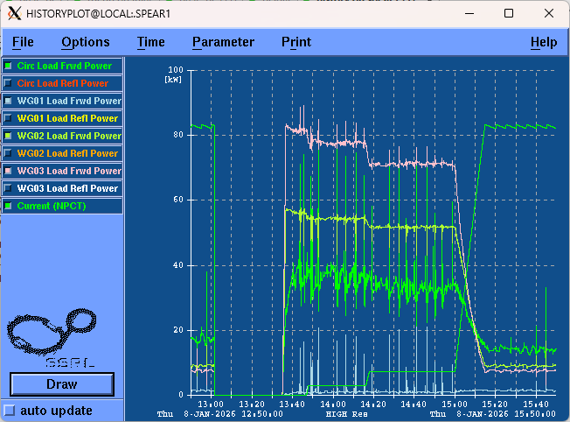
Figure 1: Load forward powers under all conditions.
At that time we can see that the forward powers on the loads were appreciable. The cavities were designed to be a well-matched load with $500 \text{mA}$ of beam. At full current the klystron outputs about $800 \text{kW}$ of power into a well-matched load. About half of this power is used to accelerate the beam; the other half is lost to currents in the cavity walls. The match is not as good at lower beam currents and power is reflected from the cavities.
We see that initially about $80 \text{kW}$ of power is reflected from cavities C and D into waveguide load 3 and about $55 \text{kW}$ of power is reflected from Cavities A and B into waveguide load 2. Waveguide load 1 shows very little power. The circulator load absorbs about $40 \text{kW}$. At $500 \text{mA}$ the powers decrease to less than $10 \text{kW}$ for waveguide loads 2 and 3 and about $16 \text{kW}$ for the circulator load.
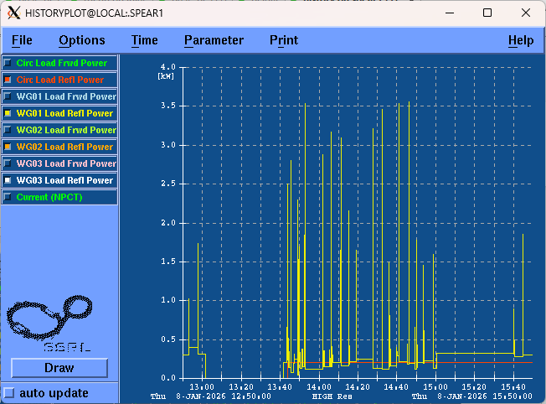
Figure 2: Load reflected powers under all condtion
Figure 2 shows the reflected power from all four loads under all conditions. We see very little reflected power under any condition. The waveguide loads are well-matched.

HVPS Data
We also want to monitor the data from the high voltage power supply (HVPS) that powers the klystron. The HVPS can fail and cause a beam loss when it does. The HVPS can also cause a system trip when a dip occurs in the input $12.47 \text{kV}$ AC line. HVPS signals are useful to diagnose the cause of a beam dump when the HVPS trips the beam. Currently we have an oscilloscope monitoring four signals and triggers on a loss of the output voltage of the HVPS. The signals monitor the HVPS voltage and current, as well as HVPS monitoring signals from which one can determine the health of the HVPS firing circuits. Figure 3 shows the signals monitored from HVPS1. The voltage on inductor 2 shows the timing of the firing circuit for one transformer, transformer 2. Spikes are visible on the current of one phase current of transformer 1. (HVPS1 has an internal open monitoring circuit on the transformer 1 voltage. This circuit is intact on HVPS2 so there we would display two sawtooth waveforms, one for each transformer.) We have found it useful to monitor about $100 \text{ms}$ of HVPS data. Trigger misfires can cause regulation problems that do not drop the system until tens of milliseconds later. It would be useful to also monitor and archive these signals automatically.
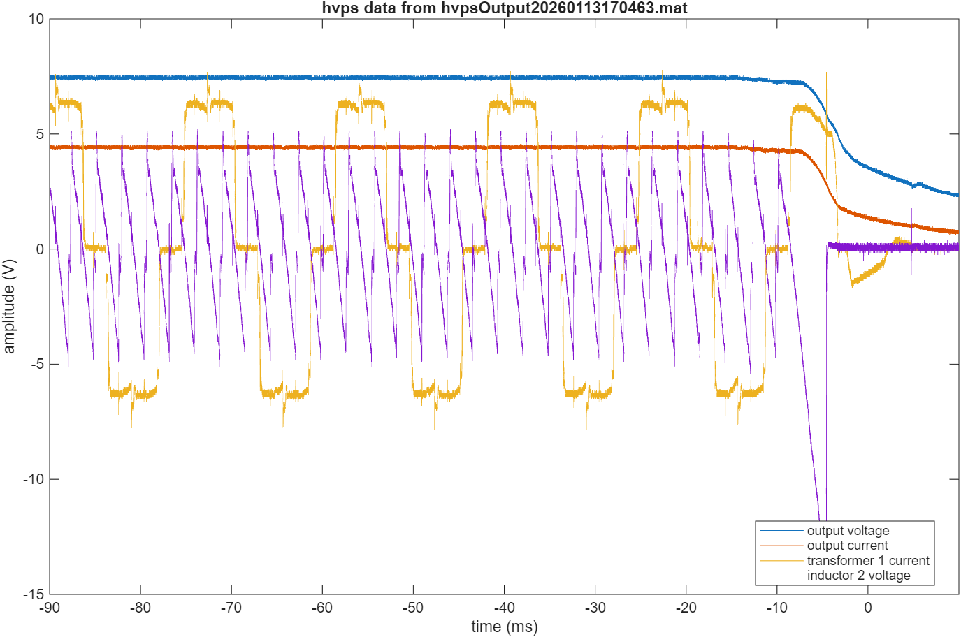
Figure 3: Typical HVPS signal during a beam dump.

Signal Processing
All the signals will have three stages of signal processing. We first may need to condition the signals. The conditioned signal will then proceed along two parallel paths. One path will go to a digitizer that will acquire the data for further archival and processing via the control system. The other path will go to analog comparator circuits. If the conditioned signals exceed a safe operating value, the comparator will register a latched fault. This fault should be registered by the control system and be an input into a digital summary circuit. The output of this summary fault will remove enables to other system controllers, one for the LLRF and another for the HVPS. It will also freeze the digitized buffers of the various signals. The latched fault shall be resettable from the control system. During normal operation averaged signals should be made available for archival to the control system at approximately one second update rates.
If it is convenient, it would be useful to have the comparator threshold values set remotely. However, these thresholds are seldom, if ever, expected to change, so the values could be set by manually adjusting potentiometers.

RF Signals
We should plan to digitize eight RF signals. We will first process the raw RF signals with RF detectors, such as the Mini-Circuits ZX47-40LN+. We will reduce the input signals, as appropriate with connectorized attenuators. The ZX47-40LN+ has an output range of $0.50 \text{V}-2.10 \text{V}$ into a $1 \text{k}Ω$ load. If necessary, we can invert and/or amplify this signal with a medium speed operational amplifier to set its amplitude to be compatible with the selected digitizer. The digitizers should have reasonable resolution, but do not need to have extreme precision or resolution. A 12 bit digitizer, if available, should be more than sufficient.
RF trips create transients in the sub-microsecond range, but these detectors have a rise time of several hundred nanoseconds. It would be convenient to sample these signals at a $1 \text{MSPS}$ rate. The transients should occur within tens of microseconds before a beam trip, it may be useful to keep a longer buffer. A $32$ kilosample buffer may be easy to implement and will store more than enough samples.

HVPS Signals
We should plan to digitize four HVPS signals. The specifications for the digitizers for the HVPS signals are similar, however the sampling rates and buffer lengths may be different. As seen from Figure 3, the amplitudes for these signals are quite large. We likely will use voltage dividers to reduce the signal amplitudes to be compatible with the input range of the digitizers.
We have found that for a particular failure of the HVPS, the cause of the failure occurred almost $100 \text{ms}$ before the result of the failure caused the system to trip. Therefore, we should design this buffer to include at least $100 \text{ms}$ of data. Sampling at a $1 \text{MSPS}$ rate would require a$128$ kilosample buffer. If we wanted to reduce the buffer size to $32$ kilosamples, we could average the sampling rate by a factor of $4$ without losing any appreciable precision. We will set the discriminator thresholds to only look for overvoltage or overcurrent faults.

Klystron Collector Power Signal
Our control system will also protect the klystron against excessive klystron collector power. A klystron amplifies RF signals by velocity modulating a drive beam emitted from the klystron cathode. The drive beam is created by the HVPS. The HVPS applies a potential between the grid and the cathode and the cathode emits current. The product of this voltage and beam current is the input DC power into the klystron. An RF drive signal is input into the klystron; this starts the velocity modulation process. Approximately half of the DC power is converted to RF and the other half of the power is the remaining kinetic energy of the drive beam at the end of the klystron. This beam is absorbed by the klystron collector, a massive water-cooled structure at the end of the tube.
The SLAC Bfactory klystrons are not “full power collector” tubes. That is, they cannot absorb the full power of the DC cathode beam. A full power DC beam will damage the collector.
We can use this chassis to trip off the system in the event of excessive collector power in the klystron. We will use one of the RF channels to monitor the RF power out of the klystron. Two of our HVPS channels will monitor the beam voltage and current from the HVPS. We should buffer out these signals to our local RF MPS PLC system. From the HVPS voltage and current, it will calculate the DC power out of the HVPS. From the RF detector it will calculate the RF power. It will then subtract the two to ensure that the klystron collector power is within limits. (If it is not difficult to calculate this on this signal conditioning and digitizing chassis, this chassis could make a redundant collector power measurement and also trip off the system on excessive collector power.)

