SPEAR3 RF Station Operation

Introduction
This note describes the general operation of the SPEAR3 RF system. Its purpose is to provide a brief guide for people documenting the EPICS scripts and operational EDM panels of the LLRF. I think that I have included sufficient graphics to the documenters to start to understand the software.

References
The github repository for the EPICS sequences is
https://github.com/slac-epics/rf-spear/tree/e9b895cde01174ca3b5e40f0ff27db2059e00922/rfApp/src/seq
The repository for the entire LLRF software is a parent of this at
https://github.com/slac-epics/rf-spear/tree/e9b895cde01174ca3b5e40f0ff27db2059e00922
The location of the rfedm script that launches the EDM panels for this system is at
/prod/epics/app/spear/script/rfedm
which launches the edm command
edm -x -m "STN=SRF1,RING=SPR,NCV=4CV,PS=RF-SOLN-MAIN" -eolc rf_station_4CVSPR.edl > /dev/null &

RF System Basic Operation
The purpose of the RF system is to provide stable high power RF power to accelerate the electron beam in SPEAR to make up for the energy lost due to its radiation of x-rays. Approximately $400 \text{kW}$ of RF power is required for this, distributed uniformly between four RF cavities. A single $1.5 \text{MW}$ klystron provides this power. The high voltage power supply for the klystron can provide up to $-90 \text{kV}$ at $27 \text{A}$. The RF input to the klystron comes from a fixed gain drive amplifier that outputs $29 \text{W}$ during normal operation. The main setpoint for the RF system is the total accelerating gap voltage seen by the beam. This is the sum of the gap voltages of the individual cavities. In normal operation, SPEAR has a total gap voltage of $2.850 \text{MV}=2850 \text{kV}$.

Fast Analog Control
There are several levels of control for the RF system. The fastest and most critical control is the LLRF RF Processor (RFP) module. The RFP is a primarily analog module that has as input the RF signals from the four cavity probes. It decomposes each signal into its in-phase and quadrature components, compares the amplitudes of these signals to the desired values, corrects the errors using analog feedback, and finally reconstructs the desired RF input to the drive amplifier. Almost all of this signal processing is done in analog.

Digital Gain Control
The VXI controller provides several slow feedback controls with update rates measured in seconds. The lowest level loop controls the amplitude of the RFP output. This is the DAC Control Loop. The VxWorks code monitors the sum of the gap voltages in the four cavities and adjusts the PV SRF1:STN:ON:IQ. The RFP output linearly depends on the value of this PV.

HVPS Output Control
The drive amplifier is a fixed gain amplifier; its only purpose is to provide gain to the output of the RFP module. However, the klystron is not a fixed gain amplifier. Its gain depends on the output of the high voltage power supply (HVPS). Technical considerations, including, among other things, the allowable heat dissipation inside of the klystron, klystron gain, and klystron stability place limits on the HVPS output as a function of klystron output RF power. Therefore, an outer VxWorks control loop adjusts the output of the HVPS. As the DAC voltage increases to achieve the gap voltage goal, the drive power also increases. The HVPS Loop monitors the drive power to the klystron, SRF1:KLYSDRIVFRWD:POWER. When that value exceeds the goal value, SRF1:KLYSDRIVFRWD:POWER:ON or SRF1:KLYSDRIVFRWD:POWER:HIGH, as appropriate, the HVPS loop process increases the setpoint of the HVPS, SRF1:HVPS:VOLT:CTRL.VAL, in order to keep the drive power at its desired value.

Tuner Control
The VxWorks control loop also is responsible for keeping the cavities tuned to the desired frequency. The RF frequency is determined by the instantaneous “best” orbit of the beam. The orbit feedback system sets the SPEAR frequency synthesizer accordingly. The resonant frequency of each cavity depends on its geometry which, in turn, is a function of temperature. Moveable cylindrical tuners inside each cavity can adjust its resonant frequency. The LLRF system keeps the cavity frequencies at their desired values by keeping fixed, at the desired value, the phase difference between the field inside of each cavity and the forward traveling wave into the cavity.
The tuners are currently controlled by an Allen-Bradley stepper motor controller that has 400 steps per revolution. The controller is set for 200 steps per revolution and there is a reduction gear that requires two turns of the stepper motor for one turn of the tuner shaft. The tuner lead screw has a pitch of 20 turns per inch, so that one revolution of the lead screw moves 1.27 mm. A more modern stepper motor controller can have 256 micro-steps per step, increasing the sensitivity of the motion.

RF Station Turn-On
The control system is also responsible to turn on the station in a controlled manner. When the station is turned on the tuners are moved to their “TUNE/ON Home” position (SRF1:CAV1TUNR:POSN:ONHOME). The HVPS is programmed to turn on at its Turn-On Voltage (SRF1:HVPS:VOLT:MIN) and the multiplying DAC in the RFP module (SRF1:STN:ON:IQ) is set to its initial value of Fast On RFP Counts (SRF1:STN:ONFAST:INIT).
These settings create low, but measurable RF power. The DAC setting creates a few watts of drive power and there are a few hundred kV of total gap voltage. At this level of power, the forward power and cavity probes measure sufficient signal to detect and measure a phase difference between the two. At this point the tuner feedback loop, if active, starts to regulate the tuner position to maintain the desired phase difference.
At this point, the VxWorks system starts to bring the station up to full power. Figure 10 shows various RF parameters as the system turns on. The DAC counts start at 100, resulting in a drive power of a few watts. The HVPS turns on at 50 kV and the DAC counts start at 100. The total gap voltage is a few hundred kV, sufficient field to start measuring the RF parameters and enabling the LLRF controls to work. The DAC counts are increased to about 200, raising the drive power slightly and then an analog switch on the RFP module is closed, engaging the direct loop feedback. This switch closure adds an integrator to the analog feedback loop. Adding the integrator causes a transient in the drive power output, raising it to about 45 W before the transient settles and the drive power returns to about 10 W. This transient rise in power is done at a sufficiently low value of the HVPS so that the resultant klystron output power is only about 50 kW, ensuring that the station is not brought up to a state that could damage the system. (Although there is a PV that requests the direct loop to be closed at any time, the internal controls of the VxWorks process prevents this request from being honored when the klystron output power would exceed a safe value.)
There are two important settings, controlled by PVs, for the direct loop that determine the stability of the RF system. The Loop Gain, SRF1:STNDIRECT:LOOP:COUNTS.A, controls the amplitude of the feedback loop and the Loop Phase, SRF1:STNDIRECT:LOOP:PHASE.C, controls the phase shift added to the feedback loop to keep the desired system phase when all other electronic delays are included in the system. Figure 8 shows the transfer function, both amplitude and phase, of the fast control feedback loop of the RFP module of the LLRF system. Note that the center is detuned to a lower frequency to provide stability against the Robinson instability. Figure 9 shows the spectrum of Cavity A with 500 mA of beam. The peaks at around 2.8 kHz are caused by internal feedback loops used to decrease the ripple at power line frequencies. The peaks around 8.8 kHz are the synchrotron oscillations, almost 90 dB lower than the fundamental. The precise detuning angle is not extremely critical; at this tuning, modifying the loop gain and phase will have only minor affects on the beam stability.
When the direct loop is closed, the slow (~1 Hz) feedback loops begin. Both the DAC setting and the HVPS voltage control are ramped up slowly for about 10 – 20 seconds. During this time the control system is waiting for the transient from the direct loop transient to die out. Then both the DAC setting and HVPS control feedback loops become active.
The DAC setting directly controls the drive power amplitude, but its ultimate purpose is to control the total gap voltage of the RF cavities. The goal of the HVPS feedback loop is to keep the drive power at its desired set point while the DAC setting is controlling the gap voltage. The klystron amplification is a function of the HVPS voltage. Over its operating range, for a fixed input drive power, the klystron output power increases with increasing HVPS voltage.
The control program monitors the gap voltage and the drive power. If the gap voltage is below the set point, the DAC setting is increased. If the drive power exceeds its set point, the HVPS control is increased, increasing the klystron gain to reduce the required drive power to achieve the desired gap voltage.
All of these loops then continue to function during operation, keeping the station operating around its nominal values. During normal operation these values vary a few tenths of a percent in order to keep the gap voltage fixed to that same tolerance.

Other RF Station Modes
The LLRF has three other modes, PARK, TUNE, and ON_FM. Of these three, the only mode we use is TUNE. PARK was designed for PEP-II operation when an RF station was down. ON-FM was designed for processing of the cavities in the event of a vacuum incident in the cavities. We have had one incident in which we brought the cavity up to pressure with nitrogen, but we could successfully process the cavity by varying the gap voltage in the ON_CW mode. We did not need the ON_FM mode.
The TUNE mode is typically used to bring up the system in a very controlled way when testing new equipment, such as a refurbished HVPS or a new klystron. The TUNE loop should turn off the DAC control loop and most of the other feedback loops. The user should ensure that the HVPS loop is off. It is reasonable to keep the Tuner Loop on in order to keep the cavity tuned during these tests.
Once the HVPS and klystron are determined to be healthy, one can then start to bring up the system. If the klystron has been replaced, one may need to adjust the Direct Loop Phase, SRF1:STNDIRECT:LOOP:PHASE.C, to compensate for phase differences between the previous and current klystrons. A significant phase difference could cause the feedback loop to become unstable.
If nothing has been changed in the system, a better way to bring up the system after, for example, an extended downtime is to bring the system up in ON_CW mode, but to set the gap voltage to reduced values.

RF Tuner Operation
I will spend some time discussing the motion control system for the RF cavity tuners, one for each of the four cavities. This system needs to be upgraded for the LLRF upgrade with new hardware and associated software driver. We discuss here the features of the control system tuner feedback software to ensure we maintain the same features after the upgrade.

Tuner Feedback Loops
The purpose of the tuner feedback loops is to keep the resonant frequency of the cavity at its desired value, slightly less than f_{RF}, as the cavity environmental conditions change due to, for example, a change in gap voltage or beam current.
The desired tuner position is determined by measuring the phase difference between the forward power input to the cavity, and the field inside of the cavity. The amplitude and phase of the forward power signal is measured in a waveguide coupler upstream of the cavity. The amplitude and phase of the cavity field is measured by a probe inside of the cavity. Measurements made during the initial setup of the system determine the measured phase difference when the two signals are in phase with each other. The second subplot of Figure 9 shows the change in cavity phase with frequency for a fixed cavity resonant frequency.
As shown in Figure 6, there are two slow feedback loops that control the tuner position. The first is the loop that controls the cavity phase described above. There is a second, slower, loop that keeps the power in the four cavities balanced. This loop would not be needed if all of the cavities and their incident powers were exactly identical. A system design decision was made to have a slow feedback loop slightly change the tuning angle of each cavity in order to equalize the gap voltage in each cavity. This is accomplished by the Load Angle Offset loop. The user sets a PV, for example SRF1:CAV1:STRENGTH:CTRL, to select what fraction of the total gap voltage should be contributed by each cavity. The feedback loop then adjusts the phase setpoints to achieve this fraction.

Mechanical Tuner Assembly
The mechanical tuner assembly main drawing is SA-341-392-61. Relevant to this discussion is the drive mechanism between a stepper motor and the lead screw that drives the moveable tuner. Our controls drive a stepper motor. Its shaft has a SDP/SI 6A 3-15DF03712 15 groove timing belt pulley. An SDP/SI 6G 3-045037 pulley connects this pulley to a SDP/SI 6A 3-30H3708 30 groove timing belt pulley on the lead screw. Therefore the pulleys’ gear ratio means that one turn rotation of the stepper motor shaft turns the lead screw ½ turn. Since the lead screw has a ½-10 Acme thread (PF-341-392-68), one turn of the stepper motor moves the tuner 0.05” = 1.27 mm.
Figure 11 shows that the total tuner movement from the home position to its initial position during the RF system startup is about 2.5 mm, one turn of the lead screw, equivalently two turns of the stepper motor. Figure 12 shows that typical motion during normal operation is only about 0.2 mm.
The stepper motor is a Superior Electric Slo-Syn M093-FC11. This is a standard NEMA size 34D motor. Two separate components make up the stepper motor driver. An Allen-Bradley 1746 HSTP1 controller module receives commands from the VxWorks controller and converts them into low power pulses. These pulses are amplified by a Superior Electric Slo-Syn SS2000MD4-M bipolar two-phase pulse width modulated (PWM) driver.
The stepper motors have no encoders. There are linear potentiometers which act as some measure of the tuner position. The readings from these potentiometers are measured and recorded by the control system, but they are not part of any feedback system.

Tuner Controller Settings
All three of these hardware components, the motors, controller module, and PWM driver are obsolete. We intend to replace these components with modern units that are currently supported by their vendors. In particular, we are investigating the use of a Galil DMC-4143 four axis motion controller. One such unit would drive all four stepper motors required for the four cavity tuners. Also, Dimtel has successfully controlled these tuners in other applications of their LLRF9 high performance RF controllers. Our conceptual design is to implement an EPICS driver that can accept and act on channel access commands generated by the LLRF9 to control the tuners.
Figure 7 shows the details of the existing controller settings. The numbers at the bottom of the figure show some numerical calculations. The M093-FC11 has 200 steps per revolution. The controller resolution has two micro-steps per step to give 400 micro-steps per revolution (MRES). The 1:2 gear ratio of the stepper motor and lead screw gear gives 800 micro-steps per lead screw revolution. The 10 pitch Acme thread means one lead screw revolution is $0.1"$. The linear motion of the tuner per pulse is then
$$Δx=\frac{0.1}{800}=1.25×{10}^{-4} \text{inches}= 25.4⋅1.25×{10}^{-4}=3.175 μ\text{m}$$
which is defined as DIST. Note that the existing system has a deadband of five micro-steps (RDBD). Figure 12 shows that the resolution and dead band are smaller than typical steps required during normal operation.
The conceptual design hardware for our upgrade will have much finer resolution than our current system has, even if we eliminated the reduction gear. The stepper motor will have the same 200 steps per revolution, but the controller has more than two micro-steps (16 or 64?).

Tuner Control Algorithm
We should review the existing tuner control algorithm and ensure that we can at least reproduce the existing one, if not improve it. We will need to understand the LLRF9 software control to properly partition the control between the LLRF9 and our EPICS driver.
We need to establish a “home” position for the tuner and ensure that we move the tuner to that position when the system is off. We also want to ensure that all tuner control loops are off until and unless we see a minimum of power in the cavity. This likely will be done in the LLRF9 system since it will be measuring the cavity signals. The load angle offset loop seems to be best suited for our EPICS application rather than LLRF9.
We should verify that LLRF9 just gives commands for delta movements of the tuners. Our driver should ensure the step size and parameters like update rates and deadbands are enforced so that we do not attempt to unnecessarily continue to move the tuner with extremely small steps that could cause mechanical wear.
We also want to develop the proper motion profiles for moving the tuner. The Galil example drivers program acceleration, steady state motion, and deceleration profiles into their movements. When observing the pulses out of the Slo-Syn PWM driver we only saw uniform pulse rates, independent of the desired distance of travel. We should set up a test stand with programmed motion both on our spare cavity and then on our real cavity to determine the best motion profiles to use for reliable motion of the stepper motors.
The current system has a useful “stop and init” feature. The controller has a step counter that records the number of steps it has programmed the motor to move from its zero position. This counter would be compared to an encoder if our system had one. We do not; we only have a linear potentiometer that gives an indication of the position of the tuner. The current stop and init does not move the tuner, rather it aligns its internal step counter with the measured voltage from the potentiometer and resets its counter accordingly.
We also need to have a well-defined startup and recovery of our stepper motor driver. We want the driver to behave properly if either it loses its power or its communication with the control system. This may involve sending information to the LLRF9, up to and including, in a worst case, turning the station off. However this worst case should be vary unlikely as hopefully LLRF9 will take the correct action if it cannot control the tuner and a cavity goes far out of tune.

RF System EDM Panels
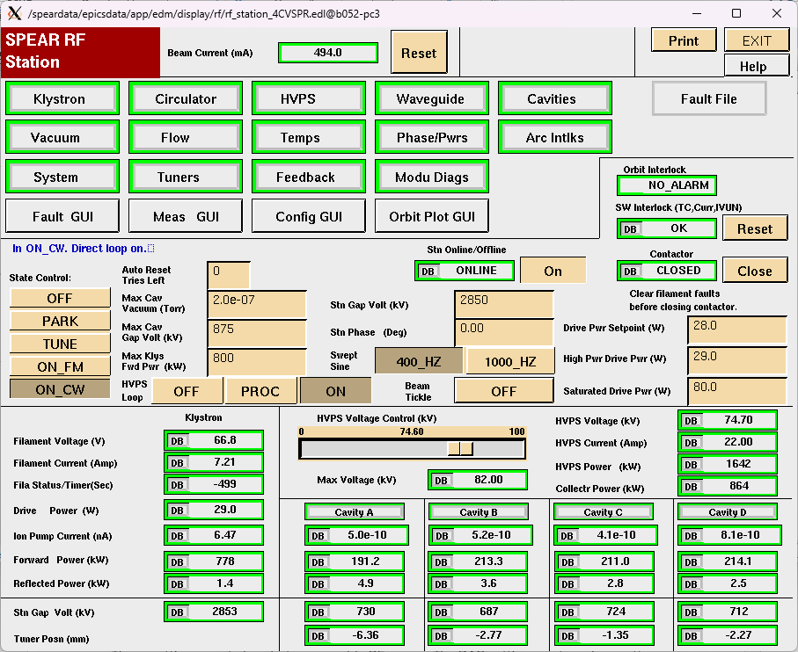
Figure 1: Main RF EDM panel

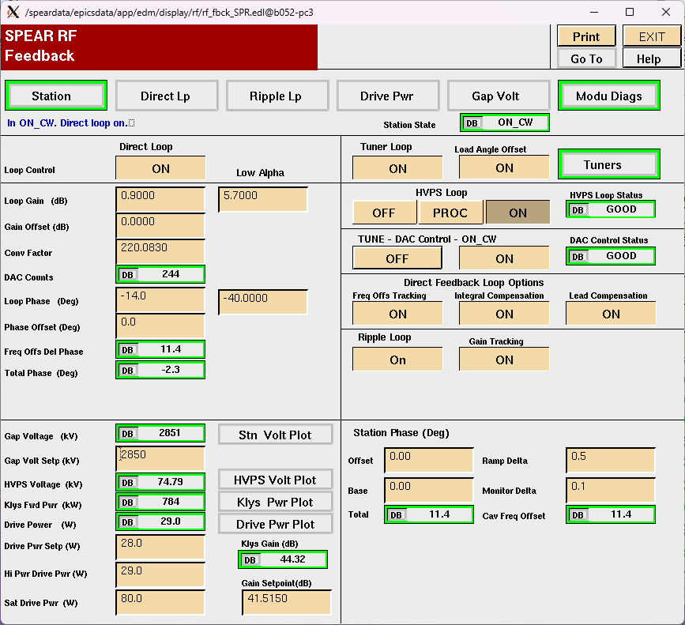
Figure 2: RF Feedback panel controlling values of feedback parameters and status of feedback loops.
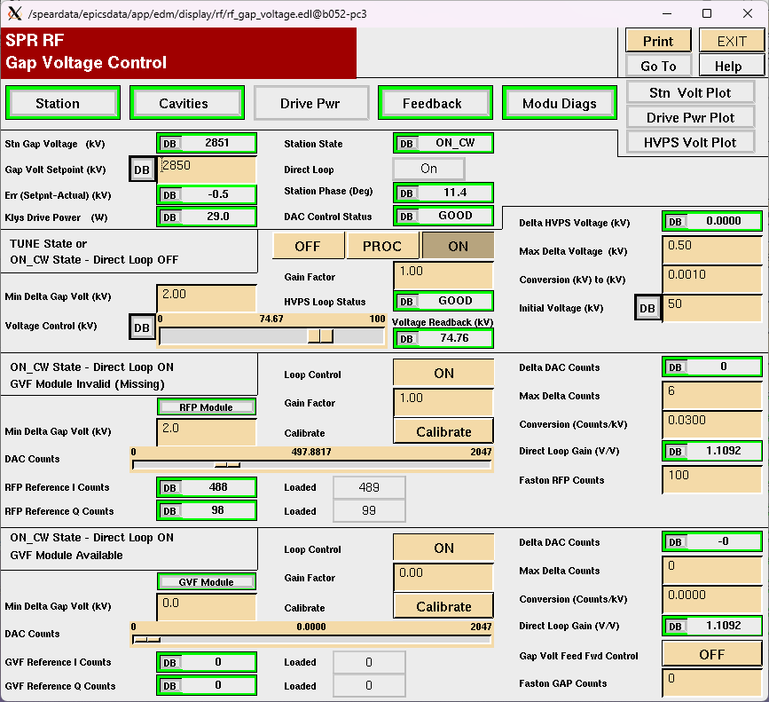
Figure 3: Gap voltage control panel showing the DAC counts for the RFP control loop.
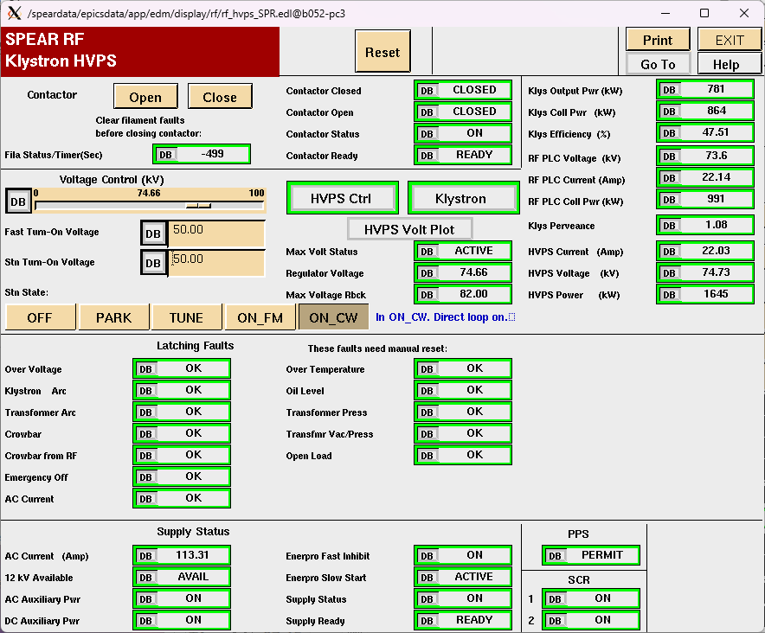
Figure 4: HVPS control panel showing status of the supply.
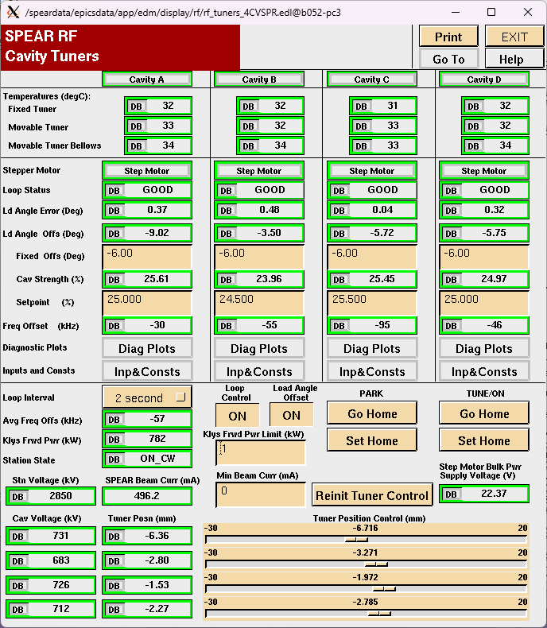
Figure 5: Summary cavity tuner panel
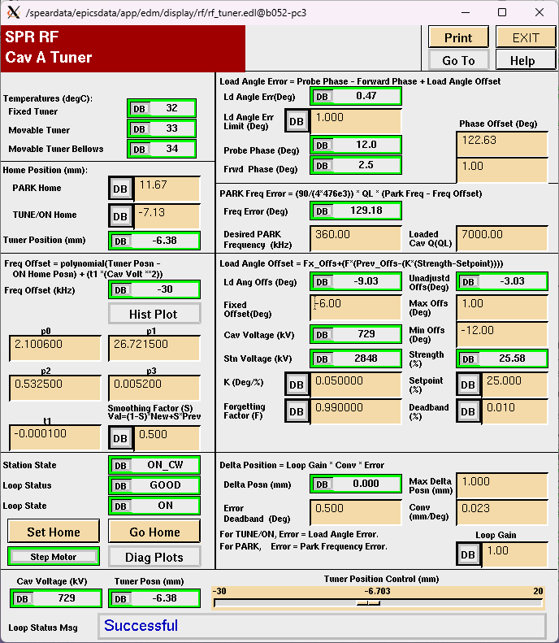
Figure 6: Typical tuner control panel showing the details of the parameters, including tuner feedback values.
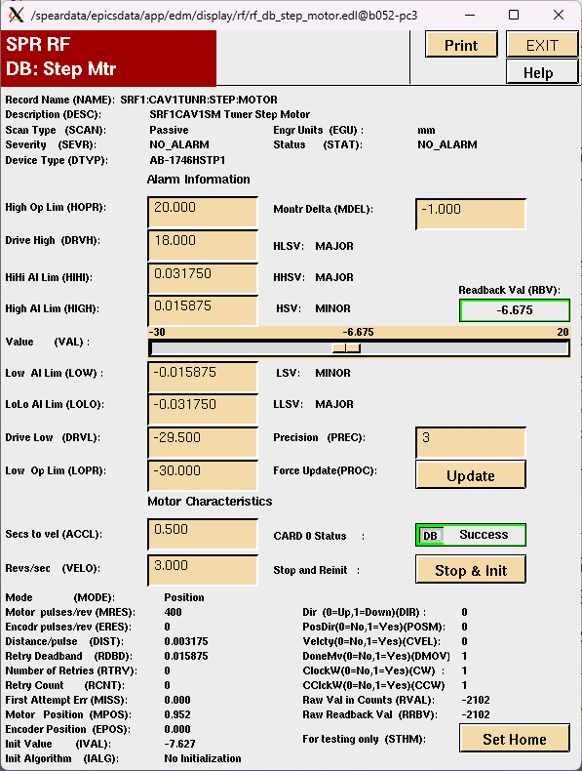
Figure 7: Stepper motor panel that details the settings for the tuner stepper motors.
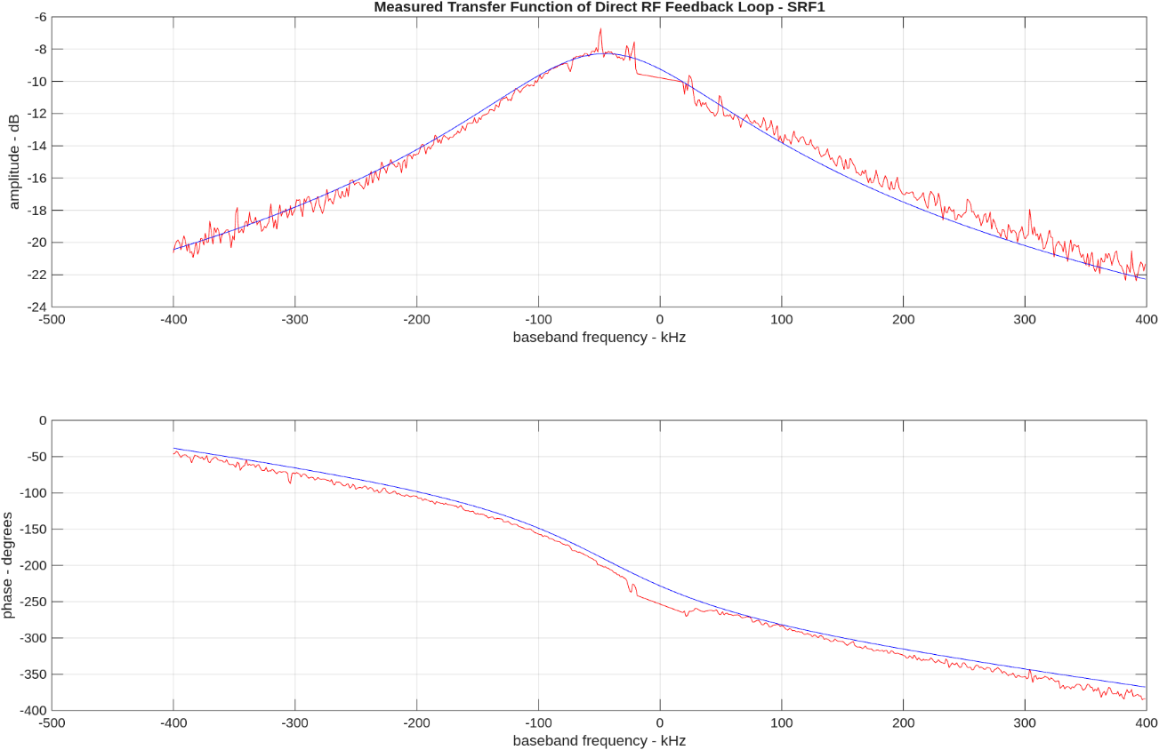
Figure 8: Amplitude and phase of RFP transfer function.
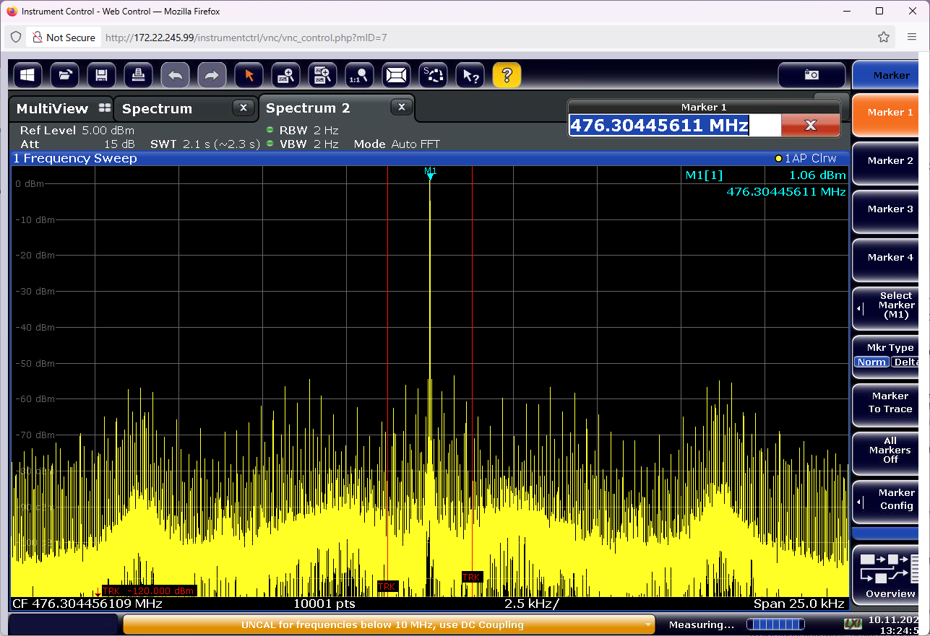
Figure 9: Spectrum of Cavity A field with 500 mA stored current.
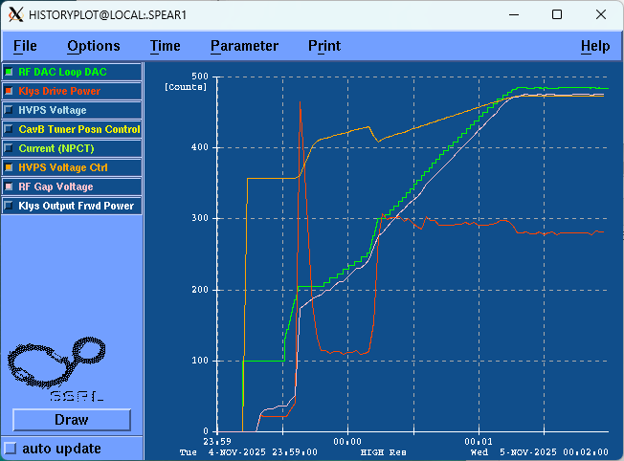
Figure 10: Initial turn-on of RF station in ON_CW.
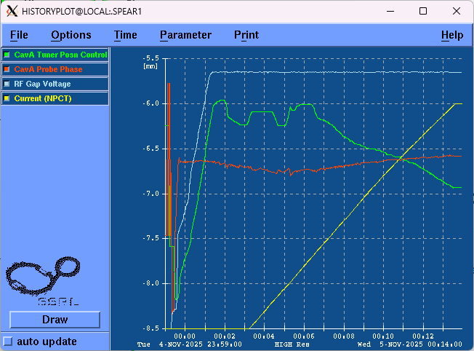
Figure 11: Tuner motion and cavity phase shifts during a fill.

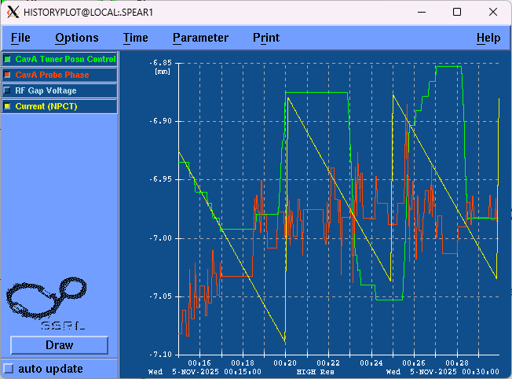
Figure 12: Tuner motion and cavity phase during normal operation.

