Fiber Optic Connections from LLRF to HVPS
  - Rev. 3 June 5, 2022

Introduction
This note documents the fiber optic connections between the LLRF system and the HVPS controller. It also documents what should control these connections and why.

Fiber Optic Connections
There are three fiber optic connections between the LLRF and the HVPS controller. Two are sourced by the LLRF and one by the HVPS controller.

Fiber Optic SCR Enable
The LLRF system generates the SCR Enable signal. This fiber optic cable must be illuminated to give a permit to the HVPS controller to enable the thyristor triggers. Removing this signal inhibits the thyristor triggers and disconnects the HVPS from the input power source. Stored energy in the output filter capacitors will still discharge into the klystron after the triggers are inhibited.
This signal should be enabled only when there are no faults on the LLRF MPS system. It should also be controlled by the LLRF controller since the klystron is not a full collector klystron. If the LLRF trips off the drive power to the klystron, there will be no RF output power from the klystron and all of the HVPS output would end up in the klystron collector. The LLRF MPS will eventually trip off the system based on its calculation of the collector power, but the LLRF system should trip it off sooner based on its knowledge that the drive power is disabled.
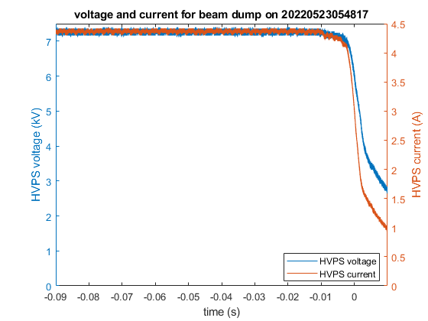
Figure 1: HVPS output voltage and current at the time of an HVPS trip without crowbar.
Figure 1 shows the normal turn-off of the HVPS because of a system fault. In this case the fault was due to a drop in the mains line voltage. At about $-10 \text{ms}$ on the figure the output voltage and current start to sag due to the sag in the mains. The HVPS is turned off at $-2 \text{ms}$ and within about $5 \text{ms}$ after that the power of the HVPS has decreased to about $25\%$ of its operational value.
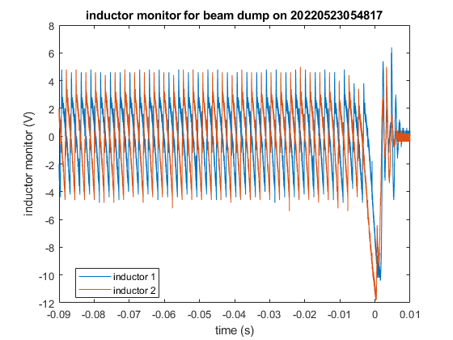
Figure 2: Voltage on primary filter inductors at the time of an HVPS trip without crowbar.
Figure 2 shows the voltages across the two filter inductors located in the center node of the primaries of the rectifier transformers. The edges of the sawteeth show when the thyristors are being fired. Since the HVPS is in steady state operation for the first $80 \text{ms}$ of the plot, the average voltage across the inductor is zero during this time. The amplitudes of the sawteeth start to decrease when the main input voltage sags. We see that the triggers stop firing at around $-5 \text{ms}$. Only the B phases of each bridge are fired. Both the +B and -B phases are fired and they latch up to allow a discharge path for the inductor. For reference, each inductor is specified to be $>0.3 \text{H}$ and the winding resistance was measured to be $0.38 Ω$. The inductors are seen to discharge much faster than the $0.79 \text{ms}$ time constant, so some of the stored magnetic energy is also being dissipated into the klystron load.

Fiber Optic Klystron Crowbar (Off) Signal

Methods of Firing the Crowbar
The LLRF system generates a signal that controls the HVPS output crowbar circuit. On the HVPS schematics this signal is labeled Fiber Optic Klystron Crowbar. However we note that an illuminated fiber cable does not cause the crowbar to fire; an unilluminated fiber cable will cause the crowbar to fire. It may be more accurate to label this the Fiber Optic Klystron Crowbar Off Signal. The reason to fire the crowbar is to minimize the amount of stored energy in the HVPS output filter capacitor that flows to the klystron. The HVPS uses hardware monitor circuits to fire the crowbar if either a transformer arc in the HVPS or a klystron arc is detected by fast current monitors located in the HVPS and the termination tank, respectively. There is circuitry for the HVPS controller to fire the crowbar, however the current code in the HVPS PLC controller does not fire the crowbar. The hardware in the HVPS controller inhibits the thyristor triggers if the crowbar triggers are fired.

Potential for Klystron Damage
The klystron crowbar only needs to be triggered when there are conditions that could damage or otherwise threaten the immediate integrity of the klystron. These conditions are discussed in “A Unique Power Supply for the PEP II Klystron at SLAC” by Dick Cassel and Minh Nguyen, published in July 1997 as SLAC-PUB-7591 and presented as a poster at PAC 1997 as poster 5P014.
The original PEP-II klystrons were designed and built by Philips. They specified that, under arc conditions, the klystron would not be damaged if the HVPS delivered less than $60 \text{J}$ or an $I^{2}t$ of $40 {\text{A}}^{2}-\text{s}$. The HVPS design includes circuit elements that reduce the available energy that can be delivered to the klystron in the event of a fault. Only one of these elements is the crowbar. As stated above, the crowbar in the HVPS is designed to dissipate the energy stored in the four output filter capacitors. These capacitors do not couple directly to the klystron; they each couple to the output through two $500 Ω$ resistors. These resistors dissipate some of the stored capacitive energy, reducing the amount of energy that would be dissipated in the klystron in the event of an arc. The termination tank, located between the HVPS and the klystron, places $200 μ\text{H}$ inductors in series with the HV cable into the tank. This also reduces the fast peak currents that can propagate over the HV cable to the klystron.
The conclusion of the analysis given in this paper is that, when the crowbar functions properly and fires, less than $5 \text{J}$ of energy from the HVPS reaches the klystron. Even if the crowbar fails to fire, the other circuit elements limit the energy from the HVPS in a klystron arc to $<20 \text{J}$. Therefore, the discharge energy from the HVPS in the event of a klystron arc is, by passive design, below the threshold for catastrophic damage to the klystron. The crowbar just reduces the energy discharged into the klystron by a further factor of four.

Parameters Monitored by the LLRF and MPS
Figure 3 shows the MPS parameters that are associated with the klystron. Of these parameters, only the focus solenoid coil, bucking solenoid coil, and klystron vacuum could indicate immediate integrity of the klystron. If the current in either of the solenoids is outside specified limits, the beam current could diffuse to the klystron vacuum chamber walls and deposit heat on these surfaces. An increase in the vacuum ion pump current could be caused by a vacuum leak. Removing power from the klystron may stop any potential leak from increasing.
If the filament trips off, the MPS will ultimately inhibit the thyristor triggers. During this time the cathode will still be at its operating temperature. The decay time of the HVPS filter capacitors into the klystron is fast compared to the thermal time constant of the cathode heater. Any change in temperature or water flow also has a time constant long compared to the decay time of the HVPS output filter. Inhibiting the thyristor triggers is sufficient to protect the klystron collector from failure.
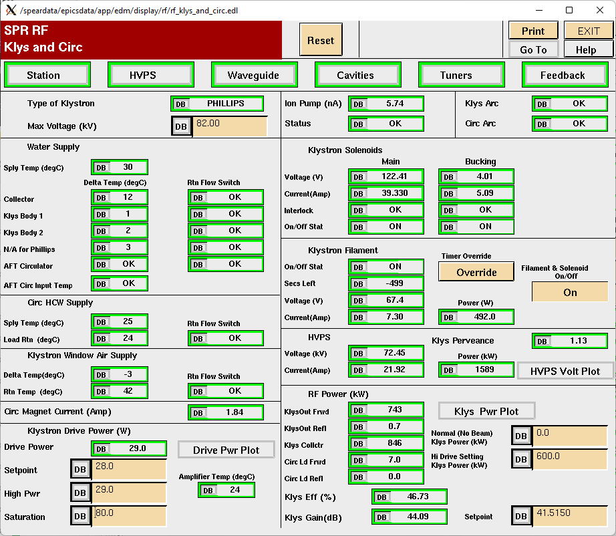
Figure 3: EDM panel showing the klystron parameters
In all cases in which the LLRF causes the HVPS crowbar to fire, it should also inhibit the thyristor triggers as a redundant measure.

Fiber Optic Status
The Fiber Optic Status signal is generated by the HVPS controller. It provides a basic signal that shows the local HVPS controller is on and that the crowbar is not being commanded to trigger. It does not give any information as to whether the HVPS thyristors are firing. If the HVPS status is good, the fiber optic cable is illuminated.

Logic to Control the Fiber Optic Signals

Legacy LLRF Logic
The fiber optic signals enter the LLRF MPS system through the RF SYSTEM LOCAL PANEL, SD-340-311-01-R0. (Note that this document is not in SEDA, but we have soft copies of this document stored in our local file system.)
Page 1 of the local panel schematic diagram gives a wiring diagram for the input connectors to the panel and the inputs to the logic that determines the states of the two fiber optic signals sent to the HVPS controller. The inputs to the logic are two beam abort signals, an HVPS ON request and statuses for the main and bucking solenoids, the waveguide pressure, and the collector summary. The waveguide pressure and collector summaries already are input from the PLC.
Wiring diagram WD-340-330-02-R0 documents the wiring through the cross-connects to the Local Panel. This diagram details two 25 pin connectors, J2 and J3. There is a disconnect in the labeling between the SD-340-311-01-R0 and WD-340-330-02-R0 diagrams. The labeling for J2 is consistent, but the labeling for J3 shows the numbering reversed on the 25 pin D connector. The diagrams for the cross-connect block show that J3-01 up to J3-13 match up with J3-13 down to J3-01 on the Local Panel drawing. Similarly, J3-14 up to J3-25 of the cross-connects match up with J3-25 down to J3-14 on the Local Panel. Also, the cross-connect drawing lists a Waveguide Air MPS signal connecting to the Spare 1 pin of the Local Panel. There is a Waveguide Pressure (Waveguide Air) signal in addition to the Waveguide Air MPS signal.
The interlocks from the main focus and bucking coil supplies are dry contacts that are supplied to digital input modules on the PLC. These connections are detailed in WD-340-330-23-R0. The interlock protecting against a failure of the main focus magnet supply is a dry contact from the Focus Coil Current Monitor, 714-113-01, which monitors the output current of the magnet supply. The contact from the monitor is connected to input 025 of the digital input module. The interlock from the bucking magnet comes from the EMS supply. (As of now I do not know how this interlock is controlled. If the interlock originates from a non-standard TDK-Lambda EMS power supply or related chassis, we should recover another such chassis from PEP to use as a spare.) This interlock is connected to input 026 of the digital input module.
The klystron ion pump also has a dry contact that is used by the MPS PLC for its interlock. It is displayed on the same wiring diagram and is connected to input 011 of the digital input module.
The PLC can then process these digital inputs and create digital outputs, which it sources from a digital output module on WD-340-330-25-R0. The main focus interlock is sourced on output 032 and the bucking coil interlock on output 033. As mentioned above, both of these outputs are input to the logic in the local panel. A vacuum interlock sum, from output 015 of the digital output module, likely goes to the local panel as well. (There are possibly some errors in the documentation for this line, including the type of PLC module and cross-connect information.) This signal is connected to J3 of the local panel and does not directly connect to the logic that determines either the SCR Enable or the Crowbar (Off) signal. Therefore it is likely that the MPS is not currently designed to fire the crowbar if there is a vacuum failure.

Fiber Optic SCR Enable
This signal should be enabled by a logical and of
- A PLC summary OK signal
- A PLC Fiber Optic Crowbar Off signal
- A LLRF controller summary OK signal

Fiber Optic Crowbar (Off) Signal
This signal should always be enabled by the LLRF.
The crowbar should probably be fired when either the manual grounding switch (mushroom) or the Ross grounding relay is closed. These switches are shown on SD-730-790-05-C1. On the wiring diagram WD-730-790-02-C6 I see that the manual grounding switch is monitored by the PLC. It appears that the PLC controls the coil on the Ross grounding relay, but the readback from the auxiliary contacts may go to the enable for the Personnel Protection System (PPS). The PLC could indirectly monitor this status by monitoring the PPS status.

Fiber Optic Status
This signal should be sent to the LLRF controller to let it know that the LLRF system can turn on the HVPS and the rest of the high-power RF system.

