Cavity Tuner Inspection
  - J. Sebek June 14, 2023

Introduction
On June 13, 2023, Marc Larrus and I inspected the four cavity movable tuners for the SPEAR3 RF system. The purpose of each of these tuners is to be able to control the resonant frequency of the cavity in response to changing beam, RF, and/or environmental conditions. We made this inspection both because we wanted to follow up on several problems we have had with the tuners in the past year and we wanted to ensure that we understood what to do in the migration to the new low level radio frequency (LLRF) control system that will have different software controls for the tuners.

Hardware Configuration
Each movable tuner is driven into and out of the cavity by a lead screw turning through a nut fixed to the tuner body. The motor that drives the lead screw is a Superior Electric SLO-SYN M093-FC11 stepper motor. The shaft of this motor is offset from the lead screw. The motor indirectly drives the lead screw shaft via a pair of gears. A set screw through the gear on the lead screw shaft fits inside a hole drilled radially through the shaft in order to secure the gear to the shaft. If this set screw backs out of the hole, the stepper motor rotation may not move the tuner as desired.
Each tuner is controlled, through the LLRF control system, by an Allen-Bradley 1746-HSTP1 stepper controller module. The modules produce low level pulses that are amplified by a Superior Electric SLO-SYN SS2000MD4 modular driver. The control system sets the position of the tuner for cavity A via the process variable (PV) SRF1:CAV1TUNR:POSN:CTRL. (Cavities B, C, and D use CAV2, CAV3, and CAV4, respectively, in their PVs.) The control system keeps track of the steps it has instructed the 1746-HSTP1 to move. It assumes that all commands are correctly implemented. The tuner assembly has a linear potentiometer that gives an independent analog reading of the tuner position. The PV for this reading is SRF1:CAV1TUNR:POSN.
The tuners travel on pillow block bearings on two parallel shafts. The tuner assembly has bellows at both the tops and bottoms of these shafts. Care must be taken to ensure that the bellows are neither compressed or stretched too much at the ends of the tuner travels.
Each tuner assembly has four hardware stops, a limit switch and hard stop pair at the upper travel limit and another at the lower travel limit. The system is designed such that the limit switch will engage before the hard stop is reached. When the limit switch is reached the control system will prevent further travel in that direction. The hard stops on both ends are adjustable by changing the amount of exposure of a threaded bolt. That is also the adjustment mechanism for the upper limit switch. The lower limit switch runs up against a metal tab. In that case, if there is insufficient adjustment travel available on the limit switch, an extension to the limit switch may have to be fabricated.
The only indication in the control system that we have found the limit has been reached is that the rectangular border that contains the Readback Val in the SRF1:CAV1TUNR:STEP:MOTOR panel changes from green to red (Figure 1 shows the panel when neither of the limit switches has been activated). When the limit switch has engaged, the tuner is able to move in the opposite direction. The limit switch status is not latched. If the limit switch has been activated in error, once the error has cleared, the tuner can again travel in that direction.
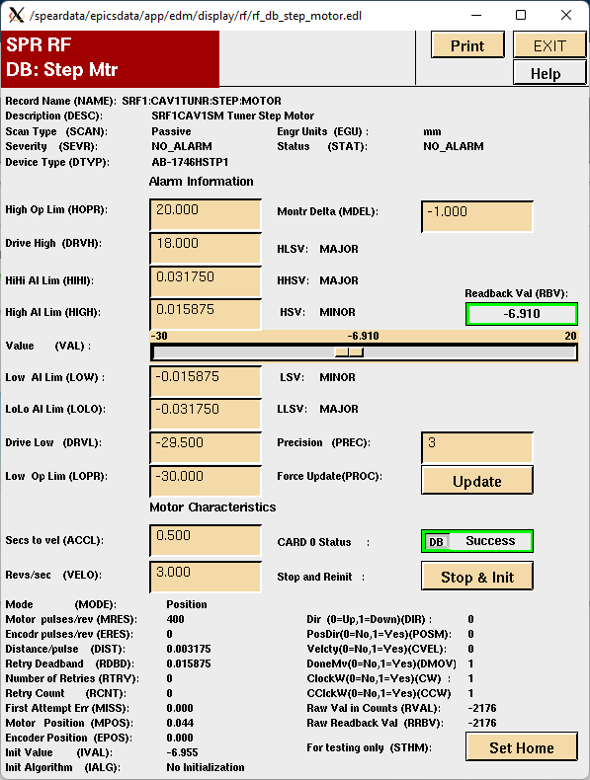
Figure 1: Cavity 1 stepper motor EDM panel.

Software Controls
The PV SRF1:CAV1TUNR:POSN:CTRL controls the tuner position. A more positive number means that the tuner is inserted further into the cavity. The control system has software limits that are intended to prevent the software from challenging the limit switch settings. The software limits are the .DRVH and .DRVL fields of the relevant PVs, so SRF1:CAV1TUNR:POSN:CTRL.DRVH is the software limit for the upper travel of the cavity 1 tuner.

Inspection Results
We inspected all four tuners. Only the tuner assembly for Cavity 4 (D) does not need any attention. The software limits for all tuner motion were set identically. SRF1:CAV1TUNR:POSN:CTRL.DRVH, and its counterparts for the other cavities, are set for 18.00 and SRF1:CAV1TUNR:POSN:CTRL.DRVL, and counterparts, are set for -28.00.

Cavity 1 (A)
The bellows on the lower ends of the shafts are almost totally compressed when the lower software limit is reached. There is still a reasonably large distance (~1/2”) before either the limit switch or the hard stop will engage. It is likely that damage to the lower bellows would occur before the dedicated hardware stops would act. Therefore, we must adjust the settings of both the lower limit switch and hard stop. There may be insufficient adjustment available in just the limit switch position. If that is the case, as described in Hardware Configuration above, we may have to fabricate an extension to the plunger of the limit switch to fix this problem.
The upper limit switch engages when the SRF1:CAV1TUNR:POSN:CTRL setting is 13.3, well less than the existing SRF1:CAV1TUNR:POSN:CTRL.DRVH value of 18.0. If we change the .DRVH value to 12.5 we can still move the tuner more than required for normal operation and have some distance between the software and hardware limits of the tuner.

Cavity 2 (B)
As with Cavity 1 above, the bellows on the lower ends of the shafts are almost totally compressed when the lower software limit is reached. There is still a reasonably large distance (~1/2”) before either the limit switch or the hard stop will engage. It is likely that damage to the lower bellows would occur before the dedicated hardware stops would act. Therefore, we must adjust the settings of both the lower limit switch and hard stop. There may be insufficient adjustment available in just the limit switch position. If that is the case, as described in Hardware Configuration above, we may have to fabricate an extension to the plunger of the limit switch to fix this problem.
The positions of the upper limit switch and hard stop should also be changed. In this case there is no apparent problem with damage to the bellows, but there is a large gap between the software limits and the action of the hardware limits. We should change them to better coordinate with the software limits.

Cavity 3 (C)
The settings of the limit switches and hard stops were compatible with the software settings and did not challenge the movement of the bellows. However, the action of the lower limit switch seems to be “soft”; it needs to be depressed some distance before it actuates. This switch should be replaced.

Cavity 4 (D)
The settings of the limit switches and hard stops were compatible with the software settings and did not challenge the movement of the bellows.

