Galil Commissioning

Introduction
We are trying to commission the Galil DMC-4143 motor controller with an integrated amplifier AMP-43547 and S/N BV-22285. The current firmware rev is 1.3h.

Stepper Motor
Our stepper motor is a Superior Electric M093-FC11. The values on the nameplate are 2.64 V, 5.5A, and a holding torque of 450 ounce-inches. This corresponds to the matrix published by Superior in an old document. Our motor is configured to be bipolar, so we use the values on the right hand side of Figure 1.
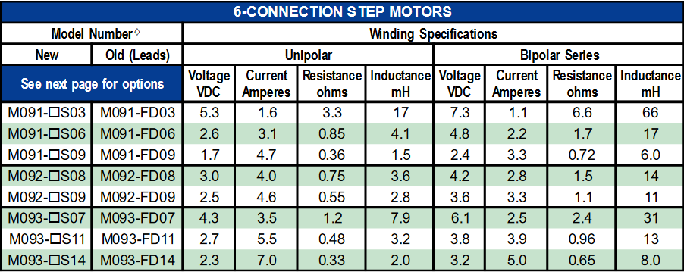
Figure 1: Data matrix for M093-FD11 from Superior Slo-Syn catalog
Superior also published a graph of torque vs motor speed for three different voltages, 36 V bipolar full step, 72 V bipolar micro-step, and 170 V bipolar micro-step. We operate at 24 V, so we will use the left most graph of Figure 2 as a guide.

Galil Setup
We will start using the Galil manual dmc-4103-r13h-manual.pdf.
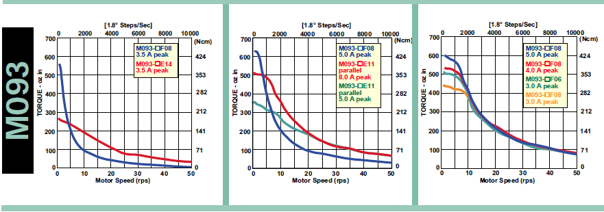
Figure 2: Torque vs speed for 36V, 72V, and 170V, from left to right.

