Instructions for Saving Data to Diagnose RF Trips

Introduction
We have diagnostics that allow us to correctly diagnose most of the causes of SPEAR beam trips caused by the RF and the high voltage power supply (HVPS). However, there are still some trips for which we do not yet have adequate diagnostics. This note documents some steps we should take to use existing software diagnostics to help diagnose further trips.

RF Expert Panels
The RF system has many EPICS process variables (PVs), too many to usefully display on a user panel. The operators have summarized the most important PVs and placed them on an RF Station EDM panel, shown in figure 1. All of the PVs are available through a series of “expert” panels. This series can be accessed by selecting the RF Detail button in the lower right-hand corner of RF Station. This brings up the SPEAR RF Station panel shown in figure 2. The information of interest for the HVPS can be accessed by selecting the HVPS button in the middle of the top row of SPEAR RF Station. This brings up the SPEAR RF Klystron HVPS page shown in figure 3. The information of interest is hopefully displayed on the EPICS PVs on that page. If there is a trip of the RF station, a screen shot of SPEAR RF Klystron HVPS or a list of the faults that are displayed may be useful in diagnosing the cause of the trip.
Table 1 lists the labels of the various status bars on SPEAR RF Klystron HVPS, the PVs that they monitor, and a terse description of their meaning.
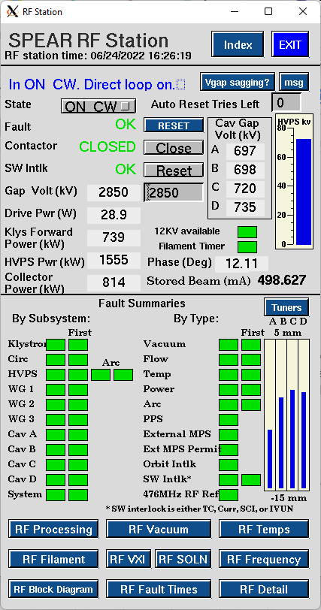
Figure 1: RF Station EDM panel
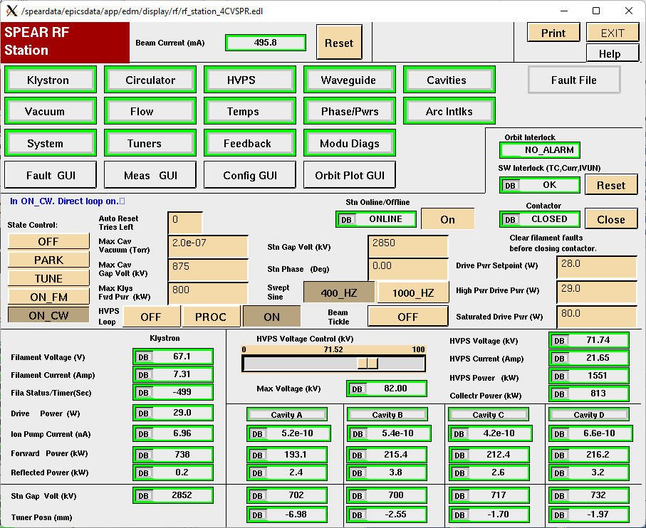
Figure 2: RF "expert" panel
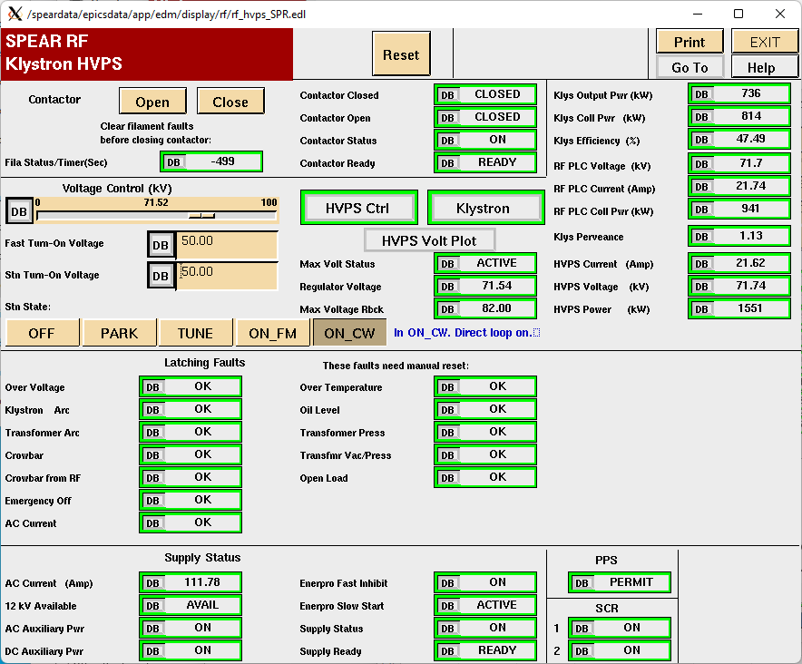
Figure 3: RF "expert" HVPS panel

Panel Label | PV | Description
Contactor Closed | SRF1:HVPSCONTACT:CLOSE:STAT | Aux. relay that closes when contactor closed
Contactor Open | SRF1:HVPSCONTACT:OPEN:STAT | Aux. relay that closes when contactor open
Contactor Status | SRF1:HVPSCONTACT:ON:STAT | Inverted value of contactor closed
Contactor Ready | SRF1:HVPSCONTACT:READY:STAT | Aux. relay closes when contactor can be closed
Over Voltage | SRF1:HVPS:VOLT:LTCH | HVPS voltage limit exceeded (reg. card)
Klystron Arc | SRF1:HVPSKLYS:ARC:LTCH | Klystron arc sensed (ground tank and LHS trigger board)
Transformer Arc | SRF1:HVPSXFORM:ARC:LTCH | Transformer arc sensed (HVPS and RHS trigger board)
Crowbar | SRF1:HVPS:CROWBAR:LTCH | Senses pulses to crowbar thyristors
Crowbar from RF | SRF1:HVPSRF:CROWBAR:LTCH | LLRF commanded crowbar to fire
Emergency Off | SRF1:HVPS:PANIC:LTCH | Status of mushroom switch in ground tank
AC Current | SRF1:HVPSAC:CURR:LTCH | 12.47 kVAC mains over-current trip
Over Temperature | SRF1:HVPS:TEMP:LTCH | Mechanical thermal switch in HVPS oil
Oil Level | SRF1:HVPSOIL:LEVEL:LTCH | Mechanical oil level switch in HVPS oil
Transformer Press | SRF1:HVPSXFORM:PRESS:LTCH | Slow HVPS oil overpressure
Transfer Vac/Press | SRF1:HVPSXFORM:VACM:LTCH | HVPS rapid overpressure and/or vacuum
Open Load | SRF1:HVPS:OPENLOAD:LTCH | Connection from HVPS to klystron is open
12 kV Available | SRF1:HVPS12KV:VOLT:STAT | 12.47 kVAC measured on phase A
AC Auxiliary Power | SRF1:HVPSAC:POWER:STAT | Control power in HVPS controller
DC Auxiliary Power | SRF1:HVPSDC:POWER:STAT | HVPS controller DC supplies on
Enerpro Fast Inhibit | SRF1:HVPSENERFAST:ON:STAT | Enerpro board fast inhibit status
Enerpro Slow Start | SRF1:HVPSENERSLOW:START:STAT | Enerpro board soft start status
Supply Status | SRF1:HVPSSUPPLY:ON:STAT | Contactor turned on and some interlocks clear
Supply Ready | SRF1:HVPSSUPPLY:READY:STAT | Supply is ready to output HV
PPS | SRF1:HVPS:PPS:STAT | PPS chain is made up
SCR 1 | SRF1:HVPSSCR1:ON:STAT | Firing status of left side board thyristors
SCR 2 | SRF1:HVPSSCR2:ON:STAT | Firing status of right side board thyristors
Table 1: PVs corresponding to displayed status bars on SPEAR RF Klystron HVPS

