  Environment, Safety & Health Division | Chapter 41: Hoisting and Rigging  Ordinary Lift Planning and Control Form  Product ID: 426 | Revision ID: 2540 | Date Published: 5 January 2023 | Date Effective: 5 January 2023  URL: https://www-group.slac.stanford.edu/esh/eshmanual/references/hoistingFormLiftPlan.pdf | docx
This form is used to document the lift plan required for ordinary lifts. The plan must be approved by someone with knowledge and experience in hoisting and rigging, either the supervisor, the supervisor’s designee, the ESH coordinator, or the hoisting and rigging program manager if requested. Deviations from the approved plan must be reviewed by the original approver. A copy of the plan must be kept at the work site (see Hoisting and Rigging: Lift Requirements [SLAC-I-730-0A21S-060]).
If the lift is covered by an existing procedure, attach it to the form and fill out only first page.
Approved plans may be reused for similar lifts of like material. The location, time, and workers may be different. Plans must be signed only once: by preparers and approvers when being written and approved and by workers after reading the plan. Plans must be revised and reapproved if conditions change.
Job / project name: SPEAR HVPS1 Maintenance | Begin date: 10/05/2023 | End date: N/A
Location (bldg, floor, grid): B514
Description: Lift covers from HVPS main tank

Plan Preparer(s)
Name: Jim Sebek | Signature: | Date: 10/04/2023
Name: | Signature: | Date:
Name: | Signature: | Date:

Approval (The plan must be approved by someone with knowledge and experience in hoisting and rigging, either the supervisor, the supervisor’s designee, the ESH coordinator, or the hoisting and rigging program manager if requested. Deviations from the approved plan must be reviewed by the original approver.)
Supervisor / designee  / ESH coordinator: | Signature: | Date: 8/29/2023
Hoisting and rigging  program manager: | Signature: | Date:
One-person lift (Ordinary lifts may be performed without a second person provided the directorate ESH coordinator and supervisor approve the plan and the hoisting and rigging program manager is notified. )
Directorate ESH EED  coordinator: Britt von Thaden | Signature: | Date:

Authorized Workers (The designated leader must ensure that all personnel fully understand the requirements of the lift plan and their role in the operation. Workers signatures below attest to this.)
Name: Steve Jenks | Signature: | Date:
Name: Eddie Guerra | Signature: | Date:
Name: Timmy Do | Signature: | Date:
Name: | Signature: | Date:
Name: | Signature: | Date:
Name: | Signature: | Date:
Name: | Signature: | Date:

Characterize the Load(s)
This plan covers Single load only Variety of similar loads (enter dimensions and weight of largest load covered by the plan)
Length: 75” | Width: 37” | Height: 0.375” | Diameter: | Load weight: 302 lbs
Weight determination (choose one)
Marked on load Weighed Estimated Other: _______________ ______________(describe)
Weight calculated by Jim Sebek (name, attach calculations) Drawing number: ___________________
75*37*0.375 = 1040.6 in^3 = 0.6022 ft^3 @502 lbs/ft^3 density of steel 0.6022*502 = 302 lbs
Add ~50 lbs for support beams to make total weight 350 lbs.

Characterize the Task (include directions for lifting, rotation, flipping, speeds, and travel)
Using the rigging outlined in this plan, a chain hoist, an adjustable lifting beam, lifting straps, shackles, and eyebolts, lift the large steel plate covering either half of the main tank of either HVPS1 or HVPS2. Before raising the main tank plate, apply full load to eye bolts by removing slack on lift system components. Inspect welded eye bolts for cracks or other visibly recognizable signs that raise safety concerns.

First prepare the fixed main tank lid by placing 8 inches of timbers on top of that lid to support the lid to be moved. After unbolting the lid to be moved from the main tank, lift and move the lid over the timbers on the main tank plate still in place. Then lower it onto these supports. After the work inside of the open half of the HVPS main tank is completed, reverse the process to install the plate back onto the HVPS.

Evaluate the Hazards (define specific controls)
Equipment falling: Crane, load, rigging, fixtures, or other mechanical parts could fail resulting in damage to the load or injury to personnel. Be aware of your surroundings and pay attention for tell-tale sounds of failure.
General mitigations for all lifts:
- PPE: Safety glasses, hard hat, steel toe shoes, and gloves (at a minimum).
- Ensure ES&H training required is up to date.
- Only qualified operator can perform the lift.
- Ensure crane inspection is current.
- Ensure all rigging is inspected and in good working order.
- Ensure the load is properly secured.
- Use spotters for both watching the lift and keeping unauthorized personnel away from the lift area.
- Install rigging gear properly paying attention to sling angles.
- Do not place any body part under the load.

Plan the Rigging (define specific controls)
On a sketch or photo (see sketch grid on next page), show how the item will be rigged and the type of gear to be used:
- Show location of shackles, hoist rings, spreader beams, slings, etc
- Show attachment points (how rigging gear will be attached to load)
- Show where padding of sharp edges are necessary
- Provide the weight of heavy equipment such as a lifter or spreader beam, or fork beam (forklift attachment)
- Show proper orientation of eyebolts
- Indicate the center of gravity (horizontal and vertical)

Rigging Sketch or Photo of Rigged Item (Include all information required to determine that the load is properly rigged and that appropriate rigging gear is selected. Include, as applicable, sling angles, eye bolt orientation, padding points, center of gravity, type of sling hitch, and any other pertinent information.)
 |  |  |  |  |  | 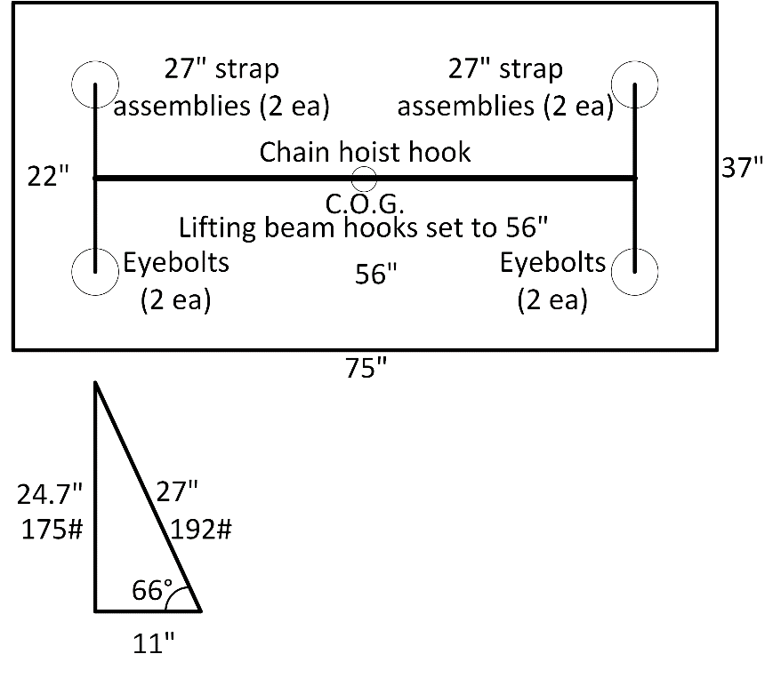 | Figure 1: Plan view of adjustable lifting beam attached to chain hoist hook, then two straps attached to each hook of the lifting beam and then to the lifting eyebolts using shackles. Also shown is a force diagram with the load angle factor. The weights in this diagram assume that only two of the straps, one on each lifting beam hook, carry the full weight of the plate.  Drawing not to scale.

Characterize the Attachment Points (attach photos to illustrate, as necessary)
Manufacturer-provided lift point
Sling in choker hitch Sling in basket hitch Sling in vertical hitch
Threaded hole (eyebolt or hoist ring) Hole diameter: Material type:
Other:
Confirm attachment points or hitch methods (load owner completes if plan preparer in doubt)
The lift points or attachment methods described in this lift plan can withstand the forces created by the rigging gear.
Load owner: Jim Sebek | Signature: | Date:

Define Rigging Gear Requirements
- List each piece of rigging gear shown on the rigging sketch or photo in the table below (such as: load hook, shackles, slings, eye bolts). If a component weighs more than 10 pounds, include the weight in the weight column.
- Label the sketch or photo using the corresponding letter for the gear.
- Draw sling angles and the resulting load reduction factors for slings and eyebolts.
- Calculate the force on each piece of rigging gear. Show that angles are accounted for in determining forces.
- Determine the required rigging gear capacity and size. Indicate if this is an exact specification or a minimum.
Type |  | Weight | Capacity / rating / working load limit | Size specifications
A | CRN280 (certification valid until 10/2024) |  | 1000 LB (supporting structure 600 lbs) | Maximum
B | Chain hoist support frame |  | 600 lbs | Exact
C | RIG050 Lifting beam (Letelier Peerless ALB-1.25-6) (certification valid until 8/2024) | 120 LB | 2500 LB | Maximum
D | 5/8” thick Crosby shackles x2 | < 10 LB | 6500 LB
E | Lifting straps (Lift-All EN1-801 endless nylon 2’ long, 1” wide) | < 10 LB | 3200 LB (vertical pull)
F | 1/2” thick Crosby shackles x4 | < 10 LB | 4000 LB
G | ½” Chicago Hdware eyebolts x4, welded to lid being lifted | < 10 LB | Angular lift is 66° | (2600 lbs straight, 650 lbs 45°)
H
I
J

Load Angle Factor
Slings at 66 deg
350lb/2 x 1.10 = 192 lbs force on two each hooks, shackles, slings, and eyebolts

