\

SPEAR RF HVPS Switch Procedure

Scope:

The purpose of this procedure is to describe the steps necessary to switch between the two SPEAR klystron high voltage power supplies. Note that executing this procedure will break the PPS interlock
chain. /'
I

- Execute LOTO procedures SR-444-636-01 and SR-444-636-02 to de-energize the two power supplies, which requires 10 red locks
- · Reconfigure the output in the switch tank located right outside B514:
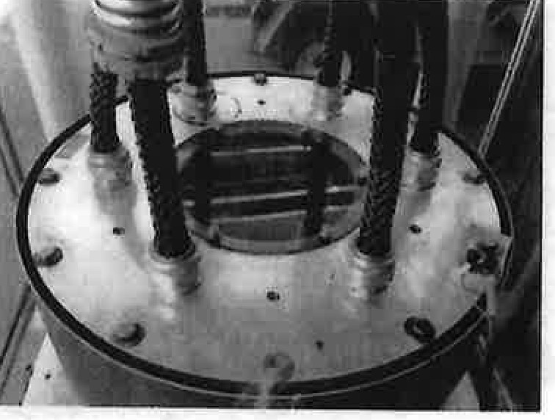
  - Drain the switch tank to gain access to the output bus work
  - Apply ground stick to each bus
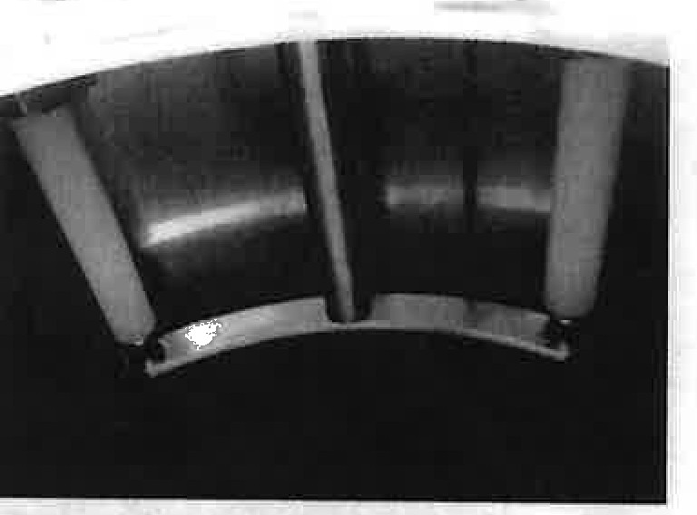
  - Connect the grounding bus bar with the aluminum standoff to the power supply being taken out of service

  - Connect the two bus bars with the Delrin standoff between the power supply and klystron load for the power supply coming Into service

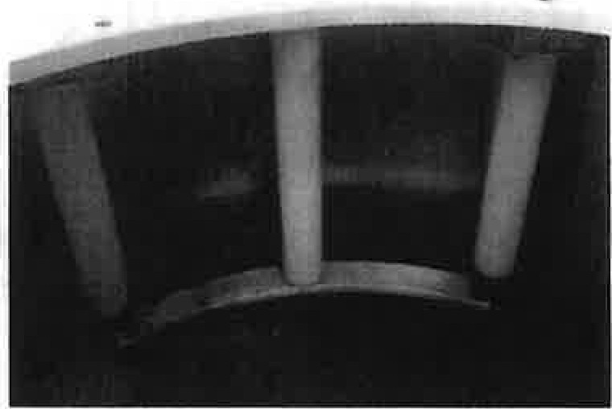
  - Refill the switch tank
- Transfer connections between power supplies
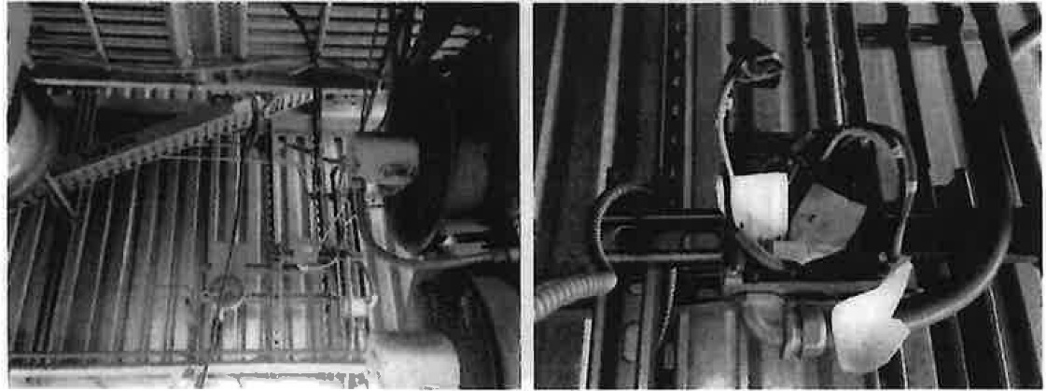
  - B514: Conriect water over-pressure interlock to the appropriate power supply. It is in a junction box 120VDC
-,IP(•

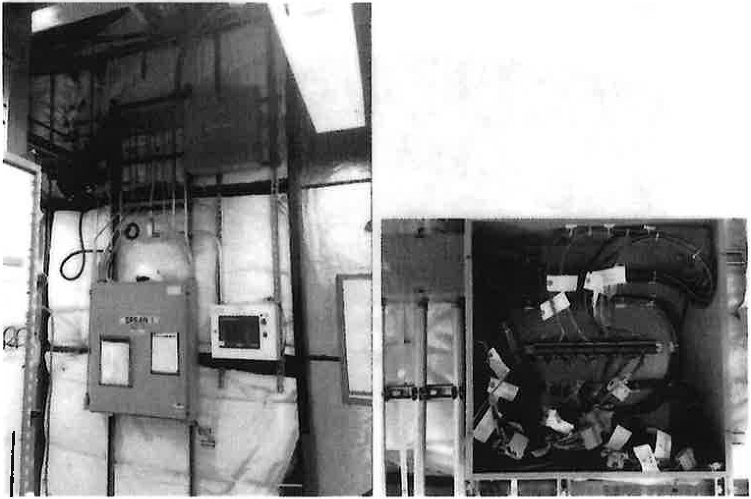
  - B118: Inside the Switchbox above the SPEAR1 Hoffman, connect the following to the appropriate power supply

    - Connect 6 terminal blocks:
Jl to JG, all of which are 10 position pluggable terminal blocks

...
Iv

    - 3 light pipes:
PS ready to SPEARl or SPEAR2 HVPS Status SCR enable to SPEARl or SPEAR2 SCR enable
Klystron crowbar to SPEARl or SPEAR2 klystron crowbar
    - 1 BNC: Klystron arc
- Energize the fans to the appropriate power supply on panel B514 HVPS2, CB7-9 for SPEAR2 and CBS-10 for SPEARl.

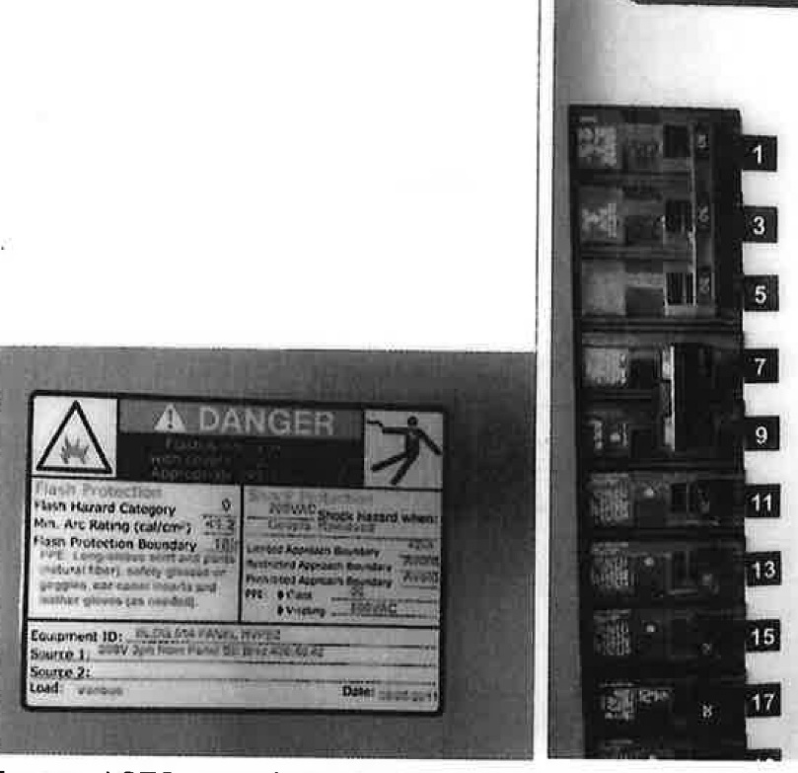
'
2
4

6
f.
8
12
I!
14
R
16
,1
·
t•.• Jf
·, ,
. ,t:1
.,. :£..·4•1
=e;:;,
·'-·
!
10
18
P.
,,.-;_' I
- Execute LOTO procedures SR-444-636-01 and SR-444-636-02 to energize the appropriate power supply. Both power supplies can be energized, except for the 12.47kVAC which is interlock limited to one power supply.

/

