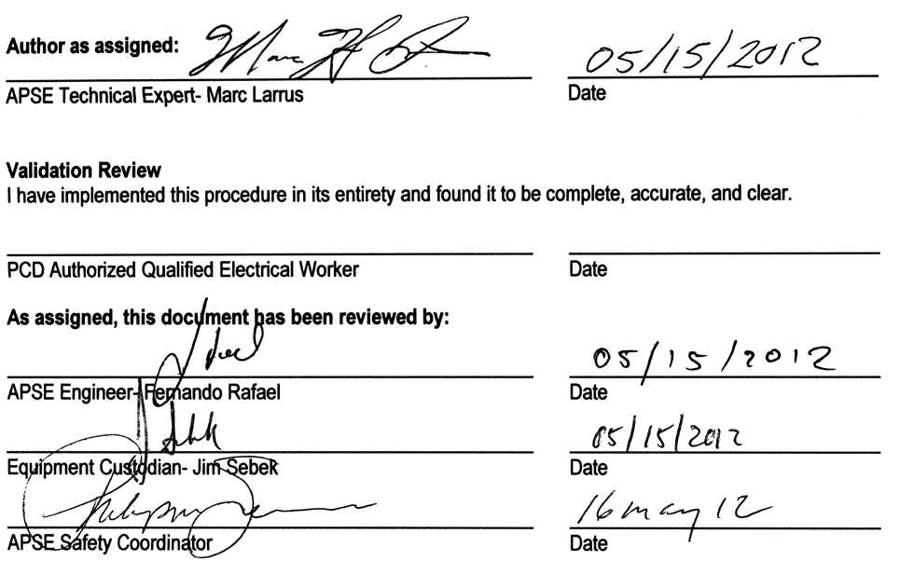

SPEAR 3 RF HVPS 1 SR-444-636-01-R3

Author as assigned:

APSE Technical Expert- Marc Larrus Date
Validation Review
I have implemented this procedure in its entirety and found it to be complete, accurate, and clear.

PCD Authorized Qualified Electrical Worker Date
As assigned, this document has been reviewed by:

APSE Engineer- Fernando Rafael Date

Equipment Custodian- Jim Sebek Date

APSE Safety Coordinator Date
Annual ELP Re-validation
ELP is correct and adequate.
ELP is corrected as marked. I will forward corrections to the equipment custodian at the conclusion of the inspection. (APSE Qualified Electrical Worker-Inspector) Date
ELP is correct and adequate.
ELP is corrected as marked. I will forward corrections to the equipment custodian at the conclusion of the inspection. (APSE Qualified Electrical Worker-Inspector) Date
ELP is correct and adequate.
ELP is corrected as marked. I will forward corrections to the equipment custodian at the conclusion of the inspection.

Authorized inspector (name and title) Date

FILE NAME: SR444636010401.DOC SPEAR 3 RF HVPS 1 ELP

A. Purpose and Scope
Purpose: This document defines the procedure for removing the sources of electrical power from and discharging stored electrical inside of the Spear 3 RF HVPS1 power supply.
Scope: Identify energy sources and appropriate circuit breakers for lock and tag, and specify a procedure for implementing lock and tag in compliance with the SLAC Control of Hazardous Energy Program (CoHE).
Stop Procedure Criteria: If any unexpected conditions are encountered or any instructions are unclear, stop the execution of this procedure and report to the system engineer for further instructions.

B. General Information
Equipment description: Spear 3 RF High Voltage Power Supply 1 (HVPS1)
Manufactured by NWL Transformers: Input: 12.47 kVAC three phase Output: -90 kVdc @ 30 amps (2.7 MW)
Property control numbers (PC #s): (Asset #) N/A | Equipment custodian/ procedure owner: Jim Sebek
Equipment location: Building 514

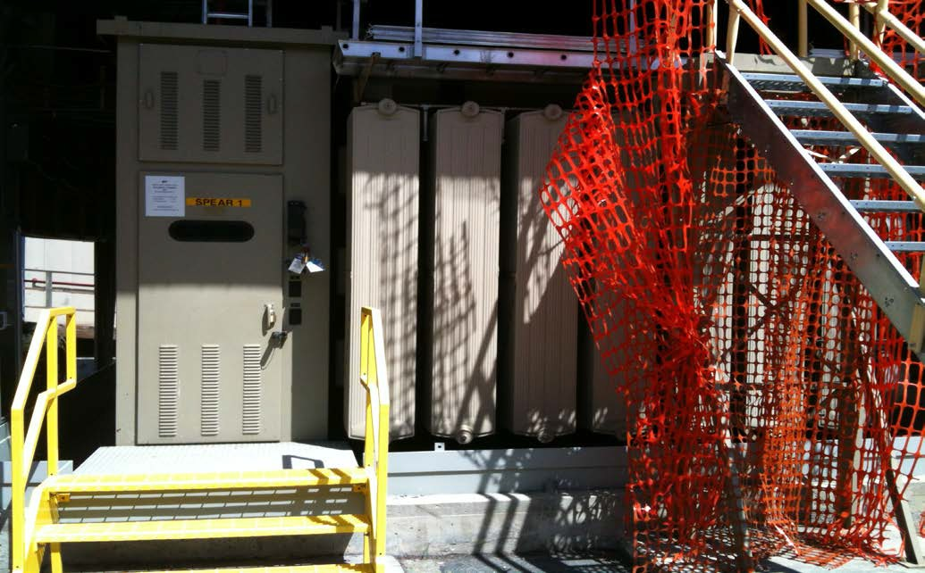

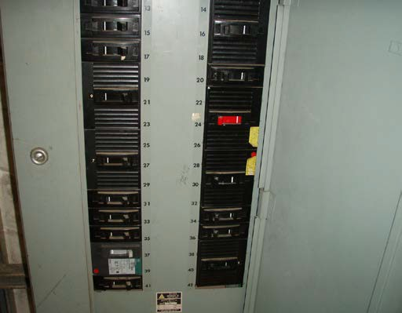
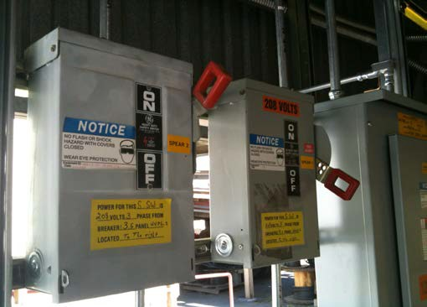
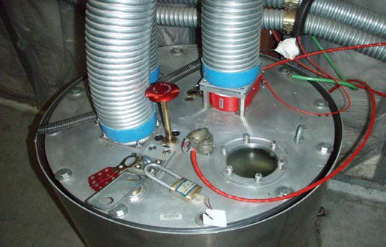

C. Hazardous Energy Schematic Showing Isolation Points
Hazard: 120 VAC used for Controls and Interlocks in HVPS controller

Mitigation: The 120 VAC source is from Circuit Breaker 20 in the LPB panel in the electrical closet in B117 (blue arrow). Note that in this photograph the breaker is closed and the circuit is energized. This breaker requires lock and tag. This voltage can be monitored for CoHE purposes on TB1 of the HVPS controller.
Hazard: 8.1 kJ of possible stored energy at -90 kVDC in the HVPS1 output capacitors.

Mitigation: There is an electrically activated ground switch (Ross Relay) that is inside of the termination tank (pictured left) as well as a manual shorting switch that must be depressed and then secured by means of lock and tag after the hasp (black arrow) is clamped over the knob of the shorting switch (blue arrow). Note that in this photograph, the switches are open and a potential hazard exists.
Verify auxiliary contacts in Ross relay and mushroom are closed. Verify contacts shorted in control system touch panel before removing power from the control. Put instructions how to access touch panel. Also use 90 kV readbacks

Hazard: 208 Vac required for the 12.47 kVAC switchgear controller, HVPS oil pump, and HVPS cooling fans.

Mitigation: The HVPS1 208 VAC disconnect must be opened and secured by means of lock and tag. The red arrow points to this switch in the open position. Where do we perform ZVV?

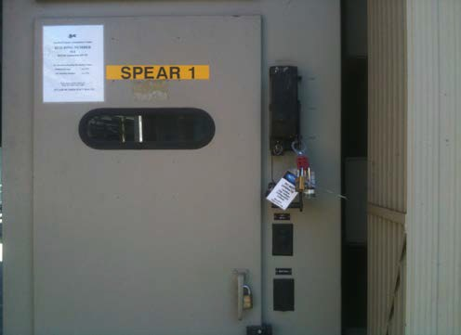
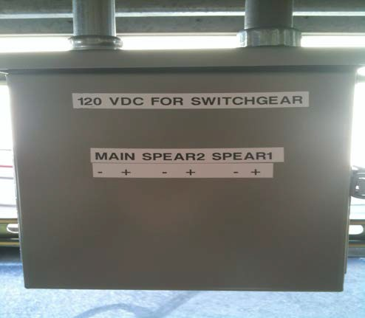
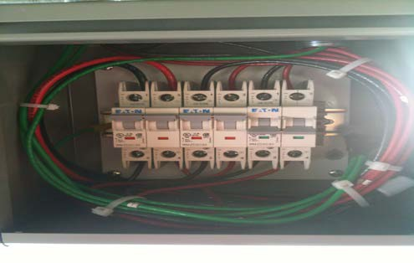

C. Hazardous Energy Schematic Showing Isolation Points (cont)
Hazard: 12.47 kVAC primary power feed to HVPS1.

Mitigation: The High Voltage Electricians, per their own CoHE procedure, will open the upstream breaker in SUB507, open the HV disconnect switch on HVPS1, remove the fuses from the switchgear, and install grounds on the busses on the load side of the switchgear
The PEM authorized workers, through the switchgear door window, visually verify that the fuses are removed and an air gap separates the line and load side of the switchgear. After this is done the HV disconnect switch is then secured in the open position by means of their personal lock and tag.
Hazard: 120 VDC required for the 12.47 kVAC switchgear operation and interlocks.

Mitigation: The 120 VDC circuit breakers are located in a small Hoffman box in B514 as displayed by the label on the front door. This box is fed from a 120 VDC source in the 507 substation. The Hoffman box distributes the 120 VDC to both HVPS1 and HVPS2. The breakers that interrupt the positive and negative leads from SUB507 are on the left, the breakers that interrupt the positive and negative leads of the circuit for HVPS2 are in the middle, and the breakers that interrupt the positive and negative leads of the circuit for HVPS1 are on the right. The breakers for HVPS1 need to be opened. In the photograph to the left, the breakers for HVPS1 are open (blue arrow). One can verify that no voltage is on the load side of the breaker by measuring the contacts at the bottom of the breakers (red arrows). After zero voltage is verified, secure the Hoffman box by means of your personal lock and tag.

D. Hazardous Energy Assessment
Evaluate the equipment for all hazardous potential energy sources in accordance with the Hazard Analysis Procedure, and check the left hand box if present. For each, describe the type and magnitude/type, danger zone (the part(s) of the equipment where the energy is found), and isolation points. Insert additional rows as needed to completely describe all sources to be controlled.
Note: describe in Section F how to control each identified hazardous energy source.
Types of Energy | Type / Magnitude | Danger Zone | Isolation Point(s)
A. Electrical – low voltage (<50 V) | N/A | N/A | N/A
B. Electrical – low voltage (50-600 V) | 120 VAC  120 VDC  208 VAC  272 VAC  350 VDC | Inside Control Hoffman box, display panel box, and any access into the power supply itself.  Inside the switchgear and pressure relief and oil temperature in the HVPS main tank  Inside switchgear, its controller, cooling fans, and the HVPS tank. | Panel LPB in B117 circuit breaker 20  Use flashing lights for ZVV or just use meter in the Hoffman.  Circuit breaker located in B514  Disconnect switch in B514  Use flashing lights for ZVV. Install during the downtime. Verify with Doug that this is approved as ZVV.
C. Electrical-high voltage(>600V) | 12.47 kVAC  90 kVDC | Inside switchgear and the power supply itself.  Inside the power supply, the switch tank and the termination tank. | Remove fuses and open disconnect switch on switchgear
D. Stored Energy-Capacitors | 90 kVDC 8 kJ in HVPS output capacitors | Inside the power supply, the switch tank and the termination tank. | Manual grounding switch on termination tank and ground sticks  ZVV with ground stick. What is the annual testing procedure for this?  Do we need to ground both negative and return with two ground sticks?  Need to think about possible fault scenarios.

E. Protective Clothing and PPE Requirements
The Two-Person Rule is in effect
1. Lock and tag the 12kVAC disconnect switch after it is opened by the HV electricians and you have verified the fuses have been removed. | Hazard/ Risk Category 0
2. Close and then lock and tag over the manual ground plunger on the termination tank | Hazard/ Risk Category 0
3. Open and then lock and tag 120 VAC CB20 in panel LPB located in B117 | Hazard/ Risk Category 0
4. Open the 120 VDC circuit breaker and then lock and tag the enclosure in B514 | Hazard/ Risk Category 0
5. Open and then lock and tag 208 VAC disconnect switch in B514 | Hazard/ Risk Category 0

F. Preparation and Notification
Step 1. Determine if you are approved to implement this procedure
Only APSE/APSEM workers who are both authorized and electrically qualified are approved to implement this procedure.
Step 2. Notify:
Before starting work, notify the SPEAR control room operator, the equipment custodian and affected workers of the activity.

G. Normal Shutdown Procedure
1. Notify Spear Operations that the RF HVPS needs to locked and tagged and so that they can notify the High Voltage Electricians.
2. After the High Voltage Electricians open the 12.47 kVAC disconnect switch, remove the HV fuses, and install grounds on the busses, lock and tag the 12.47 KVAC disconnect switch.
3. View a zero output voltage verification of the HVPS by looking at the local touch panel display. Proceed to B132, depress the manual plunger and on the termination tank, and lock and tag. Need to put something here to verify a transition if the supply is already off.
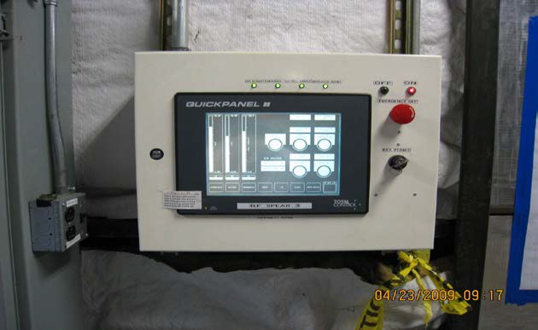

4. Proceed to B117. Open and lock and tag Panel LPB CB20.
5. Proceed to B514. Open and lock and tag the 208 VAC disconnect switch and open the 120 Vdc circuit breaker and lock and tag its enclosure.
6. Verify affected areas are clear of personnel. Perform ZZV as required before starting work. When working inside any of the tanks ZVV with ground sticks before making contact with high voltage components. We need a list of places to ground here.
7. Re-energize the equipment. Note: be certain to consider effects of re-energization on all systems downstream of energy source. We need to have a more direct command here.
8. Notify supervisor when work is complete.
9. If you find any errors in this procedure, or have suggestions on how to improve it, provide your comments to the equipment custodian.

H. Startup Procedure
1. Remove lock and tag from the 12.47 KVac disconnect switch. Notify SPEAR Operations that the RF HVPS is ready to return to operation and ask them to contact the High Voltage Electricians to remove the grounds and close the disconnect switch.
2. Once the High Voltage Electricians have restored the 12.47 kVac proceed to B117 to remove lock and tag and energize Panel LPB CB20.
3. Proceed to B514. Remove lock and tag and energize the 208 Vac disconnect switch and the 120 Vdc circuit breaker.
4. Proceed to B132. Remove lock and tag and lift up the manual grounding plunger.
5. Return control of the RF HVPS to operations.

I. Feedback and Improvements
1. If you find any errors in this procedure, or have suggestions on how to improve it, provide your comments to the equipment custodian.

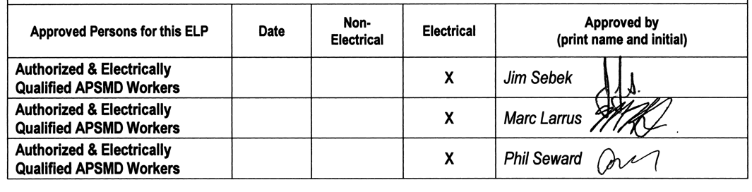
K. Approval
Workers approved to use this procedure are listed below. To be added to the list of approved workers you must:

- Read the entire procedure.
- Obtain instructions on the use of the procedure from an APSMD worker who is authorized, electrically qualified and knowledgeable with regard to the equipment
- Be authorized and electrically qualified to apply general LOTO.
- Demonstrate an understanding of the general LOTO process and the specific requirements of this procedure.
- Be trained to perform the tasks required in this procedure using appropriate and specific work methods

Workers who are authorized and qualified to apply general LOTO, but who are not on the list of approved workers in section K are considered not-approved workers for the purposes of implementing this ELP. To perform service or maintenance work on this equipment, not-approved workers can:

- Request approval from the Equipment Custodian, APSMD Shift Supervisor, APSED/MD Safety Coordinator, or APSMD Department Head. ONLY electrically qualified workers can be approved to use this ELP, or
- Lock out the equipment in cooperation with a worker approved to use this ELP. If selecting this option, an approved worker locks out the equipment using this ELP. The not-approved worker also applies his/her own red locks to the lockout devices. The approved worker demonstrates to the satisfaction of the not-approved worker that the equipment is in the electrically safe condition. The locks of both workers must remain in place when the not- approved worker is working on the equipment.

List of Approved Electrically Qualified Workers1

Workers must be current in Courses 157, 157R & 138, plus 274 or 251
Approved Persons for this ELP | Date | Non- Electrical | Electrical | Approved by (print name and initial)
Authorized & Electrically Qualified APSMD Workers |  |  | X | Jim Sebek
Authorized & Electrically Qualified APSMD Workers |  |  | X | Marc Larrus
Authorized & Electrically Qualified APSMD Workers |  |  | X | Phil Seward

