SPEAR3 RF HVPS Energy Isolation Plan
SR-444-636-02-R2
Table of Contents
2 Revision History 2
2.1 R1 September 25, 2023 2
2.2 R2 October 6, 2023 2
3 Table of Figures 3
4 Author/Approvers/Validators 3
4.1 Author 3
4.2 Reviewers 3
4.3 Management Approval 3
4.4 Validator 4
5 Procedure Purpose 4
6 Equipment Required to Execute Procedure 4
7 Equipment Description 5
8 Potential Hazards 6
8.1 Electrical Sources 6
8.1.1 Three Phase $12.47$ kV RMS Input Voltage 6
8.1.2 Thyristor Firing Pulses 6
8.1.3 Switch-over Tank 7
8.1.4 AC Control Power for Termination Tank HV Relay 8
8.1.5 AC Control Power for the Switchgear Controller 8
8.1.6 DC Control Power for the Switchgear Controller 8
8.2 Stored Electrical Energy 9
8.3 High Voltage Oil 9
8.4 Elevated Work Platform 10
9 Preparation to Work on Inactive (Idle) HVPS Supply 10
9.1 Verify Initial Conditions 10
9.1.1 Determine active HVPS 10
9.1.2 Verify the inactive supply is properly locked out 10
10 Notification of Operations of the Intent to Disable the HVPSs 13
10.1 Verify Control Documents Exist and Obtain Authorization to Disable Supplies 13
11 Control of Hazardous Energy 14
11.1 Sequence of Steps to Turn off the HVPS and Disable the Ability to Close the 12.47 kVAC Contactor 14
11.1.1 Turn Off the RF System 14
11.1.2 Open the 12.47 kVAC Contactor 15
11.1.3 Disable the Contactor Control Power 15
11.2 Document Active HVPS Turn Off 16
11.3 Remove Hazardous Inputs from System 18
11.3.1 Instruct the HV Electricians to Make Safe the 12.47 kVAC Input to the HVPS 18
11.3.2 Verify the 12.47 kVAC is Removed from the Active HVPS 18
11.3.3 208 VAC Switchgear Control Power 18
11.3.4 Remove 125 VDC switchgear control power. 20
11.3.5 Measure the Readings of the HVPS Voltage Monitors 21
11.3.6 120 VAC HVPS Controller Control Power 22
11.3.7 Verify No HVPS Controller Power on Either HVPS Controller 23
11.4 Zero Voltage Verification of HVPS Connection to the Klystron 23
12 Group Lockout Complete 24

Revision History

R1 September 25, 2023
Original version.

R2 October 6, 2023
Minor revisions added after validation.
- 6: Add locking hasps and circuit breaker lockout devices to list of required equipment.
- Figure 2: Inserted photograph of switch-over tank.
- 9.1: Defined SME (subject matter expert).
- 10.1: Record RSWCF number only if RSWCF is required.
- 11.3.5: Give building location of HVPS controller (and add more building locations throughout the document).

Table of Figures
Figure 1: Schematic diagram of SPEAR HVPS 6
Figure 2: Switch-over tank for SPEAR1 and SPEAR2. 7
Figure 3: SPEAR1 switchgear door with viewing window in B514. 11
Figure 4: HVPS 208 VAC control power disconnect switches in B514 12
Figure 5: B117 LBP breaker panel for HVPS controller 120 VAC control power. 13
Figure 6: SPEAR RF Klystron HVPS panel with HVPS off and 12.47 kV contactor still closed. 14
Figure 7: SPEAR RF Klystron HVPS panel with HVPS off and 12.47 kV contactor open. 15
Figure 8: SPEAR RF Klystron HVPS panel with HVPS off, 12.47 kV contactor open, and 120 VAC contactor control power removed. 16
Figure 9: HVPS turned off at 20:07. Contactor opened at 20:12:40. 17
Figure 10: EDM display for HVPS EPICS variables 19
Figure 11: 125 VDC control power enclosure and circuit breakers in B514. 20
Figure 12: The inside of the HVPS controller enclosure in B118. 21
Figure 13: TS3 with voltage divider terminations for SPEAR1 (left) and SPEAR2 (right) in HVPS controllers in B118. 22
Figure 14: 120 VAC control power for HVPS controller for SPEAR1 (left) and SPEAR2 (right), both in B118. 23
Figure 15: Termination tank in B132-101. 24
Figure 16: Complex Lockout Permit for the SPEAR3 RF HVPS Isolation Plan SR-444-636-02-R1 25

Author/Approvers/Validators

Author
_______________________________________ ____________________
SSRL Technical Expert: Jim Sebek Date

Reviewers
_______________________________________ ____________________
EED-OPS Technical Expert: Marc Larrus Date
_______________________________________ ____________________
Independent Reviewer: Ben Morris Date
_______________________________________ ____________________
Electrical Safety Officer: Keith Jobe Date

Management Approval
_______________________________________ ____________________
EED-OPS Deputy Department Head: Tony Beukers Date

Validator
I have implemented this procedure in its entirety and have found it to be clear, complete, and accurate.
_______________________________________ ____________________
EED-OPS Technical Validator: ______________ Date

Procedure Purpose
The purpose of this document is to be an energy isolation plan (EIP) for working on either of the SPEAR High Voltage Power Supplies (HVPSs), either SPEAR1 or SPEAR2. At the beginning of this procedure, one of the HVPSs will have been the operational supply for the SPEAR3 RF system. The other HVPS will have been “idle”, that is, it will have been disconnected from all energy sources and its output will have been verified to be at 0 VDC. It is disconnected from the $12.47$ kV RMS premises power, has been disconnected from other voltage sources, and its outputs are shorted to ground. All of its stored energy should have dissipated, but the dissipation has not been verified. The EIP will verify that there will be no stored energy accessible to the worker.
There is an underlined section, “______”, before each individual step to be executed in this procedure for the lead authorized worker (LAW) to initial as they complete it. The steps within this procedure in which lock out tag out (LOTO) locks are applied and/or zero voltage verification (ZVV) is performed have a different underlined section, “______”, intended to alert the LAW that these steps are LOTO and/or ZVV related.
This procedure only provides an EIP for the HVPS. It does not cover any work performed on the HVPS. Other maintenance procedures are required to cover that work.

Equipment Required to Execute Procedure
The following equipment is required to execute this procedure:
- Eight (8) each identically keyed red locks dedicated to the execution of this EIP and referred to in this EIP as “Operations Lockout Locks”, eight (8) each Group Lockout Tags, appropriately filled out to label the EIP and the equipment to be locked out with the Operations Lockout Locks. The locks and tags will be applied to:
  - Three of each are used to apply LOTO on the input energy sources for HVPS1,
  - Three of each are used to apply LOTO on the input energy sources for HVPS2,
  - One of each for the 125 VDC source common to both HVPSs,
  - One of each for the mechanical shorting mechanism in the termination tank immediately ahead of the klystron.
- Two circuit breaker lockout devices for GE 120 VAC breakers.
- Eight lockout hasps to apply to the devices to be locked out.
- One red personal Lockout Lock belonging to the LAW and one orange Group Master Lockout Tag, both to be applied by the LAW on the group lockout box.
- Digital multimeter (DMM), with a millivolt scale for DC, to use to measure system voltages.
- Appropriate PPE for measuring potential 120 VAC and 125 VDC sources.
This equipment should be assembled before starting this procedure.

Equipment Description
The equipment covered by this procedure are the SPEAR3 HVPSs SPEAR1 and SPEAR2, both located in building 514. (Henceforth we will refer to the storage ring as SPEAR so that the only numbered versions of SPEAR in this document will refer to HVPSs.) Each HVPS has its own associated switchgear, which includes a disconnect switch, fuses, protective relays, and a vacuum contactor. The purpose of each HVPS is to supply DC power to the SPEAR klystron which, in turn, provides radiofrequency (RF) power to the SPEAR cavities which accelerate the SPEAR electron beam. The maximum output rating of each HVPS is $-90$ kVDC at $27$ A, or $2.5$ MW. A schematic diagram of the HVPS is shown in Figure 1.
SPEAR has only one klystron, so only one of the HVPSs can ever be used at a time. The other is staged as a “warm spare”. SPEAR1 and SPEAR2 share a common three phase $12.47$ kV RMS feed that comes from breaker 160 in substation 507. The HVPSs are administratively controlled so that, at most, only one HVPS can be energized at a time. Each has its own separate controller, but they share the input $12.47$ kV RMS feed, HV output cables to the klystron, and connections to the low-level radio frequency (LLRF) system.
There is an aluminum oil-filled switch tank located next to B514 that connects the appropriate HVPS to the klystron. The aluminum tank is electrically grounded to earth at the tank location and the tank is filled with FR3 dielectric oil to increase the voltage withstand between the exposed conductors and the grounded tank. The oil is rated to exceed the IEEE C57.147 standard that specifies a breakdown of greater than 130 kV for distances of one inch (25.4 mm). The two output cables, high voltage and return, of both HVPSs are terminated in the tank. The high voltage cable of the active HVPS is connected to the high voltage cable that connects to the termination tank next to the klystron. Similarly, the return cable of the active HVPS is connected to the return cable that connects to the termination tank. The high voltage and return cables of the warm spare are always shorted together and shorted to ground in one of two configurations. Either they are connected to a shorting bar inside of the switch tank or they are shorted together and to ground outside of the switch tank. In the latter case, a worker on the warm spare can visually see an air gap between the cables and any cables connected either to the other supply or the klystron.
The termination tank, located next to the klystron, is of similar construction to the switch tank, in that it is made from aluminum and electrically grounded to earth at the tank. It also uses a high voltage dielectric oil but, for historical reasons, this oil is conventional mineral oil and not a natural ester like FR3.
The HVPS that functions as the warm spare is administratively locked off. Its input $12.47$ kV RMS switchgear disconnect switch is locked in the open position, its three input $200$ A, 50E medium voltage fuses are removed, and the load side of the vacuum contactors, the line side of the HVPS, is grounded. A low voltage disconnect switch is opened to interrupt the $208$ VAC control power to the switchgear, and the breaker for the $120$ VAC power to the HVPS controller is opened. Administrative locks from the RF group are placed on these two disconnect switches and the breaker to ensure that power is not inadvertently re-introduced into the spare.
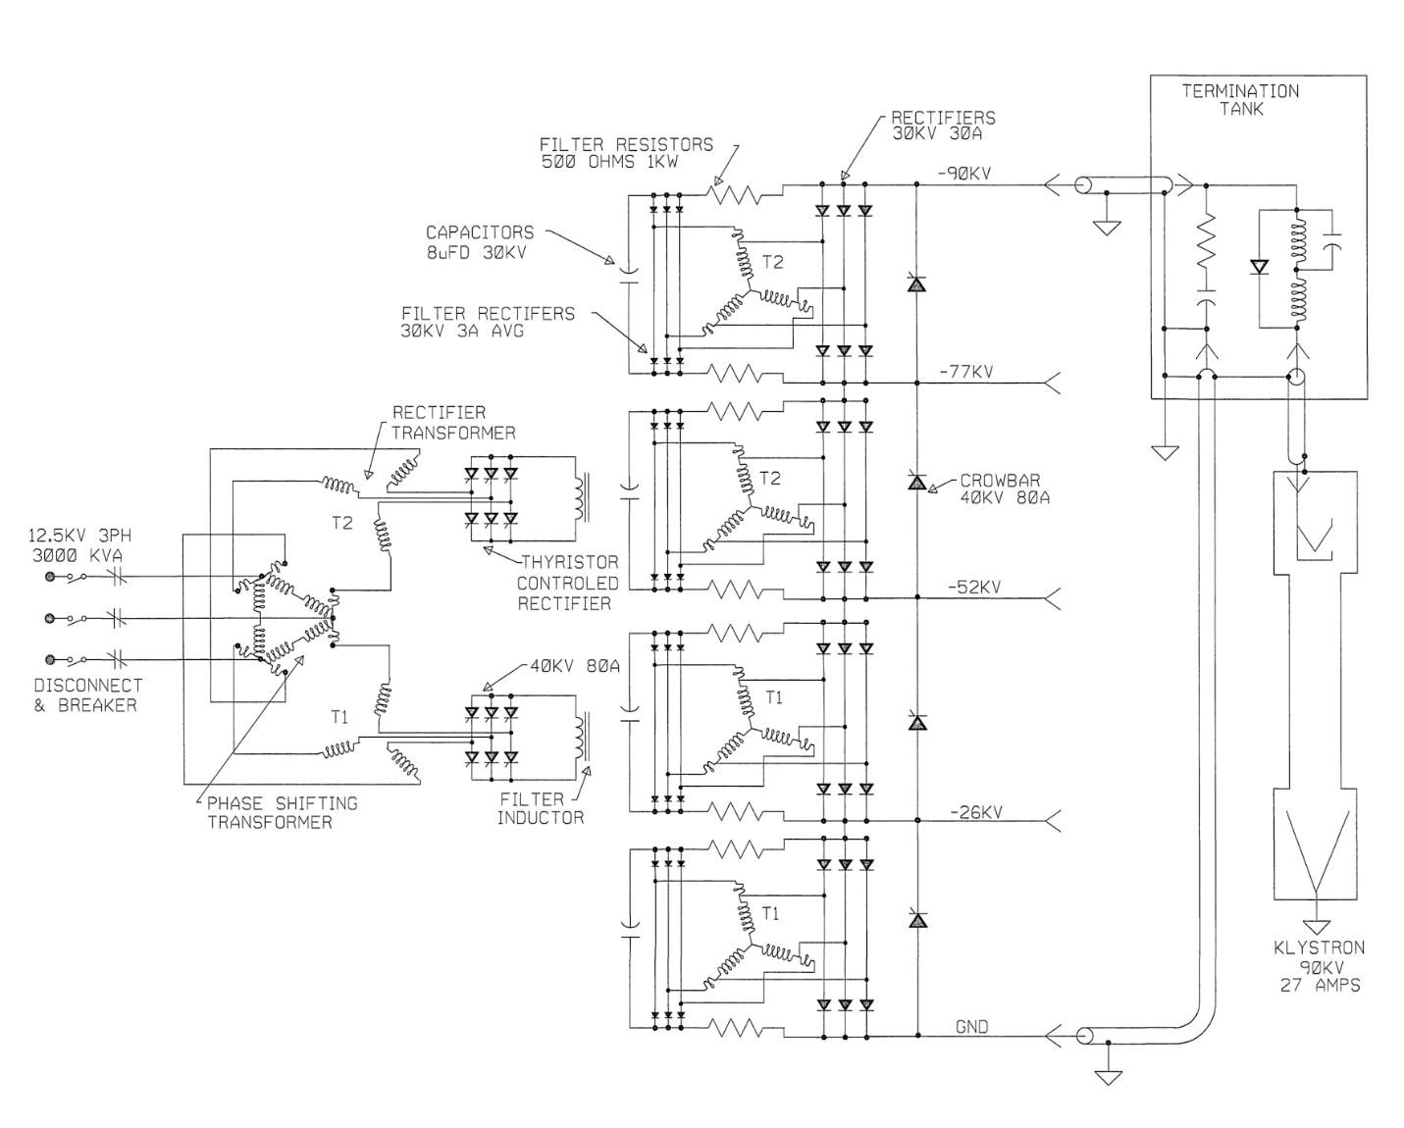
Figure 1: Schematic diagram of SPEAR HVPS

Potential Hazards

Electrical Sources

Three Phase $12.47$ kV RMS Input Voltage
The HVPS power is supplied by the $12.47$ kV RMS premises power. Removing the premises power removes this hazard and prevents the HVPS from generating continuous output power. The medium voltage disconnect switch and the vacuum contactor are shown on the left side of Figure 1.

Thyristor Firing Pulses
The HVPS power is controlled by the appropriate firing of thyristors. The firing pulses, generated by the HVPS controller, are in short bursts, but their amplitude may be as large as $200$ V. These pulses are fully contained within the HVPS. They pose no electrical hazard to anyone outside of the closed HVPS. Removing a single phase $120$ VAC control power to the HVPS controller by opening a breaker removes this hazard. The two breakers enabling the control power to the two controllers are shown in Figure 5.

Switch-over Tank
The switch-over tank is the oil-filled mechanical structure that is used to select which HVPS is connected to the klystron load. This selection is made by connecting the two cables from the -90 kV output bus of the active supply to the cables that connect to the klystron after passing through the termination tank. The output cables of the inactive supply are mechanically connected together, and therefore electrically shorted to each other and then to ground, either inside of the switch-over tank or external to this tank.
No access to nor manipulation of cables in the switch-over tank is required for this EIP. Since it is a part of the HVPS to klystron configuration, we include this description and photograph for completeness.
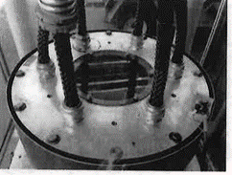
SPEAR1 HV
SPEAR1 RTN
SPEAR2 RTN
KLYSTRON RTN
KLYSTRON HV
SPEAR2 HV
Figure 2: Switch-over tank for SPEAR1 and SPEAR2.

AC Control Power for Termination Tank HV Relay
The termination tank has a high voltage (Ross Engineering) relay that needs to be energized with $120$ VAC when the HVPS is active. During the transition from making one HVPS inactive and the other one active, the source of the $120$ VAC control power is switched from one HVPS controller to the other. The connectors that carry this control power and that are required to be handled during the switch between HVPSs are touch safe. Removing the control power from both HVPS controllers removes this power during the switchover procedure. The breakers enabling the control power are shown in Figure 5.
The control power for the termination tank HV relay never enters the HVPS, itself, so this is not a hazard to working on or inside of the HVPS. This paragraph is only included in this document to show that any potential hazard it may produce has not been ignored.

AC Control Power for the Switchgear Controller
The switchgear, immediately upstream of and connected to the HVPS, has its own controller to operate its HV contactor. When its 120 VAC control power is removed from the switchgear, the 12.47 kVAC vacuum contactor cannot be closed. In addition to controlling the contactor, this control power also powers a service lamp in the switchgear and an oil pump in the HVPS main tank. This power is entirely contained within the HVPS. Opening a disconnect switch, shown in Figure 4, removes this power from the HVPS. The only potential hazard this poses to anyone working on the HVPS itself is if the oil pump within the HVPS main tank needs to be serviced.

DC Control Power for the Switchgear Controller
$125$ VDC is used for DC control power in the switchgear. This power is sourced from a supply within substation 507. We distribute that power to SPEAR1 and SPEAR2 through a local breaker panel in B514, shown in Figure 11. Opening this breaker removes that power from the switchgear and associated interlocks.
The 125 VDC control power serves several functions. First, it supplies the control power to the MX relay coil. Activating the MX relay coil is necessary to remotely close, and keep closed, the 12.47 kVAC contactor in the HVPS switchgear. Second the 125 VDC is used to provide power to the four each ABB MCO protective relays and the three each phase current meters. Finally, the 125 VDC provides the power for the 86L lockout relay and its associated circuitry. The inputs to the lockout relay are the normally open relay contacts from the trip circuits of the MCOs as well as the normally open HVPS machine protection system signals from tank over-pressure, oil over-temperature, and low flow of the HVPS low conductivity water (LCW). If any of these contacts close, the 125 VDC control power energizes the lockout relay coil. When energized, the relay opens a normally closed contact that removes the power from the MX relay coil, opening the contactor.
Both HVPSs share a common LCW flow interlock which is connected to the 125 VDC power. During the switch between HVPSs, a touch safe connector must be moved to connect the active HVPS. Removing the 125 VDC control power protects against potential damage to the control hardware.
The only potential hazard the 125 VDC control power may pose is to someone working in the HVPS main tank, near any of the HVPS MPS circuit elements that are powered by this voltage.

Stored Electrical Energy
There are three types of capacitive elements closely coupled to the HVPS output. The first is a series of four each $8 μF$ capacitors that connect to and extend across the output through pairs of $500 Ω$ resistors. The second is a single $0.22 μF$ capacitor directly across the output. The third is the approximately $60$ m of Mil-C-17/81-0001 (RG220) cable between the HVPS output and the klystron. The capacitance of this cable is about $6$ nF. The total stored energy in these three sets of capacitors, at full rated output voltage, is about $9$ kJ.
Under normal conditions, once the HVPS is turned off, the stored energy is dissipated into the klystron in a fraction of a second. If the measured output voltage of the HVPS is zero, there is no stored energy in these capacitors that can be accessed from outside of the HVPS. The HVPS output voltage is monitored by a redundant set of passive voltage dividers. The low voltage output of these dividers can be measured in the HVPS controller, and from these redundant measurements, one can calculate the output voltage of the supply. If, from these measurements, any potentially hazardous voltage is calculated to be on the HVPS output, one needs to discharge this voltage using properly rated high voltage resistive discharge sticks. Any voltage measurement directly on the HVPS output must be performed using properly rated high voltage probes. It is imperative that one does not enter the restricted approach boundary when measuring and/or discharging the unknown voltage on the conductors.
Inside of the termination tank shown in Figure 1 are two shorting mechanisms. When they are shorted together, they connect the center conductor of the -90 kV cable with the center conductor of the return cable. One mechanism is an electro-mechanical high voltage relay controlled by the HVPS controller and the other is a purely mechanical plunger. When either of these mechanisms short the cables, they provide a short across the output filter capacitors in the HVPS. (Note that these mechanisms are too detailed to be shown in the figure.)

High Voltage Oil
Tens of gallons of FR3 high voltage oil fills the switch-tank to provide electrical insulation. The switch-over from the active supply to the warm spare requires manipulation of the Mil-C-17/81-0001 cables in this tank. The oil is pumped out of the tank before the switch-over occurs and the tank is refilled after the switch-over. The pump assembly used in this step is bulky and the barrels that are used to temporarily store the oil are heavy when filled with the oil. Proper lifting techniques must be used, when required. Also, good housekeeping practices should be followed to minimize and clean up any oil spillage that could lead to slips and/or falls during this switch-over.
The HVPS contains 2600 gallons of the FR3 oil. Approximately 100 gallons is in each of the two small tanks, the phase tank and the crowbar tank, and the rest is in the main tank. Pumping out large fractions of the oil from the main tank requires setting up large temporary oil storage tanks in a temporary portable secondary oil containment berm adjacent to building 514. The secondary oil containment berm and storage tanks add potential slip and trip hazards to the work area. Care must be taken to follow safe work practices when working in this secondary oil containment berm.

Elevated Work Platform
Work to access the inside of any part of the HVPS requires access to the top of the HVPS. Both HVPSs are enclosed by permanent scaffolding that protects the worker from falling off of the HVPS when on top of it. That being said, the top of each HVPS has several trip hazards and the metallic surfaces may be slippery due to oil film on them. Care must be taken to follow safe work practices when on top of the HVPS.

Preparation to Work on Inactive (Idle) HVPS Supply

Verify Initial Conditions
The first steps of this procedure are to verify that the inactive HVPS is, indeed, in a known inactive (idle) safe state. If this is not the case, this procedure should be stopped and an appropriate subject matter expert (SME) for the HVPS should be called in to properly secure the inactive HVPS.

Determine active HVPS
______ Write either SPEAR1 or SPEAR2 in the space at right to denote the active HVPS ________
______ Write the other HVPS name in the space at the right to denote the inactive HVPS ________. If this is not the supply to be worked on, STOP THIS PROCEDURE and contact an HVPS SME for assistance.

Verify the inactive supply is properly locked out
The inactive supply, the one listed in the second line of 9.1.1, must be controlled to ensure that it does not have any active source during this procedure. Three RF Group configuration locks should be controlling these sources. This series of steps ensures that these locks are in place.

12.47 kVAC Input
______ Verify the 12.47 kVAC disconnect switch on the metal-enclosed switchgear of the inactive supply in B514 is in the open position and an RF Group configuration lock is controlling the switch. The dark blue arrow in Figure 3 shows the location of the disconnect switch. In this figure the switch is locked in the open position.
______ Apply a red CoHE Operations Lockout Lock and an appropriately filled out Group Lockout Tag to the open 12.47 kVAC disconnect switch. The common key to this red CoHE Operations Lockout Lock and all the other identically keyed Operations Lockout Locks shall be placed in a group lockout box to which all affected workers shall apply their own personal red LOTO lock.
______ By looking through the window of the switchgear door, visually verify there are three air gaps in the switchgear, one for each phase, by verifying that the three 50E 200A fuses are removed from the switchgear. The viewing window is shown by the blue arrow in Figure 3. If you are not certain if the fuses are removed, STOP THIS PROCEDURE and contact an HVPS SME for assistance. If you see that the fuses are in the switchgear and have not been removed, STOP THIS PROCEDURE and contact an HVPS SME for assistance, who will contact the facilities electricians to put this inactive HVPS input in a safe condition.
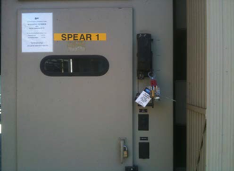
Figure 3: SPEAR1 switchgear door with viewing window in B514.

208 VAC Switchgear Control Power
______ Verify that the disconnect switch to the 208 VAC control power of the inactive HVPS in B514 is in the open position and an RF Group configuration lock is controlling the switch. In Figure 4, the disconnect switch for SPEAR1 is on the right and the disconnect switch for SPEAR2 is on the left. In Figure 4 the SPEAR1 disconnect switch is in the open position and the SPEAR2 disconnect switch is locked in the closed position with an administrative lock.
______ Apply a red CoHE Operations Lockout Lock and an appropriately filled out Group Lockout Tag to the open disconnect switch.
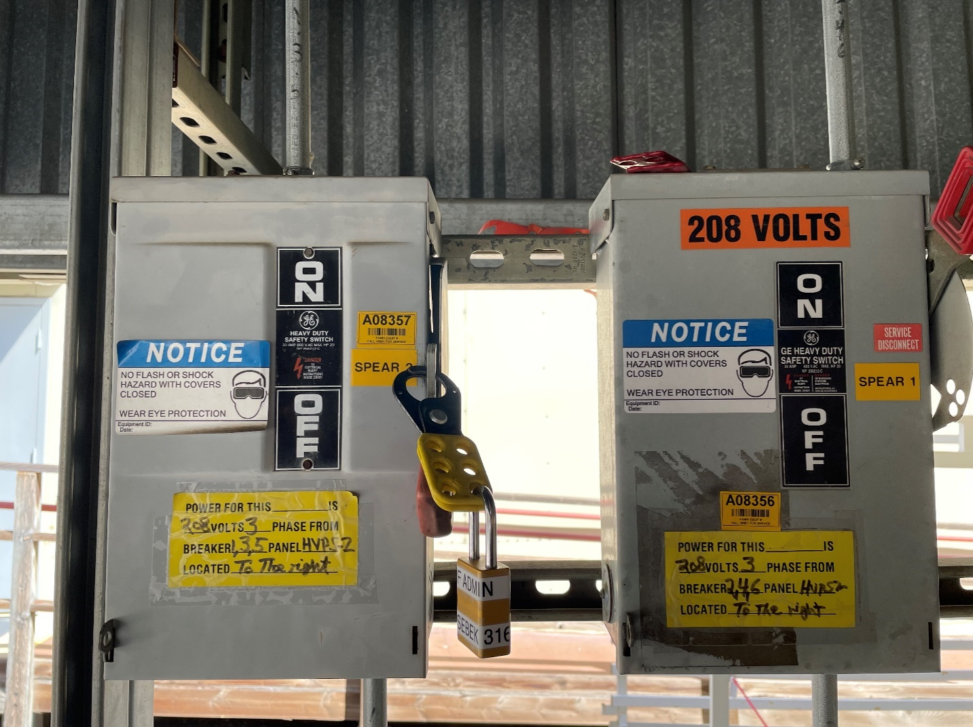
SPEAR1 208 VAC
SPEAR2 208 VAC
Figure 4: HVPS 208 VAC control power disconnect switches in B514

120 VAC HVPS Controller Control Power
______ Verify that the 120 VAC circuit breaker for the HVPS controller of the inactive HVPS is in the open position and an RF Group configuration lock is controlling the breaker. (B117 Panel LPB CB 20, the blue arrow in Figure 5, for SPEAR1 and CB 34, the dark blue arrow in Figure 5, for SPEAR2)
______ Apply a red CoHE Operations Lockout Lock and an appropriately filled out Group Lockout Tag to keep the circuit breaker in the open position.
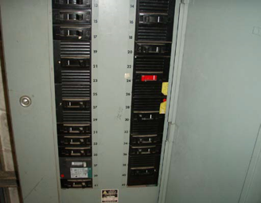
SPEAR2 120 VAC
SPEAR1 120 VAC
Figure 5: B117 LBP breaker panel for HVPS controller 120 VAC control power.

Notification of Operations of the Intent to Disable the HVPSs

Verify Control Documents Exist and Obtain Authorization to Disable Supplies
Appropriate configuration control documents for work on the HVPS system must be entered and approved. One which is always required is a CATER to track the work and to inform SPEAR operations about the work. If this work will involve switching from one HVPS to the other a radiation safety work control form (RSWCF) is also required to allow the accelerator directorate safety officer (ADSO) to manage the radiation implications of the work. (A PPS recertification of the supply may be required after the work.) The SPEAR operations group will grant permission for this work to proceed only after the appropriate configuration control documents are in place.
______ CATER number corresponding to the HVPS work ________
______ Is this EIP being executed in order to change the operational HVPS (Y/N)? ________
______ If yes, enter the RSWCF number corresponding to the HVPS work ________
______ Obtain permission from the SPEAR operations group to proceed with the work.

Control of Hazardous Energy

Sequence of Steps to Turn off the HVPS and Disable the Ability to Close the 12.47 kVAC Contactor
The orderly shutdown of the HVPS in preparation for the work on an HVPS occurs in several steps.

Turn Off the RF System
The first step in this sequence is to turn off the RF system using the EPICS control system, by setting the Station State to the OFF state. After this is done, the Klystron HVPS panel, shown in Figure 6, shows the station is OFF and certain controls of the HVPS, Enerpro Fast Inhibit, Supply Status, and the two SCR banks, are also off. Note that even though the HVPS is off, there is still about 1.3 kVDC at the supply output, as seen by the readings of the two different monitors, RF PLC Voltage and HVPS Voltage. This is due to leakage from the input 12.47 kVAC across the HVPS transformer to the output diode rectifiers. In this condition, the RF system can immediately be turned on by setting the Station State to ON_CW.
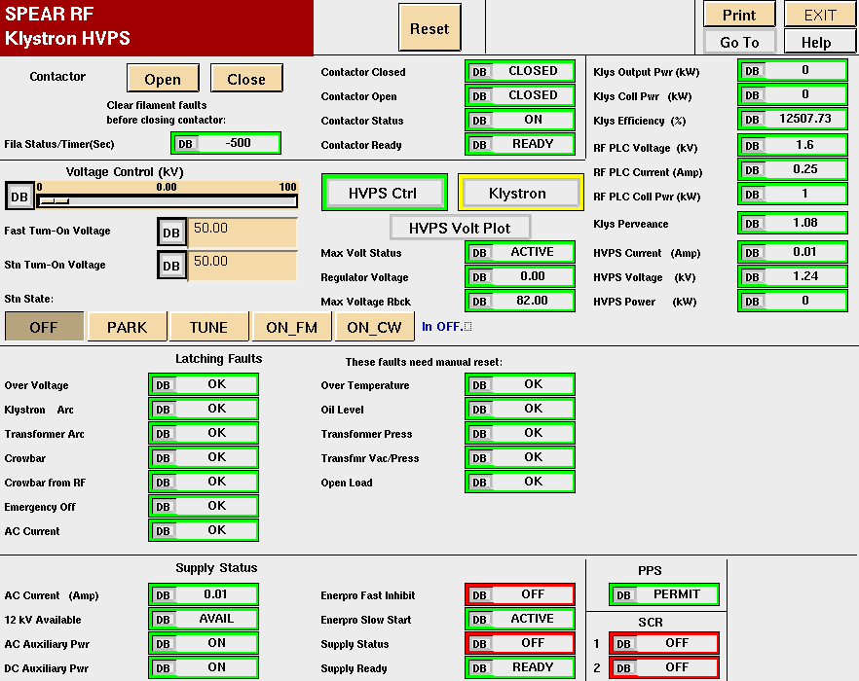
Figure 6: SPEAR RF Klystron HVPS panel with HVPS off and 12.47 kV contactor still closed.

Open the 12.47 kVAC Contactor
The next step in the sequence is to open the 12.47 kVAC contactor by pressing the Contactor Open control. Opening the contactor removes the input voltage to the HVPS and therefore also zeros the output voltage, as seen on RF PLC Voltage and HVPS Voltage. We see in Figure 7 that opening the contactor gives red alarms for five other process variables. Both the Contactor Closed and Contactor Open now display the OPEN status of the contactor. This makes the 12.47 kV input voltage NOTAVAIL. The loss of the input voltage makes the supply NOTREADY and the Enerpro Slow Start INACTIVE. The system can still be turned on remotely, first by closing the contactor and then setting the Station State to ON_CW.
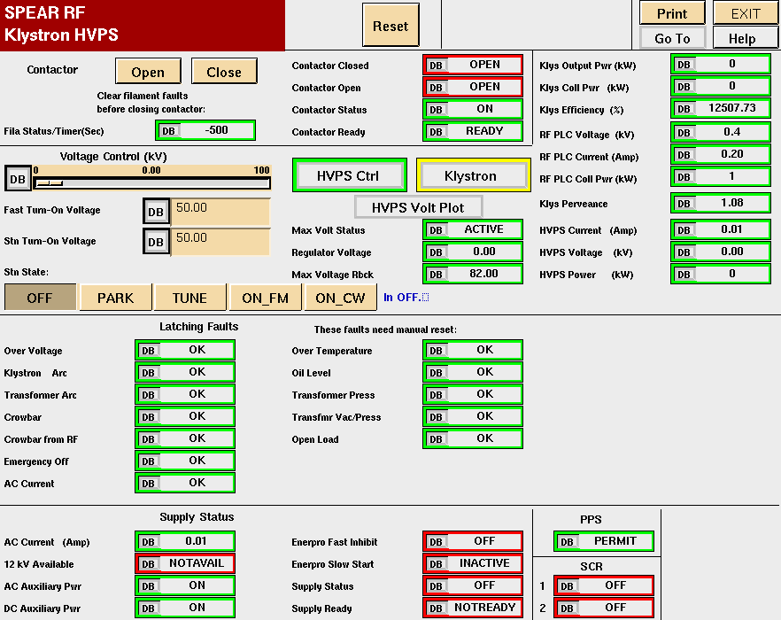
Figure 7: SPEAR RF Klystron HVPS panel with HVPS off and 12.47 kV contactor open.

Disable the Contactor Control Power
The final step in the sequence removes the control power to the contactor controller. Without this control power, the contactor is unable to close and provide any 12.47 kVAC power to the HVPS. The control power is removed by opening the appropriate 208 VAC disconnect switch, shown in Figure 4. Figure 8 shows the Klystron HVPS panel after the control power is removed. Now red alarm status is given to show that the Contactor Status is OFF and the Contactor is NOTREADY. The contactor cannot now be closed, so the system cannot be turned on until the 208 VAC control power is restored by closing the disconnect switch.
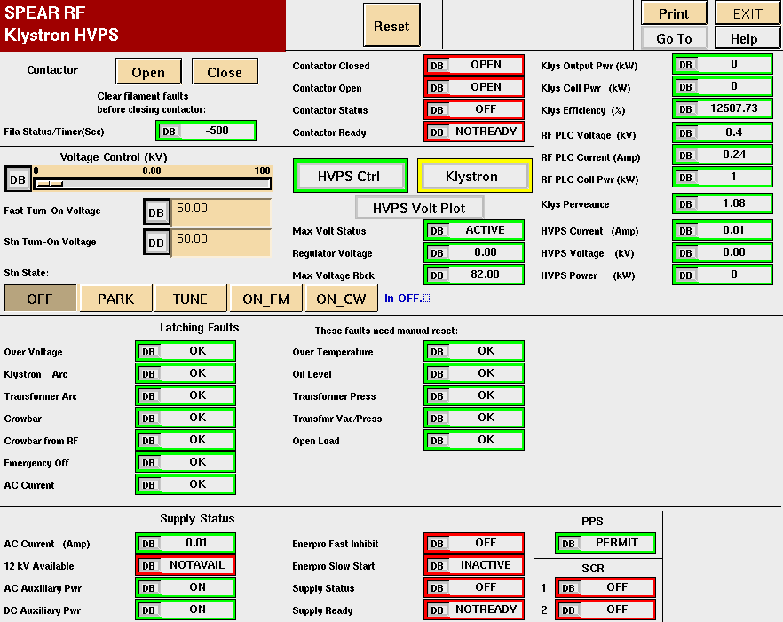
Figure 8: SPEAR RF Klystron HVPS panel with HVPS off, 12.47 kV contactor open, and 120 VAC contactor control power removed.

Document Active HVPS Turn Off
Documenting how the active HVPS turned off will allow us to better understand any potential hazards that may occur due to stored energy not discharged during the turn off.
In a normal turn off, the HVPS voltage and current transition quickly from their operating voltage and current to low values. As described above, as long as the 12.47 kVAC contactor remains closed the measured output voltage shows a residual reading of approximately 1.3 kV. Once the contactor is opened, the value of this measured voltage drops to zero.
The active HVPS Voltage and HVPS Current are archived in the SPEAR history buffers and can be viewed after the HVPS is off. They are in the pull-down menus Parameter->SPEAR RF Klys and HVPS Parameters. (If you are unfamiliar with the HISTORYPLOT application, contact an HVPS SME or a SPEAR operator for assistance.) Figure 9 shows a HISTORYPLOT of the HVPS voltage and current in preparation for access into the SPEAR ring. The supply was turned off at 20:07 and its input 12.47 kVAC contactor was opened at 20:12:40.
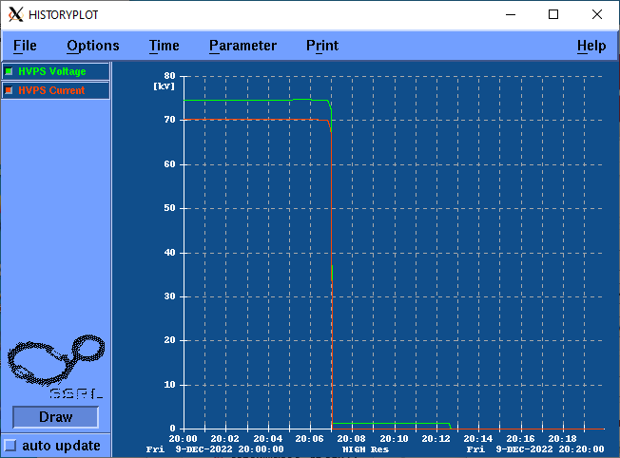
Figure 9: HVPS turned off at 20:07. Contactor opened at 20:12:40.
Using the HISTORYPLOT application:
______ Record the time when the HVPS was turned off ________.
______ Record the HVPS Voltage before ________ and after ________ shutdown. In normal operation, the HVPS voltage can range from 50 kV to 80 kV. After the shutdown, a measured residual voltage of about 1.3 kV may still remain.
______ Record the HVPS Current before ________ and after ________ shutdown. In normal operation, the HVPS current can range from 12 A to 25 A. After the shutdown, the measured current is very close to 0 A.
______ Record the time when the contactor was opened ________.
______ Record the HVPS Voltage after the contactor was opened ________. After the contactor is opened, the measured voltage is very close to 0 kV.

Remove Hazardous Inputs from System

Instruct the HV Electricians to Make Safe the 12.47 kVAC Input to the HVPS
______ Either contact the HV electricians to remove the 12.47 kVAC input from the active supply and authorize their work or verify that the electricians have already completed this work.

Verify the 12.47 kVAC is Removed from the Active HVPS
______ Verify the 12.47 kVAC disconnect switch on the metal-enclosed switchgear of the active HVPS is in the open position. Refer to Figure 3 for a picture of a typical switchgear door with window and disconnect switch.
______ Apply a red CoHE Operations Lockout Lock and an appropriately filled out Group Lockout Tag to the open 12.47 kVAC disconnect switch.
______ By looking through the window of the switchgear door, visually verify there are three air gaps in the switchgear, one for each phase, by verifying that the three 50E 200A fuses are removed from the switchgear. If you are not certain if the fuses are removed, STOP THIS PROCEDURE and contact a HVPS SME for assistance. If you see that the fuses are in the switchgear and have not been removed, STOP THIS PROCEDURE and contact the facilities electricians to put this inactive HVPS input in a safe condition.

208 VAC Switchgear Control Power
To check the effects of removing this power, one needs to bring up the SPEAR RF Station EDM panel on a linux machine. If you are unfamiliar with this EDM application, contact an HVPS SME or a SPEAR operator for assistance and ask them to bring up the RF Detail panel and, from there, the HVPS panel. This is the same panel that was used to explain the turn-off procedure of the RF system in Figure 6, Figure 7, and Figure 8 in sections 11.1.1, 11.1.2, and 11.1.3, respectively.
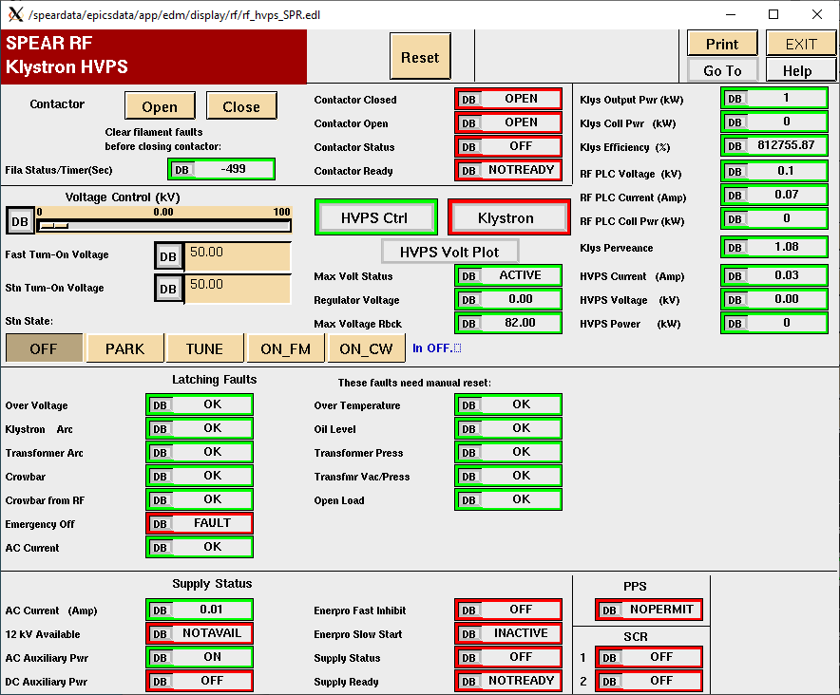
Figure 10: EDM display for HVPS EPICS variables
This section will be successfully completed if the 12.47 kVAC contactor cannot be turned on. If the PPS is still active and gives a PERMIT to the HVPS, one can verify that this action will remove the ability to close the 12.47 kVAC contactor. If the PPS gives a NOPERMIT, all we will be able to verify is that the contactor cannot close. The PPS status is displayed in the area of Figure 10 pointed to by the red arrow.
______ From the SPEAR RF Klystron HVPS panel, check and record the status of the PPS ________
______ If the status is PERMIT, verify that the Contactor Ready status is READY, in the area of Figure 10 pointed to by the dark blue arrow.
______ Move the disconnect switch to the 208 VAC control power, located in B514 and shown in Figure 4, of the active HVPS down to the open position.
______ Apply a red CoHE Operations Lockout Lock and an appropriately filled out Group Lockout Tag to the open disconnect switch.
______ Verify that the Contactor Ready status in Figure 10 is NOTREADY
______ Attempt to close the HVPS contactor by first pressing the Reset button, purple arrow, and then pressing Contactor Close, light blue arrow, in Figure 10.
______ Record the value of Contactor Ready ________
______ Record the value of Contactor Status ________
______ If either the Contactor Ready is READY and/or the Contactor Status is ON, STOP THE PROCEDURE and contact an HVPS SME. Otherwise, continue with the procedure.

Remove 125 VDC switchgear control power.
The 125 VDC control power for the switchgear passes through an enclosure in B514 that contains three touch-safe circuit breakers. The red arrow in Figure 11 points to the main breaker, which is in the ON position in the picture. The dark red arrow points to the breaker for SPEAR2, which is also in the ON position. The green arrow points to the breaker for SPEAR1, which is in the OFF position.
______ In the 125 VDC service enclosure, open the breaker switch for the active HVPS and, if it is not already in the open position, open the breaker switch for the inactive HVPS.
______ Perform a ZVV on the load (bottom) side of both 125 VDC breaker switches for both HVPSs.
______ Close the cover of the service enclosure that contains the 125 VDC breaker switches and apply a red CoHE Operations Lockout Lock and an appropriately filled out Group Lockout Tag to secure the cover of this enclosure.
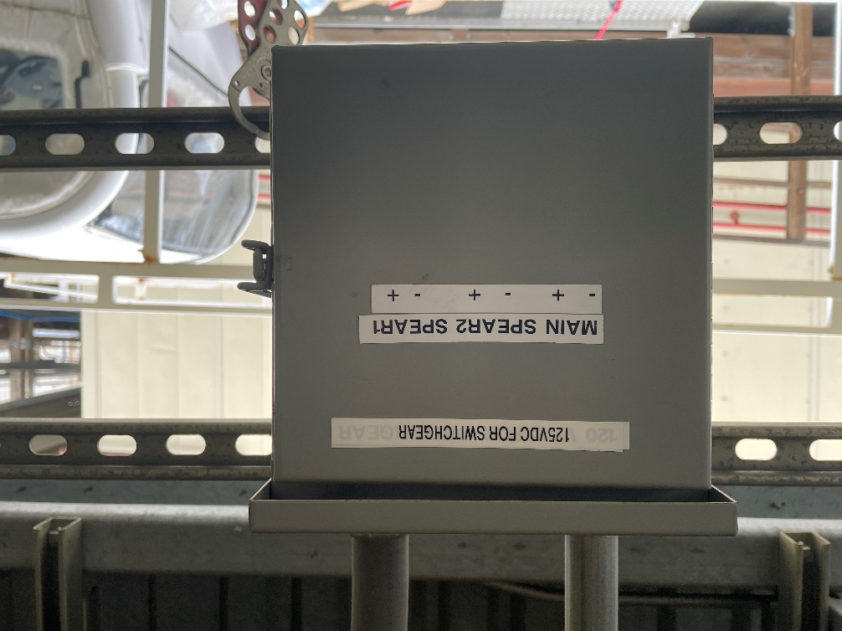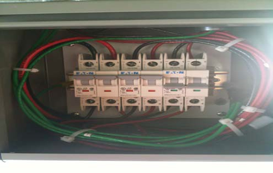
SPEAR1
SPEAR2
MAIN
Figure 11: 125 VDC control power enclosure and circuit breakers in B514.
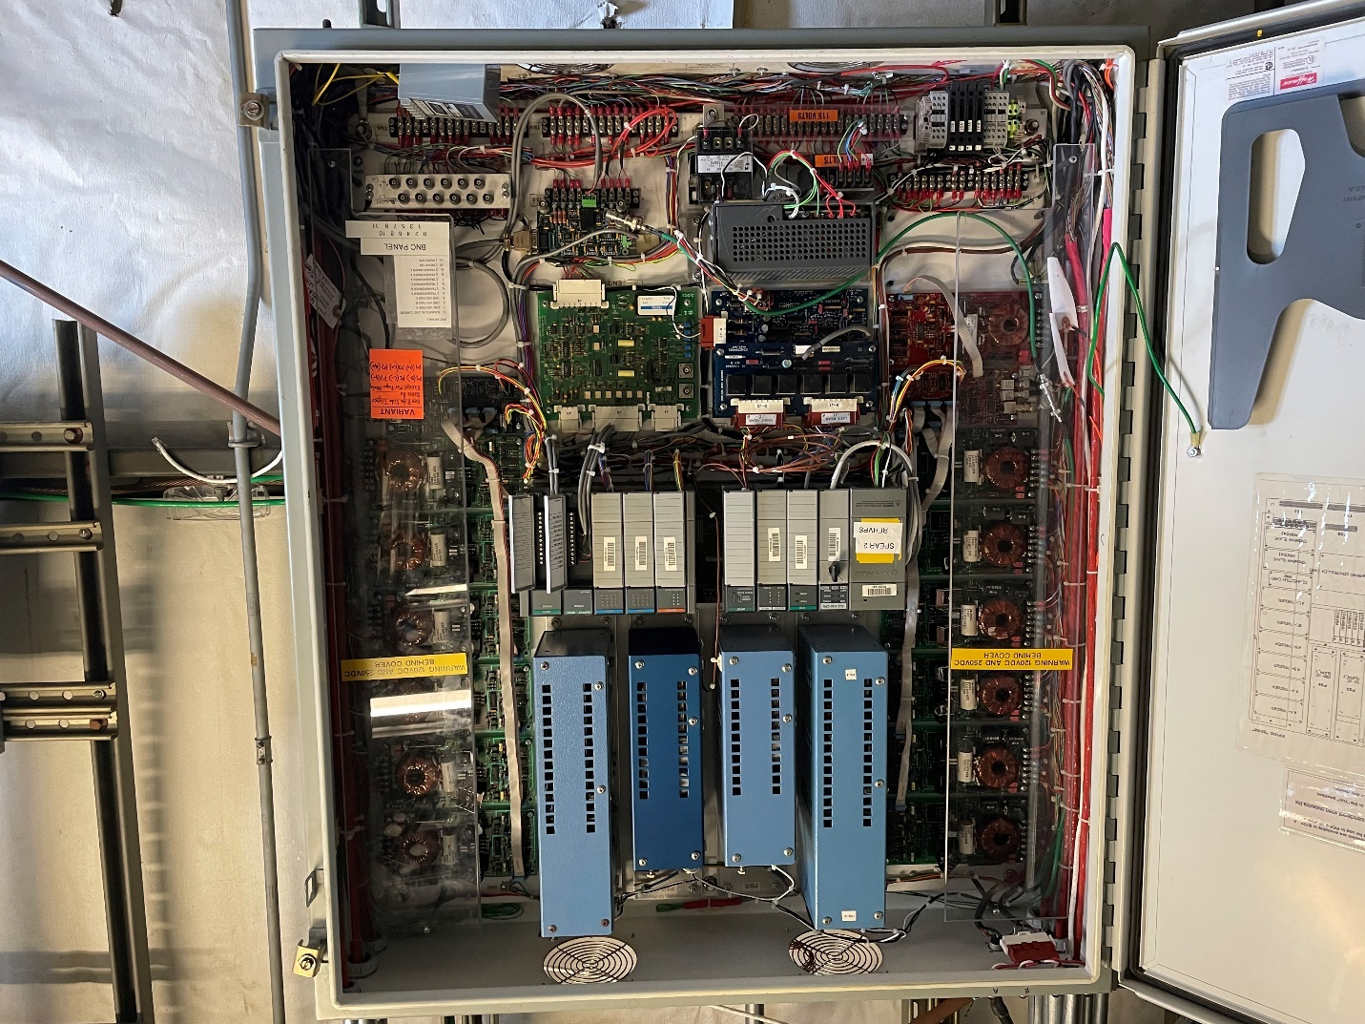
VOLTAGE DIVIDERS
120 VAC
Figure 12: The inside of the HVPS controller enclosure in B118.

Measure the Readings of the HVPS Voltage Monitors
Each HVPS has two redundant HVPS voltage dividers that are used as monitors. When properly connected to the HVPS controller on terminal strip (TS) 3, the voltage division ratio is 10000:1. By measuring the outputs of these voltage dividers on the previously active HVPS, we can gain more confidence in our knowledge of the current output voltage of the HVPS. Because of the large voltage division ratio, a Category III rated DVM that has a millivolt setting is most useful for these measurements.
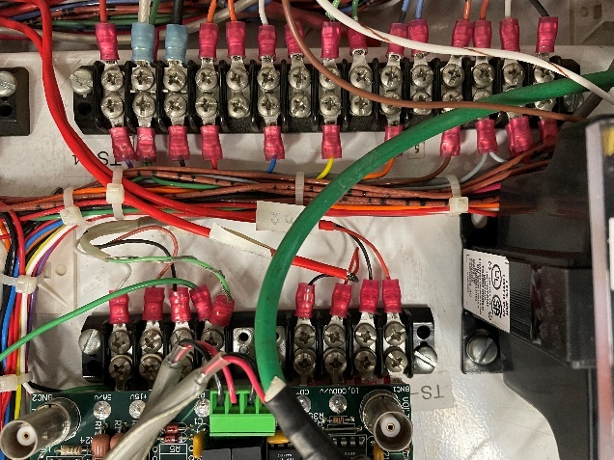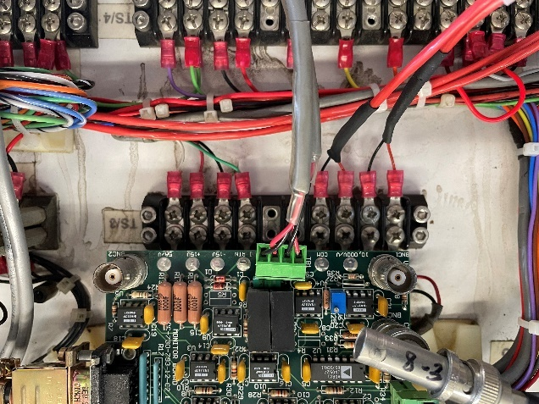
Figure 13: TS3 with voltage divider terminations for SPEAR1 (left) and SPEAR2 (right) in HVPS controllers in B118.
The inside of the HVPS controller enclosure, located in B118, is shown in Figure 12. It is safe to make the measurements described in this procedure inside of the controller since all potentially hazardous voltages are covered. In Figure 12, a blue arrow points to the location of TS3, where the voltage dividers are terminated. Figure 13 shows the details of TS3 in the controllers for both SPEAR1 and SPEAR2. In both pictures, the blue arrow points to the two terminals of voltage divider 1 and the dark blue arrow points to the two terminals of voltage divider 2.
______ Measure the voltage across TS3 1-2 of the active HVPS and record the reading of voltage divider 1 ________
______ If this reading is greater than 0.1 V, the calculated output voltage is greater than 1 kV. If so, STOP EXECUTING THIS PROCEDURE and contact an HVPS SME.
______ Measure the voltage across TS3 3-4 of the active HVPS and record the reading of voltage divider 2 ________
______ If this reading is greater than 0.1 V, the calculated output voltage is greater than 1 kV. If so, STOP EXECUTING THIS PROCEDURE and contact an HVPS SME.

120 VAC HVPS Controller Control Power
______ Open the 120 VAC circuit breaker for the HVPS controller of the active HVPS. (B117 Panel LPB CB 20 for SPEAR1 and CB 34 for SPEAR2. Refer to Figure 5.)
______ Apply a red CoHE Operations Lockout Lock and an appropriately filled out Group Lockout Tag to the open circuit breaker
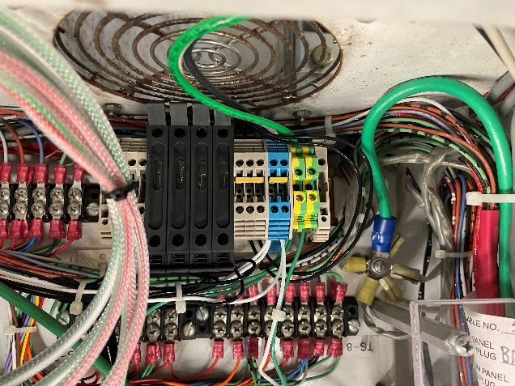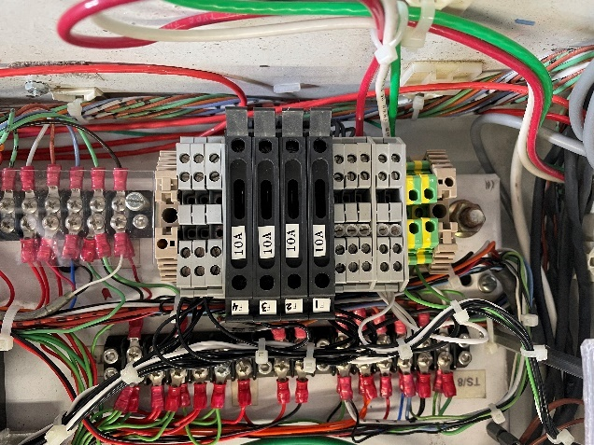
Figure 14: 120 VAC control power for HVPS controller for SPEAR1 (left) and SPEAR2 (right), both in B118.

Verify No HVPS Controller Power on Either HVPS Controller
The 120 VAC control power enters each HVPS Controller in B118 and the line and neutral wires land on terminal blocks on the TS1 DIN rail. Figure 14 shows the touch safe TS1 DIN rails on which the input control power is terminated. For both SPEAR1 and SPEAR2, the red arrow points to the line connection, the white arrow to the neutral connection, and the green arrow to the ground connection.
______ Perform a ZVV on the control power for SPEAR1 on the TS1 DIN rail connections between line (black) and neutral (white), line and ground (green), and neutral and ground.
______ Perform a ZVV on the control power for SPEAR2 on the TS1 DIN rail connections between line (red) and neutral (white), line and ground (green), and neutral and ground.

Zero Voltage Verification of HVPS Connection to the Klystron
______ Visually verify through the viewport on the oil-filled transition tank in B132-101 that the wiper of the high voltage (Ross) relay has shorted to the ground bar of the relay assembly. The blue arrow in the photograph on the left side of Figure 15 points to the viewport and the yellow arrow in the photograph on the right side of the figure points to the wiper lying on the ground bar, pointed to by the green arrow, of the high voltage relay assembly.
______ Fully depress the mechanical shorting plunger, pointed to by the red arrow in Figure 15, in the transition tank in B132-101 to short the output cables and place a red CoHE Operations Lockout Lock and an appropriately filled out Group Lockout Tag on the hasp to secure the plunger in the down position.
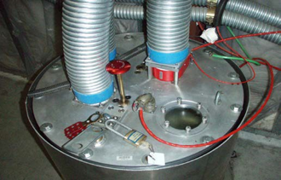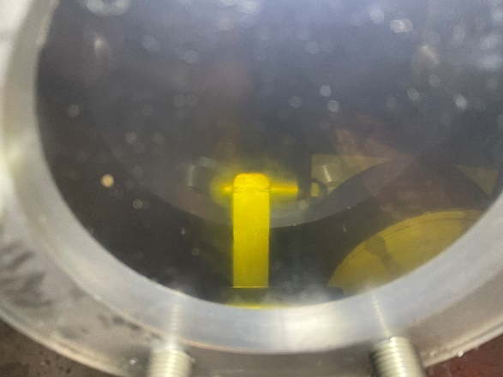
WIPER
GROUND
Figure 15: Termination tank in B132-101.

Group Lockout Complete
______ The LAW shall place the common key to the eight Operations Lockout Locks applied in this procedure in the group lockout box. Then they shall place their personal lock on the group lockout box and apply the orange Group Master Lockout Tag on the box.
______ The LAW shall obtain a copy of the Complex Lockout Permit for the SPEAR3 RF HVPS Energy Isolation Plan SR-444-636-02-R1, stored in the file Spear3HVPSComplexLockoutPermit.xlsx and a copy of which is displayed in Figure 16, complete Section 2 of the permit, and place it adjacent to the group lockout box.

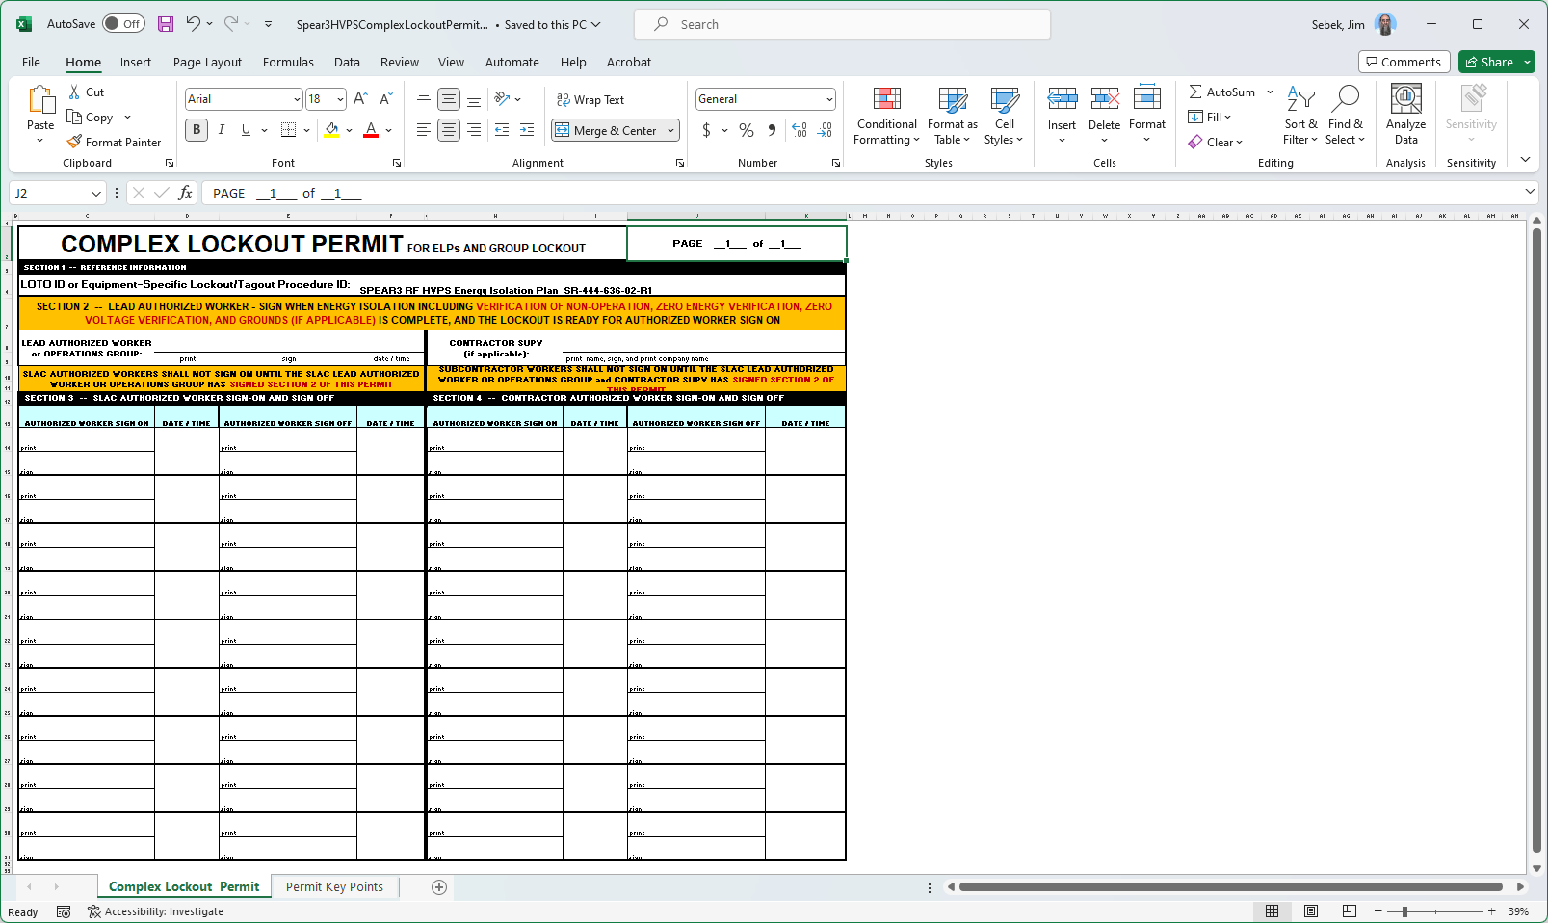
Figure 16: Complex Lockout Permit for the SPEAR3 RF HVPS Isolation Plan SR-444-636-02-R1

