SPEAR3 RF HVPS Switch Procedure with No Work Done on Idle Supply
SR-444-636-03-R1
Table of Contents
2 Revision History 2
2.1 R1 October 25, 2023 2
3 Table of Figures 2
4 Author/Approvers/Validators 3
4.1 Author 3
4.2 Reviewers 3
4.3 Management Approval 3
4.4 Validator 3
5 Procedure Purpose 3
6 Equipment Required to Execute Procedure 4
7 Equipment Description 5
8 Potential Hazards 6
8.1 Electrical Sources 6
8.1.1 Three Phase $12.47$ kV RMS Input Voltage 6
8.1.2 Thyristor Firing Pulses 6
8.1.3 Switch-over Tank 7
8.1.4 AC Control Power for Termination Tank HV Relay 7
8.1.5 AC Control Power for the Switchgear Controller 7
8.1.6 DC Control Power for the Switchgear Controller 7
8.2 Stored Electrical Energy 8
8.3 High Voltage Oil 8
8.4 Elevated Work Platform 9
9 Preparation to Change the Active HVPS Supply 9
9.1 Verify Initial Conditions 9
9.1.1 Verify that SPEAR3 RF HVPS Energy Isolation Plan has been executed and join the lockout. 9
9.2 Verify Current Operational Conditions 13
9.2.1 Determine active HVPS 13
9.3 Notification of Operations to Switch the HVPSs 13
9.3.1 Verify CATER and RSWCF exist and obtain authorization to switch the HVPSs 13
9.4 Zero Voltage Verification of HVPS Connection to the Klystron 13
10 Reconfigure Inactive HVPS to be the Active HVPS 15
10.1 Reconfigure HVPS Outputs to Connect to the Klystron 15
10.1.1 Remove Dielectric Oil 15
10.1.2 Reconfigure the Connections in the Switch Tank 15
10.1.3 Return Switch Tank to Operational Status 16
10.2 Reconfigure the Water Flow Interlock 16
10.3 Reconfigure Control Cables from the HVPS Controller to B132 16
10.4 Energize Appropriate Cooling Fans for the HVPS 17
11 End of Personal Lockout 19
12 Prepare RF System for Operation 19
12.1 Remove RF Group Configuration Locks from Newly Active HVPS and Apply to Newly Inactive HVPS 19
12.1.1 Remove RF Group Configuration Locks from Newly Active (Previously Inactive) HVPS 19
12.1.2 Place RF Group Configuration Locks on Newly Inactive (Previously Active) HVPS 19
12.2 Remove RF HVPS Energy Isolation 19
12.3 Energize Low Power Controls 19
13 Notifications 20
14 Commissioning 20

Revision History

R1 October 25, 2023
Original version.

Table of Figures
Figure 1: Schematic diagram of SPEAR HVPS 6
Figure 2: SPEAR1 switchgear door with viewing window. 10
Figure 3: HVPS 208 VAC control power disconnect switches 11
Figure 4: B117 LBP breaker panel for HVPS controller 120 VAC control power. 12
Figure 5: 125 VDC control power enclosure and circuit breakers 12
Figure 6: Termination tank 14
Figure 7: Switch tank for SPEAR1 and SPEAR2 14
Figure 8: Phenix Technologies DS100-2 discharge stick, rated for 100 kV, 40 kJ. 14
Figure 9: Bus bar connections in the switch tank. The left photograph shows the shorting of outputs of the inactive HVPS. The right photograph shows a typical connection to the klystron. 15
Figure 10: Junction box for 125 VDC control connection (left). Touch safe connectors inside of the junction box (right). 16
Figure 11: Low power control interface enclosure location (left) and details inside the enclosure (right). 17
Figure 12: 208 VAC breaker panel that contains the breakers for the power for SPEAR1 and SPEAR2 external cooling fans. 18

Author/Approvers/Validators

Author
_______________________________________ ____________________
SSRL Technical Expert: Jim Sebek Date

Reviewers
_______________________________________ ____________________
EED-OPS Technical Expert: Marc Larrus Date
_______________________________________ ____________________
Independent Reviewer: Ben Morris Date

Management Approval
_______________________________________ ____________________
EED-OPS Deputy Department Head: Tony Beukers Date

Validator
I have implemented this procedure in its entirety and have found it to be clear, complete, and accurate.
_______________________________________ ____________________
Technical Validator: Jim Sebek Date

Procedure Purpose
The purpose of this document is to detail a plan to switch between the two SPEAR High Voltage Power Supplies (HVPSs), either SPEAR1 or SPEAR2. Successful execution of the SPEAR3 RF HVPS Energy Isolation Plan (EIP), SR-444-636-02-R1, is a pre-requisite for this procedure. The EIP will ensure that all sources of external energy to the two HVPSs have been removed, the outputs of each HVPS have been measured to be zero, and two shorting devices, a Ross relay wiper and a mechanical shorting plunger, have shorted the high voltage input to the klystron, which was last sourced by the HVPS that last powered the klystron.
This procedure requires only contact with the outputs of the two HVPSs. Steps in the procedure will verify that these outputs will have no voltage across them. Engineering controls within the HVPSs should have dissipated all of the stored energy within the supplies, but the dissipation has not been verified.
There is an underlined section, “______”, before each individual step to be executed in this procedure for the lead authorized worker (LAW) to initial as they complete it. The steps within this procedure in which lock out tag out (LOTO) locks are applied and/or zero voltage verification (ZVV) is performed have a different underlined section, “______”, intended to alert the LAW that these steps are LOTO and/or ZVV related.
This procedure only applies for switching between the two HVPSs when no work is planned on the idle HVPS. If work is planned on the idle HVPS while the operational supply is energized, use SPEAR3 RF HVPS Switch Procedure with Work Done on Idle Supply, SR-444-636-04-R1, to place the outputs of the idle supply in a condition in which they are visibly grounded outside of the switch tank.
This procedure does not cover any work performed on the HVPS. Other appropriate maintenance procedures are required to cover that work.
This procedure includes an instruction to remove the group lockout implemented by the SPEAR3 RF HVPS Energy Isolation Plan, SR-444-636-02-R2, but it does not give the detailed steps to remove this lockout. The procedure that removes the group lockout is the SPEAR3 Removal of RF HVPS Energy Isolation, SR-444-636-05-R1.

Equipment Required to Execute Procedure
The following equipment is required to execute this procedure:
- One (1) each personal red LOTO lock for the worker to apply to the group lockout box.
- Tools for work in the switch tank (10.1)
  - Key to open EED-OPS blue administrative lock
  - Allen wrenches to open and redo connections within the switch tank
  - Equipment to drain and refill oil from the tank
    - Oil pump and related hoses and fittings
    - Empty oil barrel for temporary storage
    - Industrial wipes and other equipment for oil clean-up
- Two (2) each high voltage discharge sticks rated for 100 kV, such as the Phenix Technologies DS100-2 pictured in Figure 8.
- DMM to use to perform a ZVV on a 125 VDC circuit.
- A step ladder to reconfigure the water flow interlock (Figure 10) and the control cables from the HVPS controller (Figure 11).
This equipment should be assembled before starting this procedure.

Equipment Description
The equipment covered by this procedure are the SPEAR3 HVPSs SPEAR1 and SPEAR2, both located in building 514. (Henceforth we will refer to the storage ring as SPEAR so that the only numbered versions of SPEAR in this document will refer to HVPSs.) Each HVPS has its own associated switchgear, which includes a disconnect switch, fuses, protective relays, and a vacuum contactor. The purpose of each HVPS is to supply DC power to the SPEAR klystron which, in turn, provides radiofrequency (RF) power to the SPEAR cavities which accelerate the SPEAR electron beam. The maximum output rating of each HVPS is $-90$ kVDC at $27$ A, or $2.5$ MW. A schematic diagram of the HVPS is shown in Figure 1.
SPEAR has only one klystron, so only one of the HVPSs can ever be used at a time. The other is staged as a “warm spare”. SPEAR1 and SPEAR2 share a common three phase $12.47$ kV RMS feed that comes from breaker 160 in substation 507. The HVPSs are administratively controlled so that, at most, only one HVPS can be energized at a time. Each has its own separate controller, but they share the input $12.47$ kV RMS feed, HV output cables to the klystron, and connections to the low-level radio frequency (LLRF) system.
There is an aluminum oil-filled switch tank located next to B514 that connects the appropriate HVPS to the klystron. The aluminum tank is electrically grounded to earth at the tank location and the tank is filled with FR3 dielectric oil to increase the voltage withstand between the exposed conductors and the grounded tank. The oil is rated to exceed the IEEE C57.147 standard that specifies a breakdown of greater than 130 kV for distances of one inch (25.4 mm). The two output cables, high voltage and return, of both HVPSs are terminated in the tank. The high voltage cable of the active HVPS is connected to the high voltage cable that connects to the termination tank next to the klystron. Similarly, the return cable of the active HVPS is connected to the return cable that connects to the termination tank. The high voltage and return cables of the warm spare are always shorted together and shorted to ground in one of two configurations. Either they are connected to a shorting bar inside of the switch tank or they are shorted together and to ground outside of the switch tank. In the latter case, a worker on the warm spare can visually see an air gap between the cables and any cables connected either to the other supply or the klystron.
The termination tank, located next to the klystron, is of similar construction to the switch tank, in that it is made from aluminum and electrically grounded to earth at the tank. It also uses a high voltage dielectric oil but, for historical reasons, this oil is conventional mineral oil and not a natural ester like FR3.
The HVPS that functions as the warm spare is administratively locked off. Its input $12.47$ kV RMS switchgear disconnect switch is locked in the open position, its three input $200$ A, 50E medium voltage fuses are removed, and the load side of the vacuum contactors, the line side of the HVPS, is grounded. A low voltage disconnect switch is opened to interrupt the $208$ VAC control power to the switchgear, and the breaker for the $120$ VAC power to the HVPS controller is opened. Administrative locks from the RF group are placed on these two disconnect switches and the breaker to ensure that power is not inadvertently re-introduced into the spare.
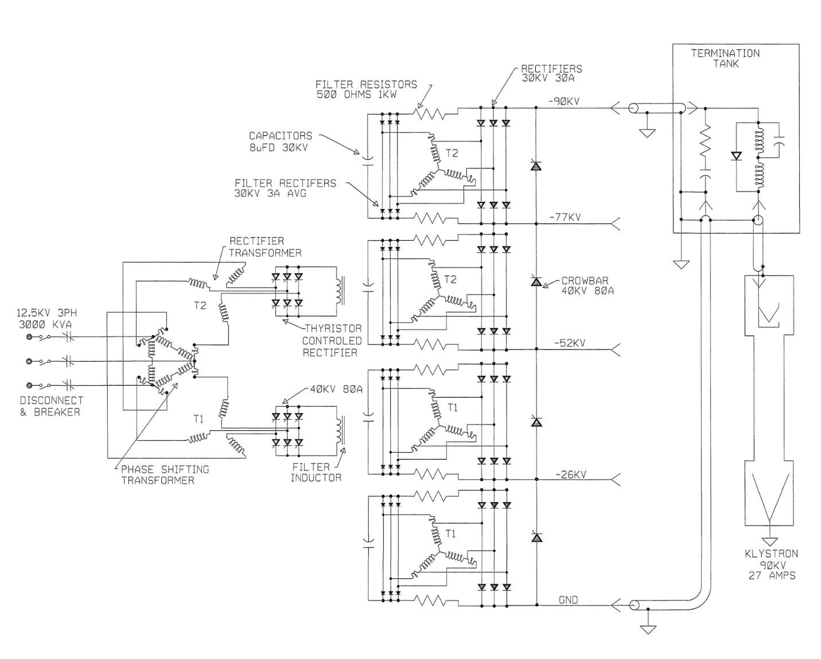
Figure 1: Schematic diagram of SPEAR HVPS

Potential Hazards

Electrical Sources

Three Phase $12.47$ kV RMS Input Voltage
The HVPS power is supplied by the $12.47$ kV RMS premises power. Removing the premises power removes this hazard and prevents the HVPS from generating continuous output power. The medium voltage disconnect switch and the vacuum contactor are shown on the left side of Figure 1.

Thyristor Firing Pulses
The HVPS power is controlled by the appropriate firing of thyristors. The firing pulses, generated by the HVPS controller, are in short bursts, but their amplitude may be as large as $200$ V. These pulses are fully contained within the HVPS. They pose no electrical hazard to anyone outside of the closed HVPS. Removing a single phase $120$ VAC control power to the HVPS controller by opening a breaker removes this hazard. The two breakers enabling the control power to the two controllers are shown in Figure 4.

Switch-over Tank
The switch-over tank is the oil-filled mechanical structure that is used to select which HVPS is connected to the klystron load. This selection is made by connecting the two cables from the -90 kV output bus of the active supply to the cables that connect to the klystron after passing through the termination tank. The output cables of the inactive supply are mechanically connected together, and therefore electrically shorted to each other and then to ground, either inside of the switch-over tank or external to this tank.

AC Control Power for Termination Tank HV Relay
The termination tank has a high voltage (Ross Engineering) relay that needs to be energized with $120$ VAC when the HVPS is active. During the transition from making one HVPS inactive and the other one active, the source of the $120$ VAC control power is switched from one HVPS controller to the other. The connectors that carry this control power and that are required to be handled during the switch between HVPSs are touch safe. Removing the control power from both HVPS controllers removes this power during the switchover procedure. The breakers enabling the control power are shown in Figure 4.
The control power for the termination tank HV relay never enters the HVPS, itself, so this is not a hazard to working on or inside of the HVPS. This paragraph is only included in this document to show that any potential hazard it may produce has not been ignored.

AC Control Power for the Switchgear Controller
The switchgear, immediately upstream of and connected to the HVPS, has its own controller to operate its HV contactor. When its 120 VAC control power is removed from the switchgear, the 12.47 kVAC vacuum contactor cannot be closed. In addition to controlling the contactor, this control power also powers a service lamp in the switchgear and an oil pump in the HVPS main tank. This power is entirely contained within the HVPS. Opening a disconnect switch, shown in Figure 3, removes this power from the HVPS. The only potential hazard this poses to anyone working on the HVPS itself is if the oil pump within the HVPS main tank needs to be serviced.

DC Control Power for the Switchgear Controller
$125$ VDC is used for DC control power in the switchgear. This power is sourced from a supply within substation 507. We distribute that power to SPEAR1 and SPEAR2 through a local breaker panel in B514, shown in Figure 5. Opening this breaker removes that power from the switchgear and associated interlocks.
The 125 VDC control power serves several functions. First, it supplies the control power to the MX relay coil. Activating the MX relay coil is necessary to remotely close, and keep closed, the 12.47 kVAC contactor in the HVPS switchgear. Second the 125 VDC is used to provide power to the four each ABB MCO protective relays and the three each phase current meters. Finally, the 125 VDC provides the power for the 86L lockout relay and its associated circuitry. The inputs to the lockout relay are the normally open relay contacts from the trip circuits of the MCOs as well as the normally open HVPS machine protection system signals from tank over-pressure, oil over-temperature, and low flow of the HVPS low conductivity water (LCW). If any of these contacts close, the 125 VDC control power energizes the lockout relay coil. When energized, the relay opens a normally closed contact that removes the power from the MX relay coil, opening the contactor.
Both HVPSs share a common LCW flow interlock which is connected to the 125 VDC power. During the switch between HVPSs, a touch safe connector must be moved to connect the active HVPS. Removing the 125 VDC control power protects against potential damage to the control hardware.
The only potential hazard the 125 VDC control power may pose is to someone working in the HVPS main tank, near any of the HVPS MPS circuit elements that are powered by this voltage.

Stored Electrical Energy
There are three types of capacitive elements closely coupled to the HVPS output. The first is a series of four each $8 μF$ capacitors that connect to and extend across the output through pairs of $500 Ω$ resistors. The second is a single $0.22 μF$ capacitor directly across the output. The third is the approximately $60$ m of Mil-C-17/81-0001 (RG220) cable between the HVPS output and the klystron. The capacitance of this cable is about $6$ nF. The total stored energy in these three sets of capacitors, at full rated output voltage, is about $9$ kJ.
Under normal conditions, once the HVPS is turned off, the stored energy is dissipated into the klystron in a fraction of a second. If the measured output voltage of the HVPS is zero, there is no stored energy in these capacitors that can be accessed from outside of the HVPS. The HVPS output voltage is monitored by a redundant set of passive voltage dividers. The low voltage output of these dividers can be measured in the HVPS controller, and from these redundant measurements, one can calculate the output voltage of the supply. If, from these measurements, any potentially hazardous voltage is calculated to be on the HVPS output, one needs to discharge this voltage using properly rated high voltage resistive discharge sticks. Any voltage measurement directly on the HVPS output must be performed using properly rated high voltage probes. It is imperative that one does not enter the restricted approach boundary when measuring and/or discharging the unknown voltage on the conductors.
Inside of the termination tank shown in Figure 1 are two shorting mechanisms. When they are shorted together, they connect the center conductor of the -90 kV cable with the center conductor of the return cable. One mechanism is an electro-mechanical high voltage relay controlled by the HVPS controller and the other is a purely mechanical plunger. When either of these mechanisms short the cables, they provide a short across the output filter capacitors in the HVPS. (Note that these mechanisms are too detailed to be shown in the figure.)

High Voltage Oil
Tens of gallons of FR3 high voltage oil fills the switch-tank to provide electrical insulation. The switch-over from the active supply to the warm spare requires manipulation of the Mil-C-17/81-0001 cables in this tank. The oil is pumped out of the tank before the switch-over occurs and the tank is refilled after the switch-over. The pump assembly used in this step is bulky and the barrels that are used to temporarily store the oil are heavy when filled with the oil. Proper lifting techniques must be used, when required. Also, good housekeeping practices should be followed to minimize and clean up any oil spillage that could lead to slips and/or falls during this switch-over.
The HVPS contains 2600 gallons of the FR3 oil. Approximately 100 gallons is in each of the two small tanks, the phase tank and the crowbar tank, and the rest is in the main tank. Pumping out large fractions of the oil from the main tank requires setting up large temporary oil storage tanks in a temporary portable secondary oil containment berm adjacent to building 514. The secondary oil containment berm and storage tanks add potential slip and trip hazards to the work area. Care must be taken to follow safe work practices when working in this secondary oil containment berm.

Elevated Work Platform
Work to access the inside of any part of the HVPS requires access to the top of the HVPS. Both HVPSs are enclosed by permanent scaffolding that protects the worker from falling off of the HVPS when on top of it. The top of each HVPS has several trip hazards and the metallic surfaces may be slippery due to oil film on them. Care must be taken to follow safe work practices when on top of the HVPS.

Preparation to Change the Active HVPS Supply

Verify Initial Conditions
The first steps of this procedure are to verify that both HVPSs have been made safe using the SPEAR3 RF HVPS Energy Isolation Plan (EIP), SR-444-636-02-R2, that the appropriate red LOTO locks are in place, and that the worker has applied their lock to the group lockout box for this EIP.

Verify that SPEAR3 RF HVPS Energy Isolation Plan has been executed and join the lockout.
______ Verify that EIP SR-444-636-02-R2 has been executed.
______ Apply a personal red CoHE lock to the group lockout box for SR-444-636-02-R2.
______ Sign into the Complex Lockout Permit for SR-444-636-02-R2.
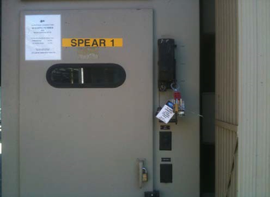
Figure 2: SPEAR1 switchgear door with viewing window.
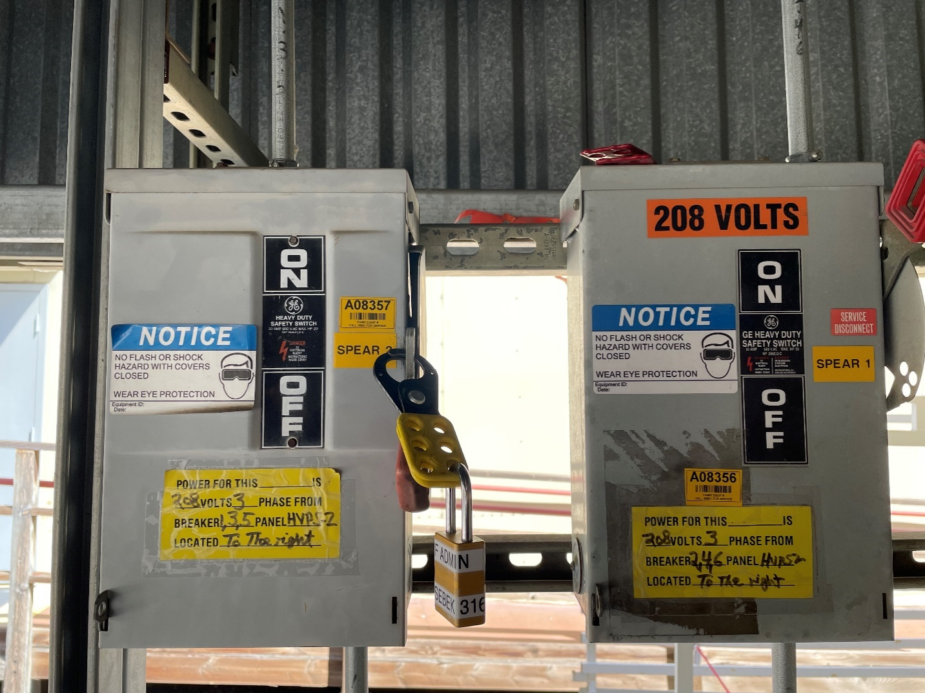
SPEAR1 208 VAC
SPEAR2 208 VAC
Figure 3: HVPS 208 VAC control power disconnect switches
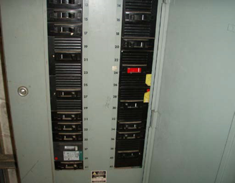
SPEAR2 120 VAC
SPEAR1 120 VAC
Figure 4: B117 LBP breaker panel for HVPS controller 120 VAC control power.

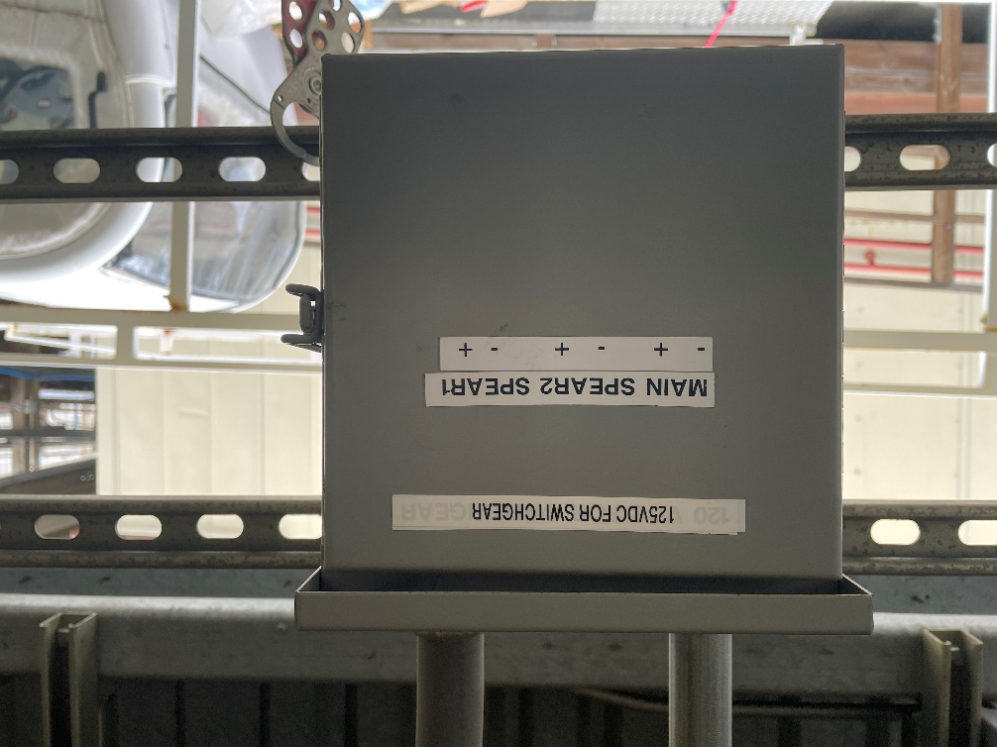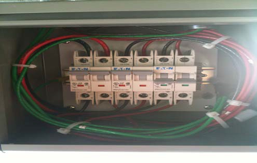
SPEAR1
SPEAR2
MAIN
Figure 5: 125 VDC control power enclosure and circuit breakers

Verify Current Operational Conditions

Determine active HVPS
______ Write either SPEAR1 or SPEAR2 in the space at right to denote the active HVPS ________.
______ Write the other HVPS name in the space at the right to denote the inactive HVPS ________. If this is not the supply to be switched to, STOP THIS PROCEDURE and contact an HVPS subject matter expert (SME) for assistance.

Notification of Operations to Switch the HVPSs

Verify CATER and RSWCF exist and obtain authorization to switch the HVPSs
For work on the HVPS system, two configuration control documents must be entered and approved. A CATER is required to let SPEAR operations know of the work and a radiation safety work control form (RSWCF) is required to allow the accelerator division safety officer (ADSO) to manage the radiation and personal protection system (PPS) implications of changing the operational HVPS. Since this procedure involves changing the operational SPEAR HVPS, a PPS recertification of the newly operational HVPS is required after the completion of the switch. The SPEAR operations group will grant permission for this work to proceed only after the CATER and RSWCF are in place.
______ CATER number corresponding to the HVPS switch ________.
______ RSWCF number corresponding to this HVPS switch ________.
______ Obtain permission from the SPEAR operations group to proceed with the switch of the HVPSs.

Zero Voltage Verification of HVPS Connection to the Klystron
Figure 7 shows the top of the switch tank enclosure with the plastic cover and six cable connections visible. The input cables to the tank are from SPEAR1 (bottom of the photograph) and SPEAR2 (top of the photograph). The output cables from the tank go to the klystron. The cables connected to the -90 kV outputs of SPEAR1 and SPEAR2 and the -90 kV input of the klystron are on the left of the photograph. The return cables for the HVPSs and the klystron are on the right of the photograph.
In an operational configuration, the -90 kV output cable of the active HVPS connects to the -90 kV klystron input cable via a copper bus bar submerged in the oil of the switch tank. Similarly, the return cable of the active HVPS connects to the klystron return cable via another copper bus bar submerged in the oil of the switch tank. Each of these bus bars is mechanically attached to the lid of the switch tank with a non-conductive G10 stand-off. The two leads of the inactive HVPS are connected to each other via a third copper bus bar. This bus bar is also connected to earth through an aluminum stand-off that is electrically and mechanically connected to the lid of the grounded switch tank.
______ Remove the OPS configuration lock from the doors of the switch tank enclosure, located on the side of B514, open the doors, and remove the plastic cover from the top of the oil-filled switch tank.
______ Gather a properly rated discharge stick, such as the Phenix Technologies DS100-2, shown in Figure 8, and connect its ground to earth at the switch tank. Keeping the proper distance away from the conductors in the tank, apply the discharge stick for at least five seconds to first the high voltage lead and then the return lead of the conductors that connect the cables from the switch tank to the klystron. One can apply the discharge stick to the three copper bus bars submerged in the oil. (One of the bus bars is already at earth potential, so applying the discharge stick to that bus bar does not serve any electrical function.)
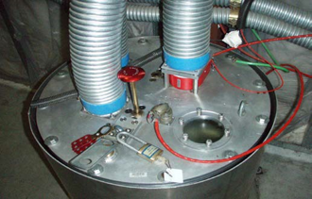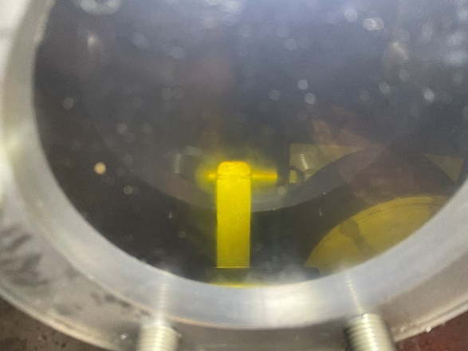
WIPER
GROUND
Figure 6: Termination tank
`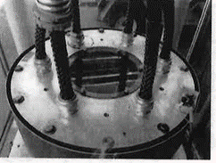
KLYSTRON RTN
KLYSTRON HV
SPEAR2 RTN
SPEAR2 HV
SPEAR1 HV
SPEAR1 RTN
Figure 7: Switch tank for SPEAR1 and SPEAR2
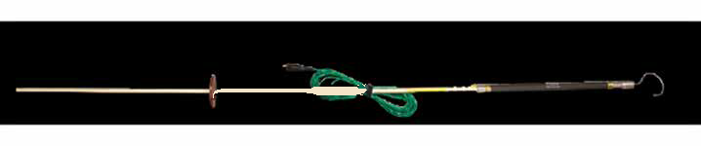
Figure 8: Phenix Technologies DS100-2 discharge stick, rated for 100 kV, 40 kJ.

Reconfigure Inactive HVPS to be the Active HVPS
There are four parts of the reconfiguration of the system to change the roles of the active and inactive HVPS. One part involves the reconfiguration of four HVPS output cables, two from each HVPS. The second part involves a swap of the water flow interlock switch from one HVPS to the other. The third is the reconfiguration of control, status, and monitoring cables from the two HVPS controllers. The fourth part turns on the cooling fans for the newly active supply and turns off those for the newly inactive supply.
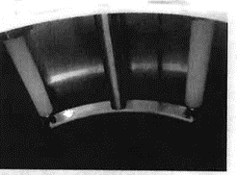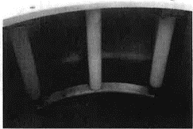
CABLE
CABLE
G10 STANDOFF
ALUMINUM STANDOFF
CABLE
CABLE
Figure 9: Bus bar connections in the switch tank. The left photograph shows the shorting of outputs of the inactive HVPS. The right photograph shows a typical connection to the klystron.

Reconfigure HVPS Outputs to Connect to the Klystron

Remove Dielectric Oil
______ Pump out the dielectric oil from the switch tank to a temporary storage container.

Reconfigure the Connections in the Switch Tank
______ Remove the shorting bus bar with the multi-lam inserts from the leads of the inactive HVPS.
______ Remove the connecting bus bars with the multi-lam inserts from the active HVPS to the klystron cables.
______ Using the shorting bus bar, connect the leads of the previously active HVPS together and mechanically fasten the bus bar to the top of the switch tank with the screws and the conductive aluminum standoff. The finished connection in the switch tank, with the oil removed, is shown on the left side of Figure 9.
______ Using the connecting bus bars, connect the high voltage and return leads of the previously inactive HVPS to the high voltage and return leads of the klystron cables, respectively. Secure the connecting bus bars, with the cables attached, to the top of the switch tank using screws and the non-conductive G10 standoffs. The finished connection in the switch tank, with the oil removed, of one of these pairs of conductors is shown on the right side of Figure 9.

Return Switch Tank to Operational Status
______ Pump the dielectric oil from the temporary storage container back into the switch tank.
______ Replace the plastic cover on the switch tank and secure the enclosure doors with the OPS administrative lock.

Reconfigure the Water Flow Interlock
______ In the electrical enclosure on the north wall of B514, using an appropriate ladder, remove the cover from the 125 VDC junction box, shown on the left hand side of Figure 10, and perform a ZVV on the cables from both supplies that connect to the water over-pressure interlock switch.
______ Remove the DC water over-pressure interlock connection, shown on the right hand side of Figure 10, from the previously active supply and connect it to the newly active supply.
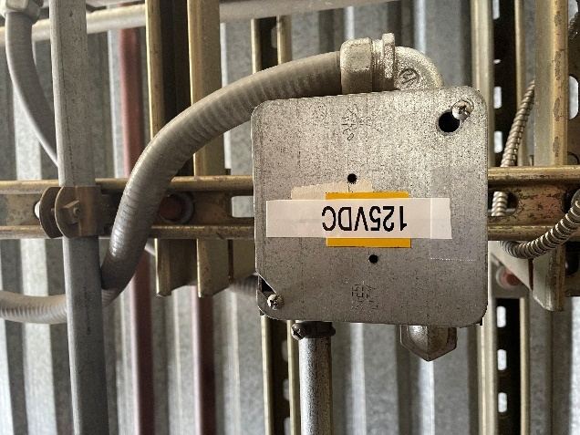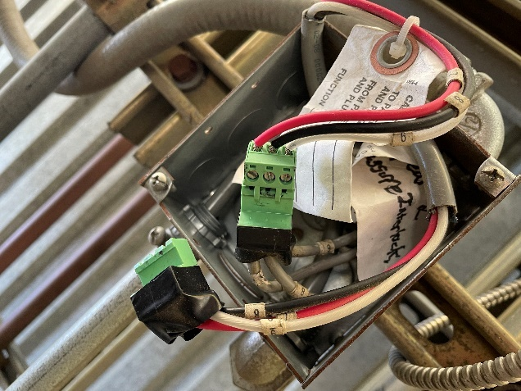
Figure 10: Junction box for 125 VDC control connection (left). Touch safe connectors inside of the junction box (right).

Reconfigure Control Cables from the HVPS Controller to B132
______ In B118, using an appropriate ladder, remove the cover of the electrical enclosure above the SPEAR1 HVPS controller enclosure (refer to the blue arrow on the left side of Figure 11), and change the connections from the previously active supply to the newly active supply for:
______ Six each touch-safe terminal block connectors containing control and monitor signals (refer to the blue arrow on the right side of Figure 11).
______ Three free standing fiber optic cables for fast permits and statuses (refer to the orange arrow on the right side of Figure 11)
Power Supply ready status from HVPS controller to LLRF interface,
SCR enable control from LLRF interface chassis to HVPS controller,
Klystron crowbar trigger from LLRF interface chassis to HVPS controller,
______ A BNC cable for transmission of a potential klystron arc signal (refer to the orange arrow on the right side of Figure 11).
______ Replace and secure the cover of the electrical enclosure.
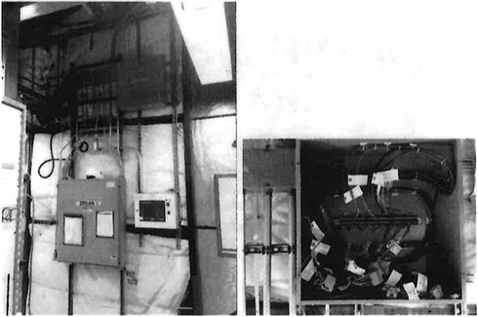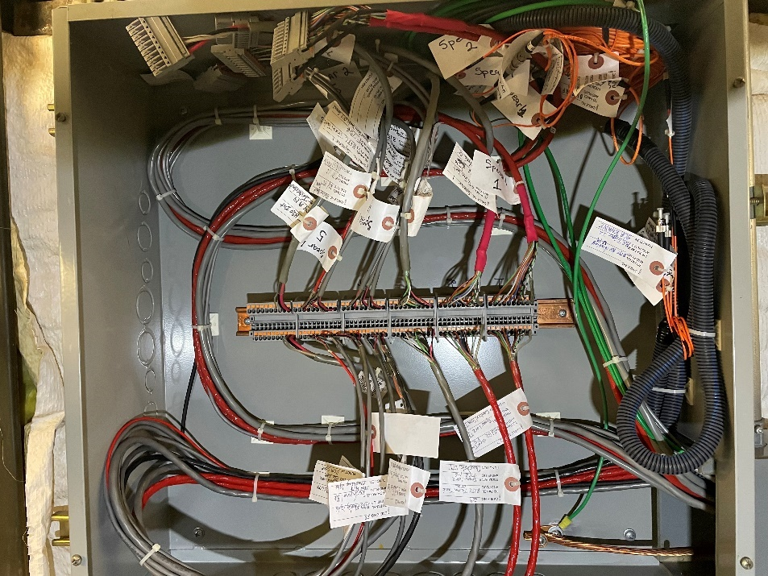
1 2 3 4 5 6
Figure 11: Low power control interface enclosure location (left) and details inside the enclosure (right).

Energize Appropriate Cooling Fans for the HVPS
Figure 12 shows panel 514 HVPS2, located on the west side of B514, with the panel door open. At the time that the photograph was taken, SPEAR1 was the active HVPS, so CB 8-10 were closed and CB 7-9 were open.
If SPEAR1 is the newly active HVPS
______ In panel B514 HVPS2, close CB 8-10 to energize fans for SPEAR1.
______ In panel B514 HVPS2, open CB 7-9 to de-energize fans for SPEAR2.
If SPEAR2 is the newly active HVPS
______ In panel B514 HVPS2, close CB 7-9 to energize fans for SPEAR2.
______ In panel B514 HVPS2, open CB 8-10 to de-energize fans for SPEAR1.
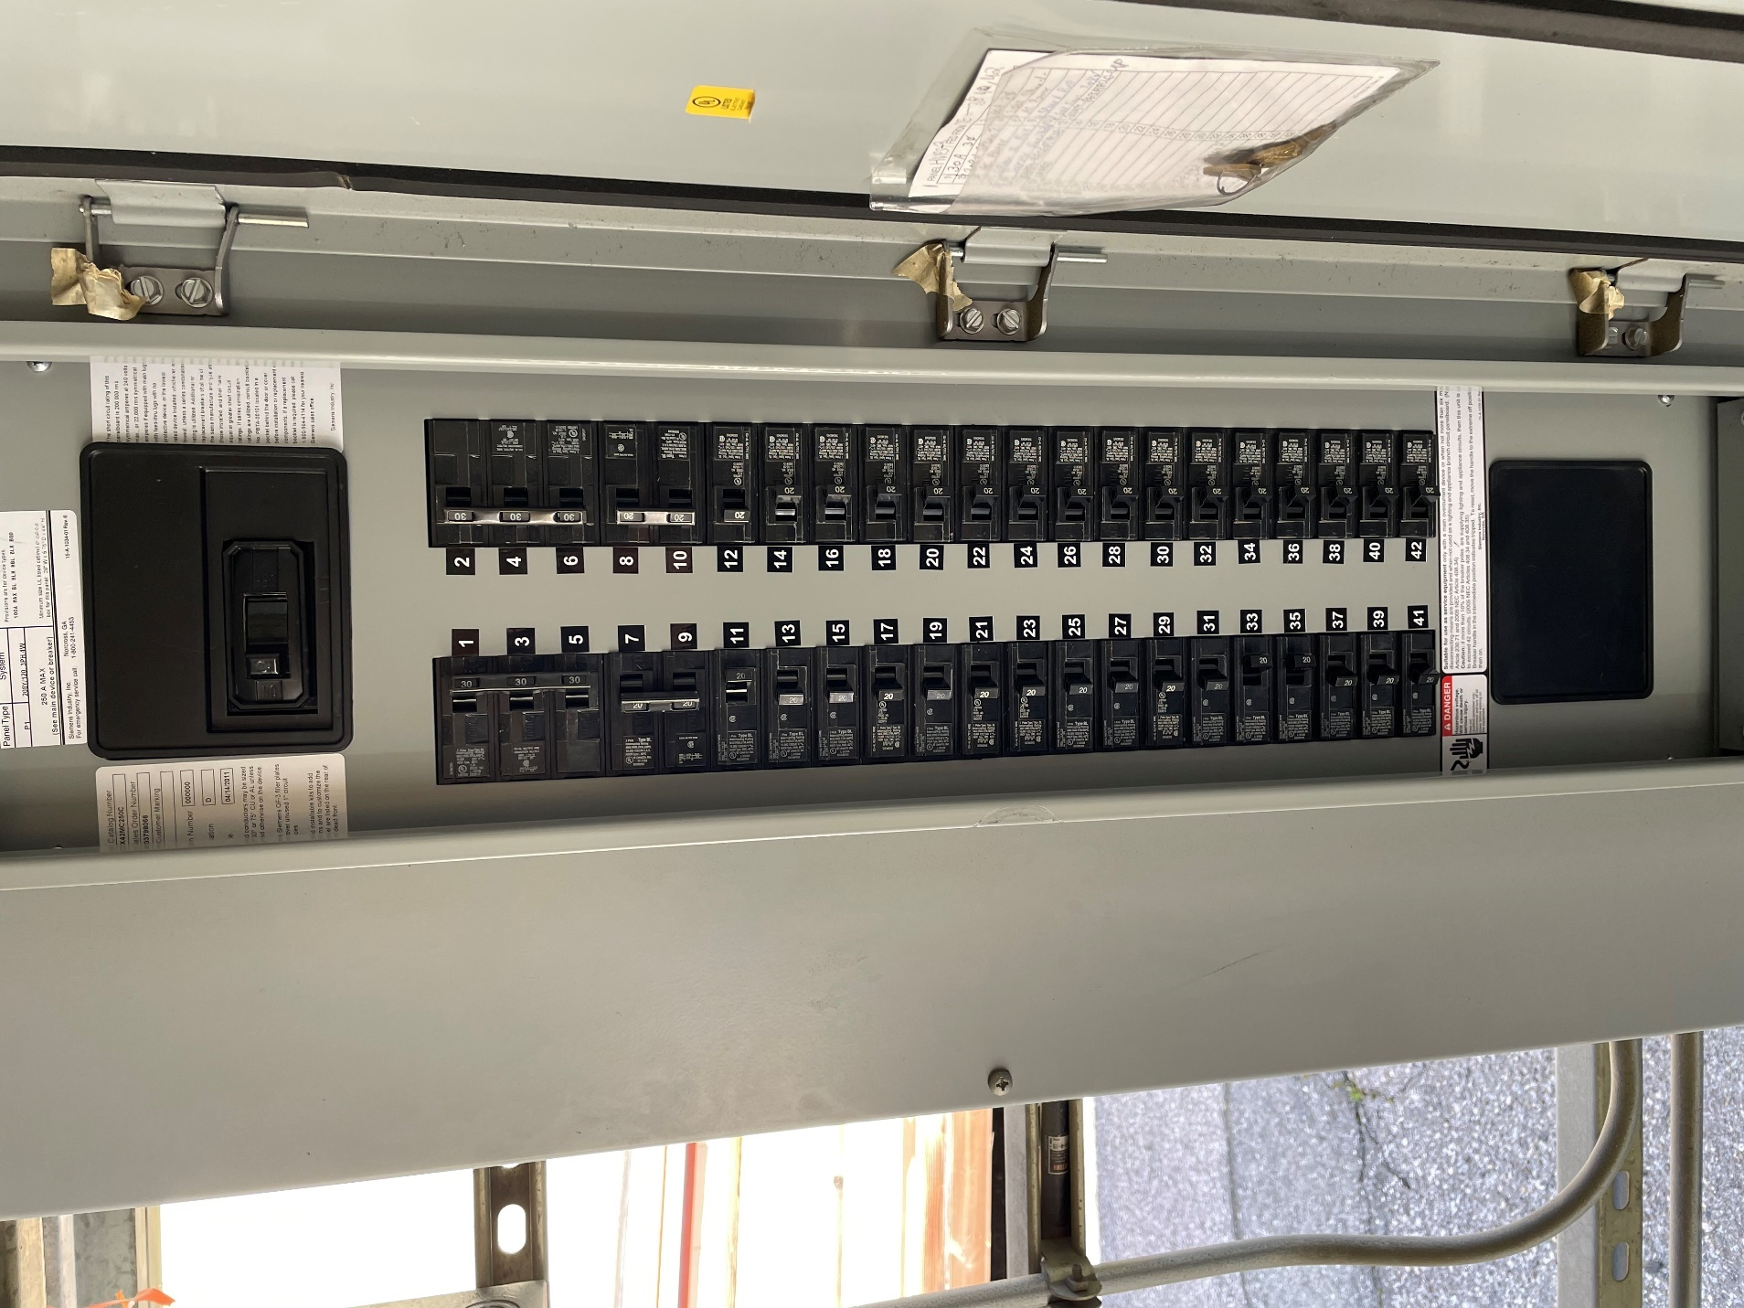
SPEAR2 COOLING FAN CB
SPEAR1 COOLING FAN CB
Figure 12: 208 VAC breaker panel that contains the breakers for the power for SPEAR1 and SPEAR2 external cooling fans.

End of Personal Lockout
______ Remove your personal LOTO red lock from the group lockout box for SR-444-636-02-R1.
______ Sign out of the Complex Lockout Permit for SR-444-636-02-R1.

Prepare RF System for Operation

Remove RF Group Configuration Locks from Newly Active HVPS and Apply to Newly Inactive HVPS

Remove RF Group Configuration Locks from Newly Active (Previously Inactive) HVPS
______ Remove RF Group configuration lock from HVPS open disconnect switch in B514 (ref Figure 2).
______ Remove RF Group configuration lock from 208 VAC switchgear control power open disconnect switch in B514 (ref Figure 3).
______ Remove RF Group configuration lock from 120 VAC HVPS controller control power open circuit breaker in B117 (ref Figure 4).

Place RF Group Configuration Locks on Newly Inactive (Previously Active) HVPS
______ Place RF Group configuration lock on HVPS open disconnect switch in B514.
______ Place RF Group configuration lock on 208 VAC switchgear control power open disconnect switch in B514.
______ Place RF Group configuration lock on 120 VAC HVPS controller control power open circuit breaker in B117.

Remove RF HVPS Energy Isolation
______ After all locks have been removed from the group lockout box, have the lead authorized worker of the SPEAR3 RF HVPS Energy Isolation Plan, SR-444-636-02-R2 end the group lockout by executing SPEAR3 Removal of RF HVPS Energy Isolation, SR-444-636-05-R1.

Energize Low Power Controls
______ Close active HVPS 208 VAC control power disconnect switch in B514 by raising the switch handle.
______ Open the 125 VDC switch enclosure in B514 (Figure 10), close the 125 VDC control power breaker for the active HVPS, and then close the switch enclosure door.
______ Close the circuit breaker for the active HVPS controller 120 VAC control power in the LPB panel in B117 (Figure 4).
______ Lift the mechanical shorting plunger in B132 to the full open position (Figure 6).

Notifications
______ Notify Facilities electricans that the newly active supply is ready to have its 12.47 kVAC energized.
______ After the 12.47 kVAC has been energized, notify SPEAR Operations that the HVPSs have been switched and the RF system is ready for testing.

Commissioning
______ Coordinate with SPEAR PPS Group to certify PPS inhibits on the newly active supply.
______ Notify SPEAR Operations when the new configuration has passed PPS certification.
______ Wait for release from SPEAR Operations after the RSWCF has been closed.
______ Close CATER to say that work is complete.
______ Begin Appropriate HVPS Testing.

