SPEAR3 Removal of RF HVPS Energy Isolation
SR-444-636-05-R1
Table of Contents
2 Revision History 2
2.1 R1 October 19, 2023 2
3 Table of Figures 2
4 Author/Approvers/Validators 2
4.1 Author 2
4.2 Reviewers 2
4.3 Management Approval 3
4.4 Validator 3
5 Procedure Purpose 3
6 Equipment Required to Execute Procedure 3
7 Equipment Description 4
8 Potential Hazards 5
8.1 Electrical Sources 5
8.1.1 Three Phase $12.47$ kV RMS Input Voltage 5
8.1.2 Thyristor Firing Pulses 5
8.1.3 Switch-over Tank 6
8.1.4 AC Control Power for Termination Tank HV Relay 7
8.1.5 AC Control Power for the Switchgear Controller 7
8.1.6 DC Control Power for the Switchgear Controller 7
8.2 Stored Electrical Energy 8
8.3 High Voltage Oil 8
8.4 Elevated Work Platform 9
9 Removal of SPEAR3 RF HVPS Energy Isolation Plan 9
9.1 Verify all work on the HVPS has been completed and system is secure 9
9.1.1 HVPSs (B514) 9
9.1.2 Switch-Over Tank (B514) 9
9.1.3 125 VDC Junction Box (B514) 10
9.1.4 Hoffman Box HVPS Controllers (B118) 10
9.1.5 Low Power Control Interface Enclosure (B118) 10
9.1.6 Termination Tank (B132) 10
9.1.7 Klystron (B132) 10
9.2 Verify All Locks are off of Group Lockout Box 10
9.3 Invalidate Complex Lockout 10
9.4 Remove Eight (8) Red Operations Lockout Locks 10

Revision History

R1 October 19, 2023
Original version.

Table of Figures
Figure 1: Schematic diagram of SPEAR HVPS 5
Figure 2: Switch-over tank for SPEAR1 and SPEAR2. 6
Figure 3: SPEAR1 switchgear door with viewing window in B514. 11
Figure 4: HVPS 208 VAC control power disconnect switches in B514 12
Figure 5: B117 LBP breaker panel for HVPS controller 120 VAC control power. 13
Figure 6: 125 VDC control power enclosure and circuit breakers in B514. 13
Figure 7: Termination tank in B132-101. 14

Author/Approvers/Validators

Author
_______________________________________ ____________________
SSRL Technical Expert: Jim Sebek Date

Reviewers
_______________________________________ ____________________
EED-OPS Technical Expert: Marc Larrus Date
_______________________________________ ____________________
Independent Reviewer: Ben Morris Date

Management Approval
_______________________________________ ____________________
EED-OPS Deputy Department Head: Tony Beukers Date

Validator
I have implemented this procedure in its entirety and have found it to be clear, complete, and accurate.
_______________________________________ ____________________
Technical Validator: Jim Sebek Date

Procedure Purpose
The purpose of this document is to remove the red locks placed on various energy sources during the SPEAR3 RF HVPS Energy Isolation Plan, SR-444-636-02, (EIP) for working on either of the SPEAR High Voltage Power Supplies (HVPSs), either SPEAR1 or SPEAR2. At the end of this procedure, any electrical isolation will only be administrative; there will be no worker safety guaranteed. Either of the two HVPSs may then be energized as the operational HVPS for the SPEAR3 RF system.
Note that there are often administrative locks placed on certain disconnect switches controlling power to the HVPSs. These locks may be placed by either the RF group and/or the Accelerator Division Safety Officer (ADSO) to control when supplies cannot be turned on for reasons not related to electrical safety. This procedure does not address any of these administrative locks.
It is intended that the lead authorized worker (LAW) who performed the SR-444-636-02 EIP will execute this procedure. If, for some reason, the LAW is unavailable, the management of the LAW can remove the personal red lock of the LAW from the group lockout box, as following established procedures prescribed by SLAC policy, and instruct another qualified person to implement this procedure.
This procedure only covers the removal of the EIP for the HVPSs. It does not cover any work performed on the HVPS. Other maintenance procedures are required to cover that work.

Equipment Required to Execute Procedure
The following equipment is required to execute this procedure:
- Key to the red personal Lockout Lock belonging to the LAW.
- Group Lockout Box containing the key to the eight (8) each identically keyed red locks dedicated to the execution of the EIP and referred to in this procedure as “Operations Lockout Locks”.

Equipment Description
The equipment covered by this procedure are the SPEAR3 HVPSs SPEAR1 and SPEAR2, both located in building 514. (Henceforth we will refer to the storage ring as SPEAR so that the only numbered versions of SPEAR in this document will refer to HVPSs.) Each HVPS has its own associated switchgear, which includes a disconnect switch, fuses, protective relays, and a vacuum contactor. The purpose of each HVPS is to supply DC power to the SPEAR klystron which, in turn, provides radiofrequency (RF) power to the SPEAR cavities which accelerate the SPEAR electron beam. The maximum output rating of each HVPS is $-90$ kVDC at $27$ A, or $2.5$ MW. A schematic diagram of the HVPS is shown in Figure 1.
SPEAR has only one klystron, so only one of the HVPSs can ever be used at a time. The other is staged as a “warm spare”. SPEAR1 and SPEAR2 share a common three phase $12.47$ kV RMS feed that comes from breaker 160 in substation 507. The HVPSs are administratively controlled so that, at most, only one HVPS can be energized at a time. Each has its own separate controller, but they share the input $12.47$ kV RMS feed, HV output cables to the klystron, and connections to the low-level radio frequency (LLRF) system.
There is an aluminum oil-filled switch tank located next to B514 that connects the appropriate HVPS to the klystron. The aluminum tank is electrically grounded to earth at the tank location and the tank is filled with FR3 dielectric oil to increase the voltage withstand between the exposed conductors and the grounded tank. The oil is rated to exceed the IEEE C57.147 standard that specifies a breakdown of greater than 130 kV for distances of one inch (25.4 mm). The two output cables, high voltage and return, of both HVPSs are terminated in the tank. The high voltage cable of the active HVPS is connected to the high voltage cable that connects to the termination tank next to the klystron. Similarly, the return cable of the active HVPS is connected to the return cable that connects to the termination tank. The high voltage and return cables of the warm spare are always shorted together and shorted to ground in one of two configurations. Either they are connected to a shorting bar inside of the switch tank or they are shorted together and to ground outside of the switch tank. In the latter case, a worker on the warm spare can visually see an air gap between the cables and any cables connected either to the other supply or the klystron.
The termination tank, located next to the klystron, is of similar construction to the switch tank, in that it is made from aluminum and electrically grounded to earth at the tank. It also uses a high voltage dielectric oil but, for historical reasons, this oil is conventional mineral oil and not a natural ester like FR3.
The HVPS that functions as the warm spare is administratively locked off. Its input $12.47$ kV RMS switchgear disconnect switch is locked in the open position, its three input $200$ A, 50E medium voltage fuses are removed, and the load side of the vacuum contactors, the line side of the HVPS, is grounded. A low voltage disconnect switch is opened to interrupt the $208$ VAC control power to the switchgear, and the breaker for the $120$ VAC power to the HVPS controller is opened. Administrative locks from the RF group are placed on these two disconnect switches and the breaker to ensure that power is not inadvertently re-introduced into the spare.
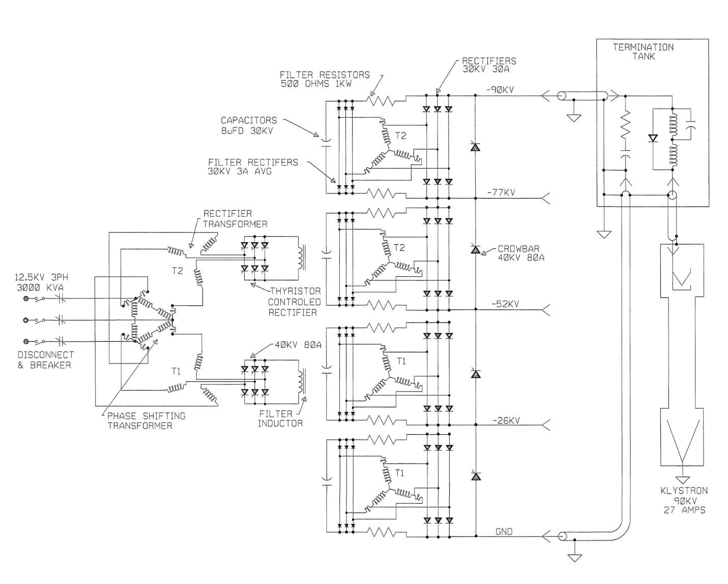
Figure 1: Schematic diagram of SPEAR HVPS

Potential Hazards

Electrical Sources

Three Phase $12.47$ kV RMS Input Voltage
The HVPS power is supplied by the $12.47$ kV RMS premises power. Removing the premises power removes this hazard and prevents the HVPS from generating continuous output power. The medium voltage disconnect switch and the vacuum contactor are shown on the left side of Figure 1.

Thyristor Firing Pulses
The HVPS power is controlled by the appropriate firing of thyristors. The firing pulses, generated by the HVPS controller, are in short bursts, but their amplitude may be as large as $200$ V. These pulses are fully contained within the HVPS. They pose no electrical hazard to anyone outside of the closed HVPS. Removing a single phase $120$ VAC control power to the HVPS controller by opening a breaker removes this hazard. The two breakers enabling the control power to the two controllers are shown in Figure 5.

Switch-over Tank
The switch-over tank is the oil-filled mechanical structure that is used to select which HVPS is connected to the klystron load. This selection is made by connecting the two cables from the -90 kV output bus of the active supply to the cables that connect to the klystron after passing through the termination tank. The output cables of the inactive supply are mechanically connected together, and therefore electrically shorted to each other and then to ground, either inside of the switch-over tank or external to this tank.
No access to nor manipulation of cables in the switch-over tank is required for this EIP. Since it is a part of the HVPS to klystron configuration, we include this description and photograph for completeness.
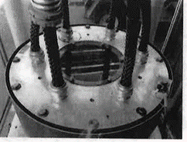
SPEAR1 HV
SPEAR1 RTN
SPEAR2 RTN
KLYSTRON RTN
KLYSTRON HV
SPEAR2 HV
Figure 2: Switch-over tank for SPEAR1 and SPEAR2.

AC Control Power for Termination Tank HV Relay
The termination tank has a high voltage (Ross Engineering) relay that needs to be energized with $120$ VAC when the HVPS is active. During the transition from making one HVPS inactive and the other one active, the source of the $120$ VAC control power is switched from one HVPS controller to the other. The connectors that carry this control power and that are required to be handled during the switch between HVPSs are touch safe. Removing the control power from both HVPS controllers removes this power during the switchover procedure. The breakers enabling the control power are shown in Figure 5.
The control power for the termination tank HV relay never enters the HVPS, itself, so this is not a hazard to working on or inside of the HVPS. This paragraph is only included in this document to show that any potential hazard it may produce has not been ignored.

AC Control Power for the Switchgear Controller
The switchgear, immediately upstream of and connected to the HVPS, has its own controller to operate its HV contactor. When its 120 VAC control power is removed from the switchgear, the 12.47 kVAC vacuum contactor cannot be closed. In addition to controlling the contactor, this control power also powers a service lamp in the switchgear and an oil pump in the HVPS main tank. This power is entirely contained within the HVPS. Opening a disconnect switch, shown in Figure 4, removes this power from the HVPS. The only potential hazard this poses to anyone working on the HVPS itself is if the oil pump within the HVPS main tank needs to be serviced.

DC Control Power for the Switchgear Controller
$125$ VDC is used for DC control power in the switchgear. This power is sourced from a supply within substation 507. We distribute that power to SPEAR1 and SPEAR2 through a local breaker panel in B514, shown in Figure 6. Opening this breaker removes that power from the switchgear and associated interlocks.
The 125 VDC control power serves several functions. First, it supplies the control power to the MX relay coil. Activating the MX relay coil is necessary to remotely close, and keep closed, the 12.47 kVAC contactor in the HVPS switchgear. Second the 125 VDC is used to provide power to the four each ABB MCO protective relays and the three each phase current meters. Finally, the 125 VDC provides the power for the 86L lockout relay and its associated circuitry. The inputs to the lockout relay are the normally open relay contacts from the trip circuits of the MCOs as well as the normally open HVPS machine protection system signals from tank over-pressure, oil over-temperature, and low flow of the HVPS low conductivity water (LCW). If any of these contacts close, the 125 VDC control power energizes the lockout relay coil. When energized, the relay opens a normally closed contact that removes the power from the MX relay coil, opening the contactor.
Both HVPSs share a common LCW flow interlock which is connected to the 125 VDC power. During the switch between HVPSs, a touch safe connector must be moved to connect the active HVPS. Removing the 125 VDC control power protects against potential damage to the control hardware.
The only potential hazard the 125 VDC control power may pose is to someone working in the HVPS main tank, near any of the HVPS MPS circuit elements that are powered by this voltage.

Stored Electrical Energy
There are three types of capacitive elements closely coupled to the HVPS output. The first is a series of four each $8 μF$ capacitors that connect to and extend across the output through pairs of $500 Ω$ resistors. The second is a single $0.22 μF$ capacitor directly across the output. The third is the approximately $60$ m of Mil-C-17/81-0001 (RG220) cable between the HVPS output and the klystron. The capacitance of this cable is about $6$ nF. The total stored energy in these three sets of capacitors, at full rated output voltage, is about $9$ kJ.
Under normal conditions, once the HVPS is turned off, the stored energy is dissipated into the klystron in a fraction of a second. If the measured output voltage of the HVPS is zero, there is no stored energy in these capacitors that can be accessed from outside of the HVPS. The HVPS output voltage is monitored by a redundant set of passive voltage dividers. The low voltage output of these dividers can be measured in the HVPS controller, and from these redundant measurements, one can calculate the output voltage of the supply. If, from these measurements, any potentially hazardous voltage is calculated to be on the HVPS output, one needs to discharge this voltage using properly rated high voltage resistive discharge sticks. Any voltage measurement directly on the HVPS output must be performed using properly rated high voltage probes. It is imperative that one does not enter the restricted approach boundary when measuring and/or discharging the unknown voltage on the conductors.
Inside of the termination tank shown in Figure 1 are two shorting mechanisms. When they are shorted together, they connect the center conductor of the -90 kV cable with the center conductor of the return cable. One mechanism is an electro-mechanical high voltage relay controlled by the HVPS controller and the other is a purely mechanical plunger. When either of these mechanisms short the cables, they provide a short across the output filter capacitors in the HVPS. (Note that these mechanisms are too detailed to be shown in the figure.)

High Voltage Oil
Tens of gallons of FR3 high voltage oil fills the switch-tank to provide electrical insulation. The switch-over from the active supply to the warm spare requires manipulation of the Mil-C-17/81-0001 cables in this tank. The oil is pumped out of the tank before the switch-over occurs and the tank is refilled after the switch-over. The pump assembly used in this step is bulky and the barrels that are used to temporarily store the oil are heavy when filled with the oil. Proper lifting techniques must be used, when required. Also, good housekeeping practices should be followed to minimize and clean up any oil spillage that could lead to slips and/or falls during this switch-over.
The HVPS contains 2600 gallons of the FR3 oil. Approximately 100 gallons is in each of the two small tanks, the phase tank and the crowbar tank, and the rest is in the main tank. Pumping out large fractions of the oil from the main tank requires setting up large temporary oil storage tanks in a temporary portable secondary oil containment berm adjacent to building 514. The secondary oil containment berm and storage tanks add potential slip and trip hazards to the work area. Care must be taken to follow safe work practices when working in this secondary oil containment berm.

Elevated Work Platform
Work to access the inside of any part of the HVPS requires access to the top of the HVPS. Both HVPSs are enclosed by permanent scaffolding that protects the worker from falling off of the HVPS when on top of it. The top of each HVPS has several trip hazards and the metallic surfaces may be slippery due to oil film on them. Care must be taken to follow safe work practices when on top of the HVPS.

Removal of SPEAR3 RF HVPS Energy Isolation Plan

Verify all work on the HVPS has been completed and system is secure
Inspect the areas around the HVPS, the HVPS controller, and the klystron termination tank to ensure that all equipment has been secured and the system appears to have been returned to a safe state that can be energized. If this is not the case, this procedure should be stopped and an appropriate subject matter expert (SME) for the HVPS should be called in to properly secure the HVPS system.

HVPSs (B514)
For each supply:
______ Ensure that the main tank covers are in place and bolted down.
______ Ensure that the two pressure relief valves, both slow and rapid, are bolted in place and their electrical connections have been made up.
______ Ensure that the dry nitrogen lines have been connected to the appropriate port on the main tank lid.
______ Ensure that the phase tank lid is in place and bolted down.
______ Ensure that the Synflex water cooling hoses are connected to the phase tank lid radiator.
______ Ensure that the crowbar tank lid is in place and bolted down.
______ Ensure that the Synflex water cooling hoses are connected to the crowbar tank lid radiator.
______ Ensure that the rear doors of the switchgear are closed and locked.

Switch-Over Tank (B514)
______ Ensure that the doors to the switch-over tank are closed and secured with a blue EED-OPS lock.
______ Ensure that either (check the appropriate line and enter N/A in the other line):
______ All six RG220 cables are securely installed in the switch-over tank or
______ Four of the six RG220 cables, the klystron high voltage cable, the klystron return cable, and the high voltage and return cable of the active supply, are securely installed in the switch-over tank. Ensure that the center conductors of the other two cables, the high voltage and return cable of the idle supply, are securely tied together and to the earth connection on the lid of the switch-over tank. Figure 2 shows the location of the cables in the switch-over tank. If you are unsure which supply will be active and which supply will be idle, do not proceed further with this procedure and contact an SME for assistance.

125 VDC Junction Box (B514)
______ Ensure that the cover on the junction box on the north wall containing the 125 VDC over-pressure interlock connections is closed.

Hoffman Box HVPS Controllers (B118)
______ Ensure that the doors to both Hoffman Box HVPS controllers are closed. (Monitoring BNC cables are allowed to pass through openings in the doors.)

Low Power Control Interface Enclosure (B118)
______ Ensure that the cover on the low power control interface enclosure located above and to the right of the HVPS1 Hoffman box controller is attached to the enclosure.

Termination Tank (B132)
______ Ensure that the HV termination tank next to the klystron is secure and that the HV cables into and out of the tank are securely connected to the tank.

Klystron (B132)
______ Ensure that the HV input to the klystron is securely connected.

Verify All Locks are off of Group Lockout Box
______ Verify that all locks have been removed from the group lockout box. If there are still locks on the lockout box contact the owners to have them remove their locks. Do not proceed further with this procedure if there are any locks remaining on the group lockout box.
______ Verify that all workers who signed onto the Complex Lockout Permit for the SPEAR3 RF HVPS Energy Isolation Plan SR-444-636-02 have signed off of this plan. Do not proceed further with this procedure if there are any missing signatures in the sign off column.

Invalidate Complex Lockout
______ The LAW shall remove the orange Group Master Lockout Tag from the group lockout box.
______ The LAW shall remove their personal lock from the group lockout box.

Remove Eight (8) Red Operations Lockout Locks
______ Remove one red operations lockout lock from the hasp controlling mechanical shorting plunger on the transition tank in B132-101.
______ Remove one red operations lockout lock from service enclosure in B514 that contains the breakers for the 125 VDC control power for the switchgear.
______ Remove one red operations lockout lock from the 208 VAC disconnect switch in B514 that provides control power for SPEAR1.
______ Remove one red operations lockout lock from the 208 VAC disconnect switch in B514 that provides control power for SPEAR2.
______ Remove one red operations lockout lock from the 12.47 kVAC disconnect switch in B514 that provides the mains power for SPEAR1.
______ Remove one red operations lockout lock from the 12.47 kVAC disconnect switch in B514 that provides the mains power for SPEAR2.
______ Remove one red operations lockout lock from Breaker 20 in B117 LBP breaker panel that provides control power to the SPEAR1 HVPS controller.
______ Remove one red operations lockout lock from Breaker 34 in B117 LBP breaker panel that provides control power to the SPEAR2 HVPS controller.
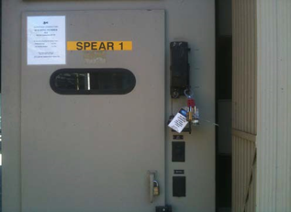
Figure 3: SPEAR1 switchgear door with viewing window in B514.

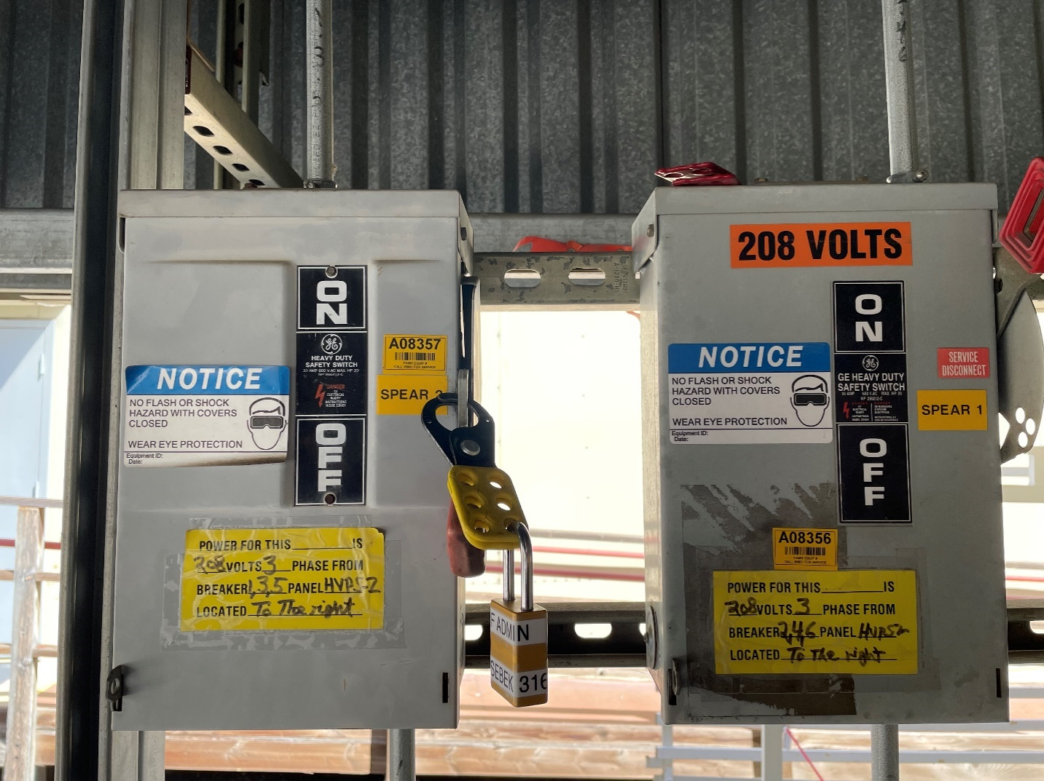
SPEAR1 208 VAC
SPEAR2 208 VAC
Figure 4: HVPS 208 VAC control power disconnect switches in B514
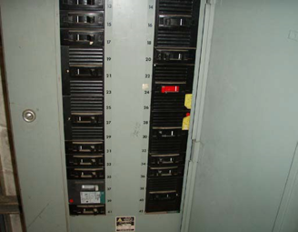
SPEAR2 120 VAC
SPEAR1 120 VAC
Figure 5: B117 LBP breaker panel for HVPS controller 120 VAC control power.

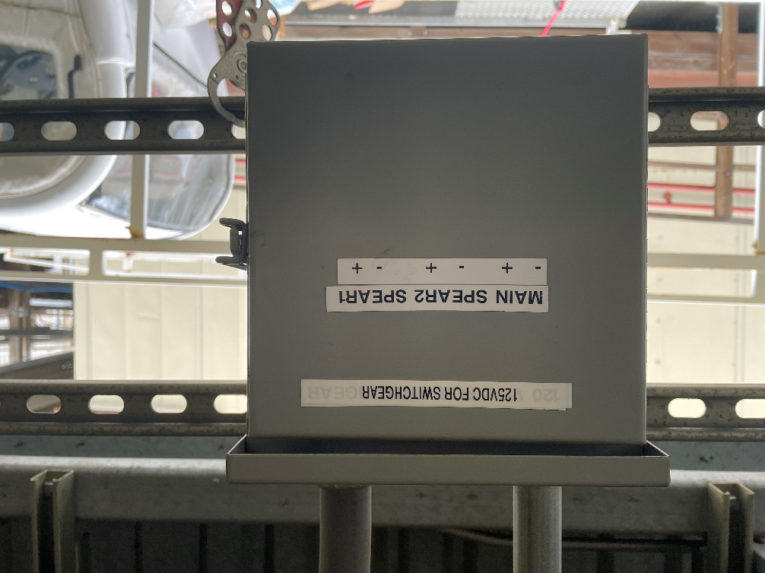
Figure 6: 125 VDC control power enclosure and circuit breakers in B514.

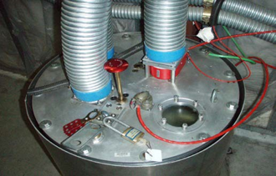
Figure 7: Termination tank in B132-101.

