Experiment-7
Fayaz Khan
E0124077
Code:
#include <iostream>
#include <vector>
#include <list>
using namespace std;
int main()
{
vector<int> v;
v.push_back(10);
v.push_back(20);
v.push_back(30);
cout << "Vector Elements: ";
for(int i = 0; i < v.size(); i++)
cout << v[i] << " ";
cout << endl;
list<int> l; // changed variable name from 1 to l
l.push_back(100);
l.push_back(200);
l.push_back(300);
cout << "List Elements: ";
for(auto it = l.begin(); it != l.end(); it++)
cout << *it << " ";
cout << endl;
return 0;}
output: 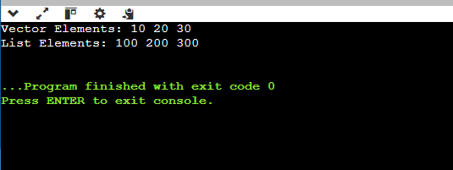
scenario 1:
#include <iostream>
#include <vector>
#include <algorithm>
int main() {
std::vector<int> marks = {45, 82, 33, 91, 56, 78, 49, 88};
std::sort(marks.begin(), marks.end(), std::greater<int>());

marks.erase(std::remove_if(marks.begin(), marks.end(), [](int m) {
return m < 50;
}), marks.end());

std::cout << "--- Final Rank List (Passing Students) ---" << std::endl;
if (marks.empty()) {
std::cout << "No students passed the exam." << std::endl;
} else {
for (size_t i = 0; i < marks.size(); ++i) {
std::cout << "Rank " << i + 1 << ": " << marks[i] << std::endl;
}
}

std::cout << "\n-----------------------------------------" << std::endl;
if (!marks.empty()) {
std::cout << "Topper Mark: " << marks[0] << std::endl;
}

return 0;
}
Output: 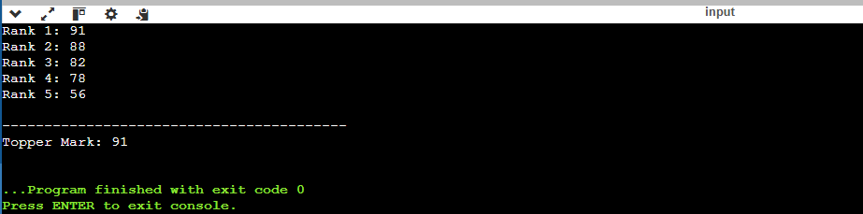
Scenario:2
#include <iostream>
#include <list>
#include <iterator>

using namespace std;

int main() {
list<int> passengerIDs;

passengerIDs.push_back(101);
passengerIDs.push_back(102);
passengerIDs.push_back(103);
passengerIDs.push_back(104);
passengerIDs.push_back(105);
passengerIDs.push_back(106);

auto it = next(passengerIDs.begin(), 2);
int vipID = 999;
passengerIDs.insert(it, vipID);

int cancelledID = 104;
passengerIDs.remove(cancelledID);

passengerIDs.reverse();

cout << "--- Final Passenger ID List (Reversed) ---" << endl;
for (int id : passengerIDs) {
cout << "ID: " << id << endl;
}

return 0;
}
Output: 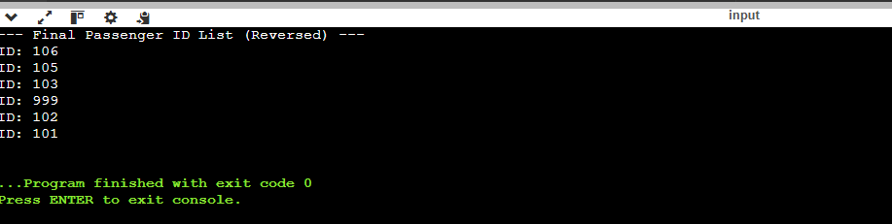
Scenario:3
#include <iostream>
#include <vector>
#include <algorithm> // For sort, unique, and remove_if
#include <numeric> // For accumulate

using namespace std;

int main() {
vector<double> cart;
int numItems;

cout << "Enter the number of products: ";
cin >> numItems;
cout << "Enter the prices: " << endl;
for (int i = 0; i < numItems; i++) {
double price;
cin >> price;
cart.push_back(price);
}

sort(cart.begin(), cart.end());
auto last = unique(cart.begin(), cart.end());
cart.erase(last, cart.end());

for (double &price : cart) {
price *= 0.90;
}

double total = accumulate(cart.begin(), cart.end(), 0.0);
cout << "\nTotal Payable Amount after discount: " << total << endl;

cart.erase(remove_if(cart.begin(), cart.end(), [](double p) {
return p < 100.0;
}), cart.end());

cout << "--- Final Cart (Items >= 100) ---" << endl;
for (double price : cart) {
cout << "Item Price: " << price << endl;
}

return 0;
}
Output:
