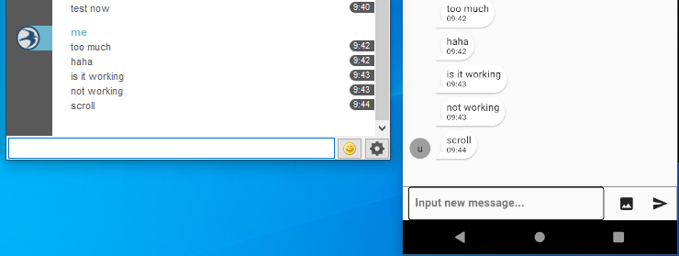
inputToolbarMargin
: top - 30

After received another message
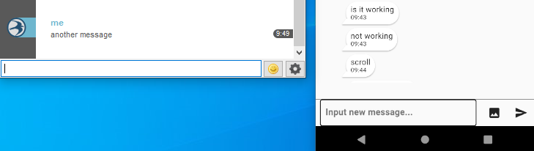
- There is no avatar. It means that new message is under margin

After manual scroll
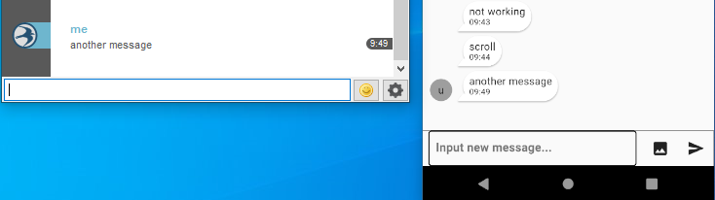
- I can see the new message

