Assignment: Exploratory analysis and presenting insights 2Market

Faye Grant

- Business context
- Analytical approach
- Dashboard design and development
- Patterns, trends, and insights
- Conclusion
- Appendices

- Business context
2Market is a global supermarket operating both online and in-store. The company aims to analyse customer purchase data to understand customer demographics, identify effective advertising channels and determine best-selling products by segment to improve marketing ROI.
A review of the data highlights limitations, including ambiguity around abbreviated titles and limited business context such as historical marketing investment, prior channel focus and stakeholder involvement. (See appendix A)
- Analytical approach
Data preparation involved cleaning and validating data by removing blanks, duplicates, standardising data and inconsistencies and correcting data formats.
Excel
Filtering, sorting, aggregation and utilising advanced excel functions allowed trends below to be identified.
- The relationship between age and marital status
Removed anomalies include “YOLO” and “Absurd” in the marital status field, due to non-alignment with standard demographic classifications. Customers living alone have the lowest average age (51) and widowed customers have the highest (65).

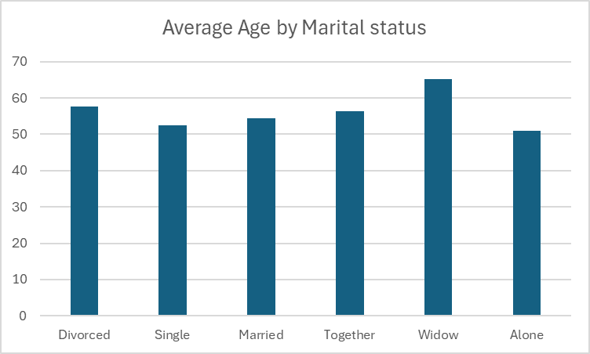

- The relationship between age and income
Using a pivot table and group function, appendix C was created. Anomalies removed included unrealistic ages and incomes. Despite minor variation in the 38-47 age group salary, the general trend is that income increases with age.

- More precise details about customers who earn between $90,000 and $100,000
It can be deduced that customers aged 53 years earn between $90,000 and $100,000.

SQL
Creating a 2market database on SQL and uploading the cleaned advertising and marketing data allowed for further, more advanced analysis to be done
The country with the highest total spend is Spain (SP) at $659,557. Review of product type data per country allows deeper insight to show, for example, that liquor is the biggest revenue generating product in Spain at $336,392, with vegetables the lowest revenue generating product at $28,288. Liquor is the most popular product, generating the highest revenue, in every country and in each category of marital status

- What is the total spending per country?
Appendix D shows the SQL aggregation query used to create the below table. COALESCE was used to prevent NULL values from breaking calculations and distorting figures. Total spend was found from summing up all categories.
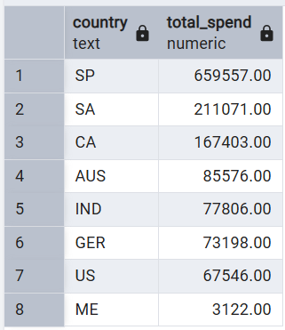

- What is the total spending per product per country?
Appendix E shows the SQL aggregation query used to create the below table. Product type names were elongated for ease of reading
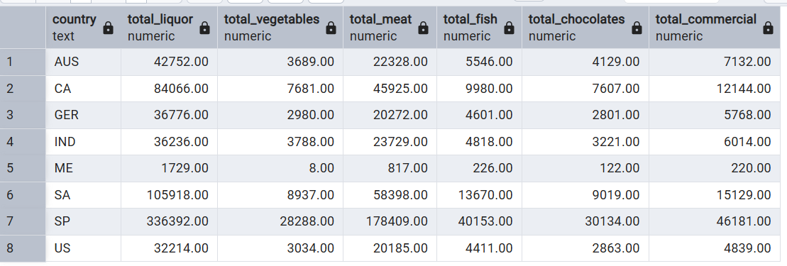

- Which products are the most popular in each country?
Appendix F shows the SQL aggregation query used to create the below table.
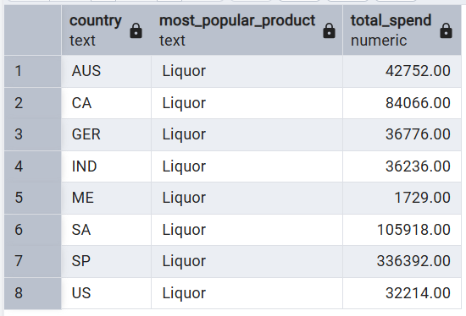

- Which products are the most popular based on marital status?
Appendix G shows the SQL aggregation query used to create the below table.

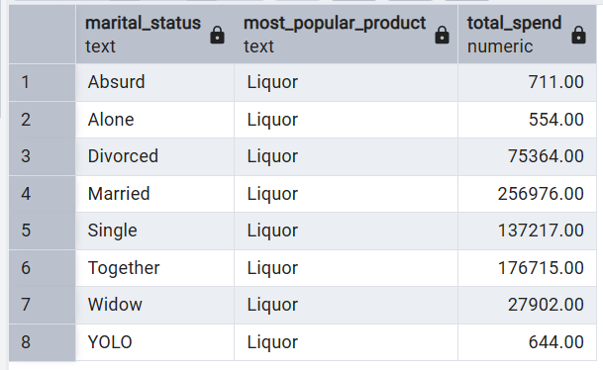
The SQL commands were developed to join the two tables and analyse the data as demonstrated in Appendix I and J. Using an inner join, due to matching values for customer ID which is used as the primary key, as broken down in Appendix H, it was deduced that :

- Most effective social media platform by country
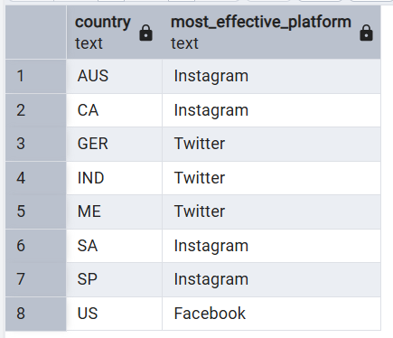
Assumptions made from the data : Twitter_ad, Instagram_ad, Facebook_ad indicate exposure (e.g. 1 = exposed, 0 = not). Count_success represents lead conversions as a measure of effectiveness
Instagram generated the highest conversion rate across the majority of countries, as shown in Appendix K.
- Most effective social media platform by marital status
The same logic was used to review marital status data as seen in Appendix L. Instagram again generates the highest conversion rate across the majority of marital status categories.

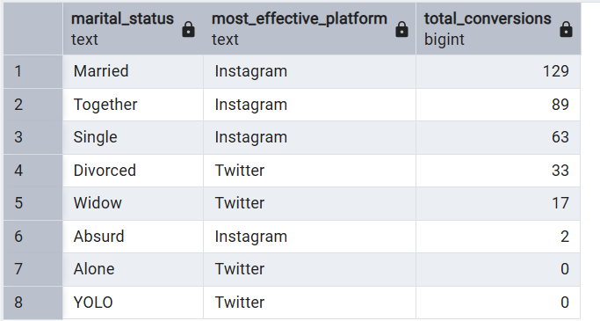

- More detailed breakdown assuming that purchases were in some way influenced by lead conversions from a campaign
For comparison, please see the table below which shows Country + total conversions for each social media platform using the SQL aggregation query in Appendix M, based on the assumption that purchases were in some way influenced by lead conversions from specific campaigns
Row 8 of the table shows total conversions for ease of comparison. Whilst Instagram conversion rate is the highest across the majority of countries, results across all platforms are similar, with Instagram having a 13% higher conversion rate than Facebook and 14% higher than Twitter.
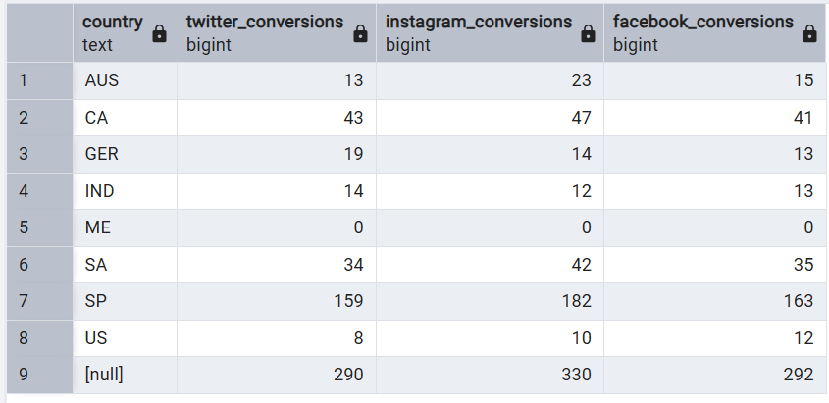
- Dashboard design and development
Marketing data and ad data was joined in Tableau to create the dashboard to show key metrics. Worksheets were created to show total sales, average customer age, spend by age, product popularity by age, spend by country and average revenue from each marketing channel. Total revenue was identified by using the create calculated field function to sum all product types. Channel specific revenue fields were created: eg IF [Twitter_ad] = 1 THEN [total revenue] END. The aggregation was changed to average for channel type, with changes to bar and marks values added for visual ease. Filters were then added for country, marital status and age bin. Filters allow for dashboard interactivity.
When creating the dashboard three key charts were used to create maximum impact and clarity. The charts detail total sales, spend by country and spend by marketing channel
From an accessibility perspective, clear labelling has been adopted by using longer titles for product types. Contrasting colours of blue and green but mainly grayscale and consistent formatting has been used to make the dashboard easily readable. Dropdown filters for country, age, and marital status allow users to drill down and explore specific segments for further analysis.

- Patterns, trends and insights
Patterns:
- Product sales: Liquor and meat respectively lead global sales, with meat only outperforming liquor among 25-year-olds.
- Age group revenue: Customers aged 50 years generate the highest total revenue.
- Geographic insights: Spain leads the revenue ranking, followed by Saudi Arabia (SA), Australia (AUS), and the US (US).
- Marketing channel performance: Instagram drives the highest average revenue across most age groups, but Facebook performs best for 50–55 age bracket.

Recommendations:
- Increase marketing efforts on Instagram for younger and mid-aged segments. Specific targeting of the 25 year old age group with meat products, with liquor campaigns targeted to all other age brackets.
- Focus Facebook campaigns at the 50–55 age group on liquor, the bestselling product for this demographic.
- Promote the highest revenue generating products - liquor and meat in Spain and Saudi Arabia. Also target countries generating lower relative revenue such as Germany (GER) to increase revenue and increase customer acquisition as well as retention. Liquor is the best revenue generator in all countries and efforts to market it ought to increase in all countries.
- Explore strategies to boost the revenue of lower-performing products like vegetables and chocolates. For example, combining offers on liquor (the highest performing product) with lower performing products.

Insights:
It would be valuable to explore current marketing spend by channel and demographic together with confirmation of product titles and the currency used for revenue tracking, to ensure valid comparability across countries.

- Conclusion:
Key trends highlight that the highest revenue by age is generated by 50-year-olds. Spain is the top-performing revenue generating country and Instagram is overall the most effective marketing channel. Harnessing and leveraging these insights can help 2Market optimize marketing strategies, enhance revenue, and better serve its customer base.

- Appendices

Appendix A - Business problem statement using a problem-solving framework 5 whys

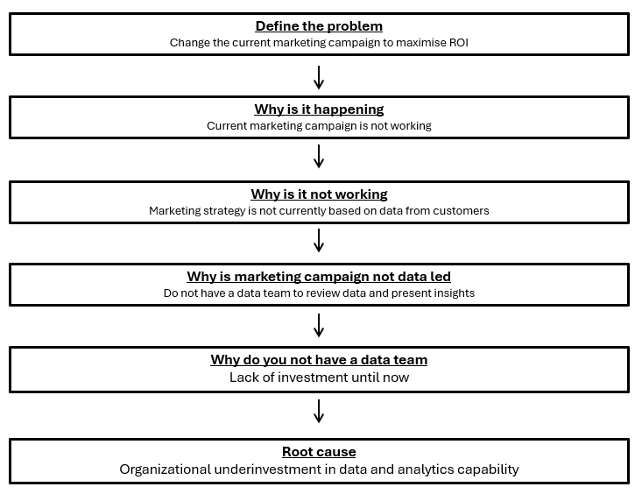
Appendix B – pivot to show the relationship between age and marital status
Marital status | Average Age
Divorced | 58
Single | 52
Married | 54
Together | 56
Widow | 65
Alone | 51

Appendix C – pivot table to show the relationship between age and income
Age | Average of Income
28-37 | $48,680
38-47 | $47,734
48-57 | $50,081
58-67 | $55,374
68-77 | $57,900
78-87 | $64,245
Grand Total | $52,247

Appendix D - SQL aggregation query used to show total spend per country
SELECT
"Country",
SUM(
COALESCE("AmtLiq", 0) +
COALESCE("AmtVege", 0) +
COALESCE("AmtNonVeg", 0) +
COALESCE("AmtPes", 0) +
COALESCE("AmtChocolates", 0) +
COALESCE("AmtComm", 0)
) AS Total_Spend
FROM "customer_data"
GROUP BY "Country"
ORDER BY Total_Spend DESC;

Appendix E - SQL aggregation query used to show total spend per country
2- total spend by product by country
SELECT
"Country",
SUM("AmtLiq") AS total_liquor,
SUM("AmtVege") AS total_vegetables,
SUM("AmtNonVeg") AS total_meat,
SUM("AmtPes") AS total_fish,
SUM("AmtChocolates") AS total_chocolates,
SUM("AmtComm") AS total_commercial,
FROM customer_data
GROUP BY "Country"
ORDER BY "Country";

Appendix F - SQL aggregation query used to show most popular products per country
SELECT
"Country",
SUM("AmtLiq") AS total_liquor,
SUM("AmtVege") AS total_vegetables,
SUM("AmtNonVeg") AS total_nonveg,
SUM("AmtPes") AS total_personal,
SUM("AmtChocolates") AS total_chocolates,
SUM("AmtComm") AS total_communication
FROM customer_data
GROUP BY "Country"
ORDER BY "Country";

WITH product_spend AS (
SELECT
"Country",
product,
SUM(amount) AS total_spend
FROM customer_data
CROSS JOIN LATERAL (
VALUES
('Liquor', "AmtLiq"),
('Vegetables', "AmtVege"),
('Non-Veg', "AmtNonVeg"),
('Personal', "AmtPes"),
('Chocolates', "AmtChocolates"),
('Communication', "AmtComm")
) AS p(product, amount)
GROUP BY "Country", product
),
ranked_products AS (
SELECT
"Country",
product,
total_spend,
RANK() OVER (
PARTITION BY "Country"
ORDER BY total_spend DESC
) AS rnk
FROM product_spend
)
SELECT
"Country",
product AS most_popular_product,
total_spend
FROM ranked_products
WHERE rnk = 1
ORDER BY "Country";

Appendix G - SQL aggregation query used to show most popular products by marital status
WITH product_spend AS (
SELECT
"Country",
product,
SUM(amount) AS total_spend
FROM customer_data
CROSS JOIN LATERAL (
VALUES
('Liquor', "AmtLiq"),
('Vegetables', "AmtVege"),
('Non-Veg', "AmtNonVeg"),
('Personal', "AmtPes"),
('Chocolates', "AmtChocolates"),
('Communication', "AmtComm")
) AS p(product, amount)
GROUP BY "Country", product
),
ranked_products AS (
SELECT
"Country",
product,
total_spend,
RANK() OVER (
PARTITION BY "Country"
ORDER BY total_spend DESC
) AS rnk
FROM product_spend
)
SELECT
"Country",
product AS most_popular_product,
total_spend
FROM ranked_products
WHERE rnk = 1
ORDER BY "Country";

WITH product_spend AS (
SELECT
"Marital_Status",
product,
SUM(amount) AS total_spend
FROM customer_data
CROSS JOIN LATERAL (
VALUES
('Liquor', "AmtLiq"),
('Vegetables', "AmtVege"),
('Non-Veg', "AmtNonVeg"),
('Personal', "AmtPes"),
('Chocolates', "AmtChocolates"),
('Communication', "AmtComm")
) AS p(product, amount)
GROUP BY "Marital_Status", product
),
ranked_products AS (
SELECT
"Marital_Status",
product,
total_spend,
RANK() OVER (
PARTITION BY "Marital_Status"
ORDER BY total_spend DESC
) AS rnk
FROM product_spend
)
SELECT
"Marital_Status",
product AS most_popular_product,
total_spend
FROM ranked_products
WHERE rnk = 1
ORDER BY "Marital_Status";

Appendix H - SQL aggregation query used to show inner join
SELECT *
FROM customer_data
INNER JOIN ad_data
ON id = id;

Appendix I - SQL aggregation query used to show inner join

SELECT *
FROM customer_data AS c
INNER JOIN ad_data AS a
ON c."ID" = a.id;

Appendix J - SQL aggregation query used to show table creation for inner join
CREATE TABLE customer_ads AS
SELECT *
FROM customer_data c
INNER JOIN ad_data a
ON c."ID" = a.id;

Appendix K - SQL aggregation query used to show most effective social media platform by Country

SELECT
c."Country",
CASE
WHEN SUM(c."Count_success" * c.twitter_ad) >= GREATEST(
SUM(c."Count_success" * c.twitter_ad),
SUM(c."Count_success" * c.instagram_ad),
SUM(c."Count_success" * c.facebook_ad)
) THEN 'Twitter'
WHEN SUM(c."Count_success" * c.instagram_ad) >= GREATEST(
SUM(c."Count_success" * c.twitter_ad),
SUM(c."Count_success" * c.instagram_ad),
SUM(c."Count_success" * c.facebook_ad)
) THEN 'Instagram'
ELSE 'Facebook'
END AS "Most_Effective_Platform"
FROM customer_ads AS c
GROUP BY c."Country"
ORDER BY c."Country";

Appendix L - SQL aggregation query used to show most effective social media platform by Marital status

WITH conversions AS (
SELECT
c."Marital_Status",
SUM(c."Count_success" * c.twitter_ad) AS Twitter_Conversions,
SUM(c."Count_success" * c.instagram_ad) AS Instagram_Conversions,
SUM(c."Count_success" * c.facebook_ad) AS Facebook_Conversions
FROM customer_ads AS c
GROUP BY c."Marital_Status"
)
SELECT
"Marital_Status",
CASE
WHEN Twitter_Conversions >= GREATEST(Twitter_Conversions, Instagram_Conversions, Facebook_Conversions) THEN 'Twitter'
WHEN Instagram_Conversions >= GREATEST(Twitter_Conversions, Instagram_Conversions, Facebook_Conversions) THEN 'Instagram'
ELSE 'Facebook'
END AS "Most_Effective_Platform",
GREATEST(Twitter_Conversions, Instagram_Conversions, Facebook_Conversions) AS "Total_Conversions"
FROM conversions
ORDER BY "Total_Conversions" DESC;

Appendix M - SQL aggregation query used to show Country + total conversions for each social media platform using breakdown in

SELECT
c."Country",
SUM(c."Count_success" * c.twitter_ad) AS Twitter_Conversions,
SUM(c."Count_success" * c.instagram_ad) AS Instagram_Conversions,
SUM(c."Count_success" * c.facebook_ad) AS Facebook_Conversions
FROM customer_ads AS c
GROUP BY ROLLUP(c."Country")
ORDER BY c."Country" NULLS LAST;

