Data Flow

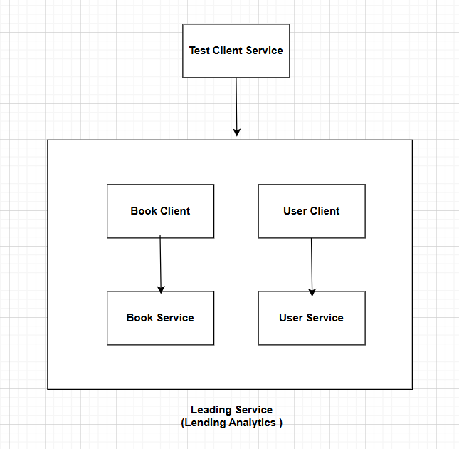

Flow Description
- TestClient calls LendingService via gRPC:
  - Requests most borrowed books, top users, reading pace, etc.
- LendingService acts as aggregator:
  - Calls BookService to fetch book titles and details (GetBookAsync)
  - Calls UserService to fetch top borrowers (GetTopBorrowingUsersAsync)
  - Computes analytics based on lending repository
- BookService provides book details:
  - GetBook by BookId
- UserService provides user details:
  - GetUserById and GetTopBorrowingUsers
- LendingService compiles results and sends response back to TestClient.
Steps to run the service to local server:

- Clone the Repository from blow URL to your local machine–
https://github.com/fayejitendra/Library
- Specify the connection string for Book, Lending and User service in appsetting.json file
"ConnectionStrings": {
"DefaultConnection": "your connection string"
},

Note- As migration script is already included in the solution so it will feed database with sample data.

- After this, build the service locally. It should build without any error.
- Set Solution setup to run all the services at once so functionality can be tested locally
- Run the service, Test client service will land you to swagger page with list of methods

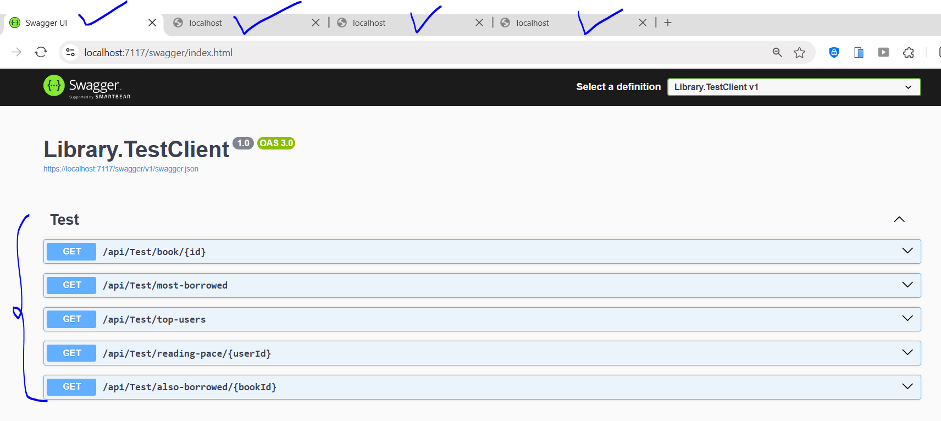

- Now, each method can be tested by passing the required inputs. Below is the sample output.

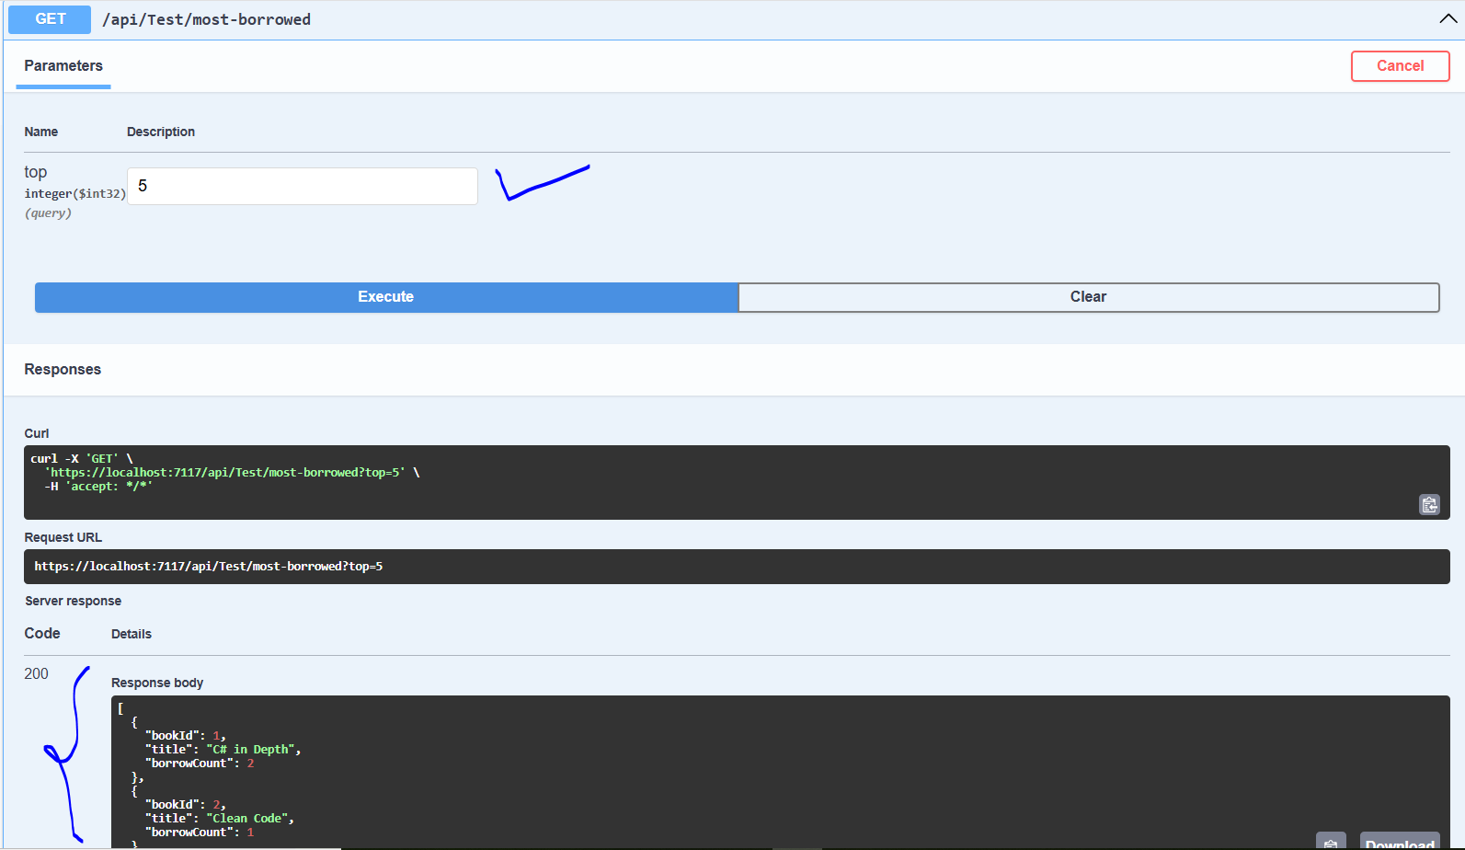

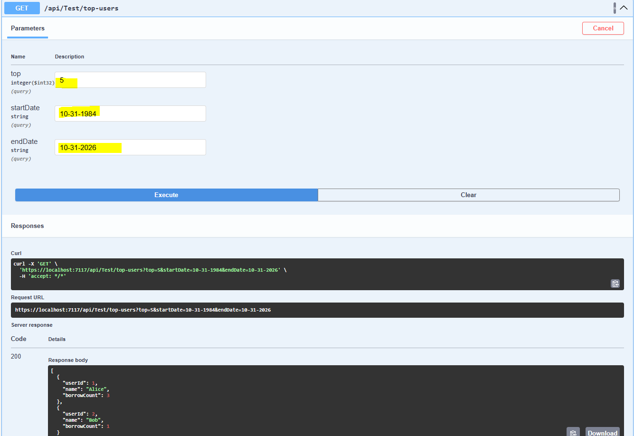
Thanks

