**Srep1: Static IP Configuration in Ubuntu**

* Go to System Settings
* Then Network Settings
* Select Wired and then click on Options

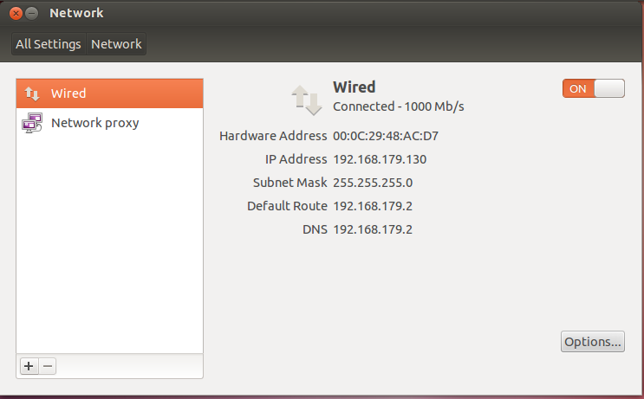

* Choose IPv4 Settings and initialize IP Address, Netmask, Gateway and DNS Server. Then click Save.

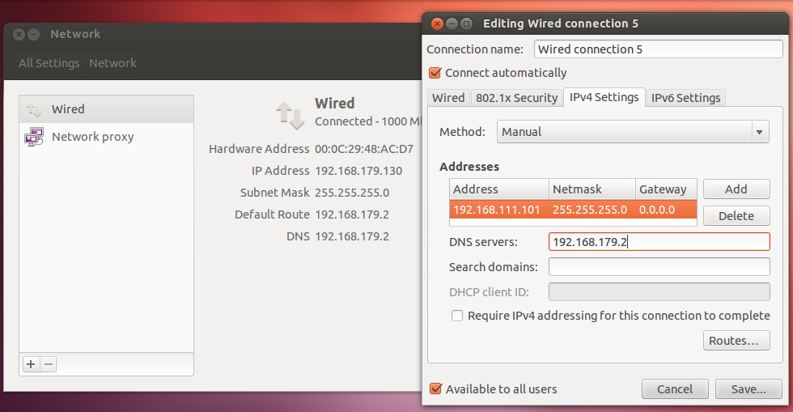

* Restart the machine
* Go to terminal and update hostname

vi /etc/hostname

* Then setup the hosts in the host file as below

Vi /etc/hosts

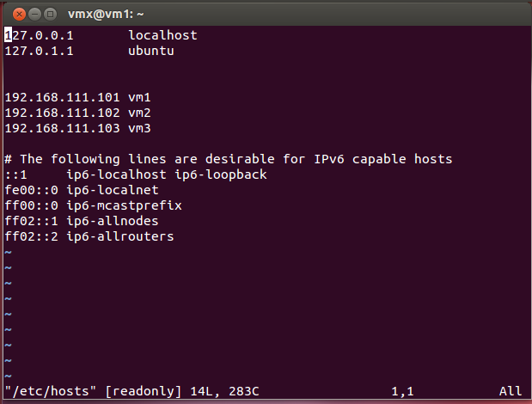

**Step 2: Setup Cassandra**

* Configure cassandra.yaml file

cd apache-cassandra-3.0.13/conf

vi cassandra.yaml

setup cluster_name: <it should be same across all nodes in the cluster>

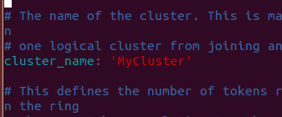

Setup seed_provider:

*you can add multiple seed nodes separated by coma

*first node can have its own address

*any new nodes added should use the IP of the previously added node

Node 1 & 2:

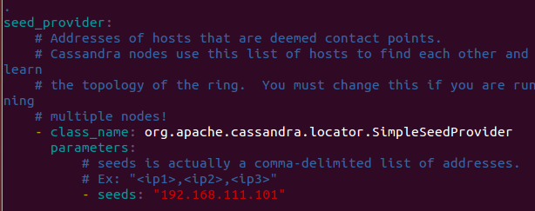

Node 3:

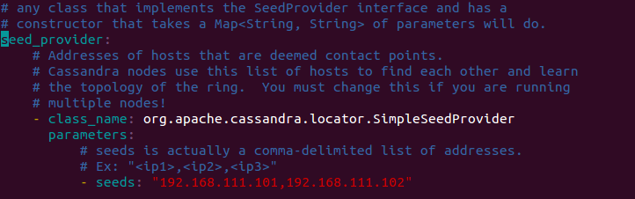

Setup listen_address:

*set to IP address of the current configuring node

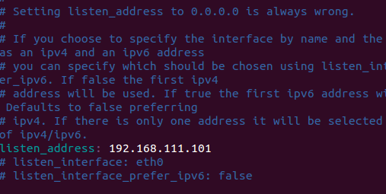

Setup rpc_address:

*set to IP address of the current configuring node

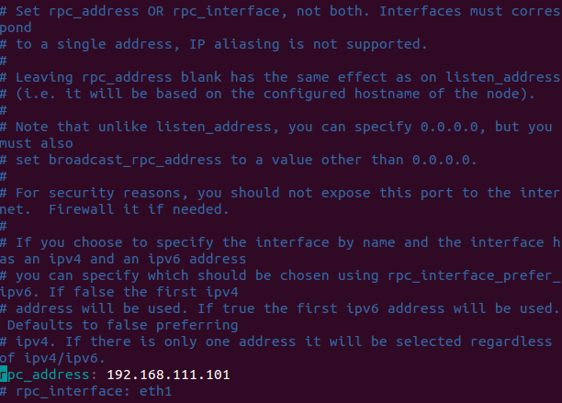

Setup endpoint_snitch:

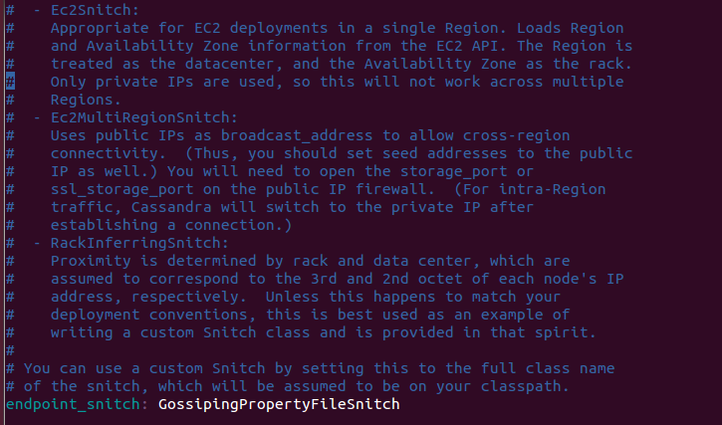

**Step 3: Setup Rackdc Properties**

vi cassandra-rackdc.properties

Node 1:

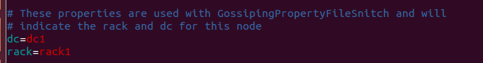

Node 2:

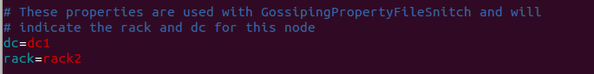

Node 3:

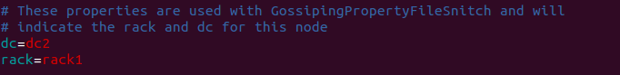

**Step 4: Clear Data Folder in Cassandra**

Move to the folder path:

cd ../data/

Remove all files in the data folder:

rm -rf *

**Step 5: Start Cassandra Cluster**

cd ../bin/

./cassandra

**Step 6: Check Cluster Status**

cd apache-cassandra-3.0.13/bin

./nodetool status

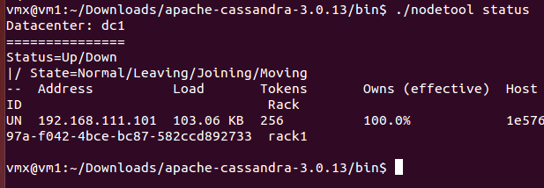

**Step 7: Add a New Node**

Repeat Step 1 to 6 for adding new nodes in to the cluster [keep different IP for each node]

***Watch Cluster Status***

watch -n2 ./nodetool status

**Node Decommission**

cd apache-cassandra-3.0.13/bin

./nodetool decommission

**Remove node from another node**

cd apache-cassandra-3.0.13/bin

nodetool removenode <Host ID>

nodetool removenode 126090cb-8f19-46a5-a1fd-0f2f2a2ce7b3