PORT:

Resource Server: 2222

Example 1.

* Access Resource From Resource Server

* This will give you error 401 UnAuthorized

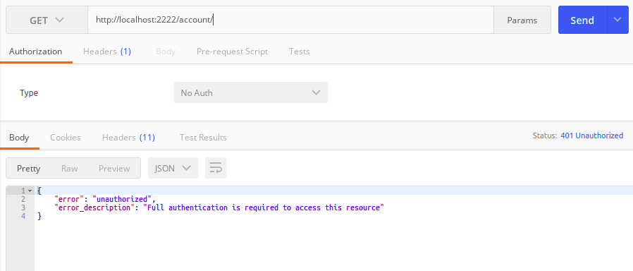

Example 2:

Grant-type-: Client Credentials:

Run Authorization Server : PORT : **8100**

** Important:   
Double check that, in this project there is no class file to configure authentication part. Which only needed in password and authorization-code grant type.

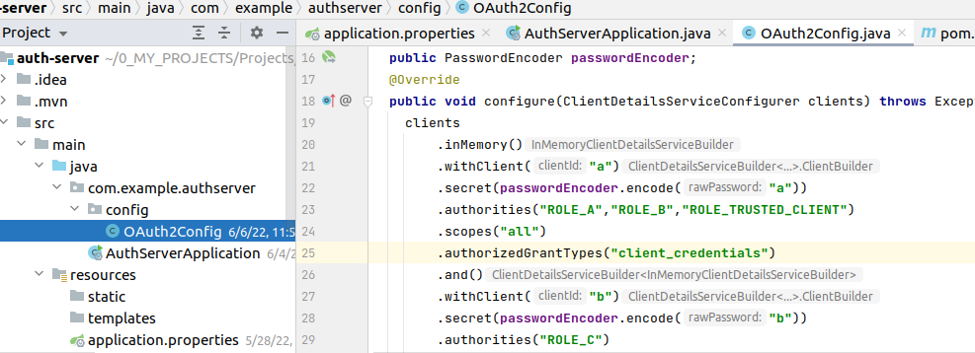

1. Run this server

2. access to this url: http://localhost:8100/oauth/token

3. Header add Authorization Basic Ytph

4. Ytph is the base64 encoded of password a which configured in Authorization server config.

5. Either you can send request like this

a. http://localhost:8080/oauth/token?grant_type=client_credentials

or

b.

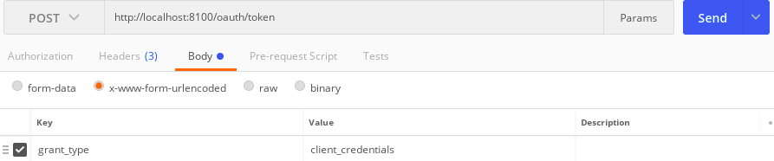

Now request for token in Authorization server like follow:

1.

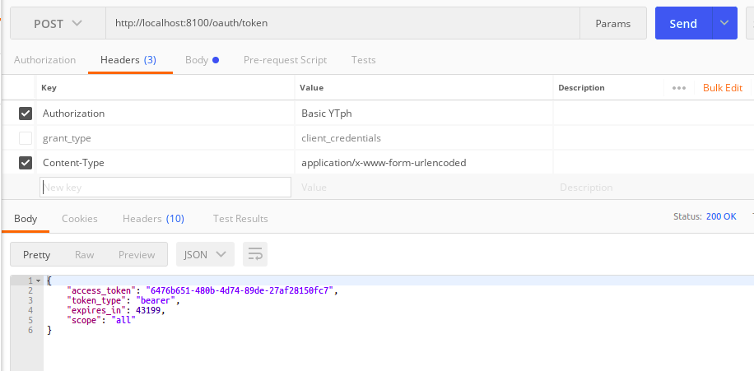2. check the Authorization in header part and also grant type in body party

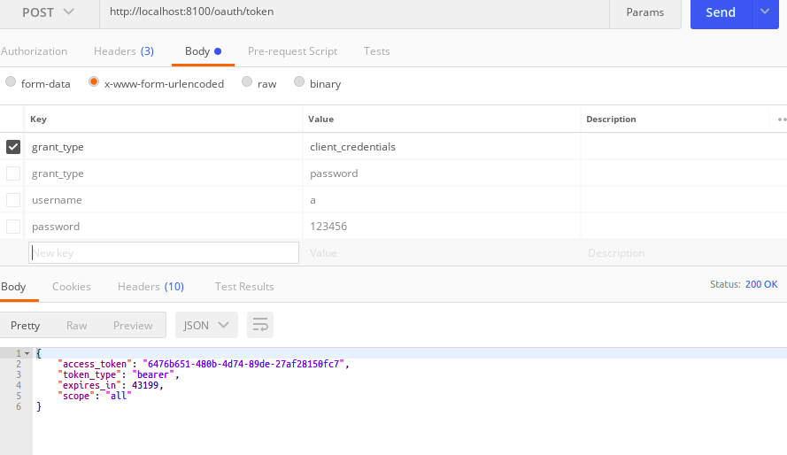  
  
  
  
  
  
Now Use this token to get resource from the resource server.

>> Double check Headers Authorization with Bearer ___**__

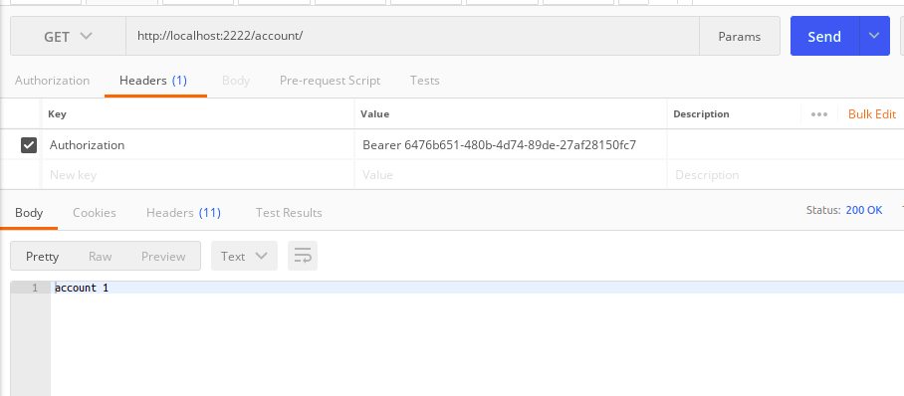  
  
  
  
  
  
  
  
  
  
  
  
  
  
  
  
  
  
  
  
  
  
  
  
  
  
  
Example 3:

Grant-type : Password:

Now the Authorization Server has Authentication configuration class

Double check the differences ::

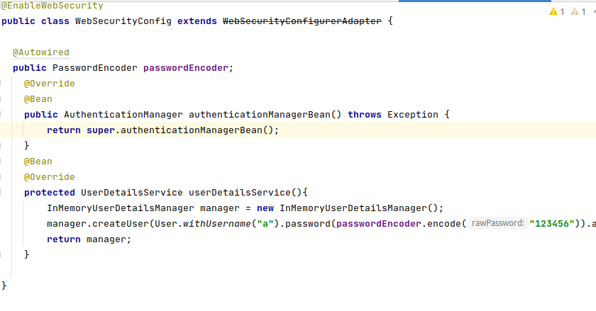  
  
For Authentication We have to add this extra configuration in Auth Configuration:

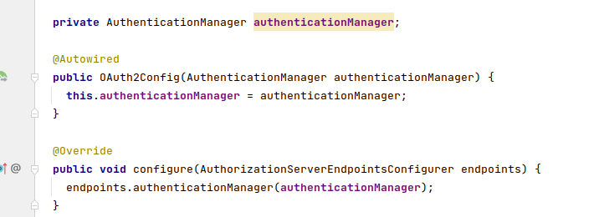  
  
  
**

Now run this Authorization Server and send request for access the token:

Look..   
Now the grant type changed also we have to provide Resource Owner name and credential….

Similar like previous … Access the resource using this token…

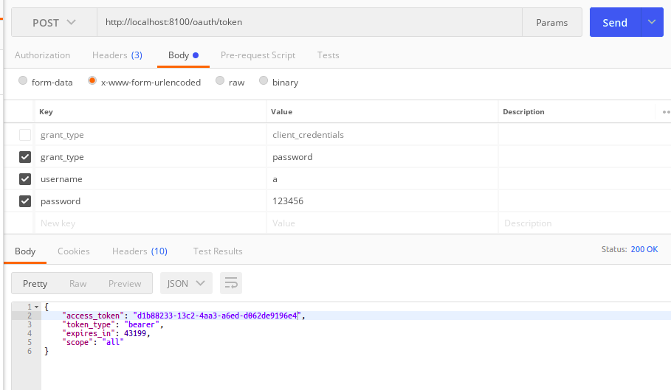

Example: 4:   
Grant-type: Authorization-Code: