

Hello

**Question 1**

You have a Laravel application with a form that submits user information using a POST request.

Write the code to retrieve the 'name' input field value from the request and store it in a variable called $name.

**Answer For Question 1:**

**Controller And using Function Section**

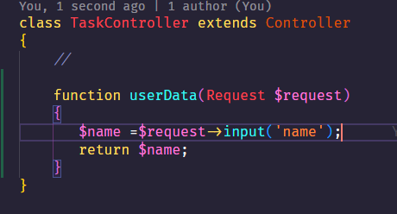

**Route Section**

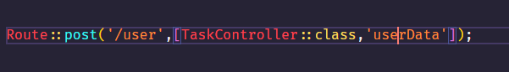

**Result From PostMan**

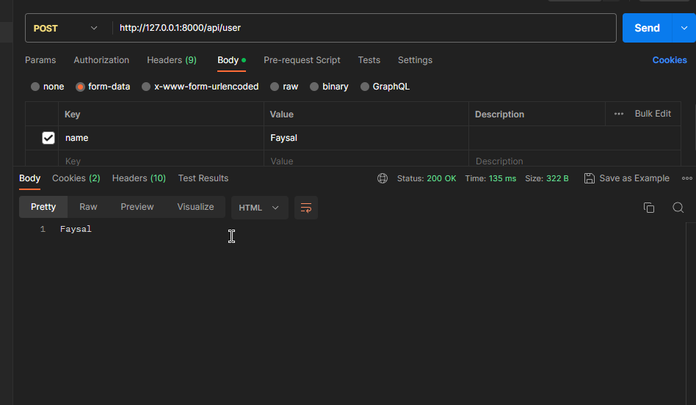



**Question 2**

Need to retrieve the value of the 'User-Agent' header from the current request. Write the code to accomplish this and store the value in a variable called $userAgent.

**Answer For Question 2:**

**Controller And using Function Section**

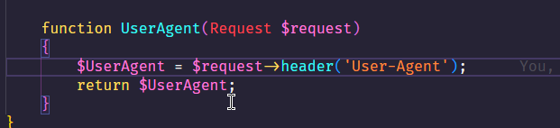

**Route Section**

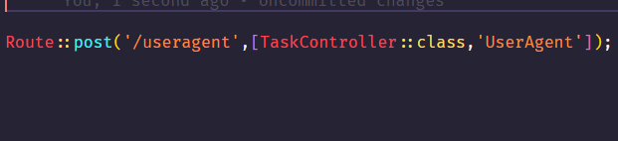

**Result From PostMan**

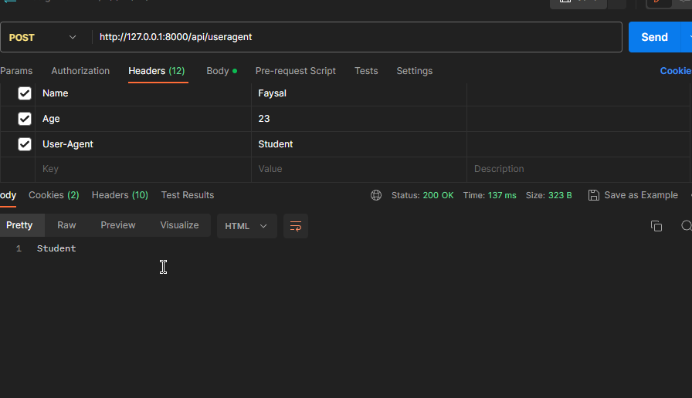

building an API endpoint in Laravel that accepts a GET request with a 'page' query parameter. Write the code to retrieve the value of the 'page' parameter from the current request and store it in a variable called $page. If the parameter is not present, set $page to null.

**Answer For Question 3:**

**Controller And using Function Section**

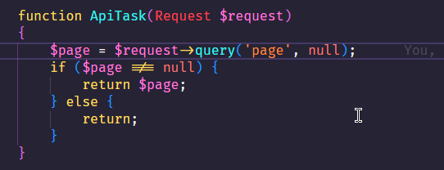

**Route Section**

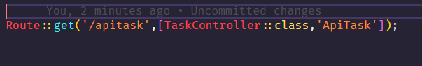

**Re**

**4**

Create a JSON response in Laravel with the.

**Answer For Question 4:**

**Controller And Using Function Section**

**Route Section**

**Result From PostMan Question 5**

implementing a file upload feature in your Laravel application. Write the code to handle a file upload named 'avatar' in the current request and store the uploaded file in the 'public/uploads' directory. Use the original filename for the uploaded file.

**Answer For Question 5:**

**Controller And Using Function Section**

**Route Section**

**Result From PostMan Question 6**

Retrieve the value of the 'remember_token' cookie from the current request in Laravel and store it in a variable called $rememberToken. If the cookie is not present, set $rememberToken to null.

**Answer For Question 6:**

**Controller And Using Function Section**

**Result From PostMan Question 7**

Create a route in Laravel that handles a POST request to the '/submit' URL. Inside the route closure, retrieve the 'email' input parameter from the request and store it in a variable called $email. Return a JSON

**Answer For Question 7: Route Sectiion**

**Result From PostMan**