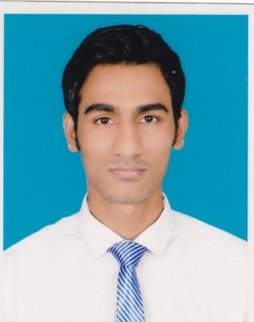**Faysal Ahmmad**

Email: [faysal725@diu.edu.bd](mailto:faysal725@diu.edu.bd)

Mobile: 01675996843

Shere-bangla nagar, Dhaka-1207

**Objective:**

A knowledgeable software engineering student with programming skill and web Development technological proficiency. Looking for an opportunity to build career in software industry where skill, honesty and performance are required.

**Skill & Qualification:**

* **Programming language proficiency**: C#, JavaScript, Typescript
* **Frontend**: HTML5, CSS3, Less
* **Frontend:**
* Bootstrap3/4
* **Angular 4**
* Jquery
* **Framework:**
* Dotnet framewok [webform**, MVC , WebApi , Entity Framework, LINQ**]
* **Expressjs, JWT**
* **Reporting:** Crystal reporting
* **Database:** **MSSQL**, Oracle, **Mongodb** , Mysql
* Database programming: complex and efficient SQL query, store procedure, function, T-SQL, PL-SQL
* Able to work with Git bash, linux os, Microsoft Azure

**Education:**

* BSc in Software Engineering [ongoing 12 semester]

Daffodil International University

Avarage CGPA-3.75

**Training:**

* LICT government project dot net training.

**Project Accomplished:**

1. Library Management system

Framework: dot net Web Form

<https://github.com/faysalah/Library-management-system>

1. Online note pad

Frontend: Html5, CSS3

Backend: PHP, MySQL

<https://github.com/faysalah/online-note-pad>

1. Bus Ticket Reservation

Frontend: Bootstrap 3

Backend: Aspnet Mvc, Entity Framework

<https://github.com/faysalah/AspDotNetMvcBusTicketReservation>

1. Virtual visiting card

Frontend: Bootstrap 3, Angualar4

Backend: Asp Webapi 2, Entiframework codefirst ,Mssql, LINQ

<https://github.com/faysalah/VVC_Webapi>

<https://github.com/faysalah/vvc_card>