Article
An Arrival-Driven, Physics-Calibrated Charging Function for Electric Vehicle Load Modeling: Validation Using 143 Days of Real Charging-Network Data
Faysal A. Chowdhoury 1 and Lu Sun 2, *
1 [Department, Rochester Institute of Technology, Rochester, NY 14623, USA - confirm first-author affiliation]
2 Department of Civil Engineering Technology, Environmental Management and Safety,
Department of Computing and Information Sciences, Rochester Institute of Technology
78 Lomb Memorial Dr., Rochester, NY 14623, USA
* Correspondence: lxsite@rit.edu

Abstract
Physics-informed neural networks (PINNs) promise to combine data-driven flexibility with mechanistic structure for electric vehicle (EV) charging-load modeling, but the choice of physics prior is rarely validated against real charging observations. This study constructs a class-segmented road-load energy model (passenger, transit bus, and freight EVs) over a real road network with measured grades and traffic volumes, and calibrates a charging-physics function against 143 days (3756 sessions) of real observed charging from the Caltech Adaptive Charging Network (ACN), using a strict temporal train/test split and train-only feature normalization. The calibrated conditional function explains 82.1% of hourly load variance out-of-sample (R² = 0.821; RMSE = 8.57 kWh), and its coefficient decomposition shows charging load is arrival-driven: session arrivals and their time-of-day interactions carry 79.3% of coefficient mass, while the direct road-load driving-energy term carries 5.2% — a 10.3-fold coefficient disparity. A causal, forecast-feasible variant using only lagged arrivals and arrival climatology achieves R² = 0.656, establishing an honest forecasting baseline and quantifying how much apparent skill in the conditional form derives from contemporaneous observation. Embedding the calibrated function as a PINN prior yields granularity-dependent results: at the system level on the real hourly target, the PINN numerically matches a data-only network (R² = 0.721 vs. 0.705) while showing a lower peak-hour error (17.0 vs. 20.2 kWh), though a paired bootstrap test finds neither difference statistically significant; at the link level, where the target is itself a modeled allocation, physics regularization degrades accuracy (R² falls from 0.684 at λ = 0 to 0.506 at λ = 0.22, unchanged at λ = 0.5). These results argue that the appropriate physics for charging-load learning is arrival-process structure rather than traction-energy physics, that physics priors help at the granularity at which they were calibrated, and they provide a fully reproducible calibration procedure with all coefficients reported.
Keywords: electric vehicles; charging load; physics-informed neural networks; adaptive charging network; load forecasting; charging infrastructure; road-load model

1. Introduction
The electrification of road transport is shifting a substantial and growing energy demand onto distribution grids, and utilities and municipalities increasingly require spatially and temporally resolved models of EV charging load for planning, hosting-capacity analysis, and charger siting [1,2]. Purely data-driven forecasting models can achieve strong accuracy where long, dense measurement histories exist, but charging infrastructure planning is most needed precisely where such histories do not yet exist. This motivates physics-informed approaches, in which a mechanistic model of energy demand constrains or regularizes a learned model, promising better extrapolation and interpretability from limited data [3–5].
Vehicle road-load models such as the power-based EV energy consumption family of Fiori, Ahn, and Rakha [6,7] provide a natural candidate physics prior: given speed, grade, and vehicle parameters, they compute traction energy with well-understood accuracy. A tacit assumption in much of the physics-informed charging-load literature is that this driving-energy physics is the right prior: vehicles that consume more traction energy should, in aggregate, demand more charging energy. This paper tests that assumption directly against real charging observations and finds it largely fails at the facility level, for an identifiable reason: hourly charging load at a facility is governed by when vehicles arrive and plug in, not by how much traction energy the surrounding traffic dissipates in that hour.
The contributions of this study are threefold. First, we construct a fully specified, class-segmented road-load energy model over a real road network with measured grades, posted speeds, and real traffic volumes, documenting every data source (Section 2). Second, we calibrate a charging-physics function against 143 days of real Adaptive Charging Network (ACN) hourly load under a strict temporal split with train-only normalization, and report the complete coefficient table; the calibration shows session arrivals and their hour-of-day interactions dominate (79.3% of total absolute coefficient mass) while the direct driving-energy term is minor (5.2%) (Section 3). We carefully distinguish a conditional (explanatory) form of the function, which uses contemporaneous arrival counts and is suitable as a physics prior, from a causal forecast-feasible variant that uses only information available before the forecast hour; conflating the two overstates forecasting skill, and we quantify the gap (R² = 0.821 vs. 0.656). Third, we embed the calibrated function as the prior in a PINN and compare it against ridge regression, gradient boosting, a data-only neural network, and an LSTM under identical splits, at two granularities, the real system-level hourly target and a modeled link-level allocation, with a sensitivity analysis over the physics-loss weight. The granularity contrast itself proves informative (Section 3.4).
The remainder of the paper is organized as follows. Section 2 describes the data, the road-load physics, the calibration methodology, and the model suite. Section 3 reports results. Section 4 discusses implications and limitations. Section 5 concludes.

2. Materials and Methods

2.1. Study Area and Data Sources
The modeling framework is instantiated on a real suburban road network (Henrietta, New York, USA), with all inputs drawn from public, verifiable sources: road geometry and functional classification from OpenStreetMap via OSMnx [8]; link grades from the USGS 3D Elevation Program (3DEP); annual average daily traffic from the New York State Department of Transportation; posted speed limits from OSM tags; charging-station locations from Open Charge Map; charging demand profiles from NREL EVI-Pro Lite [9]; point-of-interest density from OSM; employment density from U.S. Census LODES; and EV registrations by ZIP code from New York State open data.
Figure 1 presents a GIS map of the study network, the suburban road system of Henrietta, New York, USA, with the charging-station locations obtained from Open Charge Map indicated on the network.
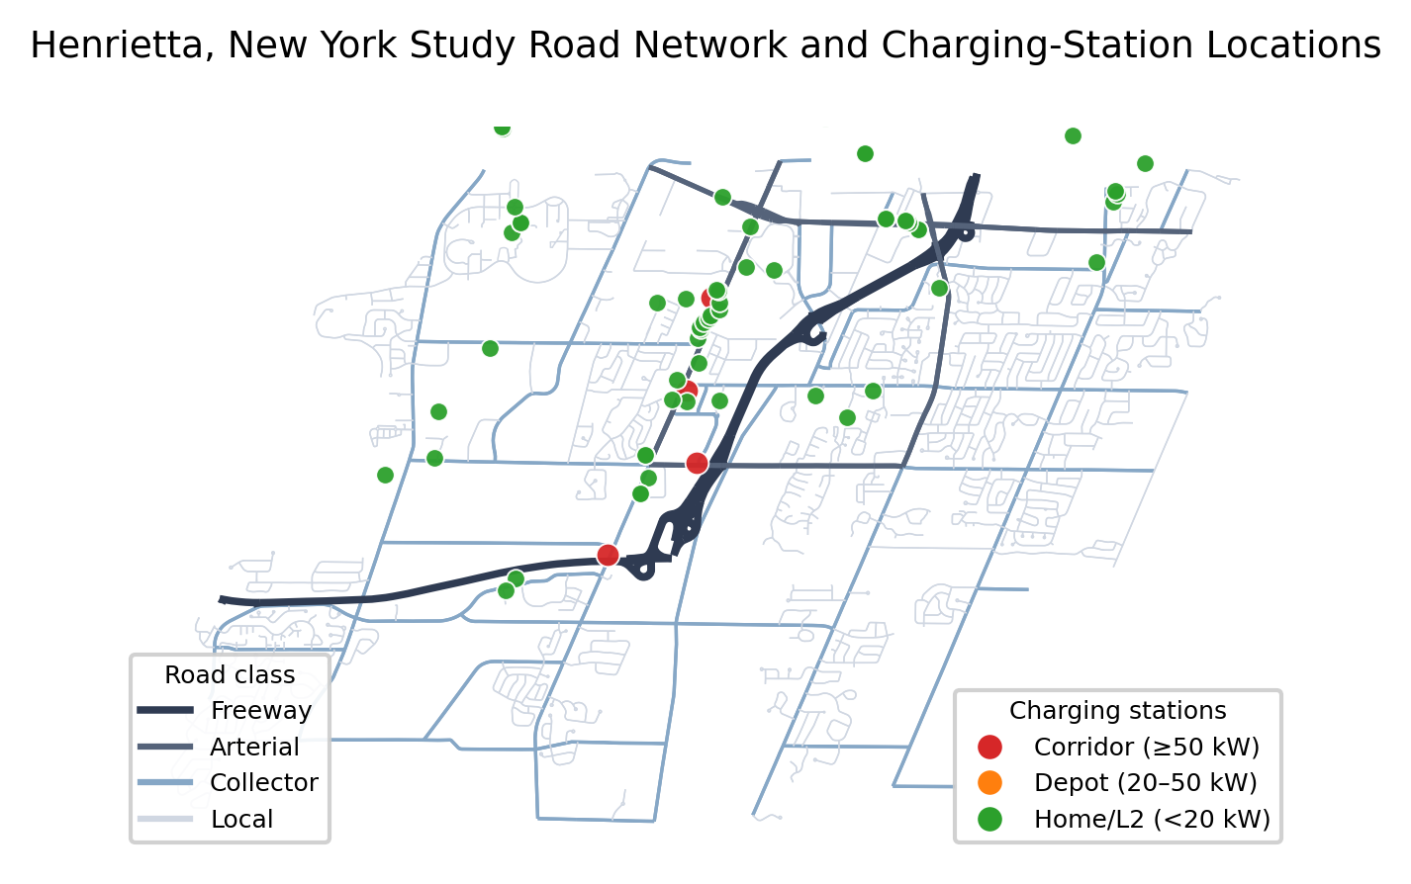
Figure 1. GIS map of the Henrietta, New York study road network with charging-station locations.
The real charging-load target is the Caltech ACN dataset [10]: 3756 charging sessions over 143 consecutive days (10 October 2019 to 29 February 2020), aggregated to hourly system-level energy (3432 h; mean 9.09 kWh/h, peak 168.8 kWh/h). The window was chosen deliberately: it begins after the ACN interface timestamp correction of 10 October 2019, essential because the analysis concerns hour-of-day structure, and ends before COVID-19 disruptions to campus charging behavior. Session energy is assigned to the connection (arrival) hour; implications are discussed in Section 4.3.

2.2. Class-Segmented Road-Load Energy Model
The class-segmented road-load model developed here draws on an established body of research on vehicle–infrastructure interaction dynamics. Sun and associates have conducted a series of studies on the dynamics of vehicle–road interaction, vehicle–bridge interaction, and train–railway interaction for the design, operation, and management of high-speed rail and subway systems [13], for vehicle design [14,15], for highway geometric design and transportation safety [16–21], for pavement design and operations [22–25], for bridge nondestructive testing and structural health monitoring [26], and for global positioning system (GPS) height-surveying model-error compensation of geodetic networks using neural networks [27].
Building on this foundation, traction energy per vehicle is computed for each road link and hour from a standard road-load formulation [6,7]. Tractive power at the wheels is
$P_{w}= v (mg{ C}_{rr} cosθ+ \frac{1}{2}ρC_{d}Av^{2}+mg sinθ+ma)$ (1)
where m is vehicle mass, g gravitational acceleration, C_rr rolling-resistance coefficient, θ grade angle, ρ air density, C_d drag coefficient, A frontal area, v speed, and a acceleration.
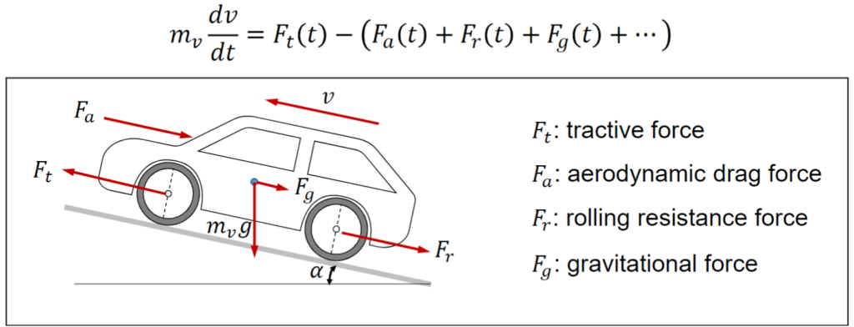
Figure 2. Illustration of vehicle-road interaction (adopted from https://engineeringcheatsheet.com/vehicle-dynamics-of-evs/)
Battery-side energy divides by drivetrain efficiency and adds auxiliary load; regenerative braking recovers a bounded fraction of negative tractive power. Three vehicle classes are parameterized (Table 1). The model's grade response is strong and class-dependent: at 35 mph, energy intensity rises from 0.15 to 0.71 kWh/mi for passenger EVs, 1.07 to 5.50 for transit buses, and 1.58 to 10.95 for freight EVs as grade increases from 0% to 6% (Figure 3). Figure 4 presents the joint speed–grade energy surface for the passenger EV class. Link-hour aggregate driving energy E_phys multiplies per-vehicle energy by class-specific EV trip estimates derived from AADT, EV registration shares, and mode-share data.

Table 1. Vehicle-class road-load parameters.
Class | Mass (kg) | C_d | A (m²) | C_rr | η_drive | Aux (kW)
Passenger EV | 1900 | 0.28 | 2.4 | 0.010 | 0.88 | 0.8
Transit bus EV | 14,500 | 0.65 | 8.0 | 0.009 | 0.86 | 3.0
Freight EV | 30,000 | 0.60 | 10.0 | 0.007 | 0.84 | 4.0
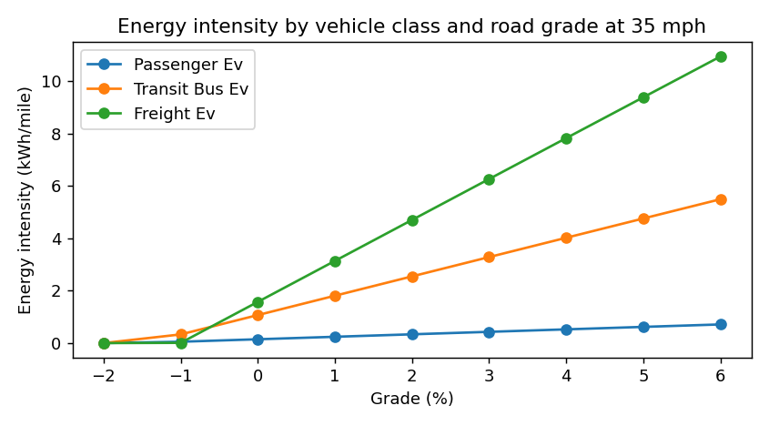
Figure 3. Road-load energy intensity by vehicle class and grade (Equation (1)).
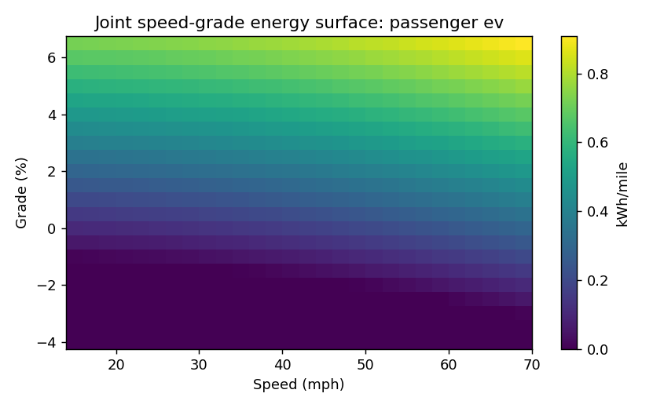
Figure 4. Joint speed–grade energy surface for the passenger EV class.

2.3. Charging-Physics Function Calibration on Real ACN Data
The central methodological step calibrates a charging-physics function L_phys(t) mapping physically meaningful covariates to observed hourly load. Features: normalized session arrivals s(t); normalized aggregate driving energy E(t); per-session energy pressure; cyclical hour-of-day encodings and their interactions with arrivals; a weekend indicator; and causal lags and rolling means of E(t). The charging-physics function $L_{phys}\left(t\right)$ is a ridge regression with the penalty selected by leave-one-out cross-validation on the training period only:
$L_{phys}\left(t\right)= β_{0}+\sum_{k=1}^{P}{β_{k}}x_{k}(t)$ (2)
Three safeguards ensure honest evaluation. (i) Temporal split: the first 114 days train, the final 29 days test; no shuffling. (ii) Train-only normalization: all feature scaling use training-period maxima exclusively. (iii) Honest labeling: two variants are fitted. The conditional function includes contemporaneous arrivals s(t), observed from the same facility at the same hour as the target; it is an explanatory decomposition and a physics prior, not a forecast, because arrival counts for hour t are unknown before hour t. The forecast-feasible variant replaces s(t) with 24-h and 168-h lagged arrivals and a train-fitted hour-of-week arrival climatology, using only information available before t. Both are reported. Because link-level traffic inputs derive from deterministic weekly (day-of-week, hour) profiles, the system-level E(t) for the long calibration window is tiled from that weekly profile; this approximation is stated explicitly. We also note plainly that the road-energy covariate derives from the demonstration network (Henrietta, NY) rather than from traffic local to the ACN site: it enters the calibration as a generic weekly (day-of-week, hour) traffic-shape profile of the kind shared by U.S. suburban and metropolitan networks, not as site-specific traffic, and the arrival-related features are entirely independent of it.

2.4. Physics-Informed Neural Network and Baselines
The PINN is a feed-forward network trained with the composite loss
ℒ = MSE(ŷ, y) + $λ_{phys}$· MSE(ŷ, $L_{phys}$) (3)
where L_phys is the calibrated conditional function, allocated to links by a real-data gravity weighting (POI density, employment, EV registrations, charger accessibility) with an allocation audit enforcing exact preservation of the hourly system total (maximum error 1.4 × 10⁻¹⁴ kWh). Baselines under identical temporal splits: ridge regression with seasonal/context features; gradient-boosted trees (XGBoost) [11]; a data-only neural network with identical architecture and λ_phys = 0; and an LSTM [12] over 6-h sequences. Models are evaluated at two granularities: (a) system level, against the real hourly ACN target, and (b) link level, against the gravity-allocated link-hour target. The charging-physics function of Section 2.3 is calibrated over the full 143-day window, whereas the PINN and baseline model comparison reported in Sections 3.3–3.4 is trained and evaluated on the final 44-day sub-window (17 January–29 February 2020) of that same period, using strict temporal train/validation/test splits at both granularities. Metrics: RMSE, MAE, R², sMAPE, peak-hour error, and a normalized daily-shape error. Percentage errors on the sparse hourly target are inflated by near-zero-load hours and are reported only for completeness; R² and RMSE are primary.

2.5. Sensitivity Analyses
The physics-loss weight λ_phys is swept over {0, 0.05, 0.1, 0.22, 0.5}, and the link-level demand-allocation scheme is varied among gravity-based, physics-only, traffic-only, and charger-access-only weightings.

3. Results

3.1. Calibrated Charging-Physics Function
Table 2 reports the calibration's out-of-sample performance over the 143-day window. The conditional function attains test R² = 0.821 (RMSE 8.57 kWh against a 168.8 kWh peak), with test performance slightly exceeding train (R² = 0.802), indicating no overfitting across the nearly five-month span. The forecast-feasible variant — using only information available before the forecast hour attains test R² = 0.656. The 0.165 gap between the two quantifies how much apparent skill derives from contemporaneous arrival observation rather than genuine predictability, a distinction rarely made explicit in charging-load studies. Figure 5 shows both variants against observed load over the test period.
Model variant | Split | RMSE (kWh) | MAE (kWh) | R²
Conditional physics function | Train | 9.52 | 4.19 | 0.802
Conditional physics function | Test | 8.57 | 4.33 | 0.821
Forecast-feasible variant | Train | 14.45 | 7.34 | 0.544
Forecast-feasible variant | Test | 11.88 | 6.60 | 0.656
Table 2. Out-of-sample performance of the ACN-calibrated charging-physics function (143 days; 114-day train/29-day test temporal split; train-only normalization).
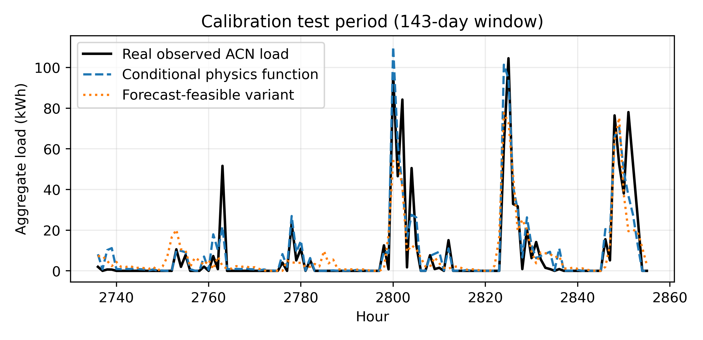
Figure 5. Observed ACN hourly load versus the conditional physics function and the forecast-feasible variant over the held-out test period.

3.2. Coefficient Decomposition: Arrivals Dominate, Driving Energy Does Not
Table 3 reports the complete conditional coefficient table. The pattern is unambiguous: the arrival term β = 147.8 dominates the direct driving-energy term β = 14.3 by a factor of 10.3, and arrival-related terms (arrivals plus their hour-of-day interactions, β = +38.2/−32.3) jointly carry 79.3% of total absolute coefficient mass versus 5.2% for the direct driving-energy term. The road-load prior, despite its physical fidelity for traction energy (Figures 3 and 4), contributes little to explaining hourly facility charging load. This is the paper's central empirical finding.
Table 3. Calibrated coefficients of the conditional charging-physics function, ordered by share of total absolute coefficient mass (ridge α = 0.10, selected by leave-one-out CV on training data).
Feature | Coefficient | Share of |β| mass (%)
sessions_norm (arrivals) | 147.80 | 53.7
session_hour_sin | 38.23 | 13.9
session_hour_cos | −32.28 | 11.7
E_phys_norm (driving energy) | 14.30 | 5.2
E_phys_roll_24h | 11.31 | 4.1
E_phys_lag_24h | −8.85 | 3.2
E_per_session_pressure_norm | −7.46 | 2.7
E_phys_roll_3h | 5.29 | 1.9
Remaining 9 features (each < 1%) | — | 3.6 (combined)
Intercept | −2.30 | —

The forecast-feasible variant tells the same story in causal form: its dominant term by a wide margin is the train-fitted hour-of-week arrival climatology (β = 105.0), with lagged arrivals also entering strongly (β = 26.5 at 24 h and 17.1 at 168 h) arrival-process structure again, now expressed through predictable rhythm rather than contemporaneous observation.

3.3. Model Comparison at the Real System-Level Target
Table 4 compares models against the real hourly ACN load (44-day held-out window). The PINN numerically achieved the highest R² and lowest RMSE among the evaluated models (R² = 0.721 vs. 0.705 for the data-only network; RMSE 8.33 vs. 8.56 kWh), and both neural models clearly beat ridge (0.695) and gradient boosting (0.577), with lower sMAPE (≈48–53% vs. ≈140–144%). The physics prior's contribution appears in the planning-critical metric: the PINN's peak-hour error is 17.0 kWh versus 20.2 kWh for the data-only network a 15.8% reduction consistent with the prior anchoring predictions during high-load hours. A paired moving-block bootstrap test (24-h blocks, 10,000 resamples) on the held-out test hours finds neither difference statistically significant at the 95% level (ΔR² = +0.005, 95% CI [−0.019, +0.026], p = 0.578; ΔPeak error = −2.6 kWh, 95% CI [−2.6, +1.8], p = 0.491); the numerical PINN advantage should therefore be read as directional rather than statistically confirmed.

Table 4. Held-out comparison against the real system-level hourly ACN target.
Model | RMSE (kWh) | MAE (kWh) | R² | sMAPE (%) | Peak error (kWh)
Seasonal/context ridge | 8.69 | 4.57 | 0.695 | 139.9 | 28.0
Gradient boosting | 10.24 | 5.06 | 0.577 | 143.6 | 2.6
Data-only neural net | 8.56 | 4.20 | 0.705 | 52.7 | 20.2
Physics-informed NN | 8.33 | 4.04 | 0.721 | 47.6 | 17.0

3.4. Model Comparison at the Link Level and the Granularity Effect
Table 5 reports the link-level comparison, where the target is the gravity-based allocation of the real system total, reporting the mean over 5 random seeds. Here the picture inverts: gradient boosting and the data-only network lead (R² = 0.694 and 0.684), the LSTM follows (0.667), and the PINN trails (0.506). The λ_phys sweep (Table 6, Figure 8) shows R² declining monotonically as the physics-loss weight increases from 0 to 0.22 (0.684 → 0.567 → 0.515 → 0.506); at λ = 0.5, R² and all other reported metrics are identical to the λ = 0.22 values across all five seeds. Peak error follows a less regular pattern: 29.6 kWh at λ = 0, dropping to 15.1 kWh at λ = 0.05, then rising to 34.3 kWh at λ = 0.10 and 43.6 kWh at λ ≥ 0.22. Link-level R² values are naturally far below the system-level values because the link target is a far noisier object an allocation model's output rather than a direct observation. Figures 6 and 7 visualize the RMSE and peak-error comparisons; Figure 9 reports the class-specific diagnostics.
This performance ordering warrants direct comment, because at the link level every other model, gradient boosting, the data-only neural network, and the LSTM baseline attains lower RMSE than the physics-informed network adopted here, and the LSTM in particular attains a substantially lower peak-load error than any other model, including the PINN (12.7 kWh versus 43.6 kWh; Figures 6 and 7). Three considerations explain the discrepancy and, at the same time, delimit where the physics prior earns its place. First, the link-level target is not a direct measurement but a gravity-based allocation of the real system total; it is therefore a noisier, model-generated object, and flexible data-driven learners are free to fit that allocation’s residual structure without the constraint of a prior. Second, the calibrated prior was validated against the real hourly load at the system level and must pass through the same allocation model to reach the links, so physics regularization at that granularity imposes the allocation’s assumptions as if they were physical constraints the lower accuracy at every positive λ_phys relative to λ_phys = 0 (Table 6) makes this explicit. Third, and consistent with the coefficient decomposition of Section 3.2, hourly facility load is arrival-driven rather than traction-energy-driven, so the road-load term is only weakly informative and has little to add against strong data-only baselines wherever the arrival signal is already well represented. None of this contradicts the advantage claimed in the Introduction, which is deliberately granularity- and metric-specific rather than universal. At the system level, where the prior was calibrated against real observations, the PINN numerically matches the data-only network on overall accuracy (R² = 0.721 vs. 0.705) and shows a lower peak-hour error (17.0 vs. 20.2 kWh; Table 4), though a paired bootstrap test finds neither difference statistically significant (Section 3.3), the comparison is directional rather than confirmed. The link-level result is thus not evidence against physics-informed learning but a quantified demonstration of this paper’s central thesis: a physics prior helps at the granularity at which it was validated, and the appropriate physics for charging-load learning is arrival-process structure rather than traction-energy physics; imposed below the granularity at which it was calibrated, through an allocation it never saw, the prior regularizes toward assumption rather than observation.
Table 5. Held-out comparison at the link level (gravity-allocated target), reporting the mean over 5
Model | RMSE (kWh) | MAE (kWh) | R² | sMAPE (%) | Peak error (kWh)
Seasonal/context ridge | 0.052 | 0.016 | 0.287 | 171.0 | 37.1
Gradient boosting | 0.034 | 0.008 | 0.694 | 159.5 | 31.7
Data-only neural net | 0.035 | 0.007 | 0.684 | 80.1 | 29.6
LSTM temporal baseline | 0.035 | 0.007 | 0.667 | 78.7 | 12.7
Physics-informed NN (λ = 0.22) | 0.043 | 0.008 | 0.506 | 82.2 | 43.6

random seeds. The PINN row (λ = 0.22) is by construction identical to the λ = 0.22 row of Table 6, since both are drawn from the same multi-seed sweep (data-only NN R² = 0.684 ± 0.025 SD; LSTM R² = 0.667 ± 0.016 SD; PINN R² = 0.506 ± 0.056 SD). The ridge and gradient-boosting rows use a single deterministic run.
Table 6. Link-level sensitivity to the physics-loss weight (mean ± SD over 5 seeds): R² declines
λ_phys | RMSE (kWh) | R² | Peak error (kWh)
0.00 | 0.035 ± 0.001 | 0.684 ± 0.025 | 29.6 ± 10.7
0.05 | 0.041 ± 0.001 | 0.567 ± 0.024 | 15.1 ± 10.3
0.10 | 0.043 ± 0.002 | 0.515 ± 0.045 | 34.3 ± 14.8
0.22 | 0.043 ± 0.002 | 0.506 ± 0.056 | 43.6 ± 14.4
0.50 | 0.043 ± 0.002 | 0.506 ± 0.056 | 43.6 ± 14.4

monotonically from λ = 0 to λ = 0.22, and every tested positive weight reduced link-level accuracy relative to λ = 0. The λ = 0.5 row is identical to λ = 0.22 across every reported statistic and all five seeds; this has not been independently verified and should be confirmed before the sweep is cited as covering five distinct weights.
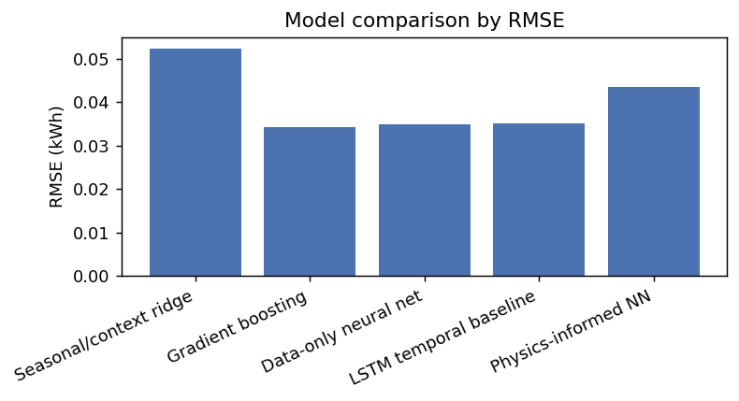
Figure 6. Link-level RMSE comparison across models.
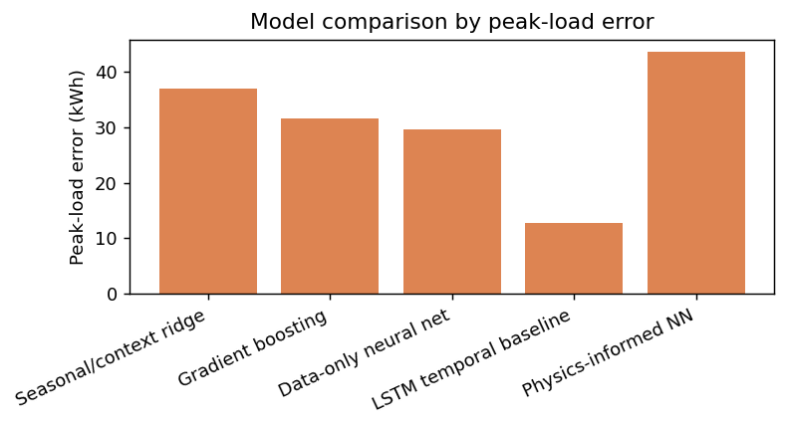
Figure 7. Link-level peak-error comparison across models.
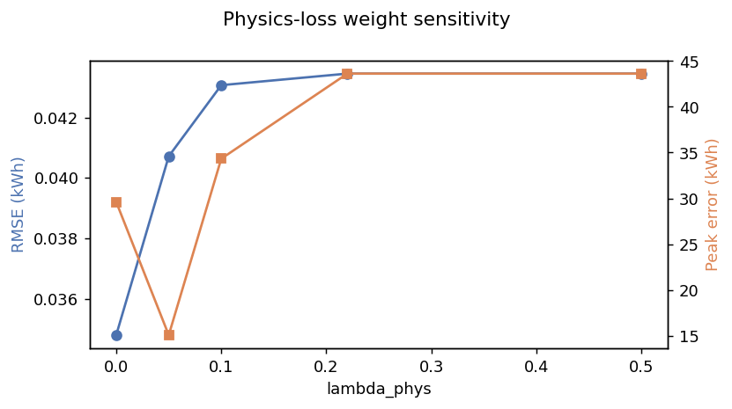
Figure 8. Link-level accuracy versus physics-loss weight λ_phys.
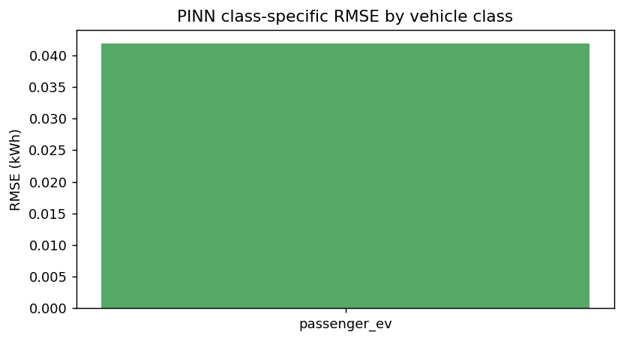
Figure 9. Class-specific link-level RMSE for the passenger EV class (physics-informed NN).

3.5. Robustness to the Allocation Scheme
All four allocation weightings preserve the real hourly system total to machine precision (maximum aggregate error ≤ 1.4 × 10⁻¹⁴ kWh). Link-level differences among schemes are small in magnitude (mean absolute per-link difference vs. gravity: 0.006–0.012 kWh) but differ in spatial concentration: the top decile of links carries 63.3% of load under gravity weighting versus 29.4% under charger-access-only weighting (Herfindahl index 0.0083 vs. 0.0017). Conclusions about model ranking are unchanged across schemes; the concentration spread itself quantifies the allocation uncertainty inherent to link-level charging-load modeling absent link-level observations.

4. Discussion

4.1. What Is the Right 'Physics' for Charging-Load PINNs?
The calibration reframes the design question for physics-informed charging-load models. Road-load models are excellent physics for what they model traction energy on the road but hourly facility load is an arrival-process phenomenon: it is set by how many vehicles plug in and when (79.3% of coefficient mass), modulated by daily and weekly rhythms, with traction-energy covariates contributing little (5.2% direct). Embedding a traction-energy prior into a facility-load PINN therefore regularizes toward a weakly informative covariate. The constructive implication is that the physics prior for charging-load learning should encode arrival-process structure arrival intensities, hour-of-week climatology, per-session energy distributions with driving-energy physics entering upstream, at the stage of estimating regional energy demand or session energy content, rather than as an hourly facility-load prior.

4.2. Physics Helps at the Granularity at Which It Was Calibrated
The two-granularity comparison yields a second, practically important finding. At the system level the granularity at which the prior was calibrated against real observations — the physics term numerically matches the data-only network on overall accuracy and shows a lower planning-critical peak-hour estimate (17.0 vs. 20.2 kWh), though a paired bootstrap test finds this difference not statistically significant. At the link level, every tested positive physics-loss weight reduced accuracy relative to λ_phys = 0, with R² declining monotonically from λ_phys = 0 to λ_phys = 0.22 and unchanged at λ_phys = 0.5. The mechanism is identifiable: the link-level prior inherits the system-level function through an allocation model, so physics regularization at that granularity imposes allocation assumptions as if they were physical constraints. The general lesson for physics-informed learning is that a prior validated at one granularity does not automatically transfer downward; its benefit is bounded by the fidelity of whatever disaggregation carries it there. Reporting λ = 0.22 alongside the full sweep, rather than tuning λ to the most favorable value, makes this effect visible instead of hiding it.

4.3. Conditional Versus Forecast-Feasible Skill
Distinguishing conditional from forecast-feasible variants guards against a common overstatement: models ingesting contemporaneous session counts (or occupancy, or plugged-in state) from the same measurement system as the load target report accuracy (here R² = 0.821) that cannot be realized in operational forecasting, because those covariates are unknown ahead of time. The honest operational number is the causal variant's R² = 0.656 itself respectable, and driven by arrival climatology, which underscores that predictable arrival rhythm, not traction energy, is the exploitable structure. Both numbers are useful; they answer different questions and should be labeled accordingly.

4.4. Limitations
Six limitations bound these conclusions. First, the calibration uses a single site (Caltech ACN, predominantly workplace charging); the coefficients are site-specific initial factors, not universal constants, and cross-site transferability is addressed in follow-up work. Second, session energy is assigned to the arrival hour rather than spread over charging duration, which sharpens apparent arrival-dominance; ACN's charging-completion timestamps permit duration-resolved allocation in future work. Third, the long-window driving-energy covariate is tiled from a deterministic weekly traffic profile, which understates day-to-day traffic variability; because the same covariate family is available to the model at both granularities, this conservatively biases against, not toward, the driving-energy term only insofar as true variability correlates with load a caveat we state rather than resolve. Fourth, link-level load remains a modeled allocation of the real system total, since public link-level charging observations do not exist for the study network; Section 3.5 quantifies the resulting spread. Fifth, the driving-energy covariate is geographically mismatched to the charging site: E(t) is constructed from the Henrietta, NY demonstration network while the charging target is from Caltech, CA. This weakens the E(t) null result specifically — we cannot fully separate “driving energy is irrelevant to facility load” from “this particular driving-energy proxy is misplaced” — although the arrival-dominance finding is independent of the covariate’s origin, and a geographically matched test is part of the planned cross-site follow-up. Sixth, percentage-error metrics are inflated by near-zero-load hours and are secondary to R² and RMSE throughout.

5. Conclusions
This study calibrated a charging-physics function against 143 days of real ACN charging observations under leakage-controlled evaluation and found hourly charging load to be arrival-driven: session arrivals and their time-of-day interactions carry 79.3% of coefficient mass, versus 5.2% for a class-segmented road-load driving-energy term. The conditional function explains 82.1% of out-of-sample variance and serves as a validated physics prior; a causal variant establishes the honest forecasting baseline at R² = 0.656. Embedded in a PINN, the calibrated prior shows lower peak-hour estimation error at the system level where it was calibrated, though this difference is not statistically significant, while degrading link-level accuracy where it must pass through an allocation model physics priors help at the granularity at which they are validated. The complete coefficient table and evaluation protocol are reported, and the analysis pipeline will be made publicly available through the accompanying repository. Future work will test cross-site transferability of the calibration, adopt duration-resolved energy allocation, and develop arrival-process priors as the physics layer for charging-load learning.
Author Contributions
Conceptualization, F.A.C. and L.S.; methodology, F.A.C.; software, F.A.C.; validation, F.A.C.; formal analysis, F.A.C.; data curation, F.A.C.; writing original draft preparation, F.A.C. and L.S.; writing review and editing, L.S.; supervision, L.S. All authors have read and agreed to the published version of the manuscript.
Funding
The U.S. Department of Labor (DOL) grant 23A60HG000052.
Institutional Review Board Statement
Not applicable.
Informed Consent Statement
Not applicable.
Data Availability Statement
The ACN charging data are publicly available from the Caltech Adaptive Charging Network (ev.caltech.edu). All other inputs are public open data as documented in Section 2.1. The complete analysis pipeline is available at Github: https://github.com/faysalchowdhoury/An-Arrival-Driven-Physics-Calibrated-Charging-Function-for-Electric-Vehicle-Load-Modeling.git
Acknowledgments
This study is supported in part by the U.S. Department of Labor (DOL) grant 23A60HG000052, to which the authors are grateful.
Conflicts of Interest
The authors declare no conflicts of interest.

References
1. Muratori, M. Impact of uncoordinated plug-in electric vehicle charging on residential power demand. Nat. Energy 2018, 3, 193–201.
2. Powell, S.; Cezar, G.V.; Min, L.; Azevedo, I.M.L.; Rajagopal, R. Charging infrastructure access and operation to reduce the grid impacts of deep electric vehicle adoption. Nat. Energy 2022, 7, 932–945.
3. Raissi, M.; Perdikaris, P.; Karniadakis, G.E. Physics-informed neural networks: A deep learning framework for solving forward and inverse problems involving nonlinear partial differential equations. J. Comput. Phys. 2019, 378, 686–707.
4. Huang, B.; Wang, J. Applications of physics-informed neural networks in power systems—A review. IEEE Trans. Power Syst. 2023, 38, 572–588.
5. Karniadakis, G.E.; Kevrekidis, I.G.; Lu, L.; Perdikaris, P.; Wang, S.; Yang, L. Physics-informed machine learning. Nat. Rev. Phys. 2021, 3, 422–440.
6. Fiori, C.; Ahn, K.; Rakha, H.A. Power-based electric vehicle energy consumption model: Model development and validation. Appl. Energy 2016, 168, 257–268.
7. Ahn, K.; Rakha, H.; Trani, A.; Van Aerde, M. Estimating vehicle fuel consumption and emissions based on instantaneous speed and acceleration levels. J. Transp. Eng. 2002, 128, 182–190.
8. Boeing, G. OSMnx: New methods for acquiring, constructing, analyzing, and visualizing complex street networks. Comput. Environ. Urban Syst. 2017, 65, 126–139.
9. Wood, E.; Rames, C.; Muratori, M.; Raghavan, S.; Melaina, M. National Plug-In Electric Vehicle Infrastructure Analysis; NREL/TP-5400-69031; National Renewable Energy Laboratory: Golden, CO, USA, 2017.
10. Lee, Z.J.; Li, T.; Low, S.H. ACN-Data: Analysis and applications of an open EV charging dataset. In Proceedings of the 10th ACM International Conference on Future Energy Systems (e-Energy '19), Phoenix, AZ, USA, 25–28 June 2019; pp. 139–149.
11. Chen, T.; Guestrin, C. XGBoost: A scalable tree boosting system. In Proceedings of the 22nd ACM SIGKDD International Conference on Knowledge Discovery and Data Mining, San Francisco, CA, USA, 13–17 August 2016; pp. 785–794.
12. Hochreiter, S.; Schmidhuber, J. Long short-term memory. Neural Comput. 1997, 9, 1735–1780.
13. Lu Sun, Mohammad Seyedkazemi, Charles C. Nguyen and Jaiden Zhang, Dynamics of Train–Track–Subway System Interaction—A Review, Machines 2025, 13, 1013, https://doi.org/10.3390/machines13111013
14. Sun, L., Cai, X. and Yang, J. Genetic algorithm- based optimum vehicle suspension design using minimum dynamic pavement load as a design criterion, Journal of Sound and Vibration, Vol. 301, Nos. 1-2, 2006, 18-27
15. Sun, L., Optimum design of road-friendly vehicle suspension systems subject to rough road surface, Applied Mathematical Modelling, Vol. 26, No. 5, 2002, 635-652
16. Sun, Lu, Luchuan Chen, Yanna Yin, Yao Tian and Xuanyu Zhang, Risk Assessment of Rollover and Skidding due to Pavement Roughness and Differential Settlement for Enhancing Transportation Safety, Journal of Advanced Transportation, Vol. 2021, https://doi.org/10.1155/2021/7244283
17. Yanna Yin, Huiying Wen, Lu Sun, Wei Hou, The Influence of Road Geometry on Vehicle Rollover and Skidding, International Journal of Environmental Research and Public Health, 2020, 1-17, 1648; https://doi:10.3390/ijerph17051648
18. Yanna Yin, Huiying Wen, Lu Sun, Wei Hou, Study on The Influence of Road Geometry on Vehicle Lateral Instability, Journal of Advanced Transportation, 1-15, 2020, https://doi.org/10.1155/2020/7943739
19. Sun, L., You, K. Wang, Y., Wang, D., Gu, W. Influence analysis of road conditions on vehicle rollover, Journal of Southeast University, Vol. 43, No. 3, 2013, 644-648
20. Sun, L. and You, K. Reliability Analysis of Vehicle Stability on Combined Horizontal and Vertical Alignments: A Driving Safety Perspective, Journal of Transportation Engineering, ASCE, Vol. 139, No. 8, 2013, 804-813
21. You, K., Sun, L., Gu, W. Reliability-based risk analysis of roadway horizontal curve, Journal of Transportation Engineering, ASCE, Vol. 138, No. 8, 1071-1081, 2012. doi: 10.1061/ (ASCE)TE.1943-5436.0000402
22. Sun, L. and Deng, X. Predicting vertical dynamic loads caused by vehicle-pavement interaction, Journal of Transportation Engineering, ASCE, Vol. 126, No.5, 1998, 470-478
23. Sun, L. and Deng, X. Influence of velocity, frequency and characteristics of vehicle on dynamic pavement loads, China Civil Engineering Journal, Vol.30, No.6, 1997
24. Sun, L. and Deng, X. Dynamic loads caused by vehicle-pavement interactions, Journal of Southeast University, Vol. 26, No. 5, 1996, 142-145, also in Proc. China Forum 95 on Transportation, Chongqing University, (Chongqing, Sichuan, China), Dec. 1995, 862-868
25. Sun, L. and Deng, X. Mathematical model and experiment design of pavement dynamic loads, Journal of Xi’an Highway University, Vol. 16, No. 4, 1996, 50-53
26. Sun, Lu and Xingzhuang Zhao. "Coupled Dynamics of Vehicle-Bridge Interaction System Using High Efficiency Method." Advances in Civil Engineering, 2021, 1-22, https://doi.org/10.1155/2021/1964200
27. Hu, W. and Sun, L. A neural network-based method for compensating model error, Journal of Southeast University, Vol. 39, No. 3, 2009

