# Title: Establishing connection between alumni and students of DIU via UniBond app

## **Description**:

Introducing UniBond: Bridging Past and Present at DIU

At DIU, we recognized the need for stronger connections between current students and our esteemed alumni. That's why we've created UniBond, an alumni network app.

With UniBond, students can:

* Seek academic guidance and assistance.
* Explore job opportunities.
* Connect with alumni for advice.

Alumni can:

* Share job openings at their companies
* Announce scholarships and part-time jobs.
* Mentor current students

Discover and connect with our DIU alumni community like never before with UniBond!

Here's a visual guide to our app's features:

## Merits:

1. Our app will be free to use.

2. A connection will be established between students and alumni which is currently unavailable.

3. Students outside of DIU cannot enter our app.

4. Job and scholarship opportunities will increase for DIU students than ago.

5.User friendly experience.

## Demerits:

1. Our app has a lack of marketing.
2. Getting alumni to actively participate and provide support to students can be challenging, as they have their own busy lives and may not always have the time to mentor or offer job opportunities.
3. It may take time to build a critical mass of users, especially among alumni.

## Existing software and tools:

Most of the famous universities of the world have a platform to connect their alumni and students. Stanford Alumni network can be a good example of the idea we want to implement.

DIU has an alumni database website but it fails to connect student and alumni. We aim to fill that gap with our app “**UniBond**”

**Stanford alumni network:** <https://alumni.stanford.edu/>

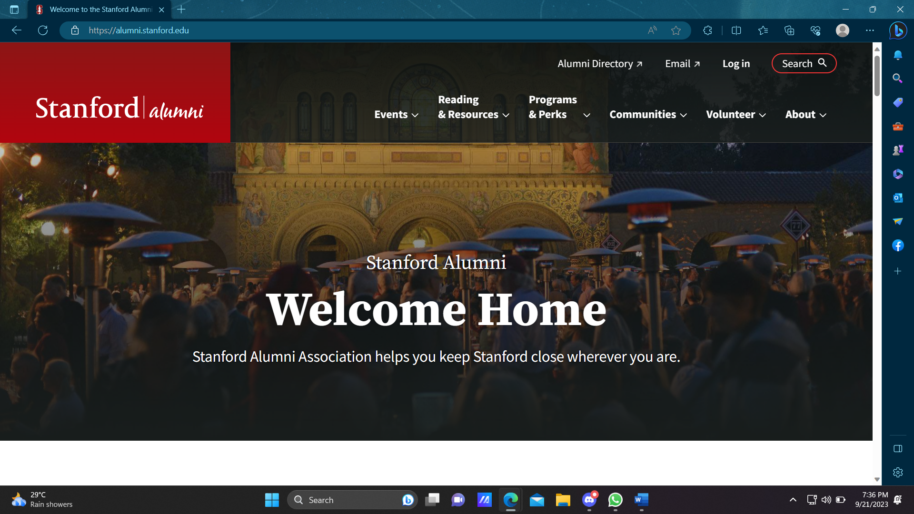

Stanford Alumni Network

**DIU alumni network:** [daffodilvarsity.edu.bd](https://daffodilvarsity.edu.bd/alumni-list)



DIU Alumni

## Used Languages and database:

1. Python

2. Backend framework: Django

3.FrontEnd CSS framework: Bootstrap

4.Javascript

5.Database: MySQL