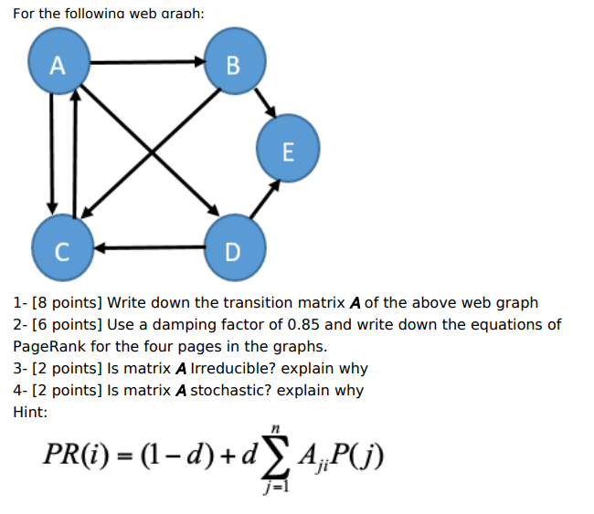

**Part 1 - Transition Matrix:**

|  |  |  |  |  |  |  |
| --- | --- | --- | --- | --- | --- | --- |
|  | A | B | C | D | E | Sum |
| A | 0 | 1/3 | 1/3 | 1/3 | 0 | 1 |
| B | 0 | 0 | 1/2 | 0 | 1/2 | 1 |
| C | 1 | 0 | 0 | 0 | 0 | 1 |
| D | 0 | 0 | 1/2 | 0 | 1/2 | 1 |
| E | 0 | 0 | 0 | 0 | 0 |  |
|  |  |  |  |  |  |  |

because no out-links for node E, which are reflected in transition matrix A by some rows of complete 0’s which does not satisfy page rank algorithm. The problem can be resolved following 2 ways:

* Remove those pages with no out-links during the PageRank computation as these pages do not affect the ranking of any other page directly.

or

* Add a complete set of outgoing links from Node E to all the Nodes.

|  |  |  |  |  |  |  |
| --- | --- | --- | --- | --- | --- | --- |
|  | A | B | C | D | E | Sum |
| A | 0 | 1/3 | 1/3 | 1/3 | 0 | 1 |
| B | 0 | 0 | 1/2 | 0 | 1/2 | 1 |
| C | 1 | 0 | 0 | 0 | 0 | 1 |
| D | 0 | 0 | 1/2 | 0 | 1/2 | 1 |
| E | 1/5 | 1/5 | 1/5 | 1/5 | 1/5 | 1 |
|  |  |  |  |  |  |  |

**Part 2- EQUATION:**

Initially we can assume Rage Rank for A,B,C,D,E are PR(A)=1, PR(B)=2 , PR(C)=3, PR(D)=4 , PR(E)=5

**1st iteration equation:**

PR(A)=(1-0.85)+0.85*(PR(c)/O(c))

= (1-0.85)+0.85*(3/1) = 2.7

PR(B)= (1-0.85)+0.85*(PR(A)/O(A))

= (1-0.85)+0.85*(1/3) = 0.433

PR(C) = (1-0.85)+0.85*(PR(A)/O(A) + PR(B)/O(B))

= (1-0.85)+0.85*(1/3 + 2/2) = 1.283

PR(D) = (1-0.85)+0.85*(PR(A)/O(A))

= (1-0.85)+0.85*(1/3) =0.433

PR(E) = (1-0.85)+0.85*(PR(B)/O(B) + PR(D)/O(D))

= (1-0.85)+0.85*(2/2 + 4/2) =2.7

**2nd iteration equation:**

Value are replaced from 1st iteration

A,B,C,D,E are PR(A)= 2.7, PR(B)= 0.433 , PR(C)= 1.283, PR(D)= 0.433 , PR(E)= 2.7

PR(A)=(1-0.85)+0.85*(PR(c)/O(c))

= (1-0.85)+0.85*(1.283/1) = 1.240

PR(B)= (1-0.85)+0.85*(PR(A)/O(A))

= (1-0.85)+0.85*(2.7 /3) = 0.915

PR(C) = (1-0.85)+0.85*(PR(A)/O(A) + PR(B)/O(B))

= (1-0.85)+0.85*(2.7 /3 + 0.433 /2) = 1.099

PR(D) = (1-0.85)+0.85*(PR(A)/O(A))

= (1-0.85)+0.85*(2.7 /3) =0.915

PR(E) = (1-0.85)+0.85*(PR(B)/O(B) + PR(D)/O(D))

= (1-0.85)+0.85*(0.433 /2+ 2.7/2) =1.481

**Part 2- EQUATION (alternative Solution by following different way):**

Initially we can assume Rage Rank for A,B,C,D,E are PR(A)=1, PR(B)=2 , PR(C)=3, PR(D)=4 , PR(E)=5

**1st iteration equation:**

PR(A)=(1-0.85)+0.85*(PR(c)/O(c))

= (1-0.85)+0.85*(3/1) = 2.7

PR(B)= (1-0.85)+0.85*(PR(A)/O(A))

= (1-0.85)+0.85*(2.7/3) = 0.915

PR(C) = (1-0.85)+0.85*(PR(A)/O(A) + PR(B)/O(B))

= (1-0.85)+0.85*(2.7/3 + 0.915/2) = 1.283

PR(D) = (1-0.85)+0.85*(PR(A)/O(A))

= (1-0.85)+0.85*(2.7/3) = 0.915

PR(E) = (1-0.85)+0.85*(PR(B)/O(B) + PR(D)/O(D))

= (1-0.85)+0.85*(0.915 /2+ 0.915/2) = 0.9277

If ask for 2nd iteration then new rank value will be used PR(A)=2.7, PR(B)=0.915 , PR(C)=1.283, PR(D)= 0.915 , PR(E)= 0.9277.

Part-3 : Is s matrix A Irreducible? explain why ?

Answer: Matrix A is not irreducible. That means it is reducible because if look into node B and E , B has direction to E but there is no way to get back to node B from Node E. to be Irreducible, any node of a graph can reach any other node.

Part-4: is matrix A stochastic? explain why ?

Answer: matrix A stochastic is stochastic because each entry is between o to 1 and sum of the entries of any column is equal to 1.

stochastic : <https://www.youtube.com/watch?v=mZqk_2IVIWs&ab_channel=BLederman>

periodic: <https://www.youtube.com/watch?v=ipQG7Eo64yo&ab_channel=SaeidehFallahFini>

<https://www.youtube.com/watch?v=sz1J8ferf24&ab_channel=StatsResource>

https://www.youtube.com/watch?v=sz1J8ferf24&ab_channel=StatsResource