Answer of Question-1

|  |  |
| --- | --- |
| User Action | System Response |
| 1. User enters PIN number into Main screen | 1. System checks validity of PIN and display different options to another screen. |
| 1. From system provided option , user chooses “Withdraw” option. | 2.The system visualizes a input box field to enter the amount for withdrawing. |
| 1. User writes the withdraw amount in input box field. And finally press submit button. | 3 . Validity is checked by the system after user submission that withdraw amount is valid or not. If it is valid ,Specific amount will be deduced from account holder’s account. At last User will receive money from ATM machine. |

Answer of Question-2

Answer of Question -3

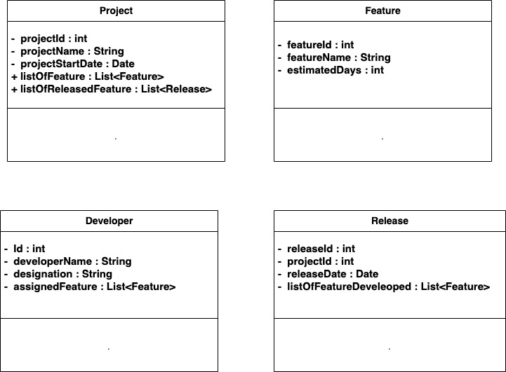

Note : for Question -3 , it is mentioned that [“you do not need to specify operations or associations. Also, you do not need to create a special class to represent the user interface ” ] . that is the reason , I did not mention any method specification.

Answer Of Question-4

