Program_1: Write a class having two private variables and one member function which will return the area of the rectangle.

Source code:

#include<iostream>

using namespace std;

class area{

double len,wid;

public:

double areaCal(){

cin>>len>>wid;

return len*wid;

}

};

int main()

{

area first;

double ans;

ans=first.areaCal();

cout<<"Area of the rectangle="<<ans<<endl;

}

Output:

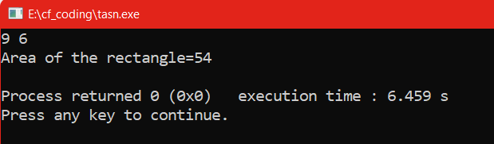

2.Program: Write a C++ program to define a class batsman with the following specifications.

Source code:

#include<bits/stdc++.h>

using namespace std;

class batsman{

int batsman_code,total_innings,notout_innings,total_runs;

string batsman_name;

double batting_avg;

void calcavg(){

if(total_innings!=notout_innings){

batting_avg=(double)total_runs/(double)(total_innings-notout_innings);

}

else{

batting_avg=0;

}

}

public:

void readata(){

cin>>batsman_code;

cin.ignore();

getline(cin,batsman_name);

cin>>total_innings>>notout_innings>>total_runs;

calcavg();

cout<<endl;

}

void displaydata(){

cout<<batsman_code<<"\n"<<batsman_name<<"\n"<<total_innings<<

" "<<notout_innings<<" "<<total_runs<<endl;

cout <<"Batting Average : "<< setprecision(4)<<batting_avg<<endl;

}

};

int main()

{

batsman first;

first.readata();

first.displaydata();

}

Output:

