Program_1: Write a program to check whether a number is even or odd by using the concept of friend function and friend class.

#include<iostream>

using namespace std;

class even_odd {

int num ;

public:

void getdata(){

cin>>num;

}

friend void print(even_odd p);

friend class even_odd_friend;

};

class even_odd_friend {

public:

void output(even_odd r)

{

cout<<"Using friend class : ";

if(r.num%2==0)

cout << "Even"<<endl;

else

cout << "Odd"<<endl;

}

};

void print(even_odd p)

{

cout<<"Using friend function : ";

if(p.num%2==0)

cout<<"Even"<<endl;

else

cout<<"Odd"<<endl;

}

int main()

{

even_odd a;

a.getdata();

print(a);

even_odd_friend b;

b.output(a);

}

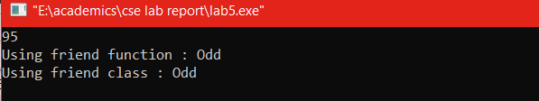

Program_2. Write a program to add two complex number by using friend function and friend class.

(2.a) Friend function:

#include<iostream>

using namespace std;

class complex_num

{

int a,b,c,d;

public:

void getdata()

{

cin>>a>>b;

}

void print()

{

cout<<a<<"+"<<b<<"i"<<endl;

}

friend void add(complex_num num1,complex_num num2);

};

void add(complex_num num1,complex_num num2)

{

int res,ans;

res=num1.a+num2.a;

ans=num1.b+num2.b;

cout<<"Summation:\n";

cout<<res<<"+"<<ans<<"i"<<endl;

}

int main()

{

complex_num c1,c2;

c1.getdata();

c2.getdata();

c1.print();

c2.print();

add(c1,c2);

}

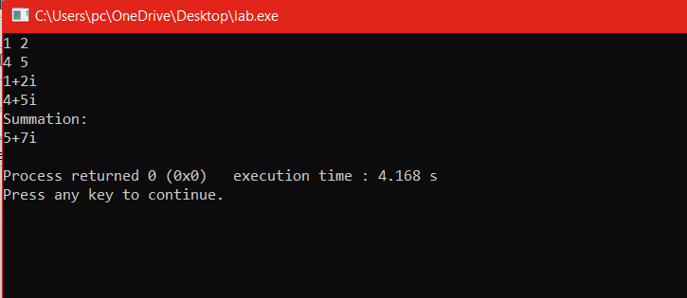

(2.b) Friend Class:

#include<iostream>

using namespace std;

class complex

{

private:

int x,y,p,q;

public:

void getdata()

{

cin>>x>>y;

}

void display_complex()

{

cout<<x<<"+"<<y<<"i"<<endl;

}

friend class sum_complex;

};

class sum_complex

{

public:

void sum(complex a,complex b){

int sum1,sum2;

sum1=a.x+b.x;

sum2=a.y+b.y;

cout<<"Summation:\n";

cout<<sum1<<"+"<<sum2<<"i"<<endl;

}

};

int main()

{

complex c1,c2;

c1.getdata();

c2.getdata();

c1.display_complex();

c2.display_complex();

sum_complex c3;

c3.sum(c1,c2);

}



Program_3.Write a program to define a class Student with the following specifications.

Source Code:

#include<iostream>

using namespace std;

class student

{

int rol_no;

static int z;

public:

void getnumber()

{

cout<<"Enter Roll No:";

cin>>rol_no;

z++;

}

void putnumber()

{

cout<<"Roll No: "<<rol_no<<endl;

}

static int getcount()

{

cout<<"number of entry="<<z<<endl;

}

};

int student::z;

int main()

{

student std1,std2;

std1.getnumber();

std2.getnumber();

student::getcount();

std1.putnumber();

std2.putnumber();

}

Sample Output:

