Article

Fay

2023-11-02

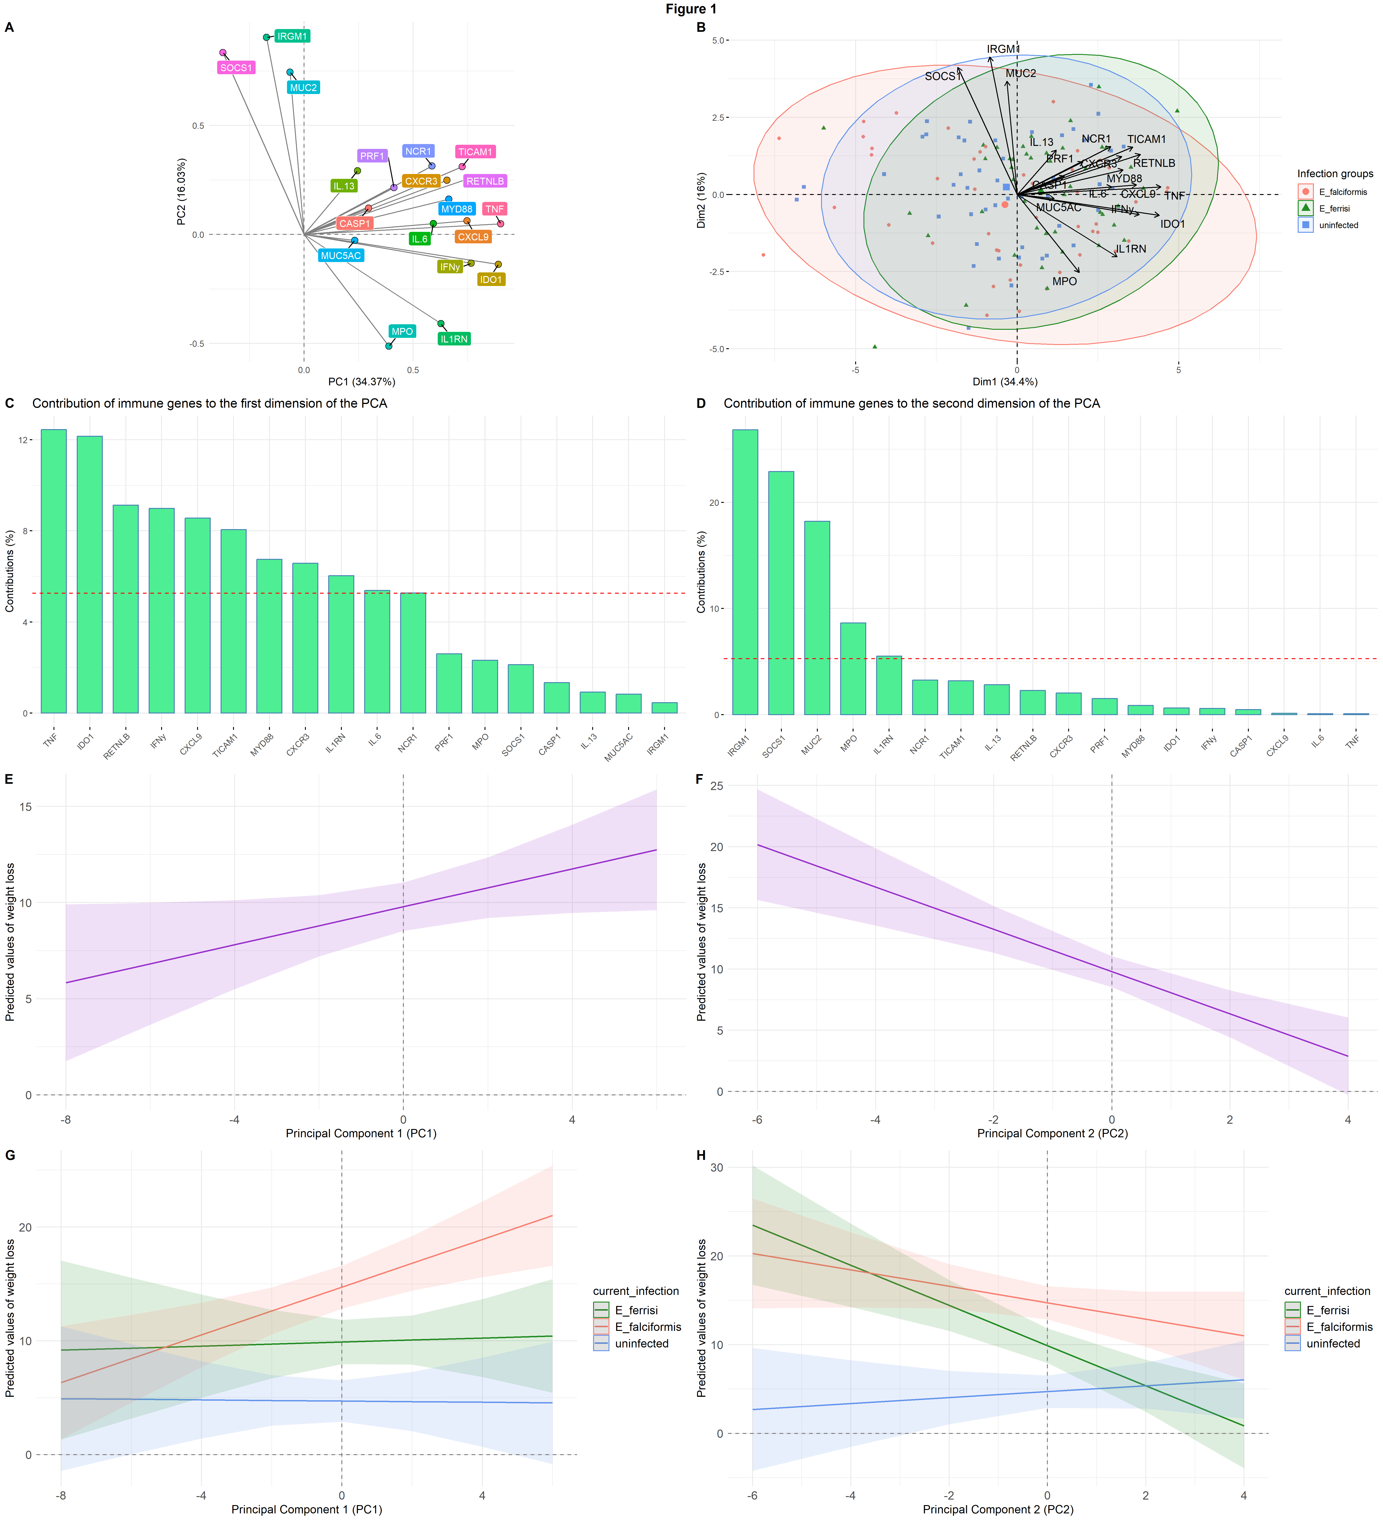

##   
## % Table created by stargazer v.5.2.3 by Marek Hlavac, Social Policy Institute. E-mail: marek.hlavac at gmail.com  
## % Date and time: Thu, Nov 02, 2023 - 16:39:18  
## \begin{table}[!htbp] \centering   
## \caption{Linear models - Predicting maximum weight loss}   
## \label{}   
## \begin{tabular}{@{\extracolsep{5pt}}lcccc}   
## \\[-1.8ex]\hline   
## \hline \\[-1.8ex]   
## & \multicolumn{4}{c}{\textit{Dependent variable:}} \\   
## \cline{2-5}   
## \\[-1.8ex] & \multicolumn{4}{c}{WL\_max} \\   
## \\[-1.8ex] & (1) & (2) & (3) & (4)\\   
## \hline \\[-1.8ex]   
## PC1 & 0.145 & 0.277 & 0.316 & 0.494$^{**}$ \\   
## & (0.234) & (0.287) & (0.204) & (0.244) \\   
## & & & & \\   
## PC2 & $-$0.693$^{**}$ & $-$0.760$^{**}$ & $-$1.105$^{***}$ & $-$1.728$^{***}$ \\   
## & (0.301) & (0.374) & (0.280) & (0.366) \\   
## & & & & \\   
## current\_infectionE\_ferrisi & $-$2.803$^{**}$ & & $-$3.088$^{**}$ & \\   
## & (1.382) & & (1.387) & \\   
## & & & & \\   
## current\_infectionuninfected & $-$1.324 & & $-$1.823 & \\   
## & (1.594) & & (1.563) & \\   
## & & & & \\   
## delta\_ct\_cewe\_MminusE & 0.629$^{***}$ & & 0.704$^{***}$ & \\   
## & (0.128) & & (0.118) & \\   
## & & & & \\   
## mouse\_strainBUSNA\_PWD & 0.056 & 0.095 & & \\   
## & (4.623) & (5.646) & & \\   
## & & & & \\   
## mouse\_strainBUSNA\_STRA & 0.268 & $-$0.637 & & \\   
## & (3.707) & (4.608) & & \\   
## & & & & \\   
## mouse\_strainNMRI & $-$6.186 & $-$1.313 & & \\   
## & (5.151) & (6.356) & & \\   
## & & & & \\   
## mouse\_strainPWD\_BUSNA & 1.145 & 0.200 & & \\   
## & (4.039) & (4.997) & & \\   
## & & & & \\   
## mouse\_strainPWD\_PWD & 5.859$^{*}$ & 11.299$^{***}$ & & \\   
## & (3.047) & (3.654) & & \\   
## & & & & \\   
## mouse\_strainPWD\_SCHUNT & $-$0.469 & 0.044 & & \\   
## & (4.018) & (5.003) & & \\   
## & & & & \\   
## mouse\_strainSCHUNT\_PWD & $-$2.845 & $-$2.694 & & \\   
## & (3.760) & (4.622) & & \\   
## & & & & \\   
## mouse\_strainSCHUNT\_SCHUNT & 2.642 & 5.658 & & \\   
## & (2.965) & (3.642) & & \\   
## & & & & \\   
## mouse\_strainSCHUNT\_STRA & 5.212 & 5.107 & & \\   
## & (4.132) & (5.142) & & \\   
## & & & & \\   
## mouse\_strainSTRA\_BUSNA & $-$1.414 & $-$0.943 & & \\   
## & (3.857) & (4.775) & & \\   
## & & & & \\   
## mouse\_strainSTRA\_SCHUNT & 0.793 & 0.788 & & \\   
## & (3.831) & (4.739) & & \\   
## & & & & \\   
## mouse\_strainSTRA\_STRA & $-$3.139 & $-$3.639 & & \\   
## & (3.798) & (4.699) & & \\   
## & & & & \\   
## immunizationhomologous & $-$0.947 & & $-$0.457 & \\   
## & (1.417) & & (1.388) & \\   
## & & & & \\   
## immunizationnaive & $-$0.642 & & 0.452 & \\   
## & (1.789) & & (1.765) & \\   
## & & & & \\   
## immunizationuninfected & $-$3.369$^{*}$ & & $-$3.162$^{*}$ & \\   
## & (1.766) & & (1.745) & \\   
## & & & & \\   
## weight\_dpi0 & 0.298$^{**}$ & 0.220 & 0.023 & \\   
## & (0.131) & (0.158) & (0.043) & \\   
## & & & & \\   
## Constant & 6.561$^{*}$ & 0.246 & 14.757$^{***}$ & 9.780$^{***}$ \\   
## & (3.931) & (4.546) & (1.743) & (0.635) \\   
## & & & & \\   
## \hline \\[-1.8ex]   
## Observations & 128 & 128 & 128 & 128 \\   
## R$^{2}$ & 0.631 & 0.391 & 0.569 & 0.173 \\   
## Adjusted R$^{2}$ & 0.557 & 0.310 & 0.536 & 0.160 \\   
## Residual Std. Error & 5.218 (df = 106) & 6.516 (df = 112) & 5.344 (df = 118) & 7.189 (df = 125) \\   
## F Statistic & 8.614$^{***}$ (df = 21; 106) & 4.796$^{***}$ (df = 15; 112) & 17.281$^{***}$ (df = 9; 118) & 13.072$^{***}$ (df = 2; 125) \\   
## \hline   
## \hline \\[-1.8ex]   
## \textit{Note:} & \multicolumn{4}{r}{$^{*}$p$<$0.1; $^{**}$p$<$0.05; $^{***}$p$<$0.01} \\   
## \end{tabular}   
## \end{table}