Template for Oxford University Press papers

# Introduction

This template is based on the generic OUP authoring template available on CTAN under [oup-authoring-template](https://www.ctan.org/pkg/oup-authoring-template). The CTAN template includes LaTeX documentation and a sample LaTeX document that provide far more details regarding the full functionality of the format. Here, only the basic functioning of the Rmarkdown adaptation of the format is demonstrated.

## A subsection

A numbered list:

1. First point
2. Second point
   * Subpoint

A bullet list:

* First point
* Second point

## Notes

* Extra white space in document will tend to disappear as text is filled in.
* Code blocks tend to generate lots of empty white space when echo=TRUE for some reason.

# Literature citations

By default, citations are handled by natbib using a numeric citation format. To use name-date citations, sets namedate: TRUE in the YAML header.

Here are two sample references:

* **author (year) example:** Horvath and Raj (2018) showed some really cool things. Only seems to work properly if namedate: TRUE.
* **(author year) example:** This is a well known result (Ji et al. 2013).

The bibliography will appear at the end of the document.

Though not normally available in the OUP LaTeX format, [CSL style files](https://www.zotero.org/styles) can also be used with the Rmarkdown adaptation by setting in the YAML header citation_package: "default" and defining the csl element to be the path towards the style file.

# Equations

An equation without a label for cross-referencing:

$$E=mc^{2}$$

An inline equation: $y=ax+b$

An equation with a label for cross-referencing:

This equation can be referenced as follows: Eq.

# Inserting R figures

The code below creates a figure. The code is included in the output because echo=TRUE.

plot(1:10,main="Some data",xlab="Distance (cm)",  
 ylab="Time (hours)")

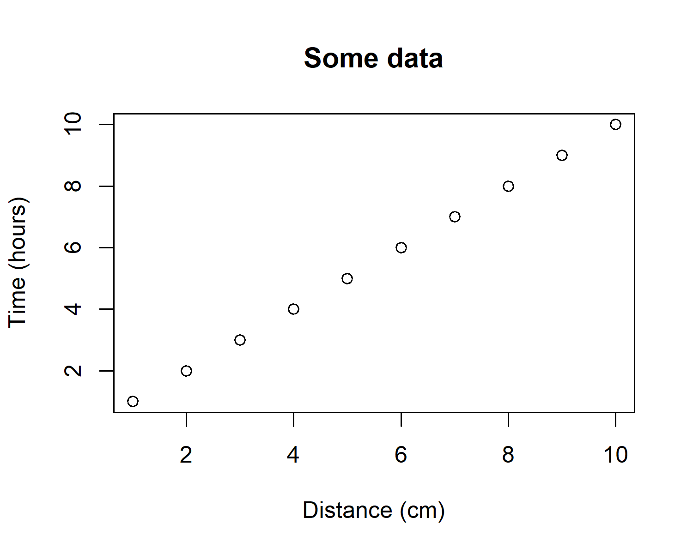

This is the first figure.

You can reference this figure as follows: Fig. .

## Figures spanning two-columns

Figures can span two columns be setting fig.env="figure*".

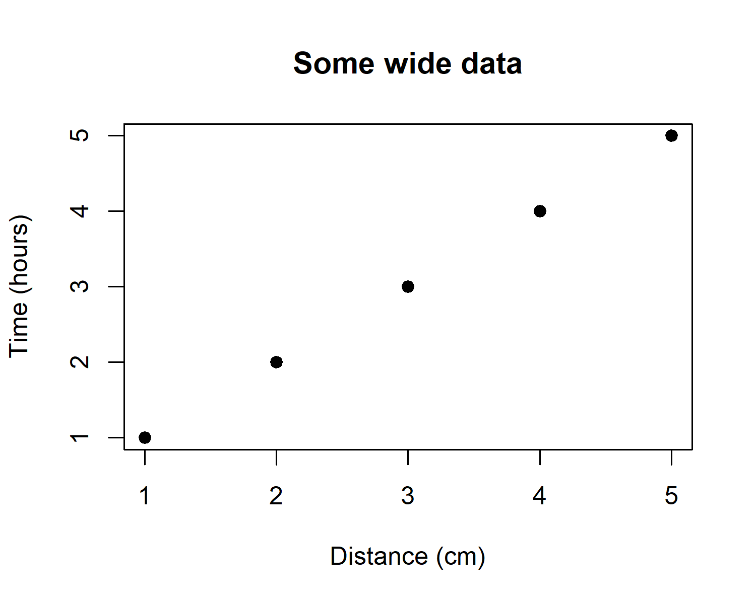

This is a wide figure.

Reference to second figure: Fig.

# Tables

## Generate a table using xtable

df = data.frame(ID=1:3,code=letters[1:3])  
  
# Creates tables that follow OUP guidelines   
# using xtable  
library(xtable)

## Warning: package 'xtable' was built under R version 4.2.1

print(xtable(df,caption="This is a xtable table.",  
 label="tab:tab1"),  
 comment=FALSE,caption.placement="top")

You can reference this table as follows: Table .

## Generate a table using kable

df = data.frame(ID=1:3,code=letters[1:3])  
  
# kable can alse be used for creating tables  
knitr::kable(df,caption="This is a kable table.",  
 booktabs=TRUE,label="tab2")

You can reference this table as follows: Table .

## Table spanning two columns

Tables can span two columns be setting table.envir = "table*" in knitr::kable.

df = data.frame(ID=1:3,code1=letters[1:3],  
 code2=letters[4:6],  
 code3=letters[7:9],  
 code4=letters[10:12],  
 code5=letters[13:15])  
  
# kable can alse be used for creating tables  
knitr::kable(df,caption="This is a wide kable table.",  
 #format="latex",  
 table.envir="table*",  
 booktabs=TRUE,label="tab3")

# Cross-referencing sections

You can cross-reference sections and subsections as follows: Section and Section .

***Note:*** the last section in the document will be used as the section title for the bibliography.

For more portable and flexible referencing of sections, equations, figures and tables, use [bookdown::pdf_document2](https://github.com/rstudio/bookdown) with YAML header option base_format: rticles::oup_article.

# Appendices

# Section title of first appendix

blabla

## Subsection title of first appendix

and so on….

# References

Horvath, Steve, and Kenneth Raj. 2018. “DNA Methylation-Based Biomarkers and the Epigenetic Clock Theory of Ageing.” *Nature Reviews Genetics* 19 (6): 371–84. <https://doi.org/10.1038/s41576-018-0004-3>.

Ji, Shuiwang, Wei Xu, Ming Yang, and Kai Yu. 2013. “3D Convolutional Neural Networks for Human Action Recognition.” *IEEE Transactions on Pattern Analysis and Machine Intelligence* 35 (1): 221–31. <https://doi.org/10.1109/TPAMI.2012.59>.