Challenge infections - Descreptive statistics

#### Challenge infections with Eimeria. Here I am presenting some summary statistics on the laboratory infection of mice with different Eimeria strains.

Here is a data frame containing all information derived from the experimental infections with *Eimeria*.

#### Read the file  
CI <- read.csv("https://raw.githubusercontent.com/derele/Eimeria_Lab/master/data_products/Challenge_infections.csv")

### Wrangling

## # A tibble: 2,984 x 98  
## EH_ID experiment primary_infecti~ challenge_infec~ mouse_strain labels weight  
## <chr> <chr> <chr> <chr> <chr> <chr> <dbl>  
## 1 LM02~ E57 E88 E64 BUSNA_STRA E57aA~ 22.2  
## 2 LM02~ E57 E88 E64 BUSNA_STRA E57aB~ 19.1  
## 3 LM02~ E57 E88 E64 BUSNA_STRA E57bx~ 22.9  
## 4 LM02~ E57 E88 E64 BUSNA_STRA E57aP~ 22   
## 5 LM02~ E57 E88 E64 BUSNA_STRA E57aF~ 20.0  
## 6 LM02~ E57 E88 E64 BUSNA_STRA E57aN~ 22.1  
## 7 LM02~ E57 E88 E64 BUSNA_STRA E57bx~ 22.9  
## 8 LM02~ E57 E88 E64 BUSNA_STRA E57bx~ 23.2  
## 9 LM02~ E57 E88 E64 BUSNA_STRA E57bx~ 23.1  
## 10 LM02~ E57 E88 E64 BUSNA_STRA E57aG~ 21.0  
## # ... with 2,974 more rows, and 91 more variables: weight_dpi0 <dbl>,  
## # relative_weight <dbl>, feces_weight <dbl>, dpi <int>, infection <chr>,  
## # oocyst_sq1 <int>, oocyst_sq2 <int>, oocyst_sq3 <int>, oocyst_sq4 <int>,  
## # dilution <dbl>, OO4sq <int>, OOC <dbl>, infection_history <chr>,  
## # Eim_MC <lgl>, delta <dbl>, IFNy_CEWE <dbl>, IFNy_MES <dbl>, CXCR3 <dbl>,  
## # IRG6 <dbl>, IL.12 <dbl>, CASP1 <dbl>, CXCL9 <dbl>, CXCR3_bio <dbl>,  
## # IDO1 <dbl>, IFNy <dbl>, IL.10 <dbl>, IL.12A <dbl>, IL1RN <dbl>, ...

Let’s add a column with the parasite names

### Summary statistics on experimental design

#### Summarizing data by each mouse

## Warning in max(OOC, na.rm = TRUE): no non-missing arguments to max; returning  
## -Inf  
  
## Warning in max(OOC, na.rm = TRUE): no non-missing arguments to max; returning  
## -Inf  
  
## Warning in max(OOC, na.rm = TRUE): no non-missing arguments to max; returning  
## -Inf  
  
## Warning in max(OOC, na.rm = TRUE): no non-missing arguments to max; returning  
## -Inf  
  
## Warning in max(OOC, na.rm = TRUE): no non-missing arguments to max; returning  
## -Inf  
  
## Warning in max(OOC, na.rm = TRUE): no non-missing arguments to max; returning  
## -Inf  
  
## Warning in max(OOC, na.rm = TRUE): no non-missing arguments to max; returning  
## -Inf

## Warning in min(relative_weight, na.rm = TRUE): no non-missing arguments to min;  
## returning Inf  
  
## Warning in min(relative_weight, na.rm = TRUE): no non-missing arguments to min;  
## returning Inf  
  
## Warning in min(relative_weight, na.rm = TRUE): no non-missing arguments to min;  
## returning Inf  
  
## Warning in min(relative_weight, na.rm = TRUE): no non-missing arguments to min;  
## returning Inf  
  
## Warning in min(relative_weight, na.rm = TRUE): no non-missing arguments to min;  
## returning Inf  
  
## Warning in min(relative_weight, na.rm = TRUE): no non-missing arguments to min;  
## returning Inf

## `summarise()` has grouped output by 'EH_ID'. You can override using the `.groups` argument.

#### How many mice do we have in each infection ? (primary or challenge infection)

## # A tibble: 2 x 2  
## infection total_mice  
## <chr> <int>  
## 1 challenge 132  
## 2 primary 153

#### How many experiments do we have? How many mice are in each experiment?

## # A tibble: 5 x 2  
## experiment total_mice  
## <chr> <int>  
## 1 E10 52  
## 2 E11 55  
## 3 E57 106  
## 4 P3 32  
## 5 P4 40

#### How many mouse strains do we have?

We here use four wild-derived inbred mouse strains. from these mouse strains F1 hybrids were generated.

Two parental strains represented M. m. domesticus: - SCHUNT (Locality: Schweben, Hessen, Germany [N: 5°0 26′, E: 9°36′] (Martincová et al., 2019))  
- STRA (Locality: Straas, Bavaria, Germany [N: 50°11′, E: 11°46′] (Piálek et al., 2008), Two parental strains represented M. m. musculus: - BUSNA (Locality: Buškovice, Bohemia, Czech Republic [N: 5°0 14′, E: 1°3 22′] (Piálek et al., 2008)) - PWD (Locality: Kunratice, Bohemia, Czech Republic [N: 5°0 01′, E: 14 2°9′] (Gregorová & Forejt, 2000))

## `summarise()` has grouped output by 'mouse_strain'. You can override using the `.groups` argument.

## # A tibble: 13 x 3  
## # Groups: mouse_strain [13]  
## mouse_strain hybrid_status total_mice  
## <chr> <chr> <int>  
## 1 BUSNA_BUSNA F0 M. m. musculus 8  
## 2 BUSNA_PWD F1 M. m. musculus 6  
## 3 BUSNA_STRA F1 hybrid 10  
## 4 NMRI other 72  
## 5 PWD_BUSNA F1 M. m. musculus 8  
## 6 PWD_PWD F0 M. m. musculus 56  
## 7 PWD_SCHUNT F1 hybrid 6  
## 8 SCHUNT_PWD F1 hybrid 8  
## 9 SCHUNT_SCHUNT F0 M. m. domesticus 73  
## 10 SCHUNT_STRA F1 M. m. domesticus 6  
## 11 STRA_BUSNA F1 hybrid 10  
## 12 STRA_SCHUNT F1 M. m. domesticus 10  
## 13 STRA_STRA F0 M. m. domesticus 12

## # A tibble: 6 x 2  
## hybrid_status total_mice  
## <chr> <int>  
## 1 F0 M. m. domesticus 85  
## 2 F0 M. m. musculus 64  
## 3 F1 hybrid 34  
## 4 F1 M. m. domesticus 16  
## 5 F1 M. m. musculus 14  
## 6 other 72

#### Which Eimeria strains were used?

The three parasite isolates used in this study were isolated from feces of three different M. m. domesticus/M. m. musculus hybrid mice captured in Brandenburg, Germany, in 2016 (capture permit No. 2347/35/2014). The parasite isolates belong to both the most prevalent Eimeria species in this area, namely E. ferrisi (isolate Brandenburg64) and E. falciformis (isolate Brandenburg88)(Jarquín-Díaz et al., 2019). Isolate Brandenburg64 was isolated in a 92% M. m. domesticus individual (hybrid index (HI) = 0.08: Proportion of M. m. musculus alleles in a set of 14 diagnostic markers, see Balard et al. (2020)) and isolate Brandenburg88 in a 80% M. m. domesticus (HI = 0.2).

Prepatency and the peak day of parasite shedding for these isolates were estimated during infection in NMRI laboratory mice (Al-khlifeh et al., 2019) which were also used for serial passaging of the isolates. Previous to the experiment, the isolates had been passaged, respectively, 3 and 4 times in NMRI laboratory mice. Parasite infective forms (oocysts) were recovered by flotation in saturated NaCl solution followed by washing and observation under light microscope (following the protocol described in Clerc et al. (2019)) and stored at room temperature in 1 ml of 2% potassium dichromate for a maximum of 2 months before infection of the wild-derived mice. Oocysts were allowed to sporulate 10 days before infection in a water bath at 30°C

1. Primary:

## # A tibble: 3 x 2  
## Parasite_primary total_mice  
## <chr> <int>  
## 1 Eimeria falciformis 60  
## 2 Eimeria ferrisi 69  
## 3 uninfected 24

1. Further, for the challenge infections

## # A tibble: 3 x 2  
## Parasite_challenge total_mice  
## <chr> <int>  
## 1 Eimeria falciformis 27  
## 2 Eimeria ferrisi 54  
## 3 uninfected 51

#### 2.6 How many mice died in each infection?

## # A tibble: 2 x 2  
## death `length(EH_ID)`  
## <chr> <int>  
## 1 challenge 264  
## 2 primary 21

#### 2.6.1 From the mice that died in the primary infection, what was the infection status?

## # A tibble: 2 x 2  
## Parasite_primary total_mice  
## <chr> <int>  
## 1 Eimeria falciformis 18  
## 2 Eimeria ferrisi 3

Most of the mice dying in the first infections are infected with Eimeria falciformis.

### 3 Summary statistics - Resistance/ Tolerance proxies

#### 3.1 What is the avarege maximum oocysts output for each mouse in the primary and challenge infections?

1. Visualizing the primary infections `

CIMouse %>%  
 filter(infection == "primary") %>%  
 ggplot(aes(max_OOC, color = Parasite_primary, fill = Parasite_primary)) +  
 geom_histogram(bins = 30, alpha = 0.5) +  
 labs(x = "Oocysts at day of maximal shedding", y = "Number of mice",  
 title = "Maximum oocyst shedding per mouse, primary infections") +  
 theme_bw()

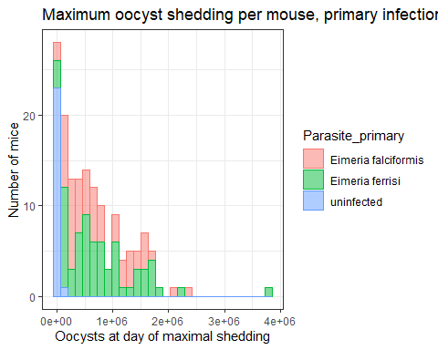

CIMouse %>%  
 filter(infection == "primary") %>%  
 ggplot(aes(x = Parasite_primary, y = max_OOC, fill = Parasite_primary)) +  
 geom_boxplot() +  
 theme_bw()

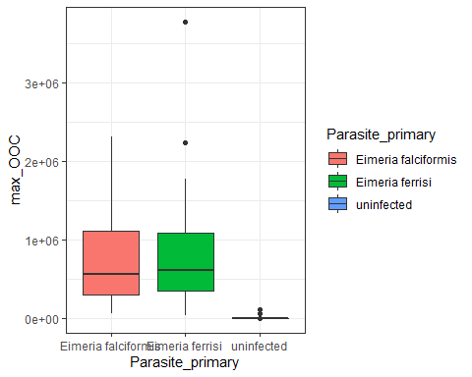

CIMouse %>%  
 filter(infection == "primary") %>%  
 ggplot(aes(x = Parasite_primary, y = max_OOC, fill = Parasite_primary)) +  
 geom_violin() +  
 theme_bw()

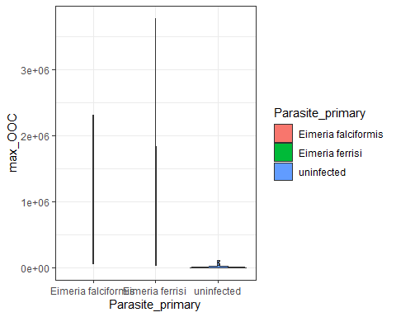

CIMouse %>%  
 filter(infection == "primary", !Parasite_primary == "uninfected") %>%  
 ggplot(aes(x = Parasite_primary, y = max_OOC, fill = Parasite_primary)) +  
 geom_violin(alpha = 0.5) +  
 geom_line() +  
 stat_summary(fun.y = "median", geom = "point", size = 3) +  
 theme_bw()

## Warning: `fun.y` is deprecated. Use `fun` instead.

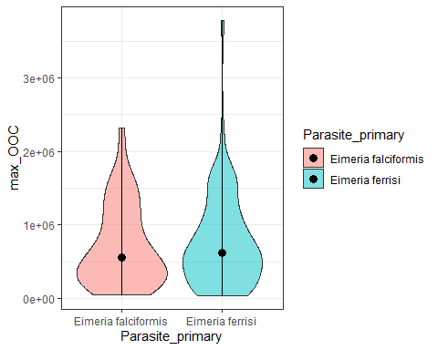

CIMouse %>%  
 filter(infection == "primary", !Parasite_primary == "uninfected") %>%  
 ggplot(aes(x = Parasite_primary, y = max_OOC, fill = Parasite_primary)) +  
 geom_violin(alpha = 0.5) +  
 geom_line() +  
 stat_summary(fun.y = "median", geom = "point", size = 3) +  
 theme_bw()

## Warning: `fun.y` is deprecated. Use `fun` instead.



1. And the challenge infections

CIMouse %>%  
 filter(infection == "challenge") %>%  
 ggplot(aes(max_OOC, color = Parasite_challenge, fill = Parasite_challenge)) +  
 geom_histogram(bins = 30, alpha = 0.5) +  
 labs(x = "Oocysts at day of maximal shedding", y = "Number of mice",  
 title = "Maximum oocyst shedding per mouse, challenge infections") +  
 theme_bw()

## Warning: Removed 7 rows containing non-finite values (stat_bin).

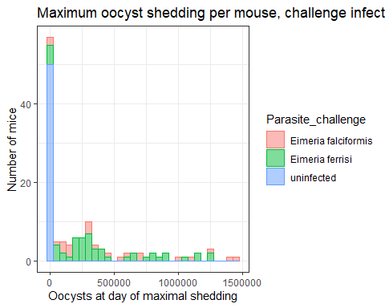

CIMouse %>%  
 filter(infection == "challenge") %>%  
 ggplot(aes(x = Parasite_challenge, y = max_OOC, fill = Parasite_challenge)) +  
 geom_boxplot() +  
 theme_bw()

## Warning: Removed 7 rows containing non-finite values (stat_boxplot).

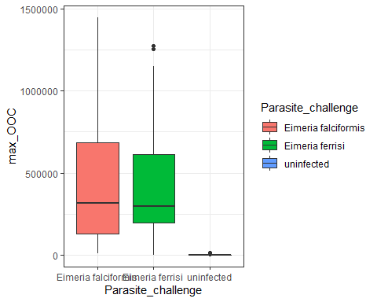

CIMouse %>%  
 filter(infection == "challenge") %>%  
 ggplot(aes(x = Parasite_challenge, y = max_OOC, fill = Parasite_challenge)) +  
 geom_violin() +  
 theme_bw()

## Warning: Removed 7 rows containing non-finite values (stat_ydensity).

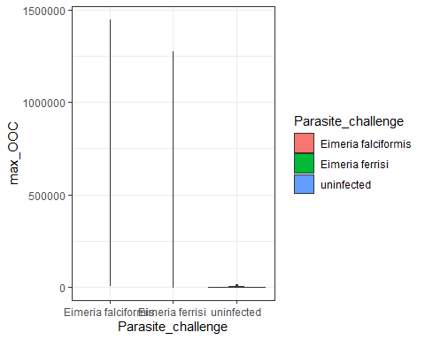

CIMouse %>%  
 filter(infection == "challenge", !Parasite_challenge == "uninfected") %>%  
 ggplot(aes(x = Parasite_challenge, y = max_OOC, fill = Parasite_challenge)) +  
 geom_violin(alpha = 0.5) +  
 geom_line() +  
 stat_summary(fun.y = "median", geom = "point", size = 3) +  
 theme_bw()

## Warning: `fun.y` is deprecated. Use `fun` instead.

## Warning: Removed 6 rows containing non-finite values (stat_ydensity).

## Warning: Removed 6 rows containing non-finite values (stat_summary).

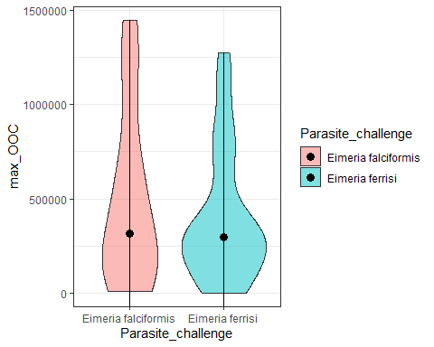

#### maximum oocysts output for each mouse strain in each infection?

1. primary infections: 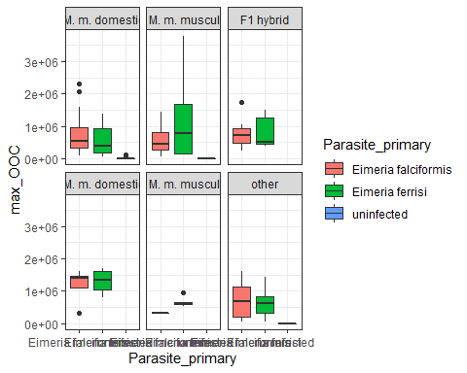
2. Challenge infections:

## Warning: Removed 7 rows containing non-finite values (stat_boxplot).

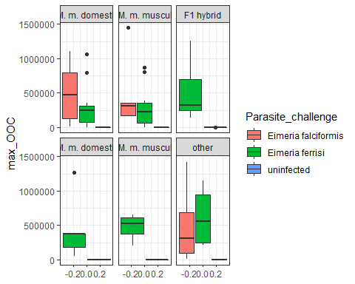 Effect of experiments on oocyst shedding?

1. primary infections: 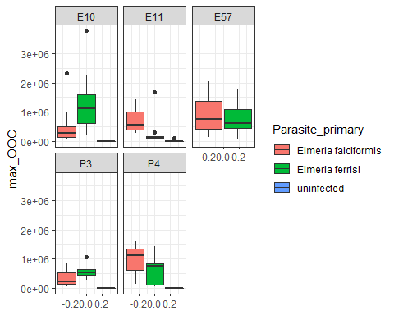
2. Challenge infections:

## Warning: Removed 7 rows containing non-finite values (stat_boxplot).

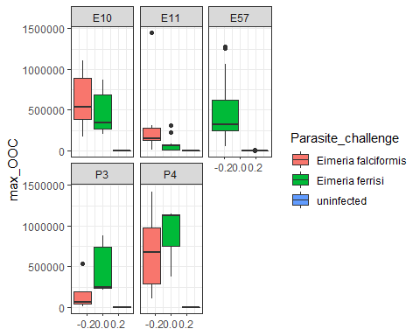 Patency in primary infections

CI %>%  
 group_by("EH_ID") %>%  
 filter(infection == "primary") %>%  
 ggplot(aes(x = dpi, y = OOC, color = Parasite_primary)) +  
 geom_point(position = position_jitterdodge()) +  
 labs(x = "Days Post Infection", y = "Oocysts per gram",  
 title = "Oocyst shedding in primary infections during the   
 course of infection") +  
 theme_bw()

## Warning: Removed 497 rows containing missing values (geom_point).

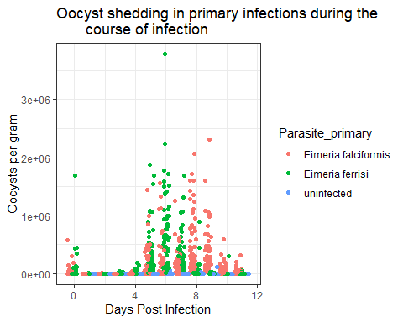

Patency in primary infections - experiments

CI %>%  
 group_by("EH_ID") %>%  
 filter(infection == "primary") %>%  
 ggplot(aes(x = dpi, y = OOC, color = Parasite_primary)) +  
 geom_point(position = position_jitterdodge()) +  
 labs(x = "Days Post Infection", y = "Oocysts per gram",  
 title = "Oocyst shedding in primary infections during the   
 course of infection") +  
 theme_bw() +  
 facet_wrap(~ experiment)

## Warning: Removed 497 rows containing missing values (geom_point).

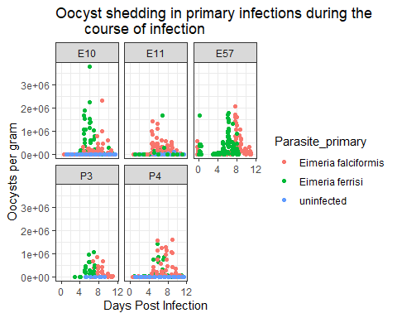 Patency in primary infections - mouse strains

CI %>%  
 group_by("EH_ID") %>%  
 filter(infection == "primary") %>%  
 ggplot(aes(x = dpi, y = OOC, color = Parasite_primary)) +  
 geom_point(position = position_jitterdodge()) +  
 labs(x = "Days Post Infection", y = "Oocysts per gram",  
 title = "Oocyst shedding in primary infections during the   
 course of infection") +  
 theme_bw() +  
 facet_wrap(~ hybrid_status)

## Warning: Removed 497 rows containing missing values (geom_point).

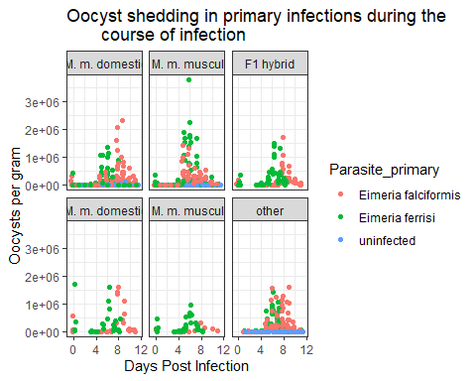 Patency in challenge infections - experiments

CI %>%  
 group_by("EH_ID") %>%  
 filter(infection == "challenge") %>%  
 ggplot(aes(x = dpi, y = OOC, color = Parasite_challenge)) +  
 geom_point(position = position_jitterdodge()) +  
 labs(x = "Days Post Infection", y = "Oocysts per gram",  
 title = "Oocyst shedding in challenge infections during the   
 course of infection") +  
 theme_bw() +  
 facet_wrap(~ experiment)

## Warning: Removed 167 rows containing missing values (geom_point).

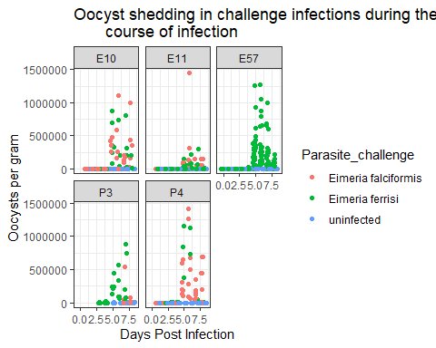 Patency in challenge infections - mouse strains

CI %>%  
 group_by("EH_ID") %>%  
 filter(infection == "challenge") %>%  
 ggplot(aes(x = dpi, y = OOC, color = Parasite_challenge)) +  
 geom_point(position = position_jitterdodge()) +  
 labs(x = "Days Post Infection", y = "Oocysts per gram",  
 title = "Oocyst shedding in challenge infections during the   
 course of infection") +  
 theme_bw() +  
 facet_wrap(~ hybrid_status)

## Warning: Removed 167 rows containing missing values (geom_point).

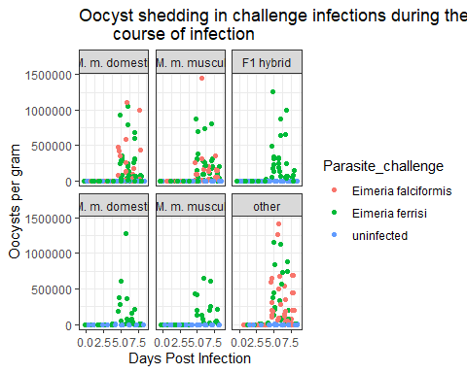

#### What is the average max weight loss output for each mouse in the primary and challenge infections?

1. Visualizing the primary infections `

CIMouse %>%  
 dplyr::filter(infection == "primary") %>%  
 ggplot(aes(max_WL, color = Parasite_primary, fill = Parasite_primary)) +  
 geom_histogram(bins = 30, alpha = 0.5) +  
 theme_bw()

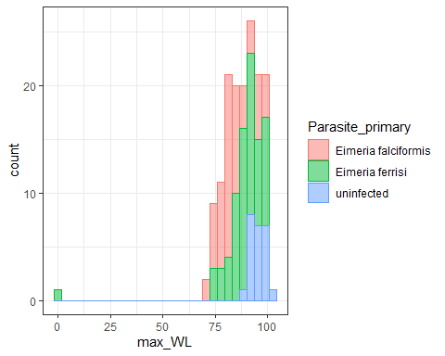

CIMouse %>%  
 filter(infection == "primary") %>%  
 ggplot(aes(x = Parasite_primary, y = max_WL, fill = Parasite_primary)) +  
 geom_boxplot() +  
 theme_bw()

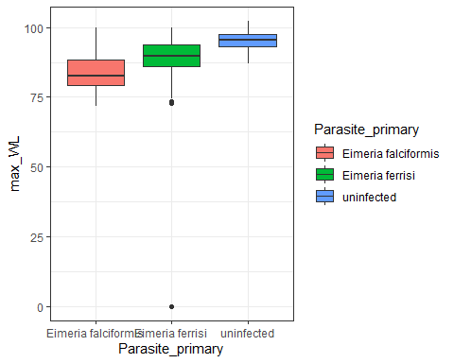

CIMouse %>%  
 filter(infection == "primary") %>%  
 ggplot(aes(x = Parasite_primary, y = max_WL, fill = Parasite_primary)) +  
 geom_violin(alpha = 0.5) +  
 geom_line() +  
 stat_summary(fun.y = "median", geom = "point", size = 3) +  
 theme_bw()

## Warning: `fun.y` is deprecated. Use `fun` instead.

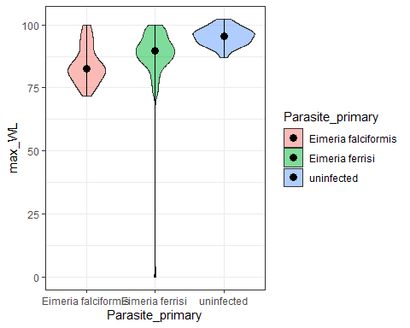

1. And the challenge infections

CIMouse %>%  
 filter(infection == "challenge") %>%  
 ggplot(aes(max_WL, color = Parasite_challenge, fill = Parasite_challenge)) +  
 geom_histogram(bins = 30, alpha = 0.5) +  
 theme_bw()

## Warning: Removed 6 rows containing non-finite values (stat_bin).

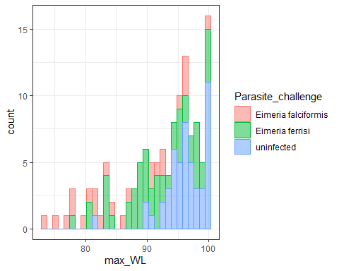

CIMouse %>%  
 filter(infection == "challenge") %>%  
 ggplot(aes(x = Parasite_challenge, y = max_WL, fill = Parasite_challenge)) +  
 geom_boxplot() +  
 theme_bw()

## Warning: Removed 6 rows containing non-finite values (stat_boxplot).

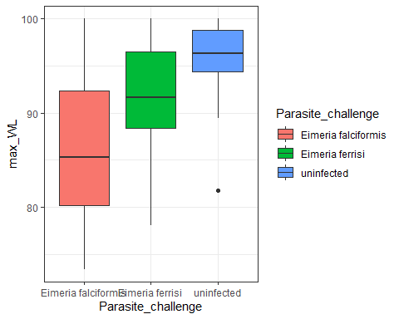

CIMouse %>%  
 filter(infection == "challenge") %>%  
 ggplot(aes(x = Parasite_challenge, y = max_WL, fill = Parasite_challenge)) +  
 geom_violin(alpha = 0.5) +  
 geom_line() +  
 stat_summary(fun.y = "median", geom = "point", size = 3) +  
 theme_bw()

## Warning: `fun.y` is deprecated. Use `fun` instead.

## Warning: Removed 6 rows containing non-finite values (stat_ydensity).

## Warning: Removed 6 rows containing non-finite values (stat_summary).

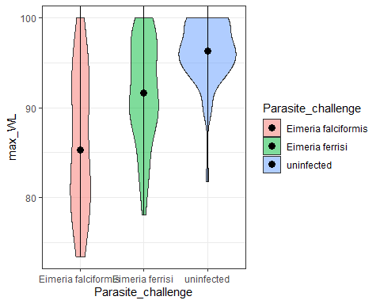

#### maximum weight loss output for each mouse strain in each infection?

1. primary infections: 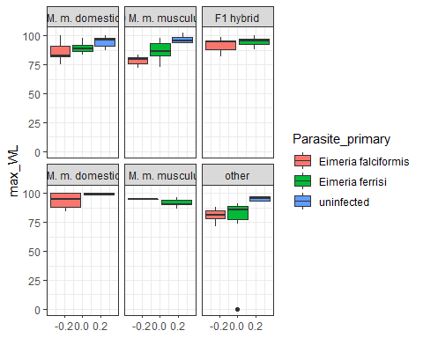
2. Challenge infections:

## Warning: Removed 6 rows containing non-finite values (stat_boxplot).

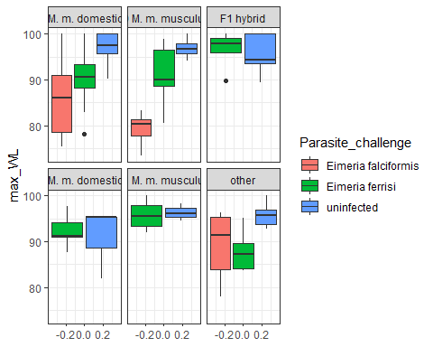 Effect of experiments on weight loss?

1. primary infections: 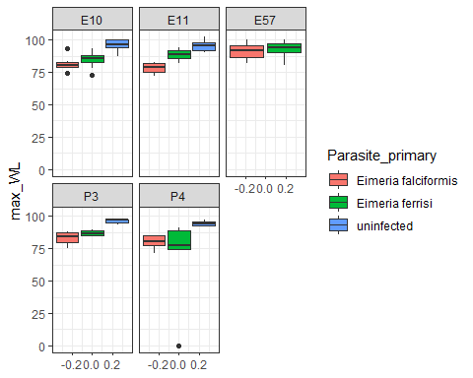 Weight changes during the course of infection
2. Primary

CI %>%   
 filter(infection == "primary") %>%  
 drop_na(weight_dpi0, relative_weight) %>%  
 group_by("EH_ID") %>%  
 ggplot(aes(x = dpi, y = relative_weight, color = Parasite_primary)) +  
 geom_jitter() +  
 stat_smooth() +  
 labs(x = "Days Post Infection", y = "Relative weight to first day",  
 title = "Weight changes during the course of the primary infection") +  
 theme_bw()

## `geom_smooth()` using method = 'loess' and formula 'y ~ x'

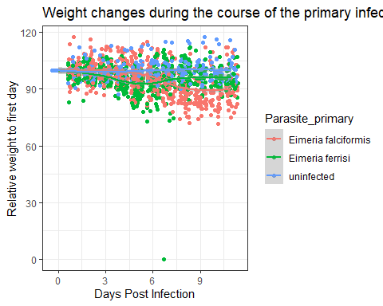

CI %>%   
 filter(infection == "primary") %>%  
 drop_na(weight_dpi0, relative_weight) %>%  
 group_by("EH_ID") %>%  
 ggplot(aes(x = dpi, y = relative_weight, color = Parasite_primary)) +  
 geom_jitter() +  
 stat_smooth() +  
 facet_wrap(~ mouse_strain) +  
 labs(x = "Days Post Infection", y = "Relative weight to first day",  
 title = "Weight changes during the course of the primary infection") +  
 theme_bw()

## `geom_smooth()` using method = 'loess' and formula 'y ~ x'

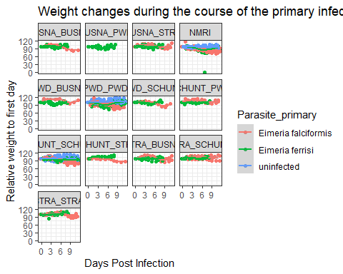

CI %>%   
 filter(infection == "primary") %>%  
 drop_na(weight_dpi0, relative_weight) %>%  
 group_by("EH_ID") %>%  
 ggplot(aes(x = dpi, y = relative_weight, color = Parasite_primary)) +  
 geom_jitter() +  
 stat_smooth() +  
 facet_wrap(~ experiment) +  
 labs(x = "Days Post Infection", y = "Relative weight to first day",  
 title = "Weight changes during the course of the primary infection") +  
 theme_bw()

## `geom_smooth()` using method = 'loess' and formula 'y ~ x'

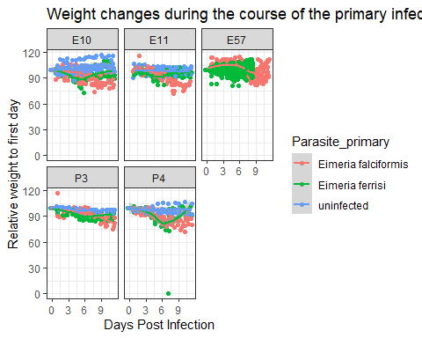 Weight changes during the course of infection 1. challenge

CI %>%   
 filter(infection == "challenge") %>%  
 drop_na(weight_dpi0, relative_weight) %>%  
 group_by("EH_ID") %>%  
 ggplot(aes(x = dpi, y = relative_weight, color = Parasite_challenge)) +  
 geom_jitter() +  
 stat_smooth() +  
 labs(x = "Days Post Infection", y = "Relative weight to first day",  
 title = "Weight changes during the course of the challenge infection") +  
 theme_bw()

## `geom_smooth()` using method = 'loess' and formula 'y ~ x'

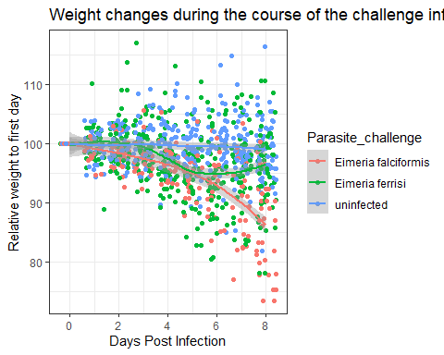

CI %>%   
 filter(infection == "challenge") %>%  
 drop_na(weight_dpi0, relative_weight) %>%  
 group_by("EH_ID") %>%  
 ggplot(aes(x = dpi, y = relative_weight, color = Parasite_challenge)) +  
 geom_jitter() +  
 stat_smooth() +  
 facet_wrap(~ mouse_strain) +  
 labs(x = "Days Post Infection", y = "Relative weight to first day",  
 title = "Weight changes during the course of the challenge infection") +  
 theme_bw()

## `geom_smooth()` using method = 'loess' and formula 'y ~ x'

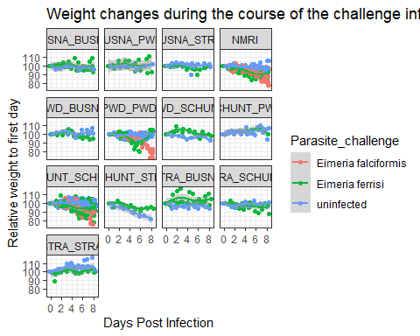

CI %>%   
 filter(infection == "challenge") %>%  
 drop_na(weight_dpi0, relative_weight) %>%  
 group_by("EH_ID") %>%  
 ggplot(aes(x = dpi, y = relative_weight, color = Parasite_challenge)) +  
 geom_jitter() +  
 stat_smooth() +  
 facet_wrap(~ experiment) +  
 labs(x = "Days Post Infection", y = "Relative weight to first day",  
 title = "Weight changes during the course of the challenge infection") +  
 theme_bw()

## `geom_smooth()` using method = 'loess' and formula 'y ~ x'

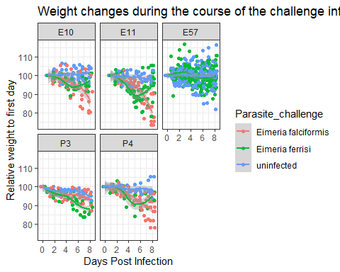

Tissue infection intensity vs max weight loss - primary

CI %>%  
 group_by("EH_ID") %>%  
 filter(infection == "primary", Eim_MC == "TRUE") %>%  
 ggplot(aes(x = delta, y = max_WL, color = Parasite_primary)) +  
 geom_jitter() +  
 labs(x = "Delta Ct, Infection intensity", y = "Maximum weight loss of each mouse",  
 title = "Maximum Weight loss for each mouse and infection intensity,   
 primary infections") +  
 theme_bw()

## Warning: Removed 11 rows containing missing values (geom_point).

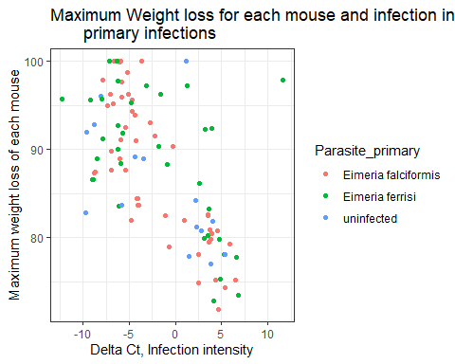

Tissue infection intensity vs max weight loss - challenge

CI %>%  
 group_by("EH_ID") %>%  
 filter(infection == "challenge", Eim_MC == "TRUE") %>%  
 ggplot(aes(x = delta, y = max_WL, color = Parasite_challenge)) +  
 geom_jitter() +  
 labs(x = "Delta Ct, Infection intensity", y = "Maximum weight loss of each mouse",  
 title = "Maximum Weight loss for each mouse and infection intensity,   
 challenge infections") +  
 theme_bw()

