Weight_problems

Fay 2024-04-24

How many mice went through primary infections?

|  |
| --- |
| Challenge **%>% filter**(infection **==** "primary", Mouse_ID **%in%** lab**$**Mouse_ID, dpi **==** max_dpi) **%>%**  **summarise**(**n**()) |

## n()

## 1 136

How many mice died in the primary infections?

|  |
| --- |
| Challenge **%>% filter**(infection **==** "primary", Mouse_ID **%in%** lab**$**Mouse_ID, death **==** "primary", dpi **==** max_dpi) **%>%**  **summarise**(**n**()) |

## n() ## 1 20

How many mice were in the challenge infections?

|  |
| --- |
| Challenge **%>% filter**(infection **==** "challenge", Mouse_ID **%in%** lab**$**Mouse_ID, dpi **==** max_dpi, death **==** "challenge") **%>%**  **summarise**(**n**()) |

## n()

## 1 148

Something is fishy here. Do we have duplicates? Yes, I forgot to remove the spleen measurements. Luke used the spleen for gene expression for some mice. We use here the mesenterial lymphnodes. (?)

|  |
| --- |
| Challenge **%>% filter**(infection **==** "challenge", Mouse_ID **%in%** lab**$**Mouse_ID, dpi **==** max_dpi, death **==** "challenge", Position **==** "mLN") **%>%**  **summarize**(**n**()) |

## n() ## 1 116 Original in article of primary infections: I include mice that died in primary infections, but also the mice that went on to be challenged.

|  |
| --- |
| **ggplot**(Challenge **%>% filter**(infection **==** "primary", Mouse_ID **%in%** lab**$**Mouse_ID) **%>% group_by**(Mouse_ID),  **aes**(x = WL_max, y = Parasite_primary, fill = Parasite_primary)) **+ geom_density_ridges**(jittered_points = TRUE,  position = **position_points_jitter**(height = 0), scale = 0.9, alpha = 0.6, point_shape = 21, point_size = 2, point_alpha = 1) **+**  **geom_boxplot**(width = 0.2, outlier.shape = NA, alpha = 0.5, position = **position_nudge**(x = 0.2)) **+**  *# coord_flip() +* **theme_minimal**() **+**  **scale_fill_manual**(values = color_mapping) **+ theme**(legend.position = "none", axis.text.x = **element_text**(angle = 0, vjust = 0.5, hjust=0.3)) **+**  **xlab**("Maximum relative weight loss") **+ ylab**("Parasite strain - primary infections") |

## Picking joint bandwidth of 1.33

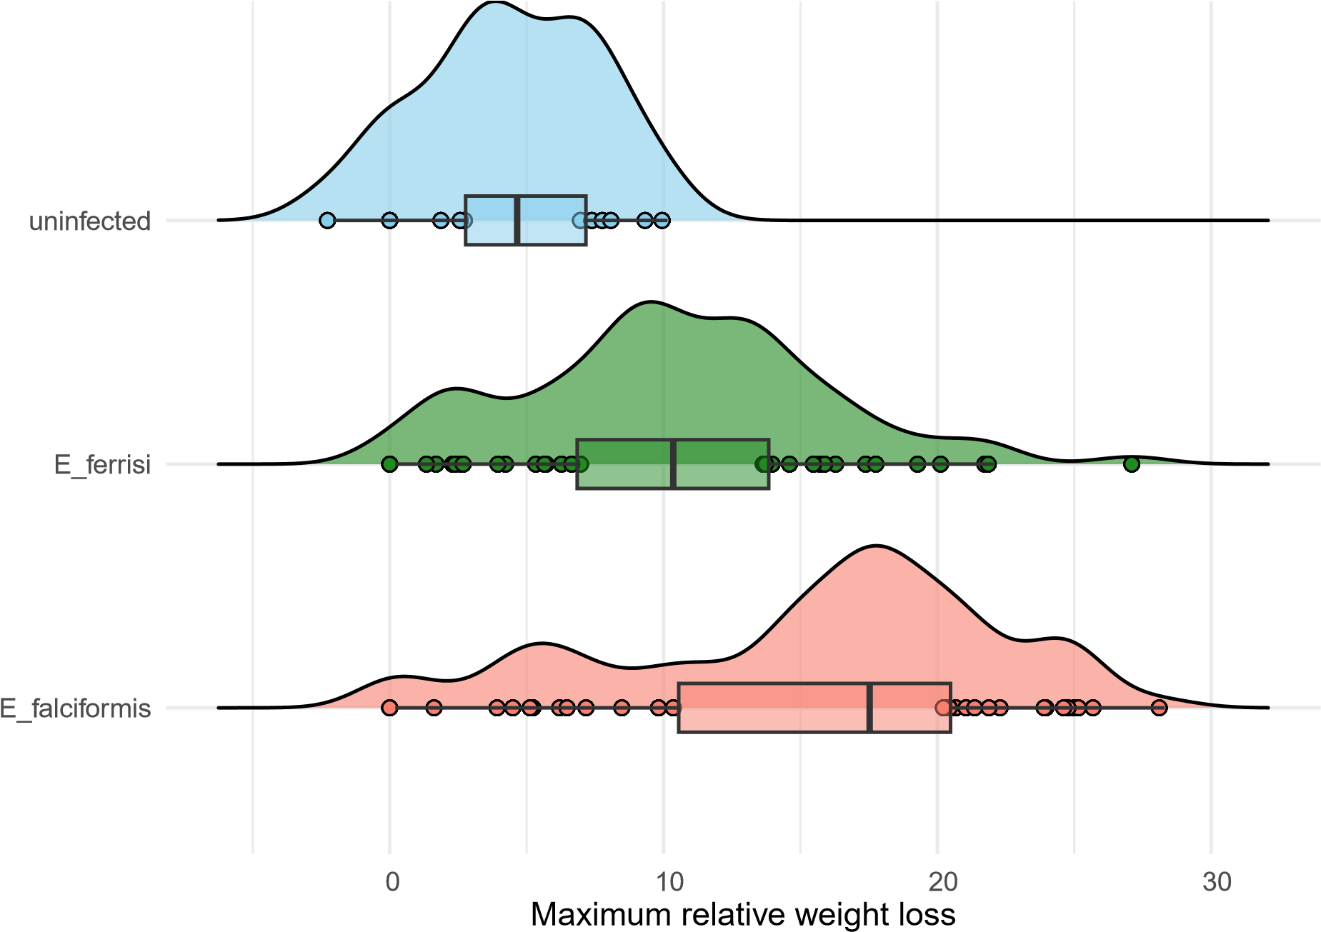

Parasite strain − primary infections

What happens, if I remove the mice that were challenged. Here, including just the mice that died in the primary infections.

|  |
| --- |
| **ggplot**(Challenge **%>% filter**(infection **==** "primary", Mouse_ID **%in%** lab**$**Mouse_ID, death **==** "primary") **%>% group_by**(Mouse_ID),  **aes**(x = WL_max, y = Parasite_primary, fill = Parasite_primary)) **+ geom_density_ridges**(jittered_points = TRUE,  position = **position_points_jitter**(height = 0), scale = 0.9, alpha = 0.6, point_shape = 21, point_size = 2, point_alpha = 1) **+**  **geom_boxplot**(width = 0.2, outlier.shape = NA, alpha = 0.5, position = **position_nudge**(x = 0.2)) **+**  *# coord_flip() +* **theme_minimal**() **+**  **scale_fill_manual**(values = color_mapping) **+ theme**(legend.position = "none", axis.text.x = **element_text**(angle = 0, vjust = 0.5, hjust=0.3)) **+**  **xlab**("Maximum relative weight loss") **+ ylab**("Parasite strain - primary infections") |

## Picking joint bandwidth of 1.27

E_falciformis

E_ferrisi

15

20

25

30

Maximum relative weight loss

Parasite strain − primary infections

Where are the uninfected mice? Did we just have infected mice? I remember reaching the same conclusion before.

How many mice died on each day in the primary infections?

|  |
| --- |
| Challenge **%>% filter**(infection **==** "primary", Mouse_ID **%in%** lab**$**Mouse_ID, death **==** "primary", dpi **==** max_dpi) **%>%**  **group_by**(max_dpi) **%>% summarise**(**n**()) |

## # A tibble: 6 x 2

## max_dpi `n()` ## <int> <int>

## 1 5 2 ## 2 6 1 ## 3 8 6 ## 4 9 6

## 5 10 3 ## 6 11 2

|  |
| --- |
| Challenge **%>% filter**(infection **==** "primary", Mouse_ID **%in%** lab**$**Mouse_ID, death **==** "primary", dpi **==** max_dpi) **%>%**  **ggplot**(**aes**(x = max_dpi)) **+ geom_histogram**() |

## `stat_bin()` using `bins = 30`. Pick better value with `binwidth`.

0

2

4

6

6

8

10

max_dpi

count

What about the challenge infections? How many mice died on each day in the primary infections?

|  |
| --- |
| Challenge **%>% filter**(infection **==** "challenge", Mouse_ID **%in%** lab**$**Mouse_ID, death **==** "challenge", dpi **==** max_dpi, Position **==** "mLN") **%>%**  **group_by**(max_dpi) **%>% summarise**(**n**()) |

## # A tibble: 5 x 2

## max_dpi `n()` ## <int> <int>

## 1 2 1 ## 2 5 1 ## 3 6 2 ## 4 7 1

## 5 8 111

|  |
| --- |
| Challenge **%>% filter**(infection **==** "challenge", Mouse_ID **%in%** lab**$**Mouse_ID, death **==** "challenge", dpi **==** max_dpi, Position **==** "mLN") **%>%**  **ggplot**(**aes**(x = max_dpi)) **+ geom_histogram**() |

## `stat_bin()` using `bins = 30`. Pick better value with `binwidth`.

|  |  |  |  |  |  |  |  |
| --- | --- | --- | --- | --- | --- | --- | --- |
|  |  |  |  |  |  |  |  |
|  |  |  |  |  |  |  |  |
|  |  |  |  |  |  |  |  |
|  |  |  |  |  |  |  |  |
|  |  |  |  |  |  |  |  |
|  |  |  |  |  |  |  |  |
|  |  |  |  |  |  |  |  |
|  |  |  |  |  |  |  |  |
|  |  |  |  |  |  |  |  |

90

60

count

30

0

2 4 6 8

max_dpi

# Challenge infections remains the same

|  |
| --- |
| **ggplot**(lab **%>% filter**(infection **==** "challenge") **%>% group_by**(Mouse_ID),  **aes**(x = WL_max, y = Parasite_challenge, fill = Parasite_challenge)) **+ geom_density_ridges**(jittered_points = TRUE, position =  **position_points_jitter**(height = 0),  scale = 0.9, alpha = 0.6, point_shape = 21, point_size = 2, point_alpha = 1) **+**  **geom_boxplot**(width = 0.2, outlier.shape = NA, alpha = 0.5, position = **position_nudge**(x = 0.2)) **+**  *# coord_flip() +* **theme_minimal**() **+**  **scale_fill_manual**(values = color_mapping) **+ theme**(legend.position = "none", axis.text.x = **element_text**(angle = 0, vjust = 0.5, hjust=0.3)) **+**  **xlab**("Maximum relative weight loss") **+ ylab**("Parasite strain - challenge infections") |

## Picking joint bandwidth of 2.45

E_falciformis

E_ferrisi

uninfected

0

10

20

30

Maximum relative weight loss

Parasite strain − challenge infections

So what about the weight loss per dpi. Here is what I originally plotted:

|  |
| --- |
| *#relative weight loss per day - primary*  Challenge **%>% filter**(infection **==** "primary", Mouse_ID **%in%** lab**$**Mouse_ID) **%>% ggplot**(**aes**(x = dpi, y = relative_weight, color = Parasite_primary, fill = Parasite_primary)) **+**  **geom_jitter**(width = 0.2, height = 0, alpha = 0.4,  shape = 21, stroke = 0.5, size = 3) **+** *# Adjusted for outlines*  **geom_smooth**(**aes**(fill = Parasite_primary), method = "loess", se = TRUE, alpha = 0.2) **+**  *# Add smooth line with confidence intervals*  **scale_color_manual**(values = color_mapping) **+** *# Apply custom color mapping* **scale_fill_manual**(values = color_mapping) **+**  *# Ensure fills match colors for confidence intervals* **labs**(*#title = "Relative Weight by Days Post Infection",* x = "Days Post Infection (dpi)", y = "Relative weight, primary infections", color = "Infection group",  fill = "Infection group") **+** *# Added for consistency with the legend*  **theme_minimal**() **+** *# Use a minimal theme for a cleaner look* **theme**(legend.position = "right", *# Adjust legend position* plot.title = **element_text**(hjust = 0.5), *# Center the plot title* legend.title.align = 0.5) |

## `geom_smooth()` using formula = 'y ~ x'

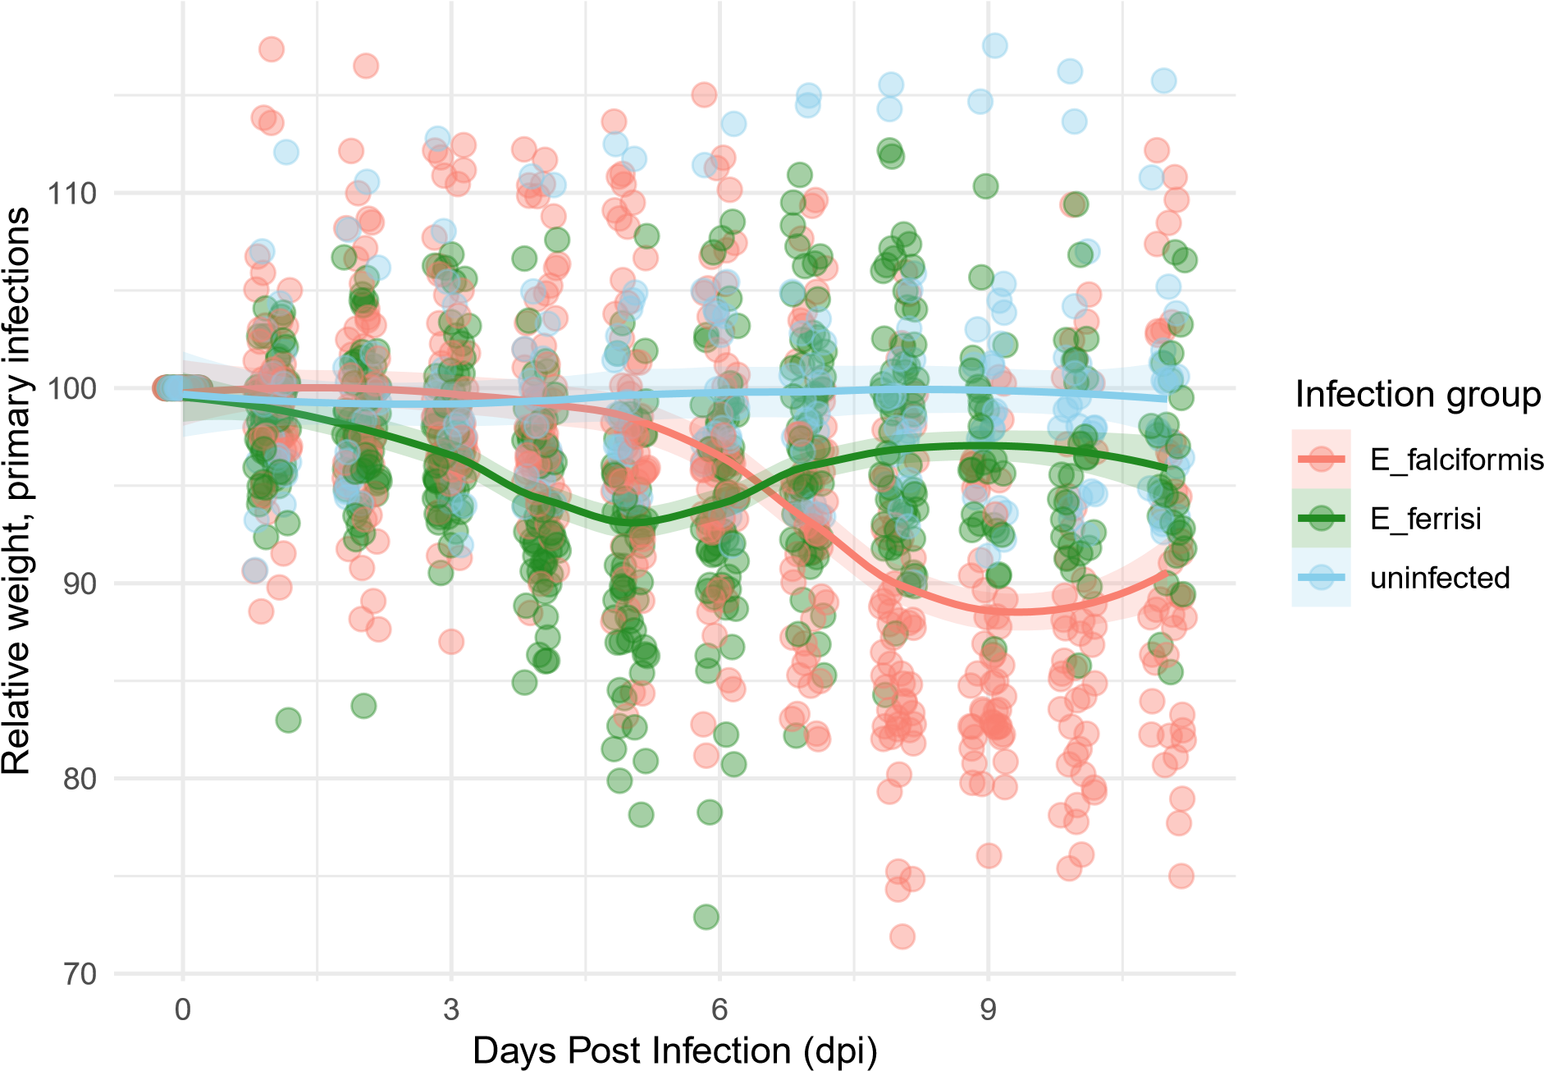

Should I include ONLY the 20 mice that were solely subjected to primary infections?

|  |
| --- |
| *#relative weight loss per day - primary*  Challenge **%>% filter**(infection **==** "primary", Mouse_ID **%in%** lab**$**Mouse_ID, death **==** "primary") **%>% ggplot**(**aes**(x = dpi, y = relative_weight, color = Parasite_primary, fill = Parasite_primary)) **+**  **geom_jitter**(width = 0.2, height = 0, alpha = 0.4,  shape = 21, stroke = 0.5, size = 3) **+** *# Adjusted for outlines*  **geom_smooth**(**aes**(fill = Parasite_primary), method = "loess", se = TRUE, alpha = 0.2) **+**  *# Add smooth line with confidence intervals*  **scale_color_manual**(values = color_mapping) **+** *# Apply custom color mapping* **scale_fill_manual**(values = color_mapping) **+**  *# Ensure fills match colors for confidence intervals* **labs**(*#title = "Relative Weight by Days Post Infection",* x = "Days Post Infection (dpi)", y = "Relative weight, primary infections", color = "Infection group",  fill = "Infection group") **+** *# Added for consistency with the legend*  **theme_minimal**() **+** *# Use a minimal theme for a cleaner look* **theme**(legend.position = "right", *# Adjust legend position* plot.title = **element_text**(hjust = 0.5), *# Center the plot title* legend.title.align = 0.5) |

## `geom_smooth()` using formula = 'y ~ x'

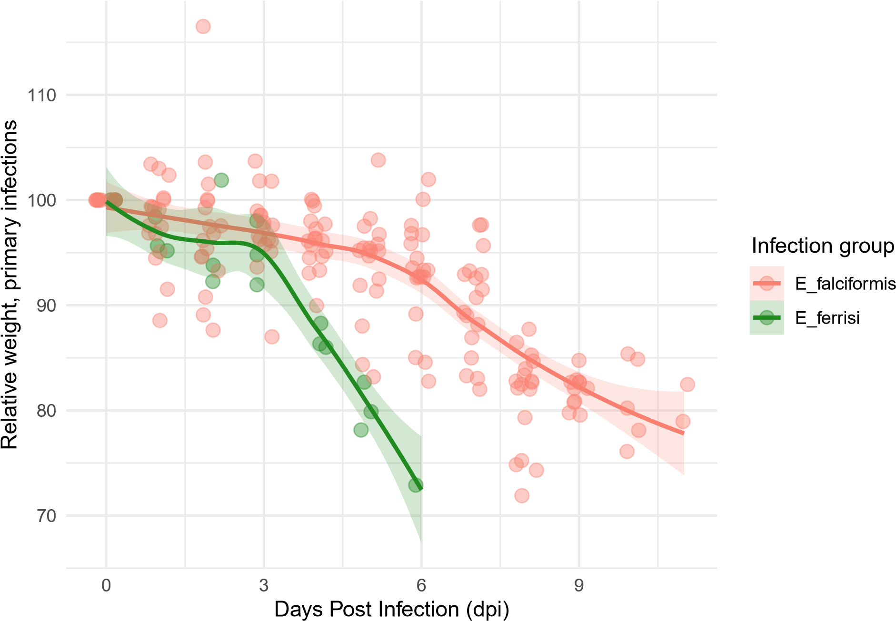

Why do the ferrisi mice loose more weight? They probably died on day 6 naturally? Many mice fall under the 80% relative weight.

Back to the challenge infections:

|  |
| --- |
| *#relative weight loss per day - challenge*  Challenge **%>% filter**(infection **==** "challenge", Mouse_ID **%in%** lab**$**Mouse_ID) **%>% ggplot**(**aes**(x = dpi, y = relative_weight, color = Parasite_challenge, fill = Parasite_challenge)) **+**  **geom_jitter**(width = 0.2, height = 0, alpha = 0.4,  shape = 21, stroke = 0.5, size = 3) **+** *# Adjusted for outlines*  **geom_smooth**(**aes**(fill = Parasite_challenge), method = "loess", se = TRUE, alpha = 0.2) **+**  *#Add smooth line with confidence intervals*  **scale_color_manual**(values = color_mapping) **+** *# Apply custom color mapping* **scale_fill_manual**(values = color_mapping) **+**  *# Ensure fills match colors for confidence intervals* **labs**(*#title = "Relative Weight by Days Post Infection",* x = "Days Post Infection (dpi)", y = "Relative weight, challenge infections", color = "Infection group",  fill = "Infection group") **+** *# Added for consistency with the legend*  **theme_minimal**() **+** *# Use a minimal theme for a cleaner look* **theme**(legend.position = "right", *# Adjust legend position* plot.title = **element_text**(hjust = 0.5), *# Center the plot title* legend.title.align = 0.5) |

## `geom_smooth()` using formula = 'y ~ x'

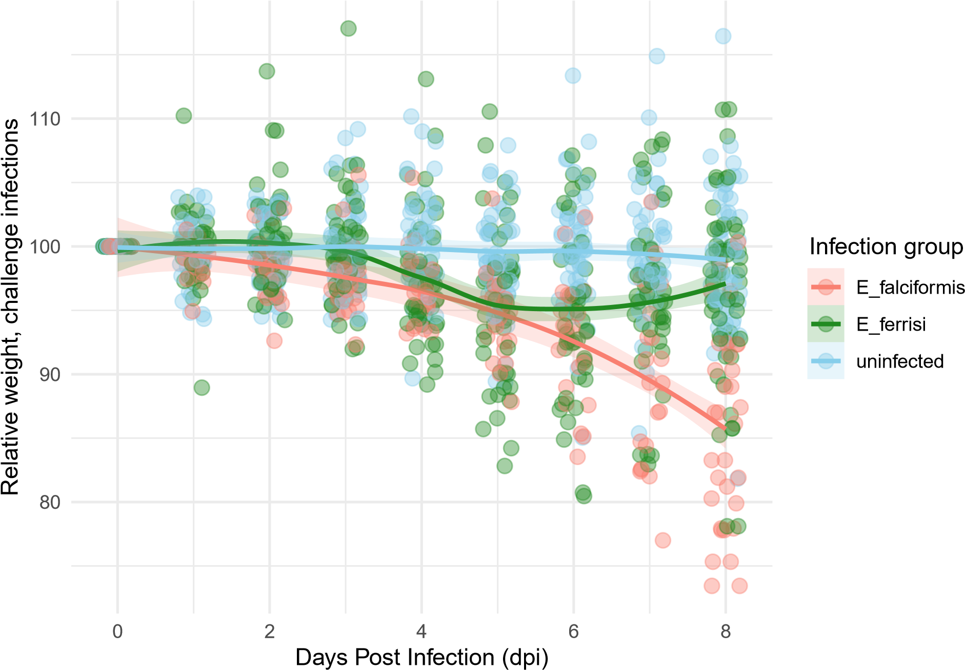

Falciformis mice falling under 80%, but only on day 8.

Mouse strains:

|  |
| --- |
| *# transform mouse strain into factor* lab**$**mouse_strain <- **as.factor**(lab**$**mouse_strain)  lab**$**mouse_strain <- **gsub**(pattern = "_", " ", lab**$**mouse_strain)  *#Numbers of each mouse strain*  **ggplot**(lab, **aes**(x = WL_max, y = mouse_strain, fill = mouse_strain)) **+ geom_density_ridges**(jittered_points = TRUE, position =  **position_points_jitter**(height = 0),  scale = 0.9, alpha = 0.6, point_shape = 21, point_size = 2, point_alpha = 1) **+**  **geom_boxplot**(width = 0.2, outlier.shape = NA, alpha = 0.5, position = **position_nudge**(x = 0.2)) **+**  **coord_flip**() **+ theme_minimal**() **+**  **theme**(legend.position = "none", axis.text.x = **element_text**(angle = 70, vjust = 0.5, hjust=0.3)) **+**  **xlab**("Maximum relative weight loss") **+ ylab**("Mouse Strain") **+ facet_grid**(**~**infection) |

## Picking joint bandwidth of 2.02

## Picking joint bandwidth of 1.64

