**Assignment-1**

**QUESTION # 01:**

Find someone who works as a project manager or someone who works on projects, such as a worker in your school s IT department or the president of a social club. Prepare several interview questions to learn more about projects and project management, and then ask them your questions in person, through e-mail, or over the phone, or using other technology.

**ANSWER:**

* What do you feel is the most important thing you do as a project manager? On what task do you spend the most time each day?
* What are some of the positive and negative risks you've encountered on projects? Please describe any notable successes and failures and what you've learned from them.
* What’s your communication style?
* Do you manage people and projects or just projects?
* Are you responsible for delivery and financials or just the administration of the project? Tell me about your recent project’s goals and results.
* What are some of the tools, software that you use, and what is your opinion on those tools?
* How do you work with customer, sponsors and stakeholders?
* What are some steps a project manager can take to improve the effectiveness and efficiency of a team? How does a new project manager gain the respect and loyalty of team members? Can you share any examples of situations you faced related to this topic?
* Do you have budget management experience?

**QUESTION # 02:**

Search the Internet for the terms project management, project management careers, project portfolio management and IT project management. Find at least three web sites that provide interesting information on one of the topics. Write a short note summarizing key information about these three web sites.

**ANSWER:**

**Project Management:**

<https://www.pmi.org/about/learn-about-pmi/what-is-project-management>

A project is **temporary** in that it has a defined beginning and end in time, and therefore defined scope and resources.

Project management is the application of knowledge, skills, tools and techniques to project activities to meet the project requirements

**Project Management Processes fall into five groups:**

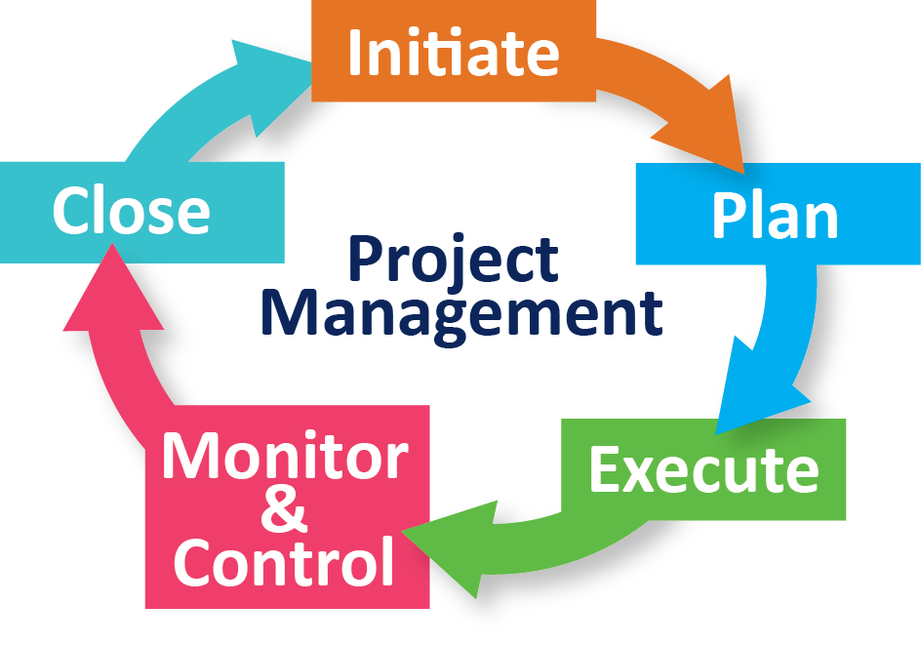

<https://en.wikipedia.org/wiki/Project_management>

Project management is the practice of initiating, planning, executing, controlling, and closing the [work](https://en.wikipedia.org/wiki/Work_(project_management)) of a [team](https://en.wikipedia.org/wiki/Project_team) to achieve specific goals and meet specific success criteria at the specified time.

The objective of project management is to produce a complete project which complies with the client's objectives. In many cases the object of project management is also to shape or reform the client's brief in order to feasibly be able to address the client's objectives.

<https://www.tutorialspoint.com/pmp-exams/project_management_fundamentals.htm>

**Why do we need Project Management?**

We need project management to manage projects effectively and drive them to success. Project Management starts with the decision to start a project upon weighing its need and viability. Once a project starts, it is crucial to watch the project progress at every step so as to ensure it delivers what all is required, in the stipulated time, within the allocated budget.

## Project Management Skills:

Many of the tools and techniques for managing projects are specific to project management. However, effective project management requires that the project management team acquire the following three dimensions of project management competencies:

* **Project Management Knowledge Competency:** This refers to what the project management team knows about project management.
* **Project Management Performance Competency:** This refers to what the project management team is able to do or accomplish while applying their project management knowledge.
* **Personal Competency:** This refers to how the project management team behaves when performing the project or activity.

**QUESTION # 03:**

Find any example of a real project with a real project manager. Feel free to use projects in the media (such as the Olympics, television shows, or movies) or a project from your work, if applicable. Write a paper describing the project in terms of its scope, time and cost goals. Also describe other impacts on a project such as quality resources, and risks. Discuss what went right and wrong on the project and the role of the project manager and sponsor. Also describe whether the project was a success, and why. Include at least one reference and cite it on the last page.

**ANSWER:**

The example I am using here is ‘Robotic Arm’. The main objective in completing this project is to select a robot that will aid needy people in the process of bringing the desire objects from desire location.

**Project Scope:**

The main scope of this project is to help the people who are paralyzed. The mobile phones in the project will be used for given voice commands so that the paralyzed person can get the desired object.

The result of this project will be demonstrated by picking the object up in front of audience.

**Project Features:**

* Raspberry Pie Camera will detect the object present on the table
* IoT Kit and Google Assistant is use to give voice input.
* Python is being used for Artificial Intelligence
* MATLAB is being used for Image processing

**Project Time:**

The expected time for the completion of this project is six months.

**Project Cost:**

As this is the hardware based project so the project cost is more than 20,000.

**Challenges:**

The challenges that can be occur in our project is installation of system libraries, raspberry pie camera, defected structure of robotic arm, performing algorithms, merging and combining all the algorithms to work together, communication between the hardware, recognizing the correct object.

**Role of a Project Manager:**

The role of a project manager is to supervise all the tasks of group members and to co-ordinate with them. Project manager has overall responsibility for the completion of project.

**Role of a Project Sponsor:**

Project Sponsor means a person who is sponsoring our project financially. As our project is related to medical field so sponsors can be from any medical college or university or Edhi home.

