**Barbie**

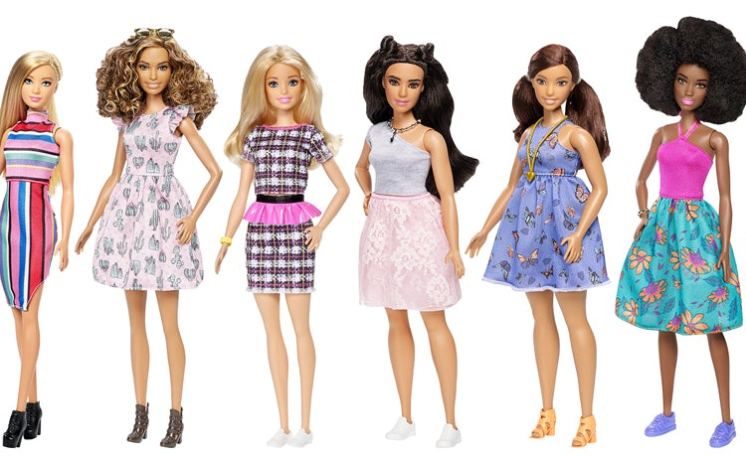

Barbie is the figurehead of a brand of Mattel dolls and accessories, including other family members and collectible dolls. Barbie has been an important part of the toy fashion doll market for over fifty years, and has been the subject of numerous controversies and lawsuits, often involving parodies of the doll and her lifest.

**PRODUCTS**

**1.**

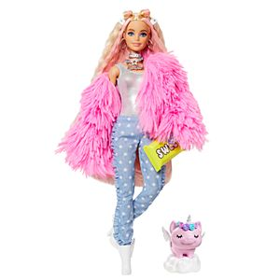

Barbie®Extra Doll #3 in Pink Coat with Pet Unicorn-Pig for Kids 3 Years Old & Up

**Price: $24.99**

**Product Details**

Barbie® Extra dolls rock bold fashions and bright colors, and they make big statements! Each Barbie® doll has their own unique style that’s playful and over the top. And their pets -- each different and all adorable -- have tons of personality, too! Barbie® Extra lets kids explore self-expression through style and offers an exciting fashion and styling play experience with posable dolls. They are all about having fun with fashion with glitter, gummy bears, emojis and stand-out hair -- bringing EXTRA vibes wherever they go. Each sold separately, subject to availability. Dolls cannot stand alone. Colors and decorations may vary.

# ****2.****

# 

# Barbie®Fashionistas™ Doll #151 with Long Pink Hair & Red Paisley Outfit

# Price: $9.99

**Product Details**

# Barbie® Fashionistas™ dolls celebrate diversity -- their unique looks and fashions encourage real-world storytelling and open-ended dreams. With a wide variety of skin tones, eye colors, hair colors and textures, body types and fashions, the dolls are designed to reflect the world kids see today. Kids can collect them for infinite ways to play out stories, express their own style and discover Barbie®! Includes Barbie® Fashionistas™ doll wearing fashions and accessories. Each sold separately, subject to availability. Barbie® dolls cannot stand alone. Flat shoes fit dolls with articulated ankles or flat feet. Colors and decorations may vary

# ****3.****

# 

Barbie®Fashionistas®Doll

**Price: $9.99**

**Product Details**

# Barbie® Fashionistas™ celebrate diversity with unique fashion dolls that encourage real-world storytelling and open-ended dreams. With a wide variety of skin tones, eye colors, hair colors and textures, body types and fashions, the Fashionistas™ dolls are designed to reflect the world girls see today, offering them infinite ways to play out stories and express their style. Includes Barbie® Fashionistas™ doll wearing fashions and accessories. Each sold separately, subject to availability. Barbie® dolls cannot stand alone. Flat shoes fit dolls with articulated ankles or flat feet. Colors and decorations may vary

# ****4.****

# Barbie®Dreamhouse®

# Price: $199.99

**Product Details**

# Move right into the Barbie Dreamhouse™ and discover a world of possibilities because with Barbie, anything is possible! Three floors, seven rooms and a working elevator let kids dream up all kinds of stories, from a fun night in to getting ready for girls' night out. Send Barbie® doll up and down the working elevator—easily activated with a child-friendly sliding tab—as they play out one fabulous story after another!

# 5.

# 

# Barbie®Pizza Chef Doll and Playset

Price: $29.99

**Product Details**

# Barbie® pizza chef doll is ready to cook up fun with a pizza shop play set, three colors of dough and accessories that let kids make their own doll-sized pizzas! Young foodies can press the dough, add "sauce" and "cheese," then slice and serve -- once they've collected payment at the register, of course! A sliding conveyor belt keeps the food and imaginations moving on this pizza maker. Start with the beige dough and the tomato-colored dough: use the pizza press to flatten a pizza crust and sauce on the conveyor pan. Slide the belt lever and the pizza along until it rests under the cheese grater. Add "cheese" using the white dough: press into the shredder and once the grater is locked into position, turn the hand crank to sprinkle the topping onto the pizza. Then move the lever again and slide the pizza into the oven with its fiery backdrop. When you think it's done, use the pizza slider to move the pizza onto its pan and cut it up with the pizza slicer. Serve a slice up on a plate (there are two) or place it in the pizza box for take-out.

# 6.

# 

# Barbie®DreamCamper™

**$109.99**

**Product Details**

The amazing **Barbie® DreamCamper™** transforms from a stylish RV into a spectacular campsite — with 35+ pieces and endless ways to play!