**LEGO**

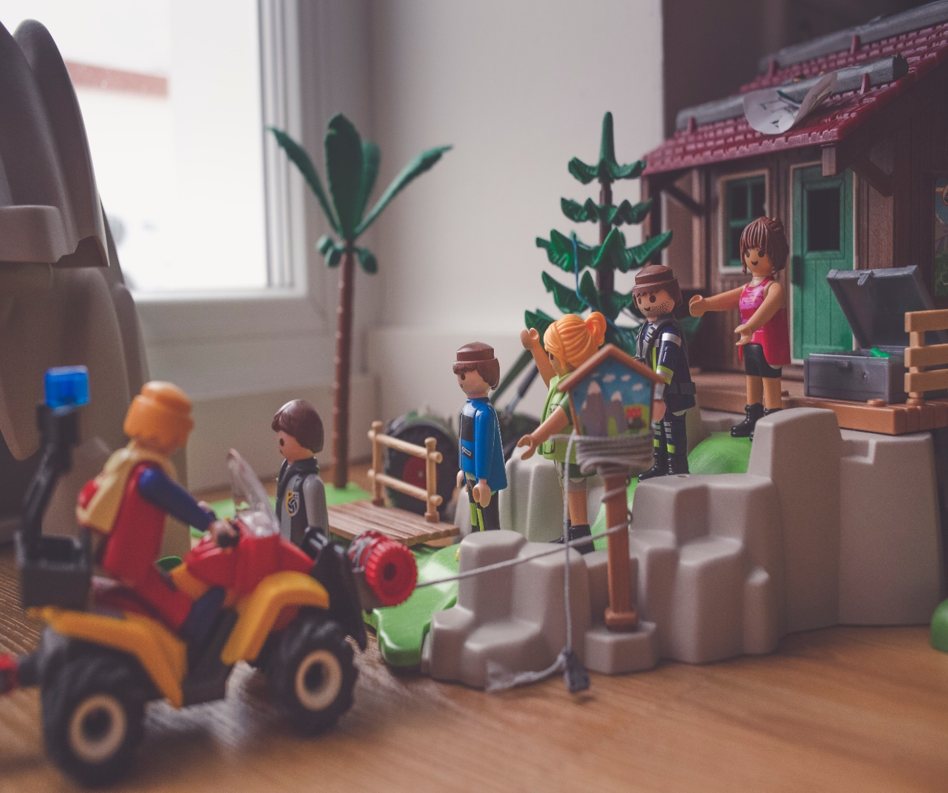

The Lego Group began manufacturing the interlocking toy bricks in 1949. Movies, games, competitions and eight Legoland amusement parks have been developed under the brand. As of July 2015, 600 billion +Lego parts had been produced

**PRODUCT**

# ****1.****

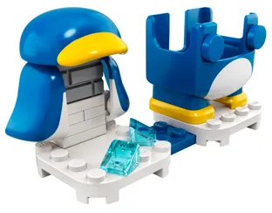

Penguin Mario Power-Up Pack

**Price: $9.99**

**Product Details**

LEGO® Super Mario™ fans can add comical action to their play experience with this Penguin Mario Power-Up Pack (71384). It features an interactive suit for LEGO® Mario™ (figure not included), which gives the player the chance to earn extra digital coins for making him slide on his belly like a penguin. This set is an ideal gift for trend-setting kids who own the Adventures with Mario Starter Course (71360), which includes the LEGO Mario figure.

# 2.

# 

# Chain Chomp Jungle Encounter Expansion Set

# Price: $19.99

**Product Details**

# Builders can add a challenging Soda Jungle level to the LEGO® Super Mario™ universe with this Chain Chomp Jungle Encounter Expansion Set (71381). A brilliant gift toy for trend-setting kids, it features Bramball and Chain Chomp figures for LEGO® Mario™ (figure not included) to defeat, a jumping platform to knock the Chain Chomp out of the way, and a Coin Block that offers players extra digital coin rewards.

# 3.

# 

Guarded Fortress Expansion Set

**Price: $49.99**

**Product Details**

Kids choose their own route for LEGO® Mario™ to reach the Guarded Fortress with this fun-packed Expansion Set (71362). A fantastic gift for kids who own the LEGO® Super Mario™ Starter Course (71360), it features a buildable fortress, catapult, brick-built water and lava routes and POW Block, plus Bob-omb, Koopa Troopa and Piranha Plant toy figures for LEGO Mario to defeat. (Note: LEGO Mario figure is not included; find it in the Starter Course set.)\

# 4.

# 

# Chinese New Year Pandas

# Price: $19.99

**Product Details**

# Help kids mark a special occasion with these charming LEGO® BrickHeadz™ Chinese New Year Pandas (40466). This set contains a mother panda and her 2 cubs, one sitting, the other lying down. Each bear has its own sturdy baseplate so they can either be displayed together or separately around a bedroom. The set also comes with bamboo stalks, a lantern and a buildable mandarin orange tree, which is a symbol for good luck.

# 5.

# 

Goofy & Pluto

**Price: $14.99**

**Product Details**

Collectors of LEGO® BrickHeadz™ will love Goofy & Pluto (40378), featuring 2 classic Disney characters. Goofy, wearing his familiar turtleneck sweater and tall green hat, stands alongside the playful Pluto. The 2 lovable Disney friends come with sturdy baseplates that make them easy to display, either individually or alongside other BrickHeadz models. Collectors of LEGO BrickHeadz can combine elements of different sets to create fun, mashed-up characters of their own.

# 6.

# 

# Mr. & Mrs. Claus

# Price: $19.99

**Product Details**

Invite LEGO® BrickHeadz™ 40274 Mr. & Mrs. Claus into your home for some festive fun. Check out Mr. Claus’ bobbled hat, bushy white beard, brown buckle and detachable sack, plus buildable tree and pile of gifts. Mrs. Claus has a buildable candy stick plus assorted cakes and cookie elements. Each construction character comes with a buildable collector's baseplate with a seasonal calendar and BrickHeadz logo for easy display by the fireplace, in your office or anywhere you like.