**MATTEL**



Mattel Creations was formed in March 2016 to bring all three of Mattel's content production units, including the American Girl creative team in Middleton, Wisconsin, under its aegis

**PRODUCTS**

# 1.

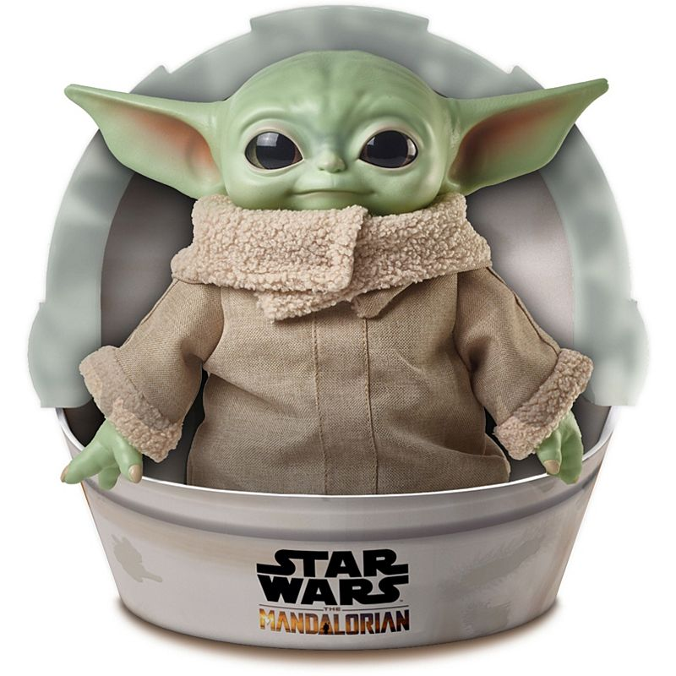

**Star Wars the Child Plush Toy**

**Price: $24.99**

**Product Details**

Fully embrace the cuteness of the 50-year-old Yoda species with this adorable 11-inch plush toy. He may look like a Baby Yoda, but this lovable creature is referred to as The Child. Inspired by the Disney+ live-action series The Mandalorian, this sweet Star Wars plush toy makes a Force-sensitive addition to your collection.

# 2.

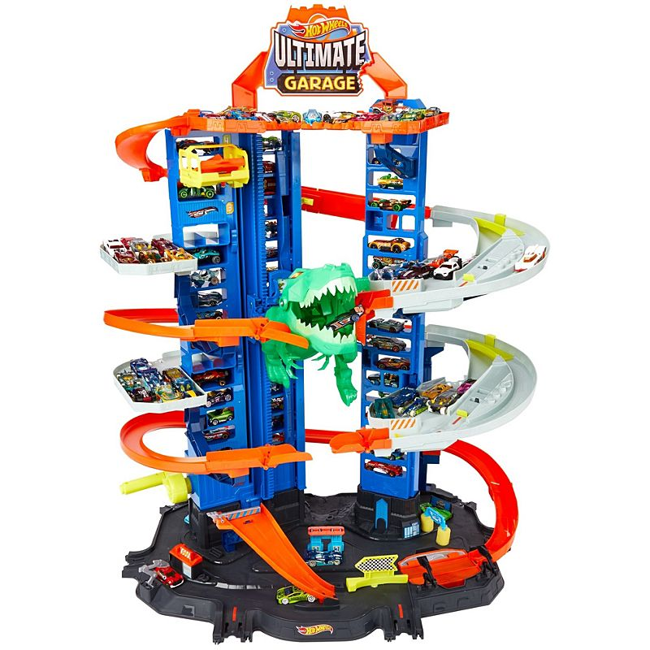

# Hot Wheels®City Ultimate Garage

**Price: $99.99**

**Product Details**

New for 2020, it's the ULTIMATE challenge in the TALLEST Ultimate Garage so far, offering endless storytelling and vehicle action play! This enormous playset has parking for up to 100+ vehicles and a surprising Robo T-Rex nemesis that fuels kids' imagination! Kids take vehicles all the way up in the kid-powered two-car elevator. They can race down through the multi-level garage and experiment with multi-play mode for continuous thrills! Connects to other Hot Wheels® sets (sold separately) and includes 2 Hot Wheels® 1:64 scale vehicles and a feature for Hot Wheels™ id action, too! Plug in the Hot Wheels™ id Portal (sold separately) to unlock the additional play experience: scan a car, race opponents, escape from Robo T-Rex and win

# 3.

# 

# UNO™ Harry Potter Card Game

**Price: $5.99**

**Product Details**

# It's the fun, fast-paced card game you love now featuring iconic characters from the world of Harry Potter! Join Harry, Hermione, Ron, Professor Dumbledore and more of your favorite characters from Hogwarts for a night of UNO™ gameplay. Players race to get rid of all their cards by matching a card in their hand with the current card shown on top of the deck. Score points by being the first to get rid of all the cards in your hand. Special action cards deliver game-changing moments as they each perform a function to help you defeat your opponents.

# 4.

# 

# Thomas & Friends™ Talking Thomas & Percy Train Set

# Price:$49.99

**Product Details**

Thomas & Friends™ Talking Thomas & Percy Train Set, Sodor can also be in the living room. This highly detailed playset features favorite places from the island of Sodor, including the Vicarstown Bridge, the Railyard, the Brendam docks, and Blue Mountain. It also includes motorized Thomas and Percy train engines who recognize and talk to each other when they meet on the track! Young conductors can help Thomas and Percy work together by dropping boulders down in the Blue Mountain cave for them to load and unload along with other cargo at Bulstrode the boat and by creating their own exciting adventures all around Sodor.

# 5.

# 

# Hot Wheels®Monster Truck Scorpion Sting Raceway™

# Price: $44.99

**Product Details**

# ​Hot Wheels® Monster Trucks delivers an over-the-top boosted set for Hot Wheels® cars and Hot Wheels® Monster Trucks with a striking new nemesis— a giant scorpion! Team your Monster Trucks with Hot Wheels® 1:64 scale vehicles to defeat the deadly scorpion nemesis in this thrilling large track set with an awesome banked turn and booster for multiple vehicle play. It won't be easy to avoid being snapped up in the scorpion's claws or his massive stinger, but teamwork can overcome challenges never met before! Set includes one exclusive Monster Truck with giant wheels and one 1:64 scale Hot Wheels® car.​

# 6.

# 

# Jurassic World Camp Cretaceous Epic Roarin' Tyrannosaurus Rex

# Price: $39.99

**Product Details**

# Be a part of the adventure with the Epic Roarin' Tyrannosaurus Rex inspired by the Jurassic World animated series, Camp Cretaceous! This larger-scale dinosaur action figure features "Primal Attack" which enables kids to control the battle play with awesome battle moves. Move the tail up and down, side to side and around for head movements, body twists and an awesome chomping action (activate all moves at once for total animated control of the figure