### **Author**

Fayyaz H M

22dp3000014

[22dp3000014@ds.study.iitm.ac.in](mailto:22dp3000014@ds.study.iitm.ac.in)

Having three and half year experience in software testing(CTS) and 7 years experience in Canara Bank as officer. Right now I am not working. I am doing DAD in software programming alone.

### **Description**

To create a grocery store web app using python(flask-SQLAlchemy) as backend and sqlite as database and html with jinja 2 templates as frontend.

### **Technologies used**

1.Flask-SQLAlchemy package, Python----Backend controller for the business workflow logic.

2.HTML,CSS,Jinja2--------Front end display along with styling for the app.

3.SQLite -Database for the storing the app data.

**DB Schema Design.**

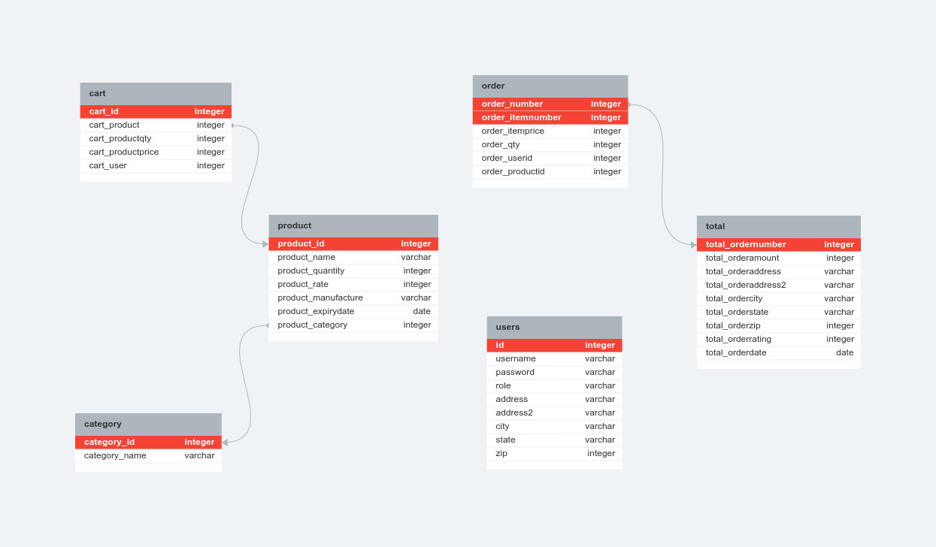

### **API Design**

1.CRUD on Products

2.CRUD on Category.

3.Display all the products details of requested Category.

### **Architecture and Features:**

All the code for the app and API is placed inside the file grocery_app_login_api.py. The model for the app is place inside the models_grocery_login.py. There is total of 36 html templates, which is placed inside the folder templates. The app has two login one for Admin and the other for user.

**Admin**

Admin can add, edit and delete Category and products. The admin login has summary page which has 1.Category wise summary-which in turn has the individual category was summary, 2.Product wise summary and 3. Order wise summary.

**User**

User login page has registration page. Once registered the user can add items of same or different sections. The same is stored in the database as user-wise, hence the same can be accessed by individual user during multiple login till the order has been placed. There is an edit and delete option for the items in cart.

It also checks for the availability of the selected item during the process of placing the order from the cart. If the item becomes unavailable during any of the workflow the order would not be placed for the particular item alone if there are multiple products in the cart or the order would not be placed if its the only item in the cart.

There are two search

1. Normal search which checks for the item its not case sensitive.

2.Advance search has search based on category, product, order number, expiry date and rate.

There is also a page for displaying the order placed. which has the option of providing rating.

### **Video**

https://drive.google.com/file/d/1iM6W9PYzWKCAGCgMo8m10TH1zjYwaJt0/view?usp=drive_link