Author
Fayyaz H M
22dp3000014
22dp3000014@ds.study.iitm.ac.in
Having three and half year experience in software programming(CTS) and 7 years experinece in Canara Bank as officer. Right now I am not working. I am doing DAD in software programming alone.

Description
To create a grocery store web app using python(flask-API-sqlalchemy) as backend and sqlite as database and html with vue js as frontend UI.
Redis and Celery for batch jobs

Technologies used
1.Flask-SQLAlchemy package, Python, API----Backend controller for the business workflow logic.
2.HTML, CSS, Vue JS--------Front end display along with styling for the app.
3.SQLite -Database for the storing the app data.
4.Redis and Celery for batch jobs

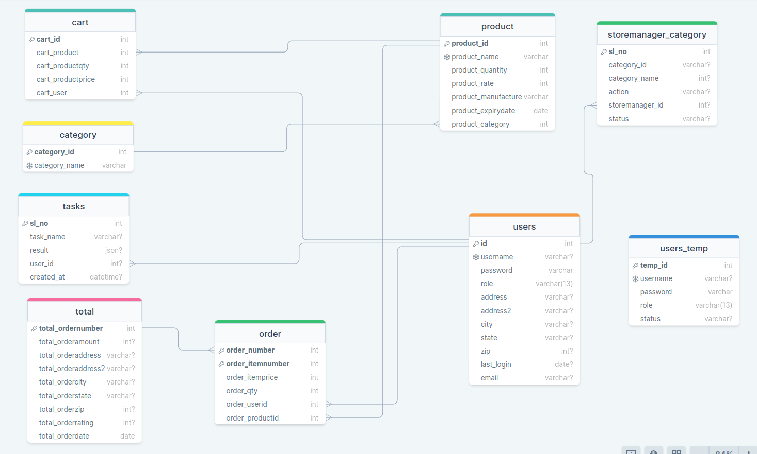
DB Schema Design.

Architecture and Features:

All the code for the app is placed inside the file grocery_app_login_api.py. The model for the app is place inside the models_grocery_login.py. The code for celery task is placed in task.py ,celeryconfig.py and workers.py There is total of 16 html templates which is placed inside the folder templates. There is a total of 44 js Files which are placed inside static folder. The app has three login one for Admin, Store Manager and for user.

Admin
Admin can add, edit and delete Category and Products. He is super user. The admin login has summary page which has 1.Category wise summary-which in-turn has the individual category was summary, 2.Product wise summary and 3. Order wise summary. There is an authorization page where he can authorise/reject the requests made by store manager for add/edit/delete of category and for also to authorise/reject new store manager signup requests.

Store Manager:
When a new store manager profile addition request is made from the store manager registration page the same is sent to admin for authorization. Store Manager can add, edit and delete a product. Store manager can request for addition/deletion/edit of category. The same is sent to the admin for his authorization. There is a request tab in store manager home page where he can see the requests made to the admin. There is also export button for getting the all the product details in csv format. There is also a button for adding bulk products by csv file. The bulk addition details of the same is reflected in the same page.

User
User login page has registration page. Once registered the user can add items of same or different sections. The same is stored in the database as user-wise, hence the same can be accessed by individual user during multiple login till the order has been placed. There is an edit and delete option for the items in cart. It also checks for the availability of the selected item during the process of placing the order from the cart. If the item becomes unavailable during any of the workflow the order would not be placed for the particular item alone if there are multiple products in the cart or the order would not be placed if its the only item in the cart. Once an order is placed the order details are sent to the users email id using celery task.

There are two search 1. Normal search which checks for the item its not case sensitive.2.Advance search has search based on category, product, order number, expiry date and rate.There is also a page for displaying the order placed,where rating can be given.
Celery Tasks:
There are three celery task apart from the task of sending mail once an order is placed. The details of the task are given below.
1.Task Buy Notification:-Email is sent to users who have not made login to the app during the day . The email is sent at 16:10 hrs. Its a daily reminder
2.Chat Buy Notification:-On google chat message is sent to user who have not made login to the app during the day. Its a daily reminder.
3.Monthly report:- Monthly report category wise summary, product wise summary and order summary is sent to the admin on the first day of every month

Video
https://drive.google.com/file/d/1jH_JkcAKNHDT_W8FVi9wwH1DGe8a8Gki/view?usp=sharing

