LAB 5 TASKS
TASK1
INCLUDE IRVINE32.inc
.data
.code
main Proc
mov eax,15000
call DumpRegs
add eax,1
call DumpRegs
exit
main endp
end main
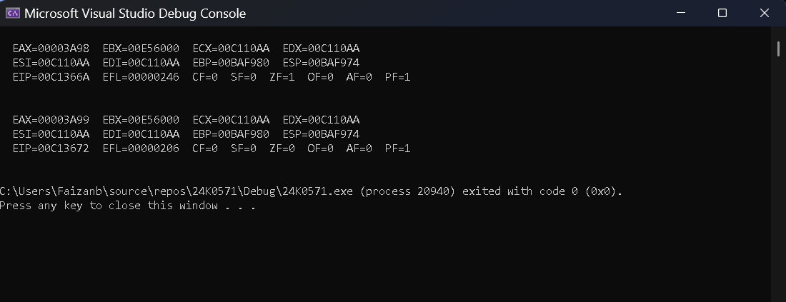
TASK 2
a) add al, 15h → CF=1, SF=0, ZF=0, OF=0
b) add ah, 1h → CF=0, SF=1, ZF=0, OF=0
c) add ax, 2h → CF=0, SF=1, ZF=0, OF=0
TASK 3
INCLUDE IRVINE32.inc
.data
arr word 45,32,71,44,92
sortarr word 5 dup(?)
.code
main Proc
mov [sortarr+1],32
mov eax,32
call WriteInt
call Crlf
mov [sortarr+2],44
mov eax,44
call WriteInt
call Crlf
mov [sortarr+3],71
mov eax,71
call WriteInt
call Crlf
mov [sortarr+4],44
mov eax,44
call WriteInt
call Crlf
mov [sortarr+5],92
mov eax,92
call WriteInt
call Crlf
exit
main endp
end main
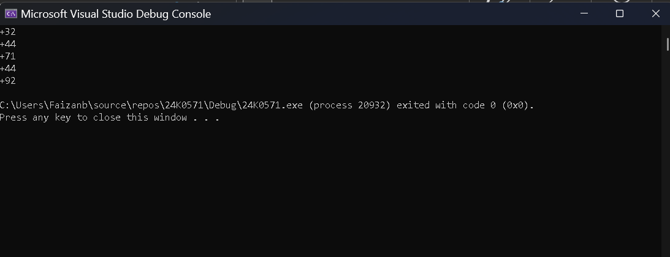
TASK 4

INCLUDE Irvine32.inc

.data
arrayB BYTE 25,45,65
arrayW WORD 155,185,225
arrayD DWORD 645,690,735
Sum DWORD ?

.code
main PROC
movzx eax, arrayB
movzx ebx, arrayW
add eax, ebx
add eax, arrayD
mov Sum, eax
call WriteDec
call Crlf

movzx eax, arrayB[1]
movzx ebx, arrayW[2]
add eax, ebx
add eax, arrayD[4]
mov Sum, eax
call WriteDec
call Crlf

movzx eax, arrayB[2]
movzx ebx, arrayW[4]
add eax, ebx
add eax, arrayD[8]
mov Sum, eax
call WriteDec
call Crlf

exit
main ENDP
END main
