***LAB 03: Latches, Flip-Flops and Registers***

**Task 1: RS Latch via Gates/Equations**

File: B_latchRSg.v, B_latchRSe.v

FPGA: X.

Code:

RS LATCH (GATES)

module B_latchRSg(

input clock, R, S,

output Q

);

wire Qa, Qb, R_g, S_g/* synthesis keep */;

and(R_g, R, clock);

and(S_g, S, clock);

or(Qa, R_g, Qb);

or(Qb, S_g, Qa);

assign Q = Qa;

endmodule

RS LATCH (EQUATIONS)

module B_latchRSe(

input clock, R, S,

output Q

);

wire Qa, Qb;

assign Qa = ~((R & clock) | Qb);

assign Qb = ~((S & clock) | Qa);

assign Q = Qa;

endmodule

**Task 2: D Latch Implementation using Equations**

File: B_latchDe.v

FPGA: X.

Code:

MAIN

module lab03part02(

input [1:0]SW,

output[0:0]LEDR

);

B_latchDe testDe(SW[1], SW[0], LEDR[0]);

endmodule

D LATCH (EQUATIONS)

module B_latchDe(

input CLK, D,

output Q

);

wire Qa, Qb;

assign Qa = ~(~(D & CLK) & Qb);

assign Qb = ~(~(~D & CLK) & Qa);

assign Q = Qa;

endmodule

Output (Technology Map):

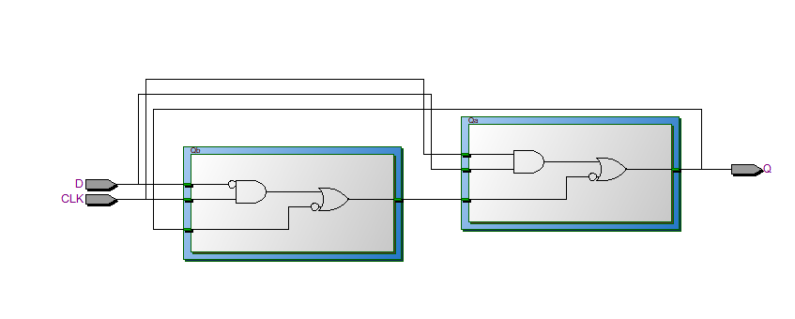

**Task 3: Master Slave D Flip Flop**

File: lab03part03.v, B_flipflopDmse.v, B_latchDe.v

FPGA: DONE.

Code:

MAIN

module lab03part03(

input [1:0]SW,

output [0:0]LEDR/*,

output [2:0]LEDG*/

);

/* assign LEDG[0] = LEDR[0];

assign LEDG[1] = SW[0];

assign LEDG[2] = SW[1]; */

B_flipflopDmse ff1(SW[1], SW[0], LEDR[0]);

endmodule

MASTER SLAVE D-FLIPFLOP [POSITIVE EDGE]

module B_flipflopDmse(

input CLCK, D,

output Q

);

wire Qm, Qs, CL2;

assign CL2 = ~CLCK;

B_latchDe ffa(CL2, D, Qm);

B_latchDe ffb(CLCK, Qm, Qs);

assign Q = Qs;

endmodule

**Task 4: D LATCH, POSEDGE/NEGEDGE D FLIPFLOPS**

File: lab03part04.v, B_memoryFlops.v

FPGA: X.

Code:

MAIN

module lab03part04(

output Q1, Q2, Q3,

input D, Clk

);

mem_DLatch dl1(Q1, D, Clk);

mem_Dflippos dff1(Q2, D, Clk);

mem_Dflipneg dff2(Q3, D, Clk);

endmodule

MEMORY (LATCHES, FLIPFLOPS)

/* GATED D LATCH */

module mem_DLatch(

output reg Q,

input D, clk

);

always@(D, clk)

begin

if(clk)

Q <= D;

end

endmodule

/* POSITIVE EDGE TRIGGERED - D FLIP FLOP */

module mem_Dflippos(

output reg Q,

input D, clk

);

always@(posedge clk)

begin

Q <= D;

end

endmodule

/* NEGATIVE EDGE TRIGGERED - D FLIP FLOP */

module mem_Dflipneg(

output reg Q,

input D, clk

);

always@(negedge clk)

begin

Q <= D;

end

endmodule

**Task 5: D Latch Implementation using Equations**

File:

FPGA: X.

Code:

MAIN

**Task 2: D Latch Implementation using Equations**

File: B_latchDe.v

FPGA: X.

Code:

D LATCH (EQUATIONS)