
Faculty of Engineering & Technology
Department of Electrical & Computer Engineering

ENCS4380, INTERFACING TECHNIQUES

E-Nose Homework Report

Student name: Fayzeh Elzghier
Student ID: 1221160
Section: 2

Instructor: Dr. Wasel Ghanem
Date: 12-Oct-2025

Table of Contents
Table of Contents 2
Table of Figures 3
1. Introduction Error! Bookmark not defined.
2. Case Study: Application in Palestinian Olive Oil. Error! Bookmark not defined.
3. Design Challenge: Proposed E-Nose System Error! Bookmark not defined.
4. Critical Reflection 4
5. Personal Insight Error! Bookmark not defined.
6. Conclusion Error! Bookmark not defined.
References 6

Table of Figures
Figure 1:Electronic nose block diagram[3]………………………………………………………4
Figure 2: Schematic overview of e-nose system[5]………………………………………………6
Figure 3:Olive Oil E-Nose System Flowchart…………………………………………………….7

1. Introduction:
“Intelligent sensor systems are very much like conventional sensors in that they detect a physical phenomenon and output raw data but also have the ability to filter, process, and analyze the information thus enabling more meaningful and autonomous responses.”[1]
The application of intelligent sensor systems in e-noses (electronic noses) is a point of excellence. An e-nose is built to copy the human sense of smell. It employs a configuration of chemical or gas sensors to pick up superfine chemical compounds in the air. The individual sensor, depending on its nature, “reveals different compounds generating a unique "smell fingerprint." This fingerprint is classified by pattern recognition algorithms or machine learning models.”[2] For example, an e-nose can determine if food is spoiled, differentiate between various kinds of drinks or even check if certain agricultural products are genuine.
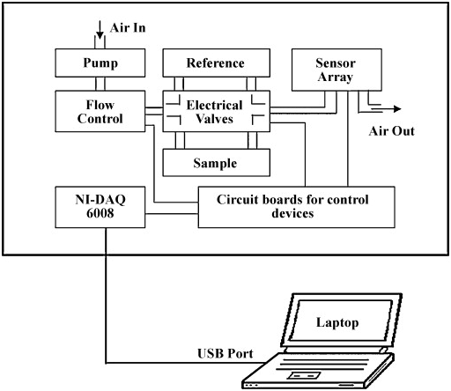
“The electronic nose was developed in order to mimic human olfaction whose functions are non separate mechanism , i.e. the smell or flavor is perceived as a global finger print. Essentially the instrument consists of sensor array, pattern reorganization modules, and headspace sampling, to generate signal pattern that are used for characterizing smells. The electronic nose consists of three major parts which are detecting system, computing system, sample delivery system.”[3]
Figure 1:Electronic nose block diagram[3]
2. Case Study: Application in Palestinian Olive Oil
Olive oil is still the main product of Palestinian culture, economy, and cooking. It is a product not only for consumption but also for export and represents the Palestinian identity. Yet, the olive oil market is going through a tough time due to adulteration and lack of proper quality control. The mixing of cheaper oils with the pure olive oil is a common practice that misleads the consumers and the farmers suffer a great loss. The only method of quality testing that can give accurate results is laboratory-based chemical analysis, which is thus very costly and takes a long time.
The electronic nose has come up with a solution. “The e-nose can detect the presence of volatile organic compounds in olive oil, which is the main difference between authentic extra virgin olive oil and adulterated or rancid ones”[3] . The device is fast, is non-destructive, and can operate outside the laboratory as it is easily set up.
“The e-noses can classify olive oils according to their freshness, aroma, and adulteration levels”[4] Thus, the e-nose technology could be a game changer for Palestinian olive oil in terms of both quality assurance and global competitiveness.
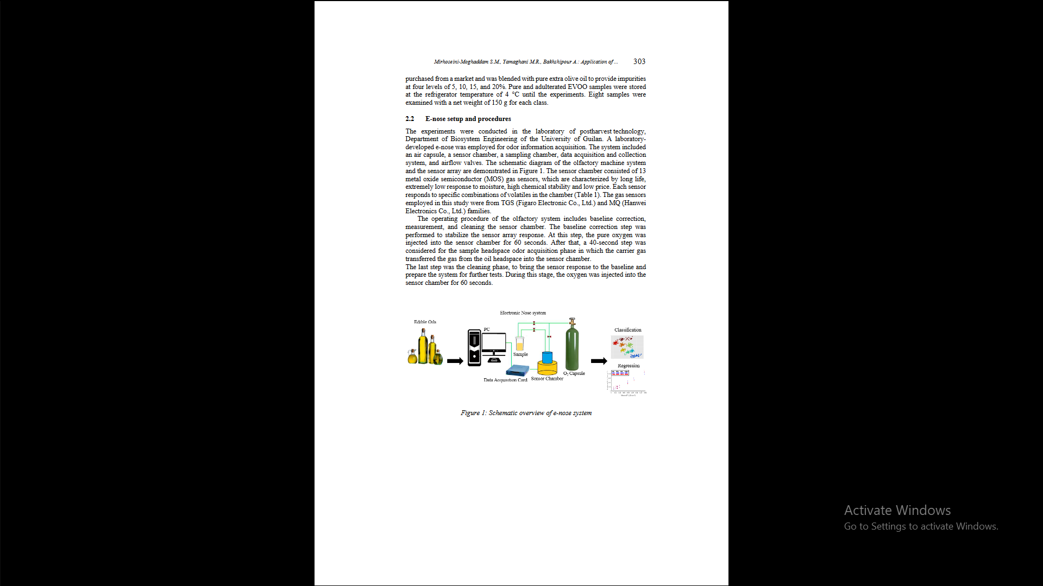
- E-nose setup and procedures : ”The experiments were conducted in the laboratory of postharvest technology, Department of Biosystem Engineering of the University of Guilan. A laboratory-developed e-nose was employed for odor information acquisition. The system included an air capsule, a sensor chamber, a sampling chamber, data acquisition and collection system, and airflow valves. The schematic diagram of the olfactory machine system and the sensor array are demonstrated in Figure 2. The sensor chamber consisted of 13 metal oxide semiconductor (MOS) gas sensors, which are characterized by long life, extremely low response to moisture, high chemical stability and low price. Each sensor responds to specific combinations of volatiles in the chamber . The gas sensors employed in this study were from TGS (Figaro Electronic Co., Ltd.) and MQ (Hanwei Electronics Co., Ltd.) families.The operating procedure of the olfactory system includes baseline correction, measurement, and cleaning the sensor chamber. The baseline correction step was performed to stabilize the sensor array response. At this step, the pure oxygen was injected into the sensor chamber for 60 seconds. After that, a 40-second step was considered for the sample headspace odor acquisition phase in which the carrier gas transferred the gas from the oil headspace into the sensor chamber. The last step was the cleaning phase, to bring the sensor response to the baseline and prepare the system for further tests. During this stage, the oxygen was injected into the sensor chamber for 60 seconds.”[5]

Figure 2: Schematic overview of e-nose system[5]

E-nose Data Processing :”Before extracting the e-nose-based features, pre-processing was applied to the recorded information.
1. feature extraction step: the size of the data was reduced during a The type of analyte can be identified by classifying the data in the feature space.
2. The fractional manipulation (Equation 1) Ys(t) = xs(t) – xs(0) / xs(0) was employed on the raw data to provide a dimensionless and normalized response. In equation 1, the ys(t), xs(0), and xs(t) stand for the preprocessed response, the baseline value in the raw response, and the dynamic raw response of the sensors, respectively [Hai and Wang, 2006, Heidarbeigi et al., 2015]. In this study, the baseline manipulated responses of sensors during the headspace odor acquisition stage were used for feature extraction”[5]

3. Design Challenge: Proposed E-Nose System

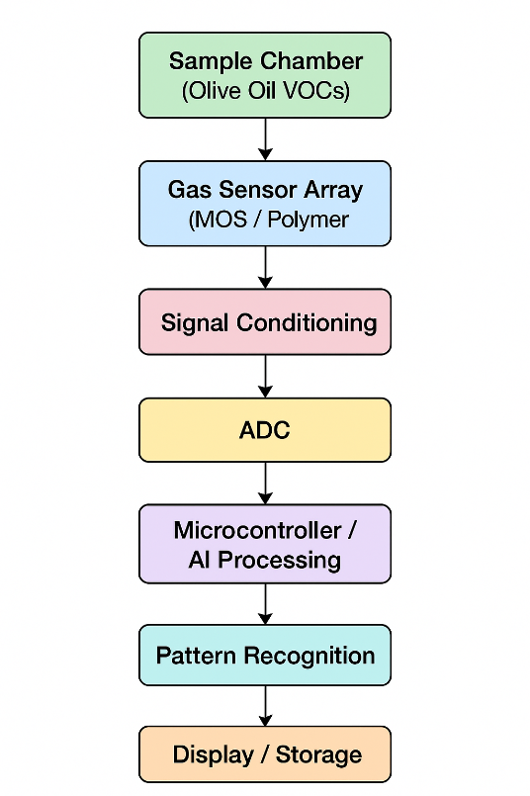
Block Diagram :

Figure 3:Olive Oil E-Nose System Flowchart
Component Descriptions:
- Sample Chamber: Holds the olive oil sample, allowing volatile compounds to accumulate.
- Gas Sensor Array: MOS or polymer-based sensors that respond to volatile organic compounds.
- Signal Conditioning: Amplification and noise filtering.
- ADC (Analog to Digital Converter): Converts analog sensor signals to digital form.
- Microcontroller/AI Unit: Runs machine learning models for odor classification.
- Pattern Recognition: Classifies data into categories: authentic, adulterated, or unknown.
- Display/Storage: Provides results and logs data for analysis.

Example Pseudocode:
input_data = read_sensors()
pattern = process_signals(input_data)

if pattern == "authentic":
display("Authentic Olive Oil")
elif pattern == "adulterated":
display("Adulterated Olive Oil")
else:
display("Unknown sample")

4. Critical Reflection

The two main difficulties are sensor drift and poor specificity, importantly with the case of unknown gases.
4.1. Sensor Drift

4.1.1 Problem Description
“Drifting sensors are the gradual and often irreversible change in resistance and sensitivity baseline of the E-Nose sensors over a period of time. Among the factors contributing to this drift are dust accumulation, changes in humidity, and wear and tear of sensor materials. Therefore, with time, the same substance might yield a "smell fingerprint" different from the previous one. This can cause misclassifications and consequently unreliable readings.thus It becomes hard to get accurate results in long-term monitoring.” [6]
Mistakes in classifying substances could end up compromising food safety or hindering medical diagnostics.
4.1.2 Improvements Overview:

1 -Carry out regular hardware maintenance that will involve recalibration and cleaning.
2-Implement adaptive software models that would consider the drift over a period of time.

4.2. Limited Specificity & Unknown Gas Scenario
4.2.1 Problem Description:
“E-Nose sensors occasionally show cross-selectivity, meaning they react to several compounds instead of just one. This hinders the system’s ability to differentiate between chemically alike compounds. Moreover, when an unknown gas that is not part of the system’s training dataset is present, the pattern recognition models frequently misclassify it as one of the known categories. This misclassification can cause unreliable detection and consequently lower confidence in practical applications.thus there is a risk of making mistakes during the gas identification process especially with novel or unanticipated gases.”[7]
The performance of real-world applications such as air quality monitoring or food contamination detection is diminished.
4.2.2 Overview of Improvements:

1-Specially design models that are capable of recognizing even unknown gases similar to Open Set Recognition systems.
2-Improve the sensor array design so that specificity is increase and cross-reactivity is decreased.

5. Personal Insight
In my community, the implementation of smart sensors would be a game changer right from the start. For us in Palestine, olive oil is not just an agricultural product but also a part of our cultural heritage. Nevertheless, mixing of inferior oils with our good ones has become a common practice, and consequently, consumers have lost trust in the product and farmers' income has been dented. The producers can set up an e-nose system in the local olive oil factories and take the oil samples at a fast pace before the distribution. This would not only fraud detection but also maintain product authenticity and build up consumer trust in Palestinian olive oil.
Smart sensors not only authenticate olive oil but also help to monitor air pollution in Palestinian urban areas like Hebron and Ramallah where emissions from cars and factories negatively impact the health of the population. The use of e-nose systems could make it possible to deliver real-time data on pollutants to the citizens and policymakers. The application of smart sensors is not limited to these areas but could go as far as to help diagnosis in hospitals, provide intelligence in smart homes, and perform environmental monitoring to ensure the conservation of resources. To me, these tools are not just a means of addressing the greatest technical issues but also avenues for acquiring competence in programming, electronics, and AI which in turn can lead to the community being tech-self-sufficient thus raising the standard of living.

6. Conclusions
This report explored the concept of intelligent sensor systems with a focus on the electronic nose and its potential application in the Palestinian olive oil industry. The key lesson is that E-noses offer a fast, objective, and non-destructive method for detecting authenticity, freshness, and adulteration of olive oil. Compared to traditional human tasters or laboratory-based methods, E-noses provide consistent and reproducible results that are practical for real-world use.
Despite existing challenges such as sensor drift, limited specificity, and the need for recalibration, continuous improvements in materials, data processing, and AI are making E-nose devices more reliable and accessible. In the Palestinian context, this technology not only protects farmers and consumers but also supports the competitiveness of olive oil in international markets.
References for Conclusion:
[1]Wilson, A. D., & Baietto, M. (2009). Applications and advances in electronic-nose technologies. Sensors, 9(7), 5099–5148.
https://www.mdpi.com/1424-8220/9/7/5099
[4]Pizarro, C., Rodríguez-Aguilera, R., Pérez-Juan, P. M., & García, J. (2013). Electronic nose prediction of the sensory quality of virgin olive oils from volatile and phenolic profiles. Journal of Agricultural and Food Chemistry, 61(30), 6984–6992.
https://www.researchgate.net/publication/303414887_Olive_Oil_and_Electronic_Nose

References
[1] https://www.mdpi.com/1424-8220/9/7/5099 accessed at 14/10/2025 9:52
[2]https://www.researchgate.net/publication/299598752_Electronic_Noses_and_Tongues_in_Food_Science accessed at 14/10/2025 15:12
[3] https://www.elprocus.com/electronic-nose-work/ accessed at 14/10/2025 18:46
[4] https://www.researchgate.net/publication/303414887_Olive_Oil_and_Electronic_Nose
accessed at 15/10/2025 17:37
[5] https://lib.jucs.org/article/90346/ accessed at 15/10/2025 19: 16
[6] https://re.public.polimi.it/retrieve/e0c31c0e-fd8f-4599-e053-1705fe0aef77/LC145.pdf
Assecced at 15/10/2025 21:05
[7] https://www.sciencedirect.com/science/article/abs/pii/S0925400522002945
Assecced at 15/10/2025 21:45

