Big O is a way of measuring how efficient your code is.
O(n) – linear. Inputlar soni oshishi bilan operationslar soni ham ortadi. Proportional.
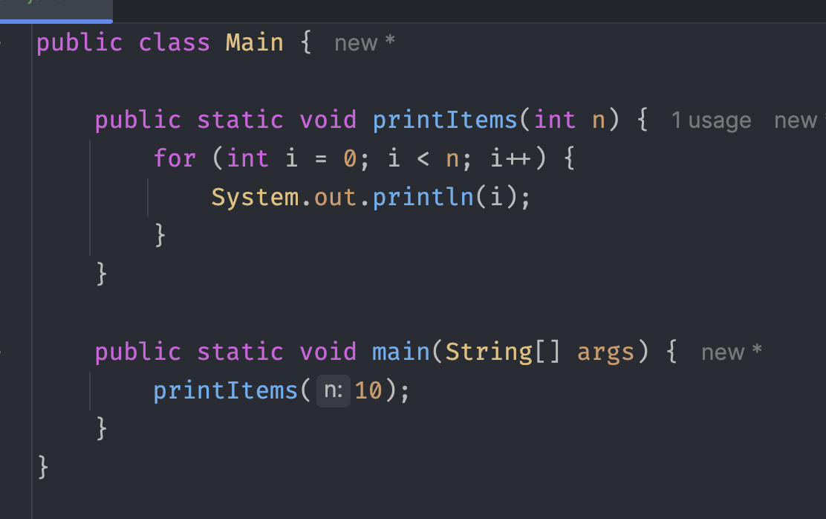

Drop constants n+n = 2n = n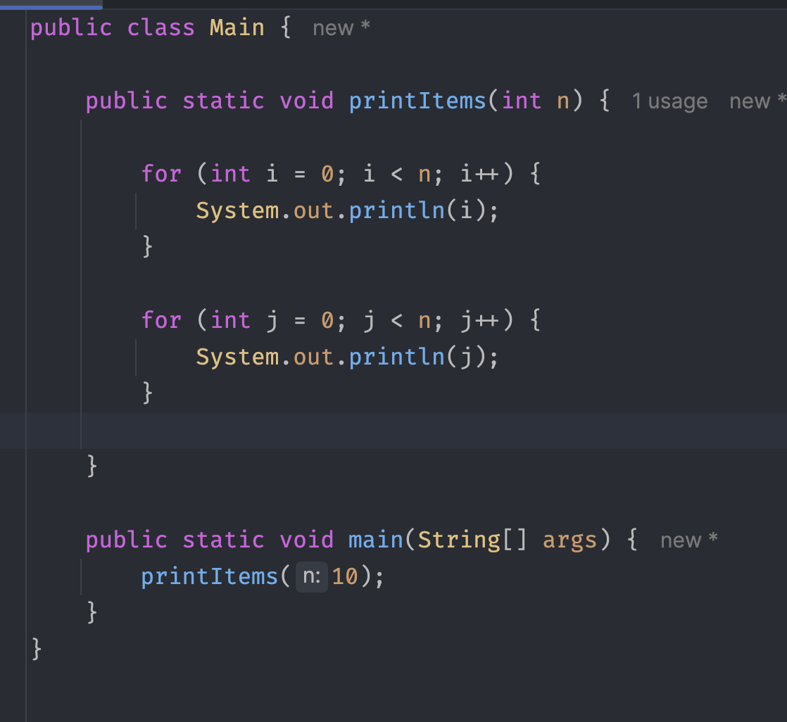
Quadratic O(n²)
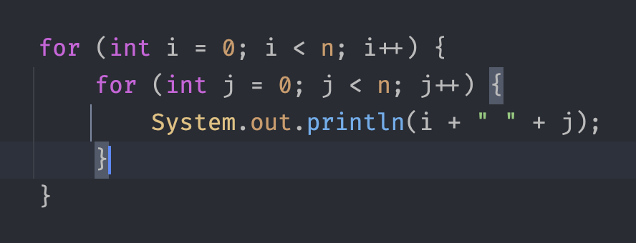
Drop Non-Dominants O(n²)
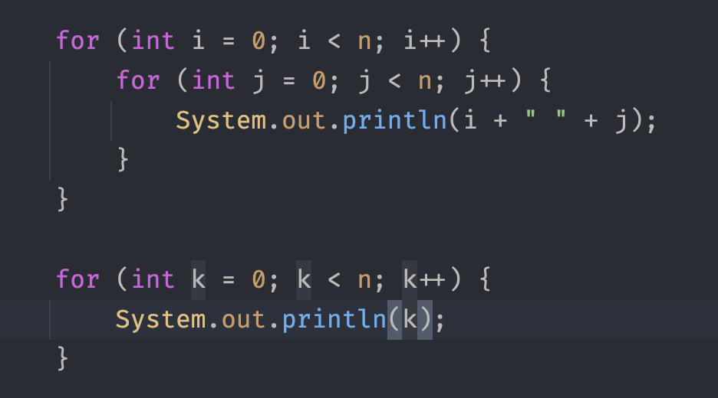
O(1)
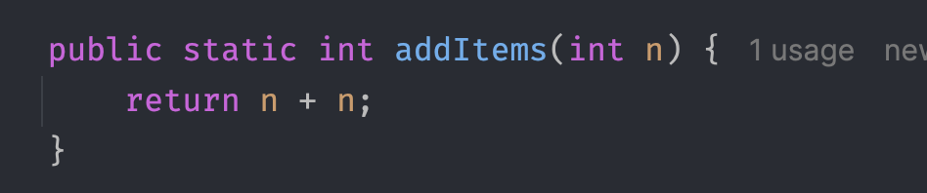
O(log n) – ikkiga bo’lib ketaverish.
O(a+b)
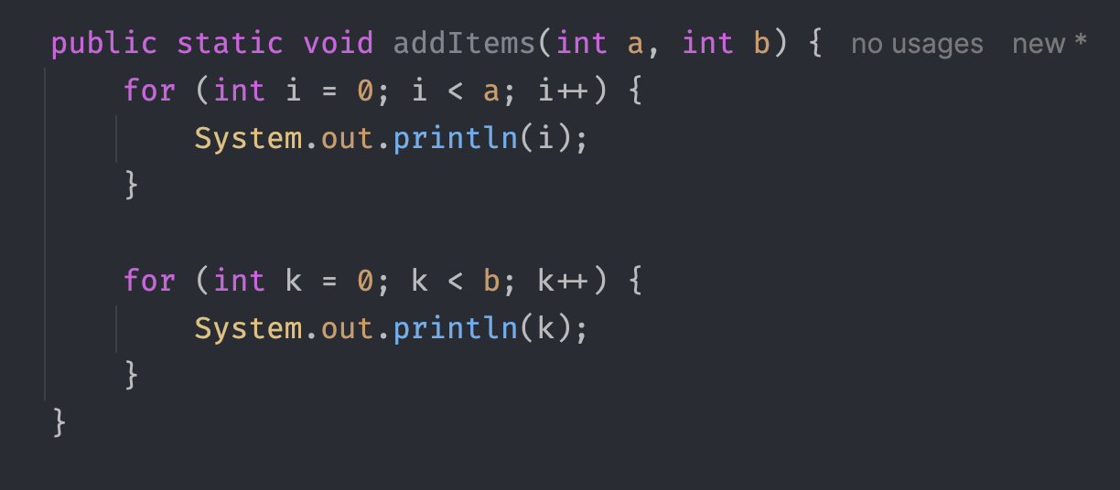
O(a*b)
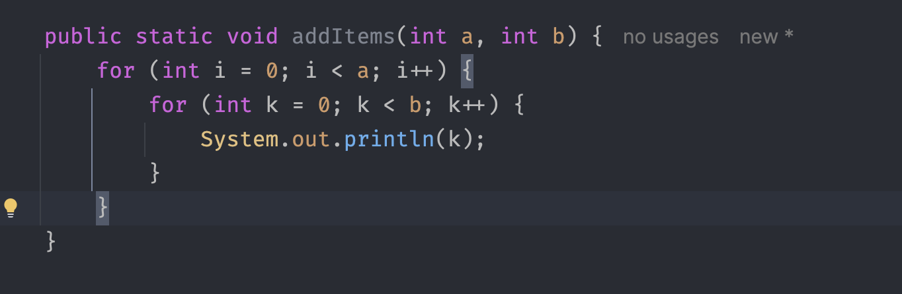

O (n²) – Loop within a Loop
O(n) – Proportional
O(log n) – Divide and Conquer
O(1) – Constant time
--------------------------------------------------------
ArrayList
Adding/Deleting
Oxiriga qo’shish va Oxiridan o’chirish – O(1)
Boshqa joylarga qo’shish va o’chirish - O(n)
Finding by VALUE O(n)
Finding by INDEX O(1)
LinkedList – index bo’lmaydi. Chunki xotirada turli xil joylarda saqlanadi.
Oxiriga qo’shish – O(1)
Oxiridan o’chirish – O(n)
Boshiga qo’shish – O(1)
Boshidam o’chirish – O(1)
Boshqa joylarga qo’shish – O(n)
Boshqa joylardan o’chirish - O(n)
Finding by VALUE O(n)
Finding by INDEX O(1)

