**README.md**

**Group B**

**“Explore Malaysia”**



Prepared by Faza Amal Sophian (2027009)

Explore Malaysia is a website mainly targeting tourists, showing the different attractions of Malaysia.

**1) Project Description**

Our group has chosen to make a website on tourism in Malaysia. It will be called Explore Malaysia and will showcase the different tourist attractions, both natural and man-made, for both foreign and domestic tourists to visit. We aim for our website to be attractive and easy-to-navigate for the users, and will incorporate many of the elements and objects that we have learned to use in class.

Our website will show eye-catching images of Malaysia’s different attractions alongside some information about its location, history and name. This will all be shown under sections of the Places to Visit page of the website. This may entice potential tourists to visit. Thus, we also provide an easy way to book holiday packages straight from our website.

If the visitors of the website wish to find out more about us or have any queries, they have several ways to do so. We will have a Contact Us page, an About Us page and also link our social media pages. The Contact Us page will provide Explore Malaysia’s phone number and email. The About Us page will contain information about the team behind the website, and also specify what the website is for. Our social media pages will be linked to each of the social media’s logos, which may allow the visitor to be more engaged, as not only are the logos eye-catching on their own, but they are also seeing logos which they are already familiar with.

Our project supports the Sustainable Development Goals from an environmental standpoint. Firstly, we will showcase many of Malaysia’s natural landmarks. This will help boost the visitors to many of nature’s beauties and may cause people to be more aware of how their actions may be affecting nature. Also, visitors may also directly help the wildlife in Malaysia by donating their money to ensure that they are well-taken care of. Donation forms are provided through our website.

As for the website design, we have chosen to go with a large icon style website. This will allow ease-of-use for the visitors and not make it seem overloaded with information. The colours are based off the website's logo, which is mainly made up colours from the Malaysian flag.

**2) Sitemap**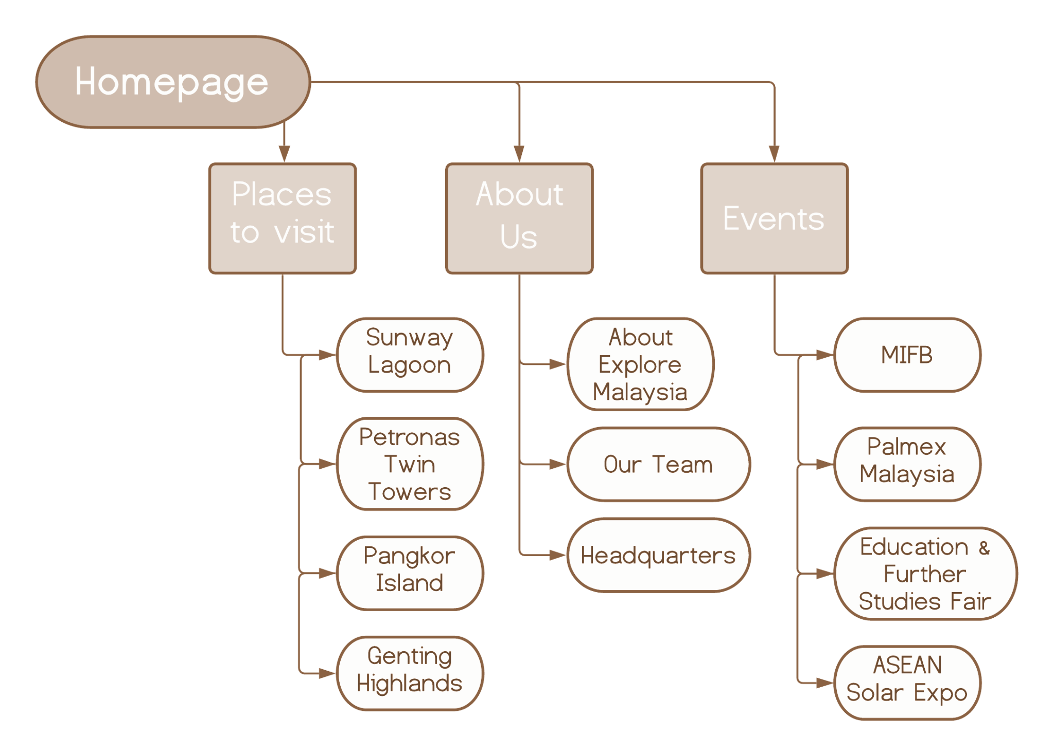

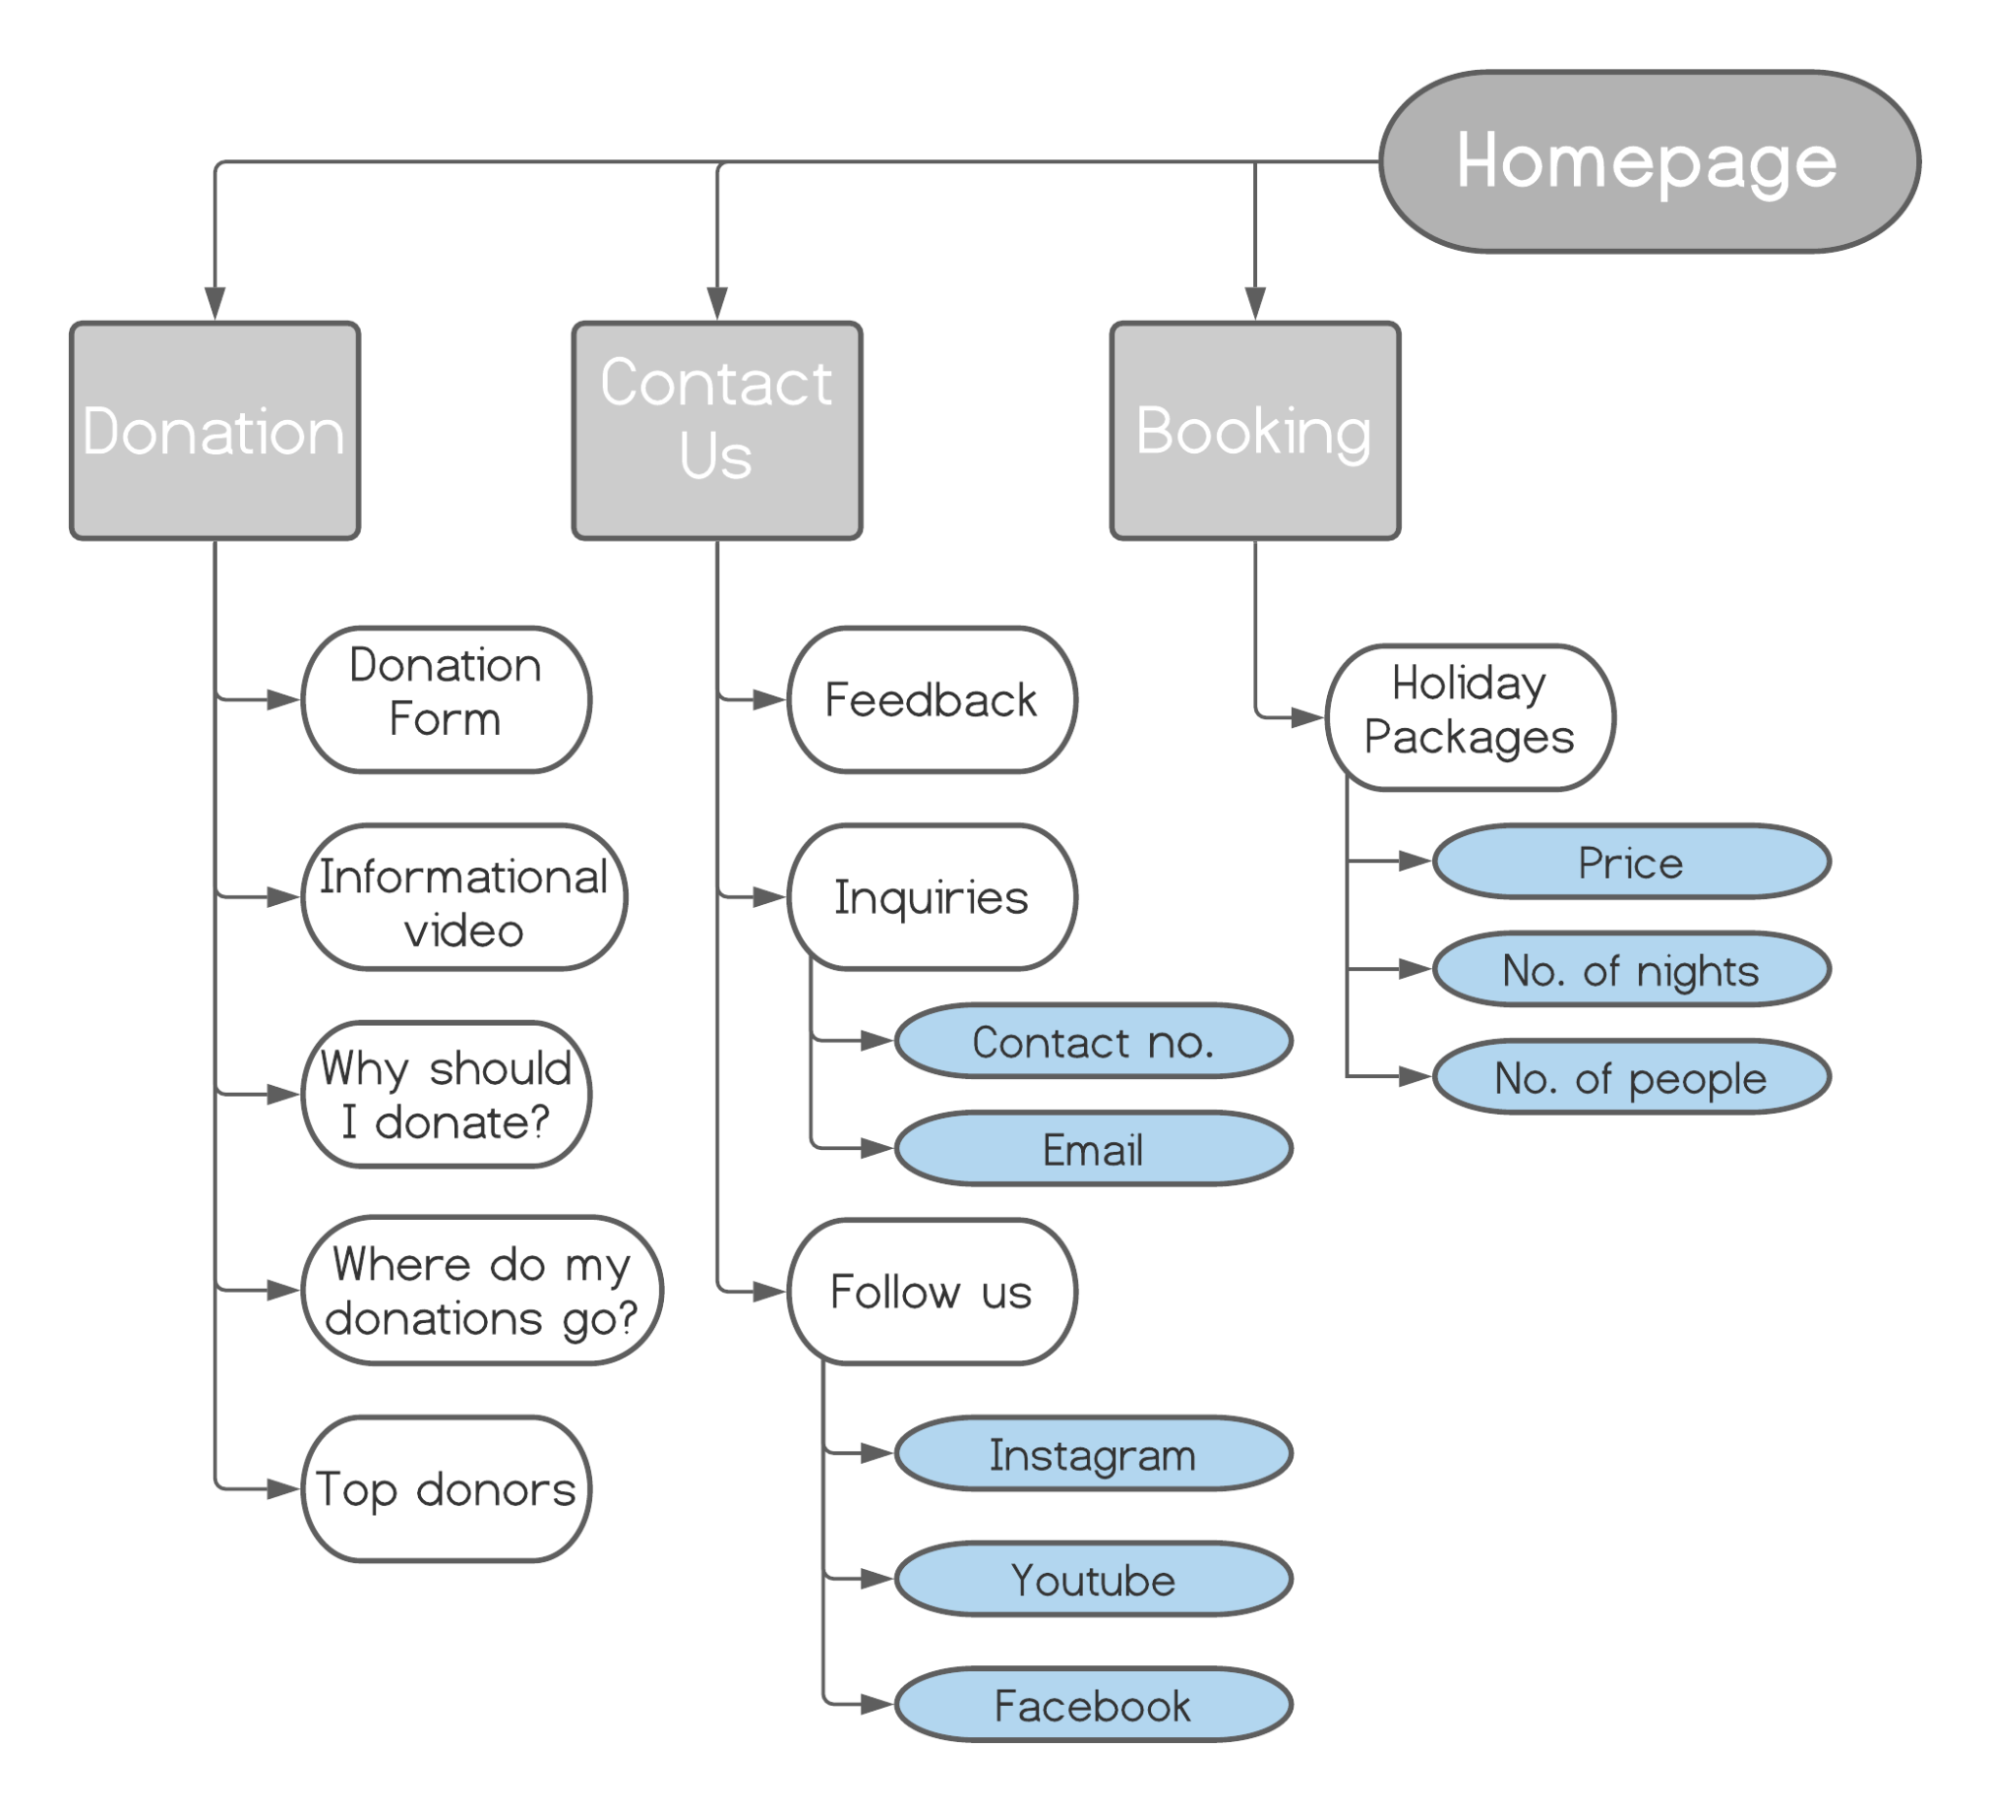

**3) Contributions**

|  |  |
| --- | --- |
| **Name** | **Contributions** |
| Faza Amal Sophian (2027009) | * Pages: Home, Events, Holiday Booking * Web elements: Header, Footer, Logo, Donation Form Validation, Navigation Bar, Colour Theme Selection * Table used for footer * Added Javascript to Home page and Places to Visit for mouse hover effect * Used Javascript for loops for form validation |
| Ramadhani Nurfikri Sulaeman (2029353) | * Pages: About Us * Web elements: Responsive show and hide text on About Us page * Used Javascript functions and events (onmouseover, onmouseout, onclick) for showing and hiding section * Web elements: Added interactive Google Maps for headquarters * Added appropriate CSS styling for the About Us page |
| Aiman Syahmi Bin Ahmad Sabri (2029589) | * Pages: Places To Visit, Place 1, Place 2, Place 3, Place 4 * Web elements: Added interactive Google Maps with location marked for each tourist destination * Added the different unique spots to the Places to Visit page with appropriate styling |
| Bashir Md Monjur (2028113) | * Pages: Donation Page * Web Elements: Donation Form, Accordion, Video * Video shown with controls |

**4) Third-party resources**

|  |  |  |  |
| --- | --- | --- | --- |
| Web elements | Name | Use of third-party resource | Modifications (if any) |
| Accordion Widget | Accordion (JQueryUI) | In donation page |  |
| Interactive Google Maps | Google Map API | * In each tourist location page * In About Us page | * Height set to 80% * Lat and Long set to locations of places and HQ * Zoom set to 16 |

**5) References**

i) Donation Page Video - Qistina Shaharudin (YouTube) - 28/5/21

ii) Home Page Banner - Nafis Abman (Pexels) - 20/5/21

ii) Home Page Pangkor - Afif Al-Shabaini (Dreamstime) - 20/5/21

iii) Home Page KLCC - Zukiman Muhammad (Pexels) - 20/5/21

iv) Home Page Tiger - George Despiris (Pexels) - 20/5/21

v) Home Page Waterpark- sunwaylagoon.com - 20/5/21

vi) About Us Banner - Munzir (Pexels) - 2/6/21

vii) Our Team Pictures - <https://thispersondoesnotexist.com/>

xv) Places to visit Sunway lagoon -hotelroomrenonv (image) - 3/11/19

x) Places to visit Petronas Twin Tower - thrillophia (image)- 31/5/21

xi) Places to visit Pulau Pangkor - visit pangkor laut malaysia vacation (image) -20/6/18

xii) Places to visit Genting Highland - Gurmeet Kaur (image) -30/5/2020