**INDEX**

|  |  |  |
| --- | --- | --- |
| **Sr.no** | **Title** | **Page.no** |
| **Part-I Introduction** | | |
| **1** | **Introduction to Project** |  |
|  | * **Project Profile** |  |
| **Part-II System Analysis and Design** | | |
| **2** | **Project Planning** |  |
|  | * **Scope of the Project** |  |
|  | * **Project Team** |  |
| **3** | **System Design** |  |
|  | * **Data Flow Diagrams** |  |
|  | * **Database Design** |  |
| **Part-III Implementation Details** | | |
| **4** | **Screen Layouts** |  |
| **Part-IV Appendix** | | |
| **5** | **Bibliography** |  |

**PART - I**

**INTRODUCTION**

**1. INTRODUCTION TO PROJECT**

**Project Title:** Online Event Management System

**Project Profile:-**

**The Event Management System is a web application designed to simplify**

**process of organizing and attending events. This platform allows event**

**organizers to create and manage events, providing all the necessary details**

**such as event the event name, date, location and description. On the other**

**side, user can browse through various events, view detailed information,**

**and easily enroll in the ones that interest them.**

**Purposes:**

* **1.Streamline Event Registrations: To provide users with an easy platform to discover, view, and register for events, both paid and free.**
* **2.Empower Organizers: To allow event organizers to efficiently create, manage, and track their events and user registrations.**
* **3.Enhance User Experience: To offer users a personalized experience where they can manage their registered events in one place.**
* **4.Simplify Administration: To give admins control over managing users, organizers, event categories, and system languages efficiently.**

**Project Modules:**

**Users Modules:-**

* **Register for Events: Users can sign up for various events.**
* **View Registered Events: Users can see a list of events they have registered for.**

**Organisers Modules:-**

* **Register as an Organiser: Organisers can sign up to manage events, but they need admin approval before creating events.**
* **Create, Update, and Delete Events: Once approved, organisers can manage their own events.**
* **Events can be either paid or free.**
* **View Registered Users: Organisers can see how many users have registered for their events.**
* **View and Manage Created Events: Organisers have access to all the events they've created and can update or delete them.**
* **Manage Profile: Organisers can update their personal or organisation information on their profile page.**
* **Request Event Cancellation: If an organiser wants to cancel an event, a request is sent to the admin for approval.**

**Admin Modules:-**

* **Dashboard Overview: Admins can view statistics on how many users and organisers are registered.**
* **View Event Details: Admins have access to all the information about events, including details on users and organisers.**
* **Approve or Reject Organiser Registrations: When a new organiser registers, the admin decides whether to approve or deny the request.**
* **Manage Organiser Permissions: Admins can block or allow organisers from creating events.**
* **Approve or Reject Event Cancellations: When an organiser requests to cancel an event, the admin decides whether to approve or reject the request. If approved, users get refunds with a reason for the cancellation.**
* **Manage Event Categories and Languages: Admins can add, update, or remove categories and languages for events on the platform.**

**Tools & Technology:** React.js, Express.js, Node.js, Mongodb and Shadcn

**Team Size:** 1 member

**Internal Project Guide:**

**Submitted To:** KBS Commerce & NATRAJ Professional Science Collage

**Duration:** 3 Months

**Project Developed By: Fazal Hussain**

**PART-II**

**SYSTEM ANALYSIS**

**&**

**DESIGN**

**2. Project Planning**

**Scope of Project:-**

* **Implementing secure login and role-based access for Admin, Organisers, and Users.**
* **When the Admin logs in, they will have full access to handle all the web pages and system information, including managing events, categories, and languages, approving organiser registration requests, reviewing and managing organiser permissions, and deciding on event cancellation requests. They will also have access to view user and organiser details, as well as approve refunds for cancelled events.**
* **When the Organiser logs in, they will be able to create, update, and delete events, view how many users have registered for their events, manage their profile, and submit cancellation requests for their events, which will require admin approval. Organisers can create either paid or free events once their account has been approved by the admin.**
* **When the User logs in, they will have access to register for events and view all the events they have signed up for.**

**Project Team**

There is only one member in this project whose details are as follows:

|  |  |
| --- | --- |
| **Personal Profile** | |
| **Name** | Fazal Hussain |
| **Address** | Kanchan Nagar, Vapi |
| **Contact No.** | 9054267997 |
| **E-mail Address** | Fazalhussain1441@gmail.com |
| **Seat No.** | 11 |

**3. System Design**

**Data Flow Diagram of Onilne Event Management System:**

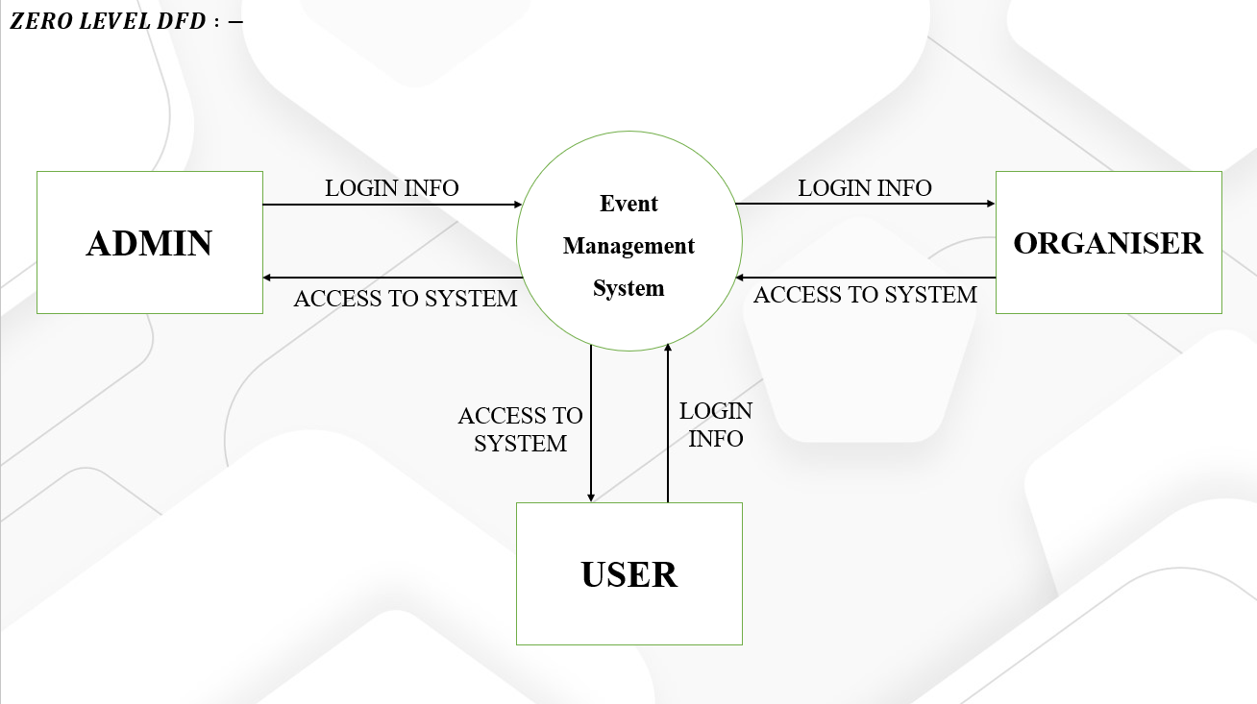

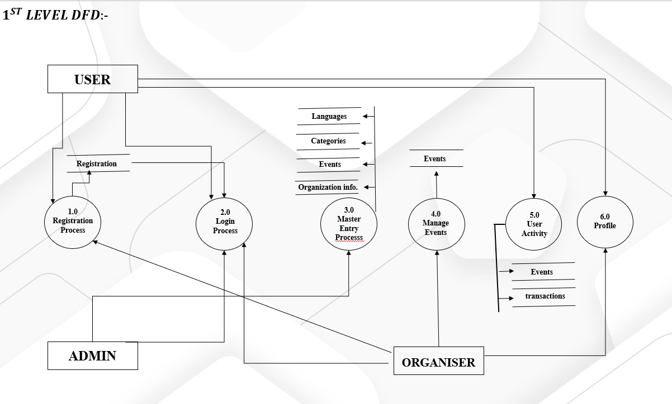

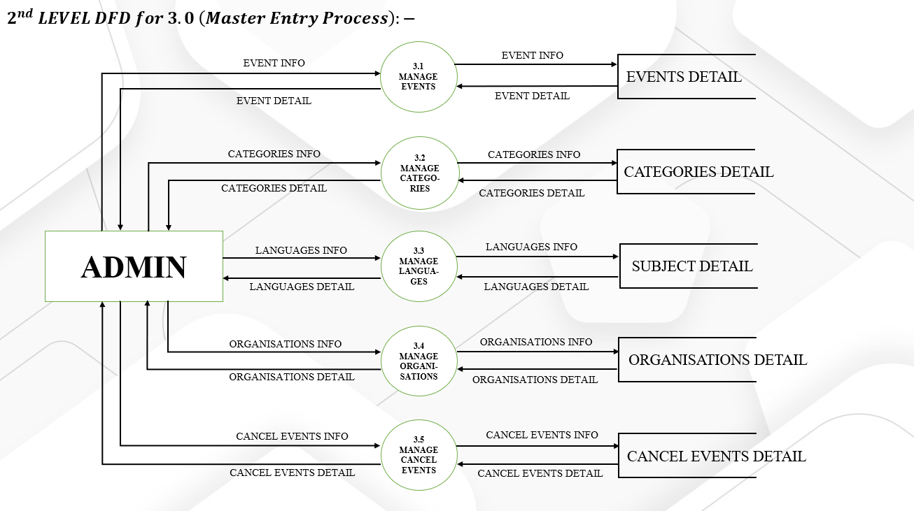

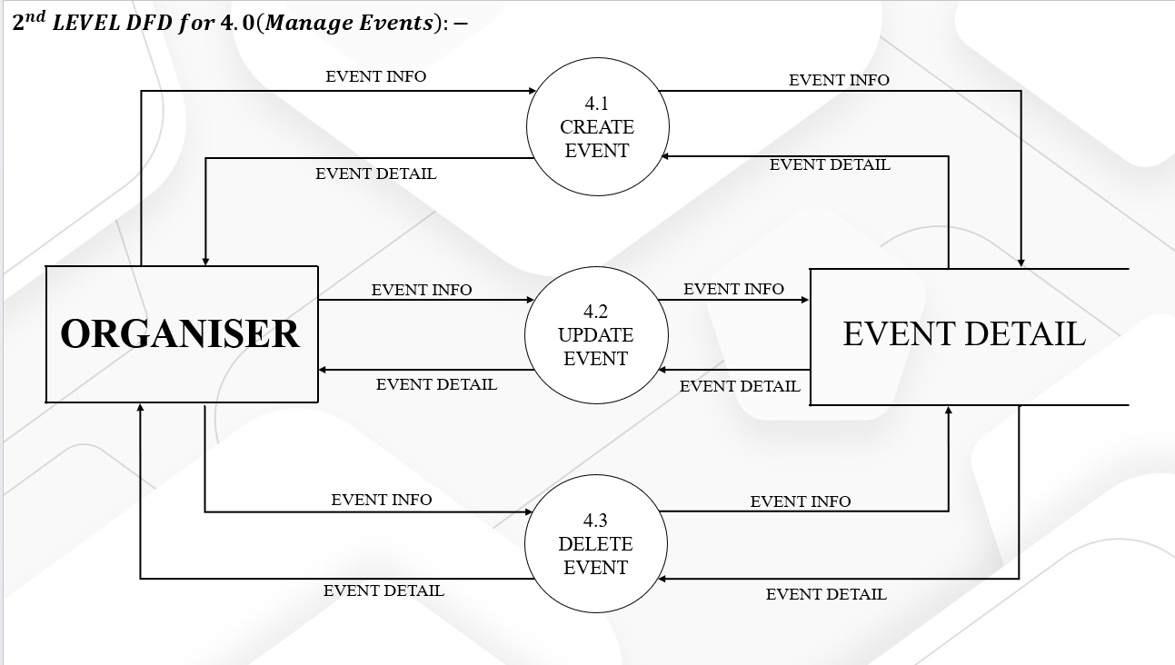

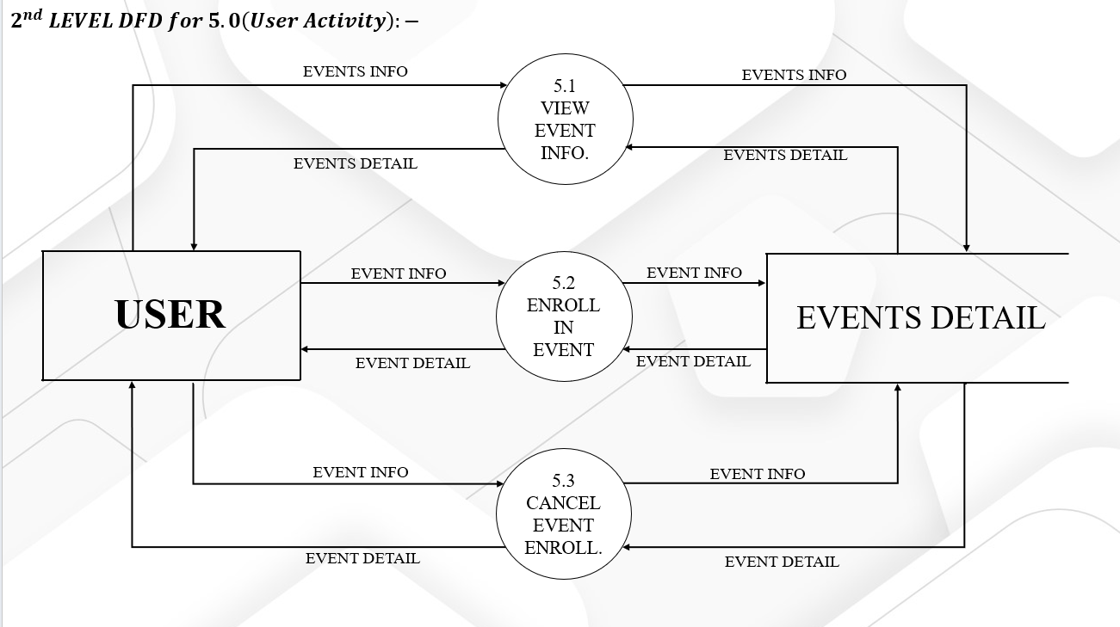

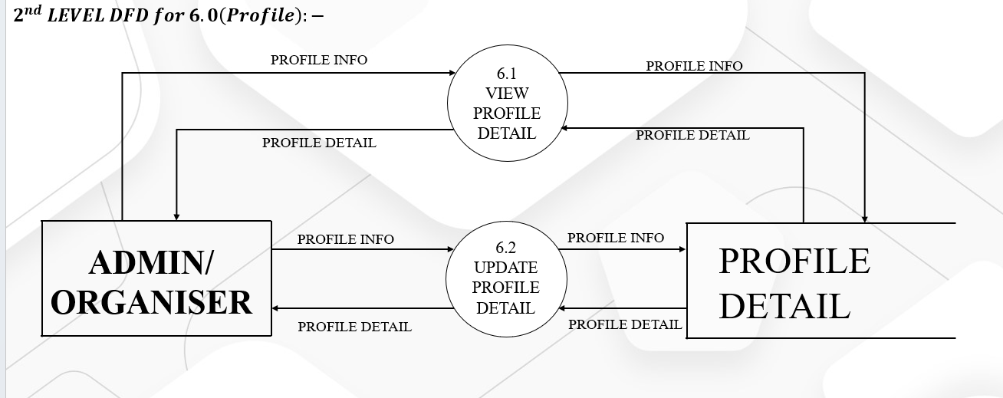

**DataBase-Design of Online Event Management System**

**Roles Table:-**

**Description: This table is used for storing Roles details**



**Users Table:-**

**Description: This table is used for storing Users details**

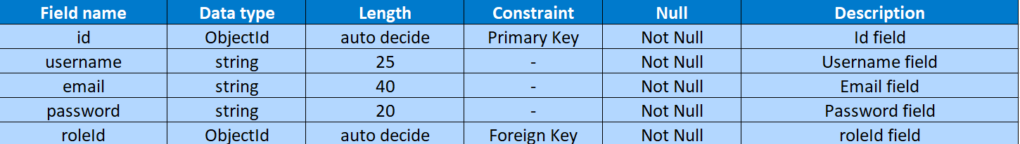

**OrganiserInformation Table:-**

**Description: This table is used for storing Organisations details**

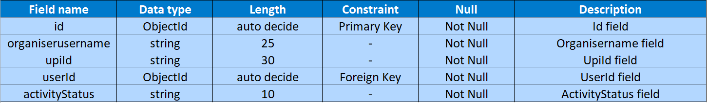

**Events Table:-**

**Description: This table is used for storing Events details**

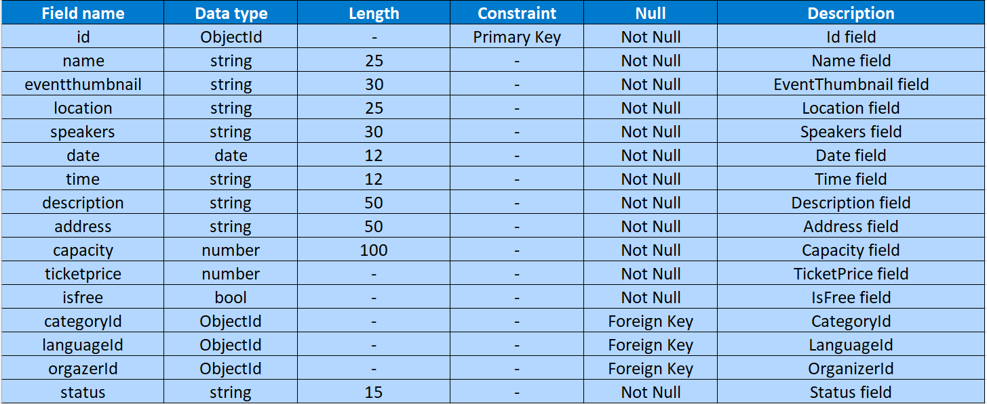

**Categories Table:-**

**Description: This table is used for storing Categories details**



**Languages Table:-**

**Description: This table is used for storing Languages details**



**JoinUsers Table:-**

**Description: This table is used for storing The Users details who have joined the event**



**CancelEvents Table:-**

**Description: This table is used for storing the events details which will get canceled.**

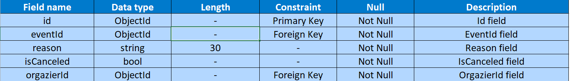

**Transactions Table:-**

**Description: This table is used for storing Transaction details of the event**

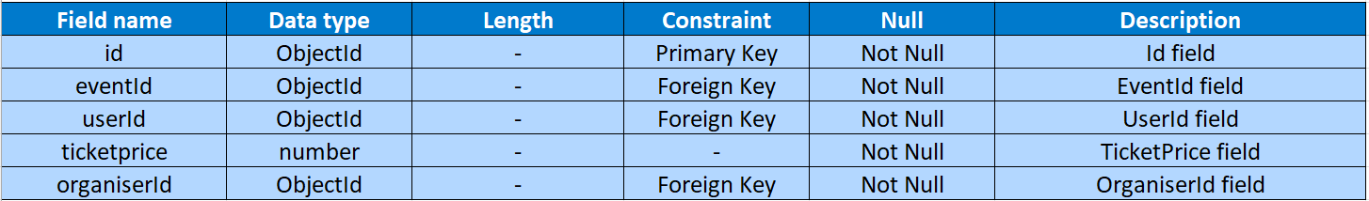

**PART-III**

**Implementation**

**Details**

**Organiser Side:**

**1. Signup Form:-**

Used to Register to system.

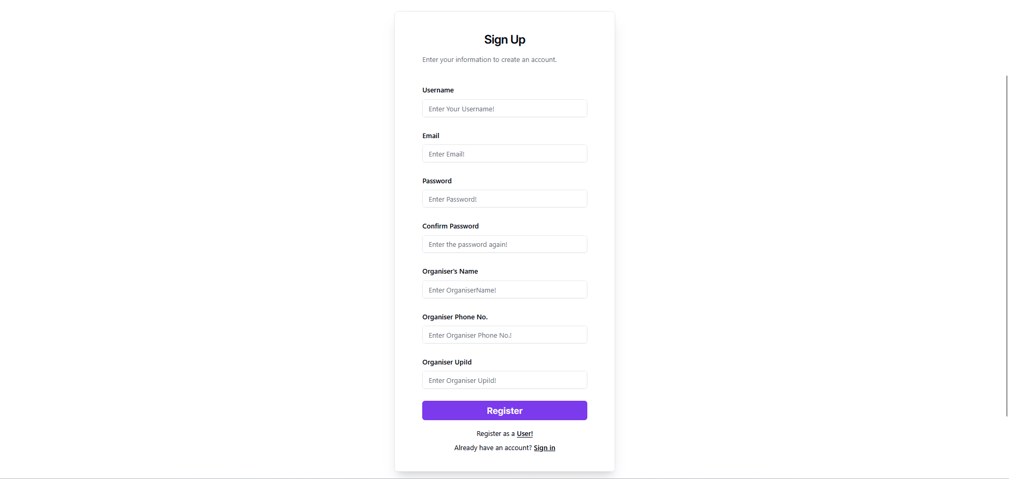

**2. Login Form:-**

Used to Login to system.

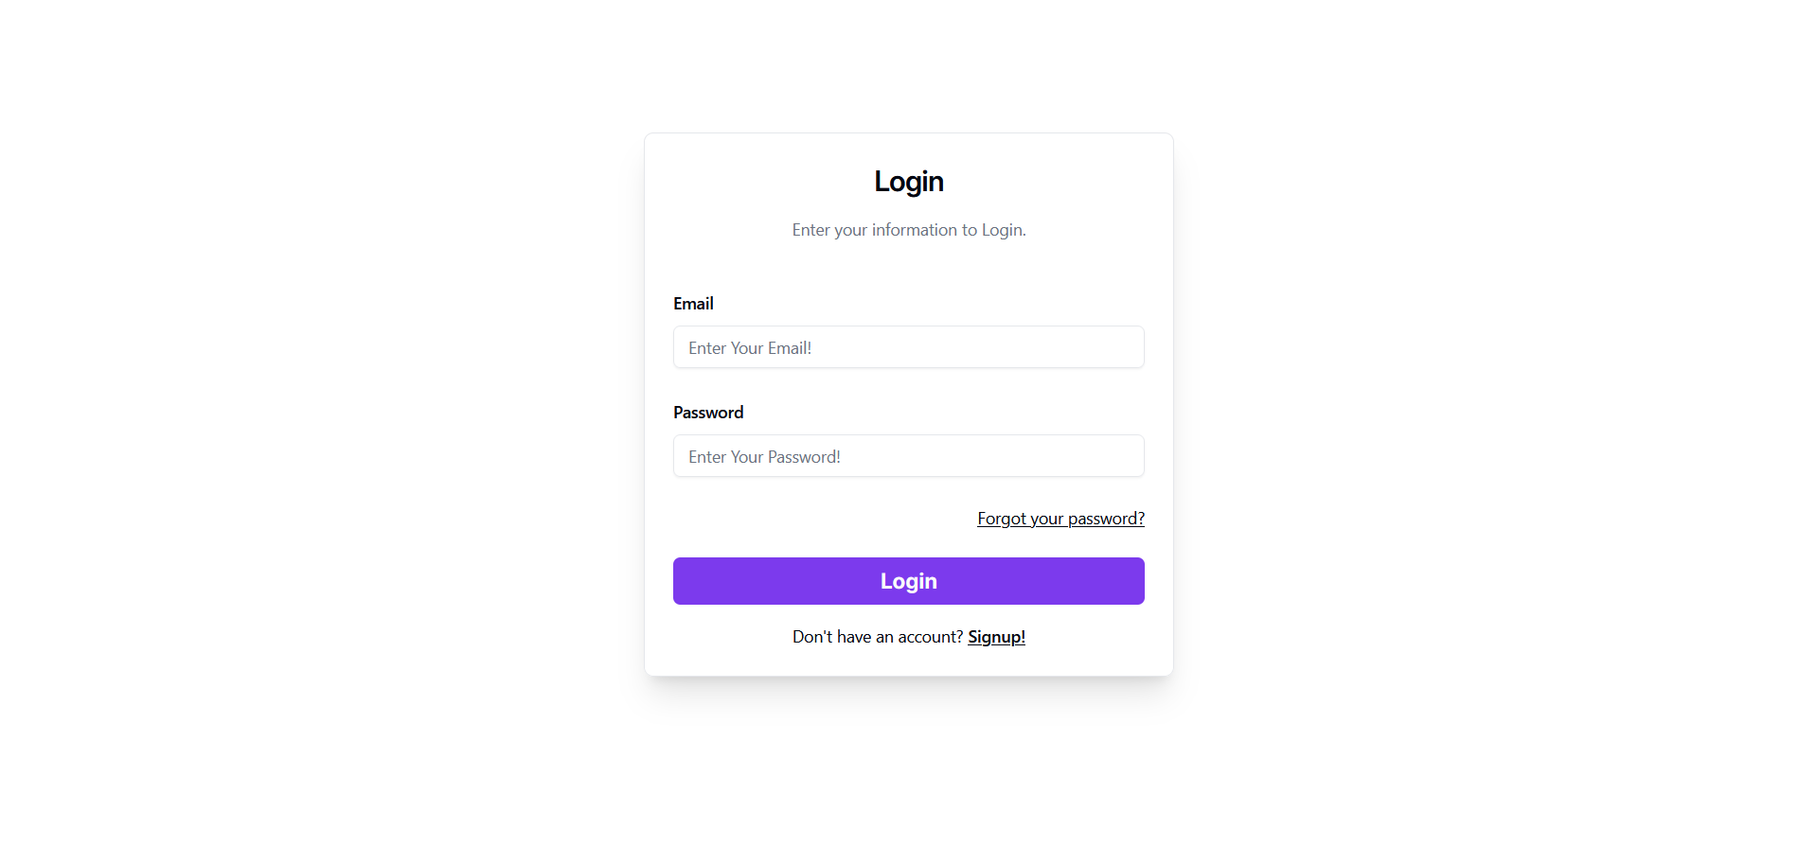

**3. Recent Events (Dashboard):-**

Used to Manage Events.

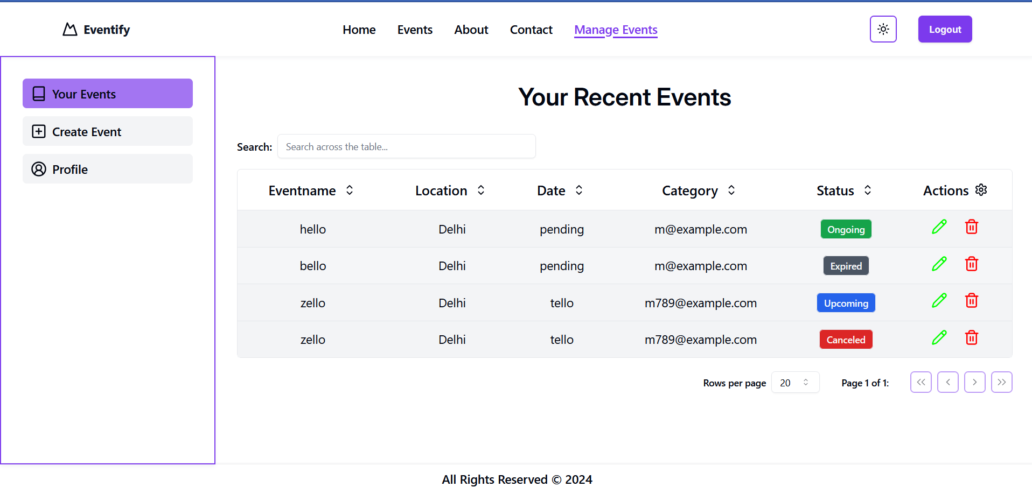

**4. Create Events (Dashboard):-**

Used to Create Events.

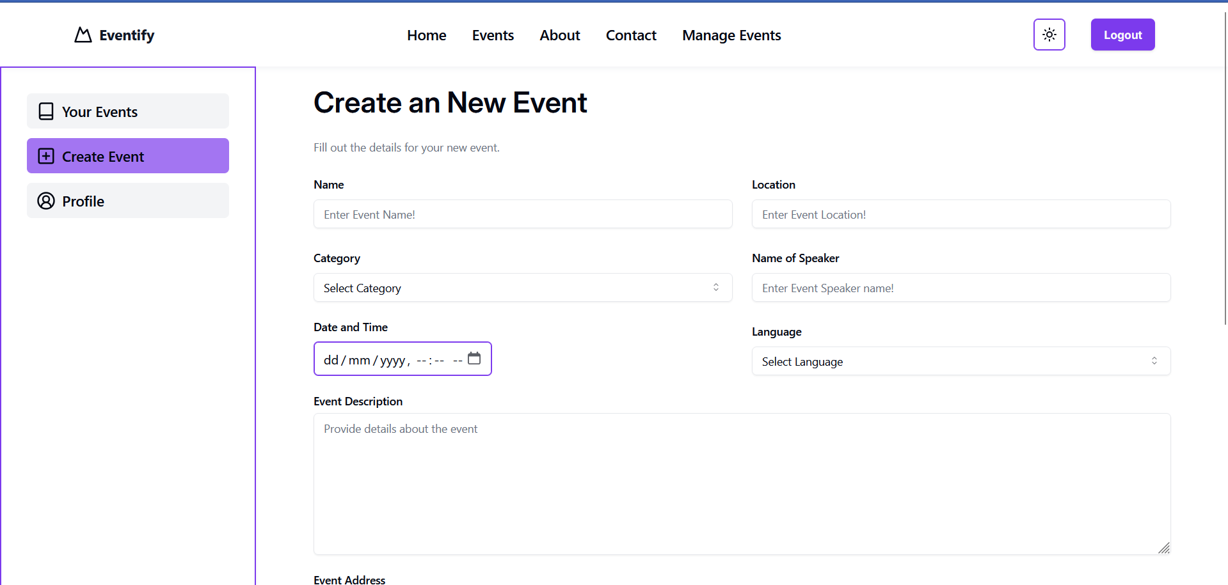

**5. Update Profile (Dashboard):-**

Used to Update Profile Information.

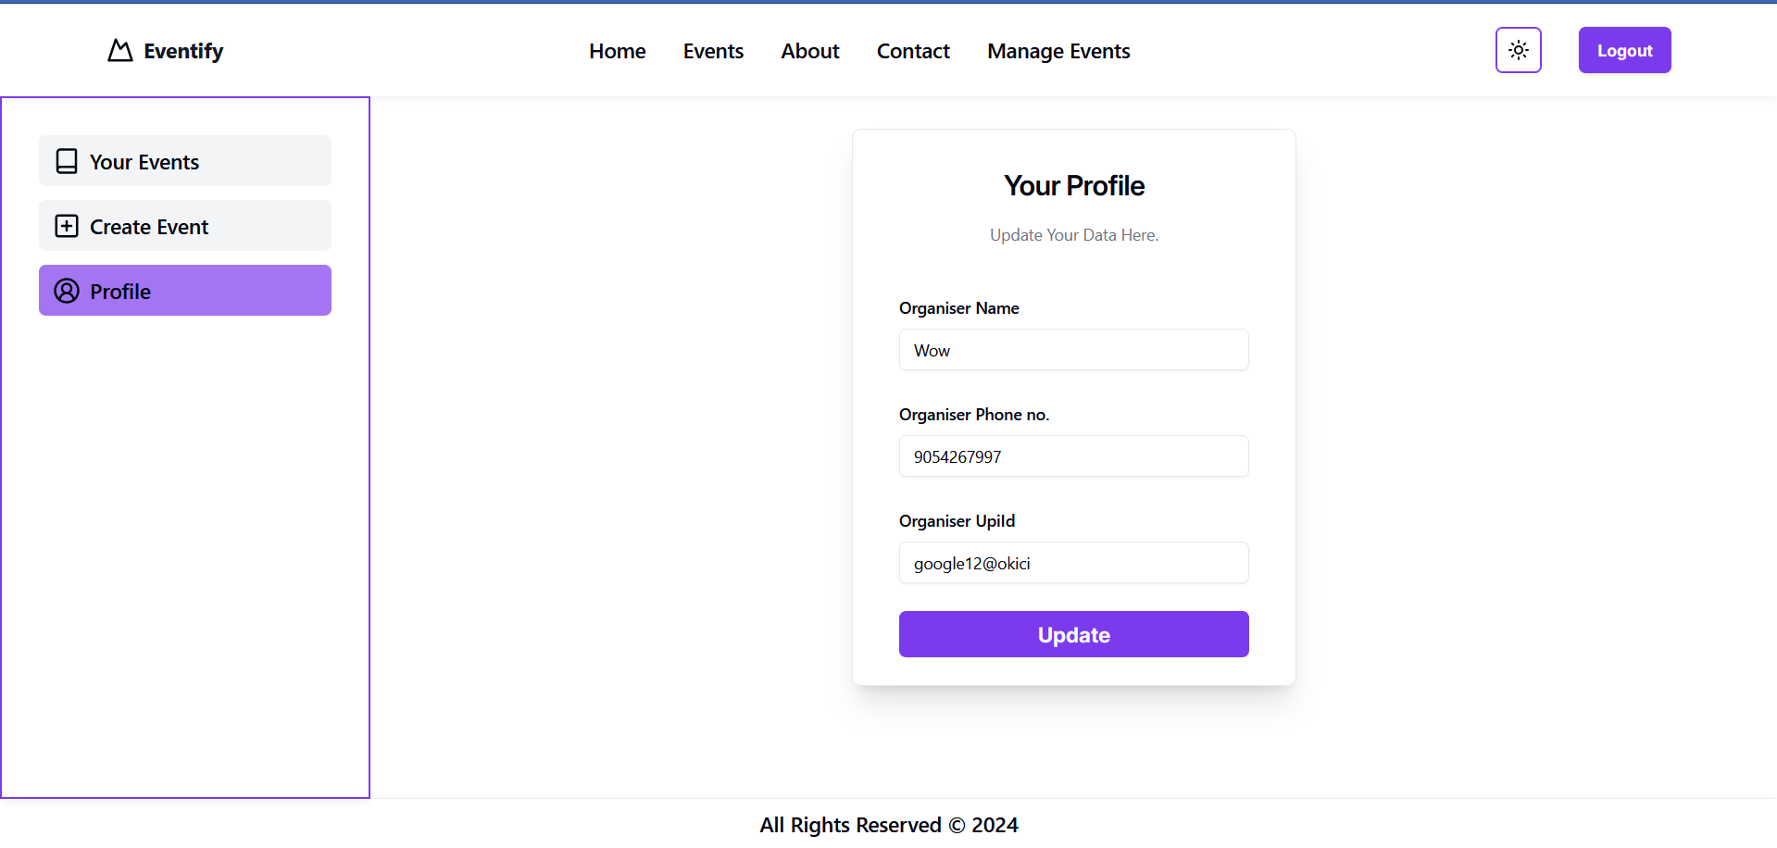

**Admin Side:**

**1. Login Form:-**

Used to Login to system.



**2. Dashboard:-**

Used to See Summary of the System.

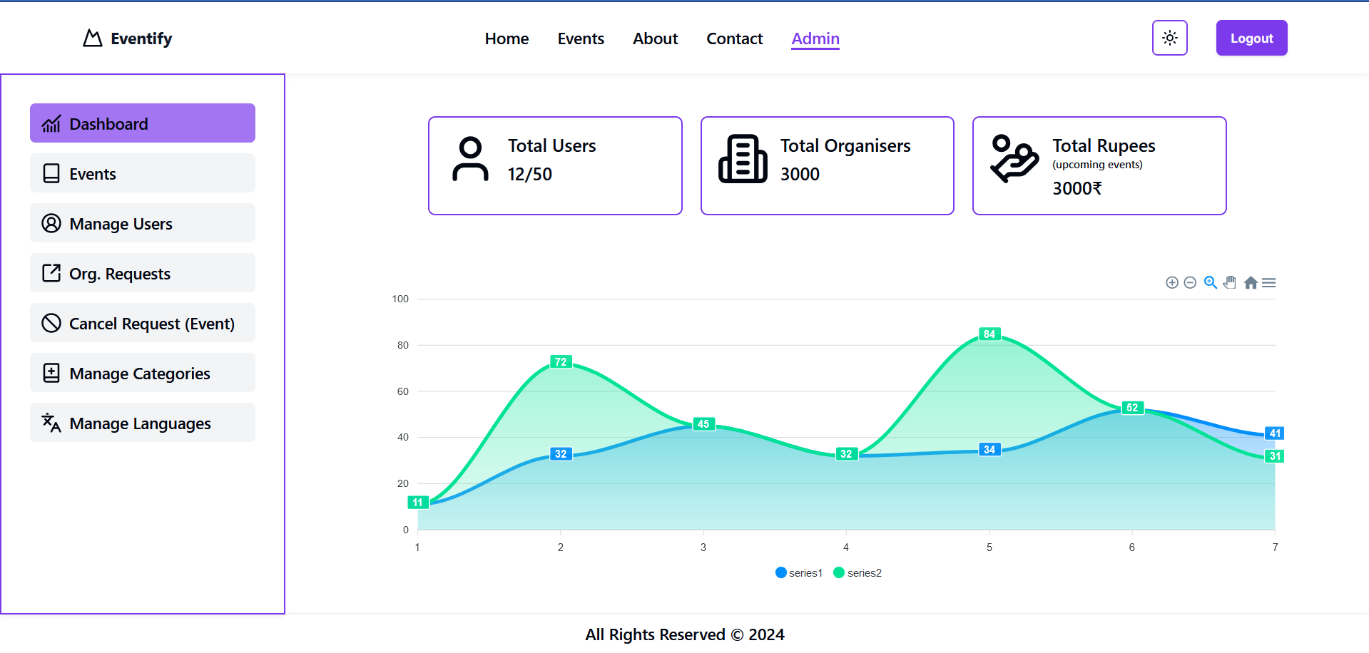

**3. All Events Page(Dashboard):-**

Used to See Information of All Events.

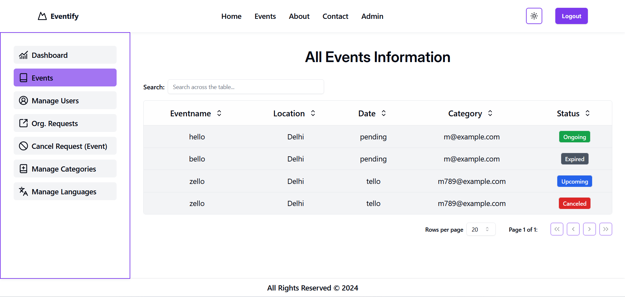

**4. All Users Page(Dashboard):-**

Used to See Information of All Users.

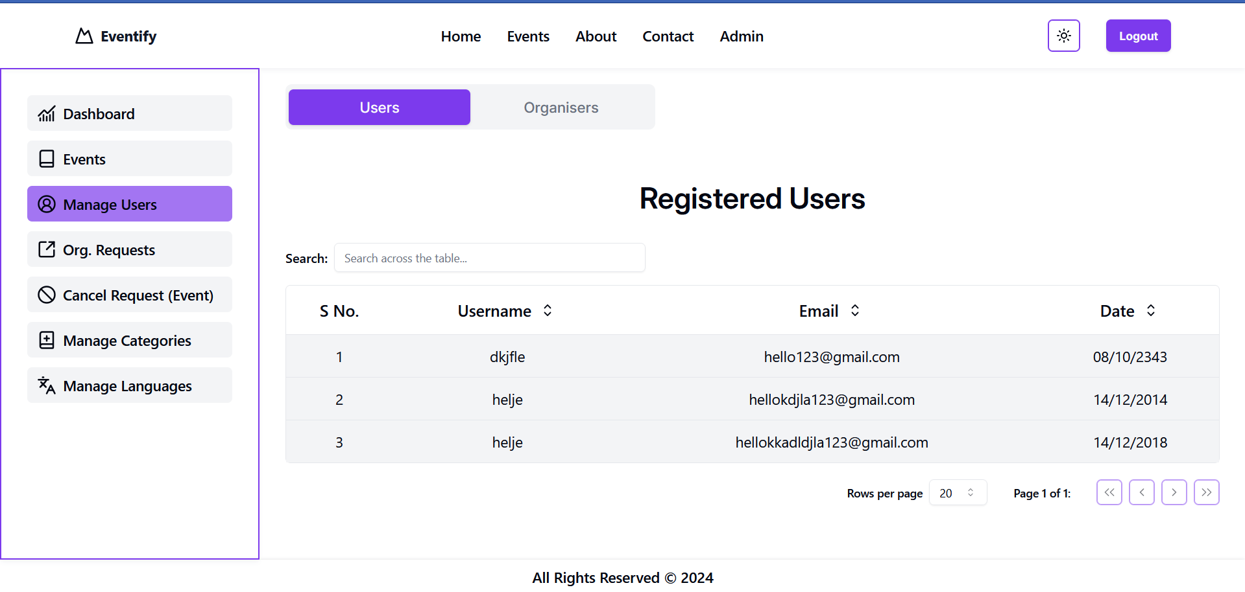

**5. Organisation Request Page(Dashboard):-**

Used to Manage New Organisers.

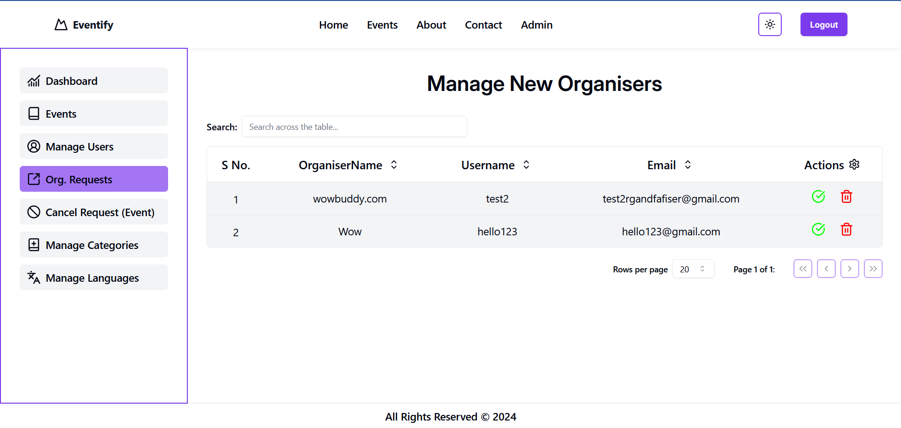

**6. Event Cancel Request Page(Dashboard):-**

Used to Manage Cancel Events Requests.

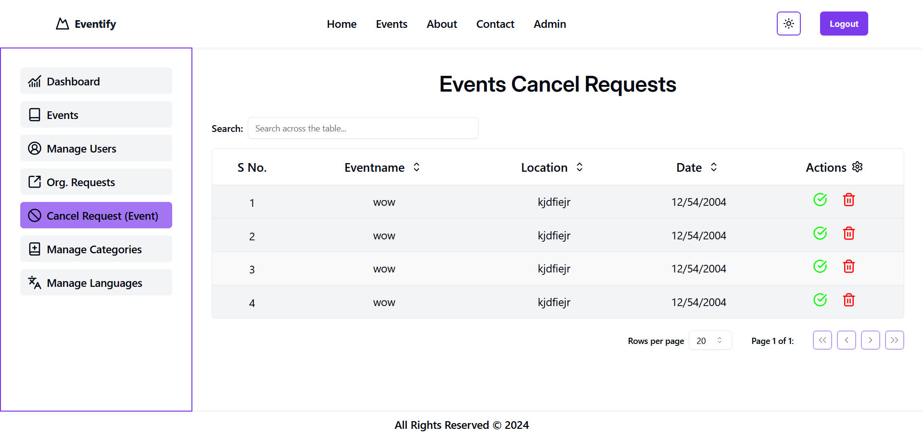

**7. Categories Page(Dashboard):-**

Used to Manage Categories for Events.

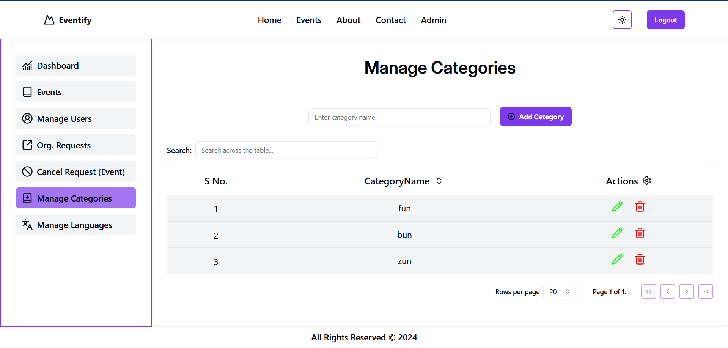

**8. Languages Page(Dashboard):-**

Used to Manage Languages for Events.

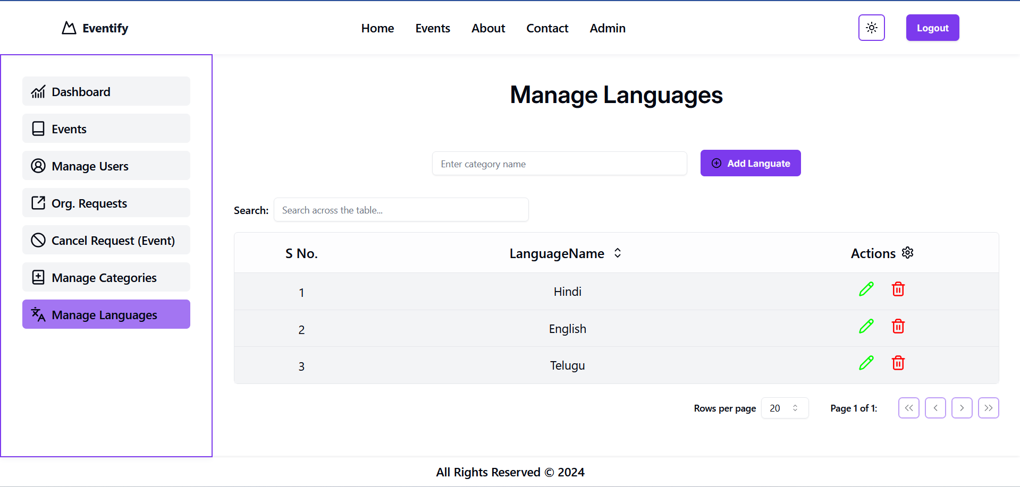

**PART-IV**

**Appendix**

**5.Bibliography**

**Books: ---**

**Search Engine: Google**

**Online Resource : w3schools, chatgpt**