**INDEX**

|  |  |  |
| --- | --- | --- |
| **Sr.no** | **Title** | **Page.no** |
| **Part-I Introduction** | | |
| **1.1** | **Introduction to Project** |  |
| **1.2** | **Project Profile** |  |
| **Part-II System Analysis and Design** | | |
| **1.** | **Scope of the System** |  |
| **2.** | **Software Process Model** |  |
| **3.** | **Project Team** |  |
|  | **✔️System Design** |  |
|  | 1. **Data Flow Diagrams** |  |
|  | 1. **Database Design** |  |
| **Part-III Implementation Details** | | |
|  | **Screen Layouts** |  |
| **Part-IV Tools & Technology** | | |
|  | **About Frontend** |  |
|  | **About Backend** |  |
|  | **Framework or Other Technologies** |  |
| **Part-IV Appendix** | | |
| **5** | **Bibliography** |  |

**PART - I**

**INTRODUCTION**

**1. INTRODUCTION TO PROJECT**

**Project Title:** Online Event Management System

**Project Profile:-**

**The Event Management System is a web application designed to simplify**

**process of organizing and attending events. This platform allows event**

**organizers to create and manage events, providing all the necessary details**

**such as event the event name, date, location and description. On the other**

**side, user can browse through various events, view detailed information,**

**and easily enroll in the ones that interest them.**

**Purposes:**

* **1.Streamline Event Registrations: To provide users with an easy platform to discover, view, and register for events, both paid and free.**
* **2.Empower Organizers: To allow event organizers to efficiently create, manage, and track their events and user registrations.**
* **3.Enhance User Experience: To offer users a personalized experience where they can manage their registered events in one place.**
* **4.Simplify Administration: To give admins control over managing users, organizers, event categories, and system languages efficiently.**

**Key Purposes:**

**For Users:**

* **View event details and register for both paid and free events.**
* **Access and manage their list of registered events.**

**For Organizers:**

* **Register as an event organizer and create detailed events.**
* **View and manage the events they've created.**
* **Track and monitor user registrations for their events.**

**For Admin:**

* **Manage users and organizers, including approvals and account settings.**
* **Oversee and organize event categories.**
* **Manage system languages to ensure the platform is accessible to different language-speaking users.**

**Hardware Requirements:**

**AMD Ryzen 5 5500U with Radeon Graphics [2.10 GHz]**

**8.00 GB RAM**

**64-bit operating system, x64-based processor**

**Software Requirements:**

**Frontend:-**

**Html, Tailwindcss, Nodejs, React.js**

**Backend:**

**Nodejs, Express.js, Mongodb**

**Modules:**

**Users Modules:-**

* **Register for Events: Users can sign up for various events.**
* **View Registered Events: Users can see a list of events they have registered for.**

**Organisers Modules:-**

* **Register as an Organiser: Organisers can sign up to manage events, but they need admin approval before creating events.**
* **Create, Update, and Delete Events: Once approved, organisers can manage their own events.**
* **Events can be either paid or free.**
* **View Registered Users: Organisers can see how many users have registered for their events.**
* **View and Manage Created Events: Organisers have access to all the events they've created and can update or delete them.**
* **Manage Profile: Organisers can update their personal or organisation information on their profile page.**
* **Request Event Cancellation: If an organiser wants to cancel an event, a request is sent to the admin for approval.**

**Admin Modules:-**

* **Dashboard Overview: Admins can view statistics on how many users and organisers are registered.**
* **View Event Details: Admins have access to all the information about events, including details on users and organisers.**
* **Approve or Reject Organiser Registrations: When a new organiser registers, the admin decides whether to approve or deny the request.**
* **Manage Organiser Permissions: Admins can block or allow organisers from creating events.**
* **Approve or Reject Event Cancellations: When an organiser requests to cancel an event, the admin decides whether to approve or reject the request. If approved, users get refunds with a reason for the cancellation.**
* **Manage Event Categories and Languages: Admins can add, update, or remove categories and languages for events on the platform.**

**Scope of Project:-**

**Implementing secure login and role-based access for Admin, Organisers, and Users.**

**When the Admin logs in, they will have full access to handle all the web pages and system information, including managing events, categories, and languages, approving organiser registration requests, reviewing and managing organiser permissions, and deciding on event cancellation requests. They will also have access to view user and organiser details, as well as approve refunds for cancelled events.**

**When the Organiser logs in, they will be able to create, update, and delete events, view how many users have registered for their events, manage their profile, and submit cancellation requests for their events, which will require admin approval. Organisers can create either paid or free events once their account has been approved by the admin.**

**When the User logs in, they will have access to register for events and view all the events they have signed up for.**

**Objectives:**

* **Admin can easily manage all web pages, including handling event approvals, organiser management, category and language settings, and refund processes.**
* **Organisers can easily manage event creation, updates, cancellations, and view user registrations for their events.**
* **Users can view and register for events, as well as see details of the events they have signed up for.**

**Tables of Event Management System:**

**Roles Table:-**



**Users Table:-**

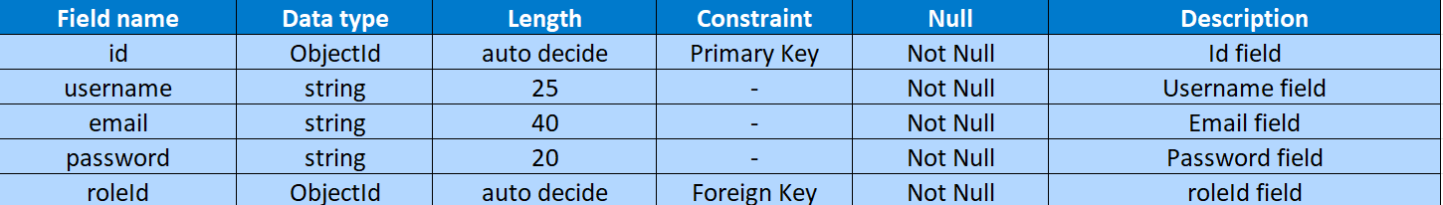

**OrganiserInformation Table:-**

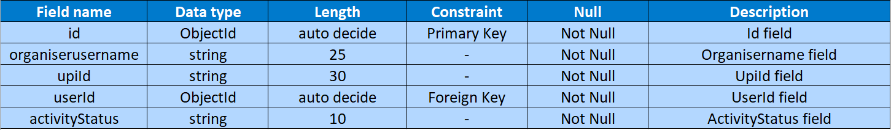

**Events Table:-**

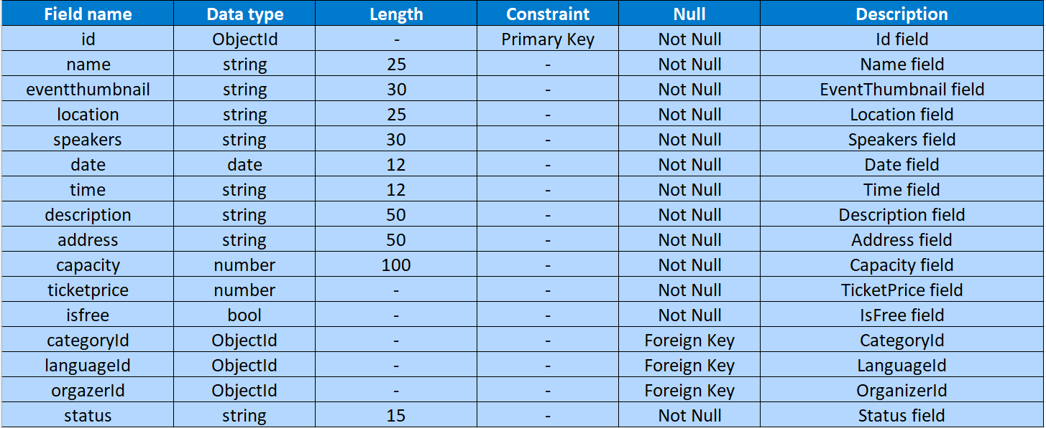

**Categories Table:-**



**Languages Table:-**



**JoinUsers Table:-**



**CancelEvents Table:-**

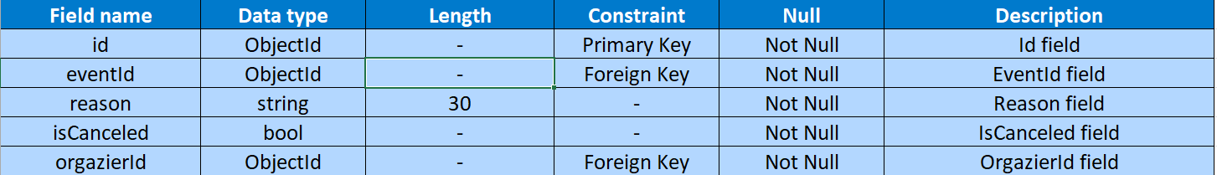

**Transactions Table:-**

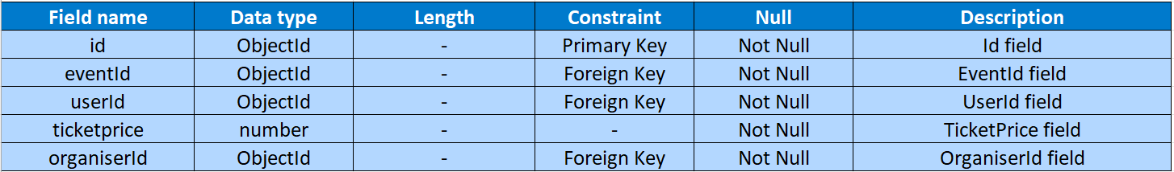

**Event Management Dfd:-**

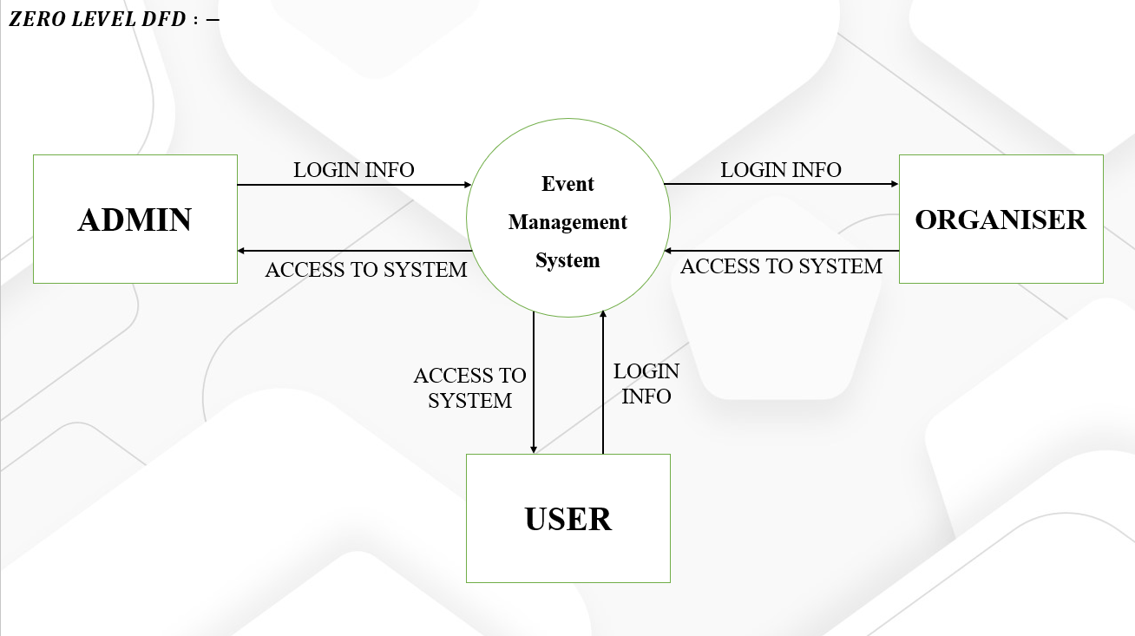

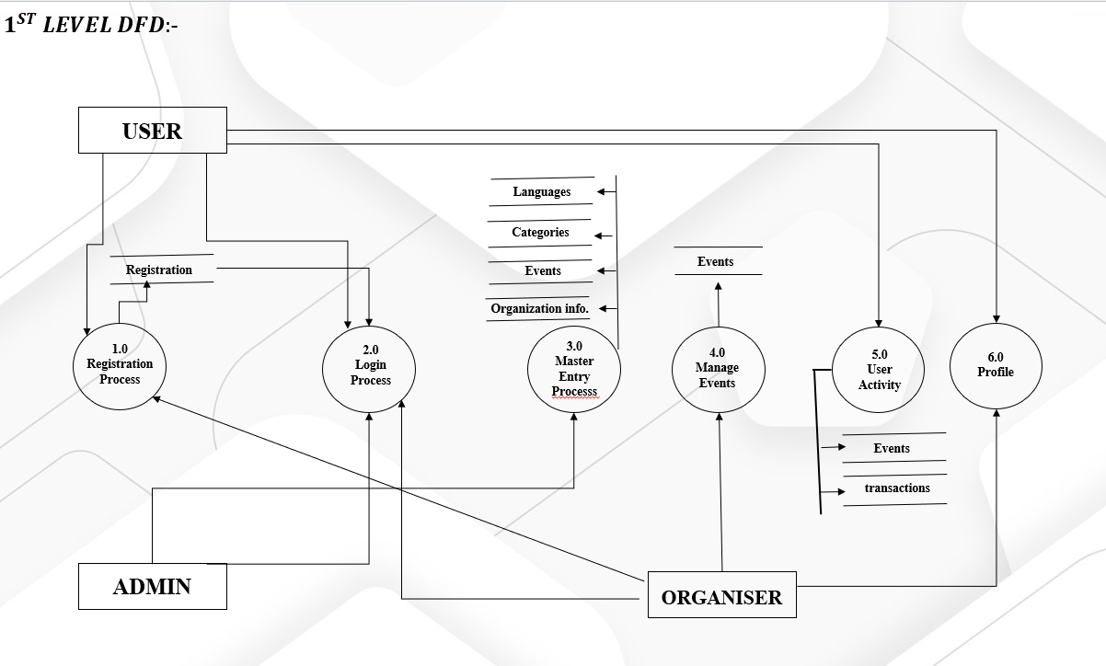

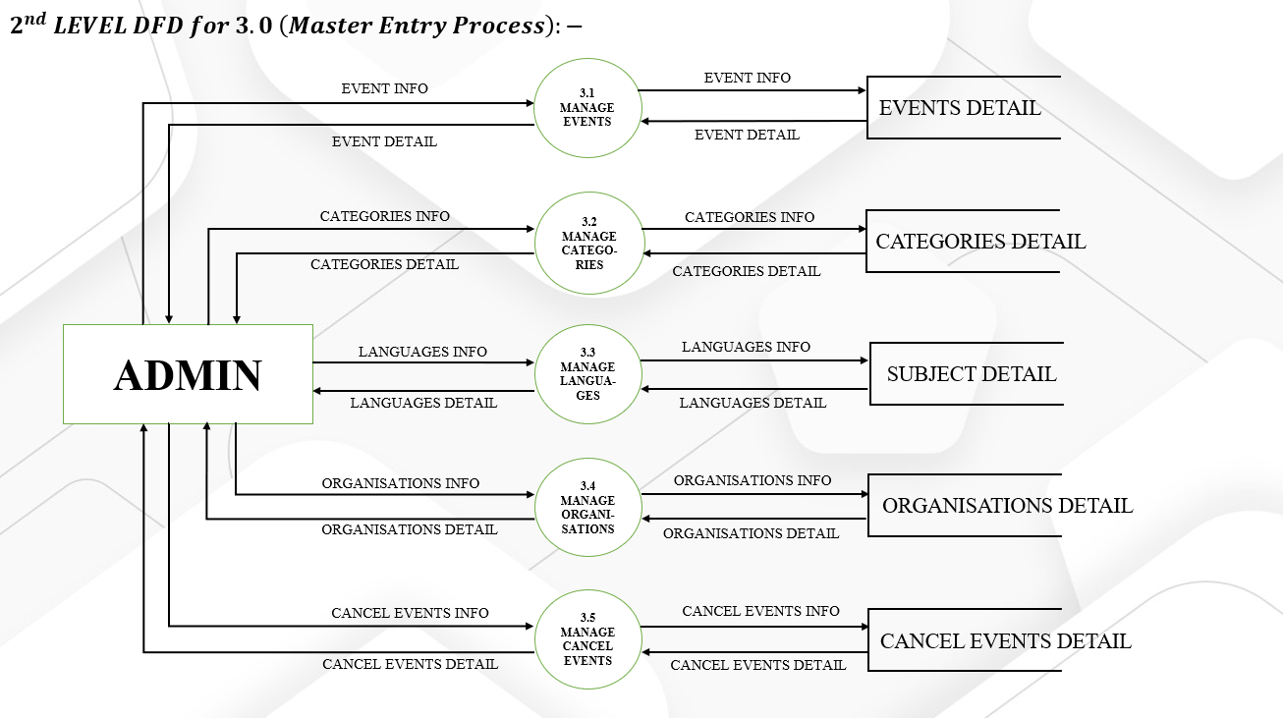

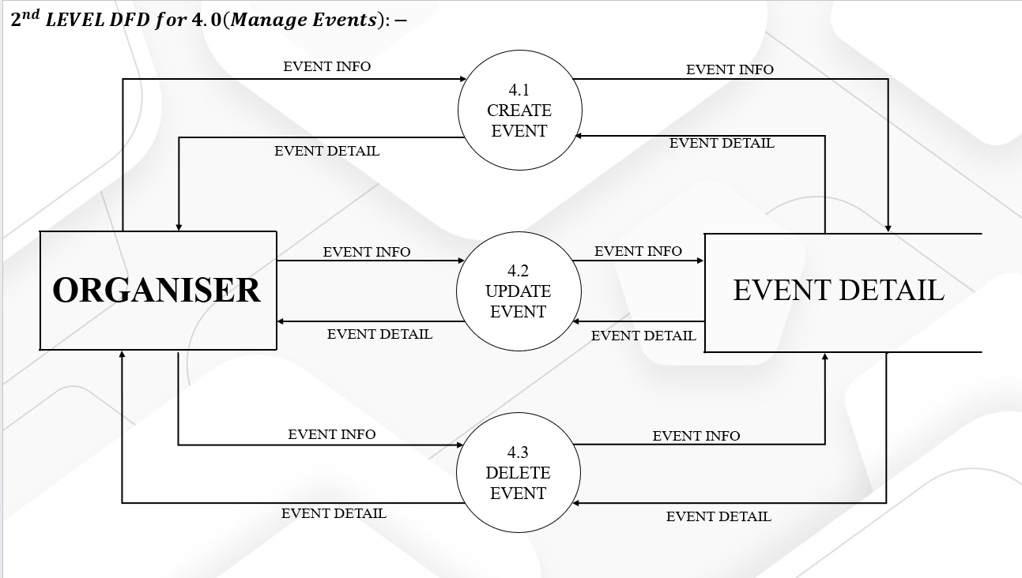

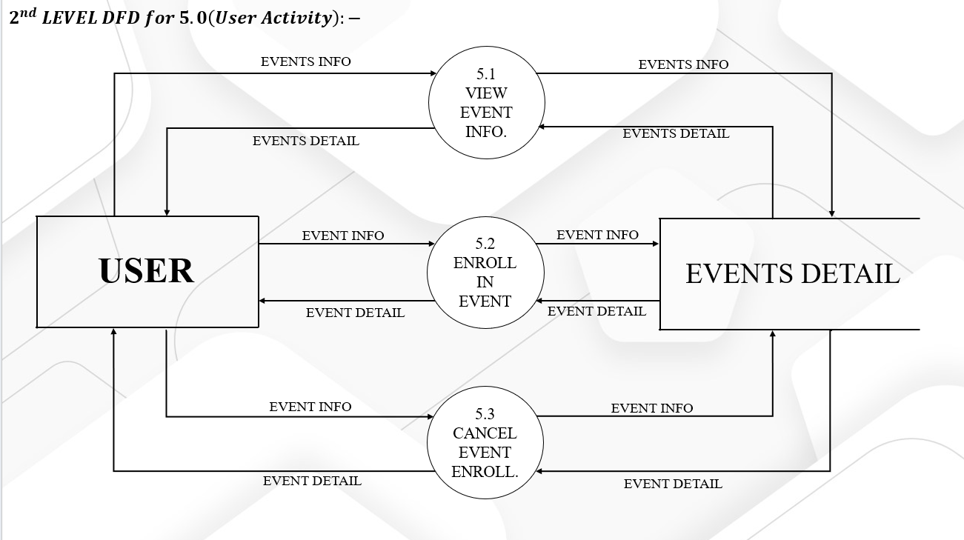

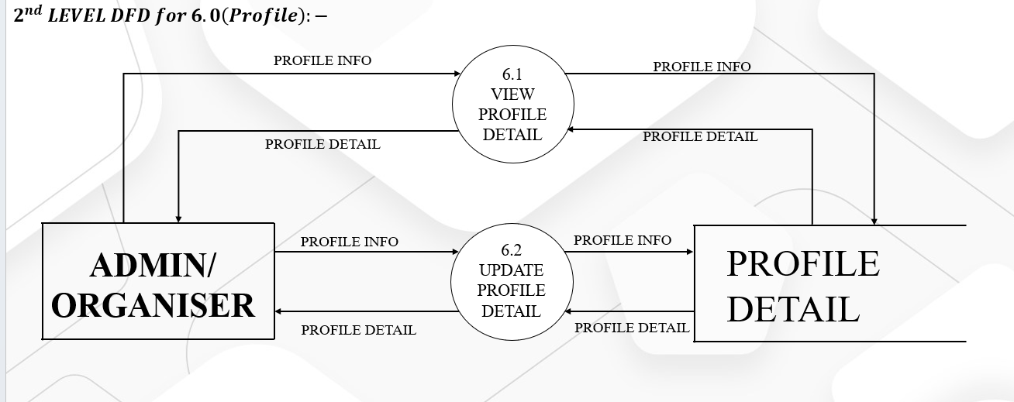

**Organiser Side:**

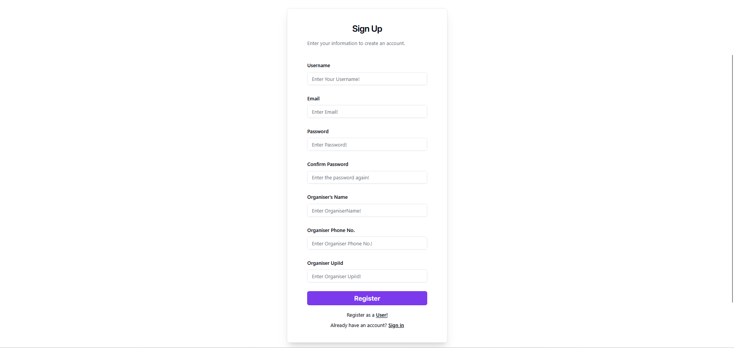

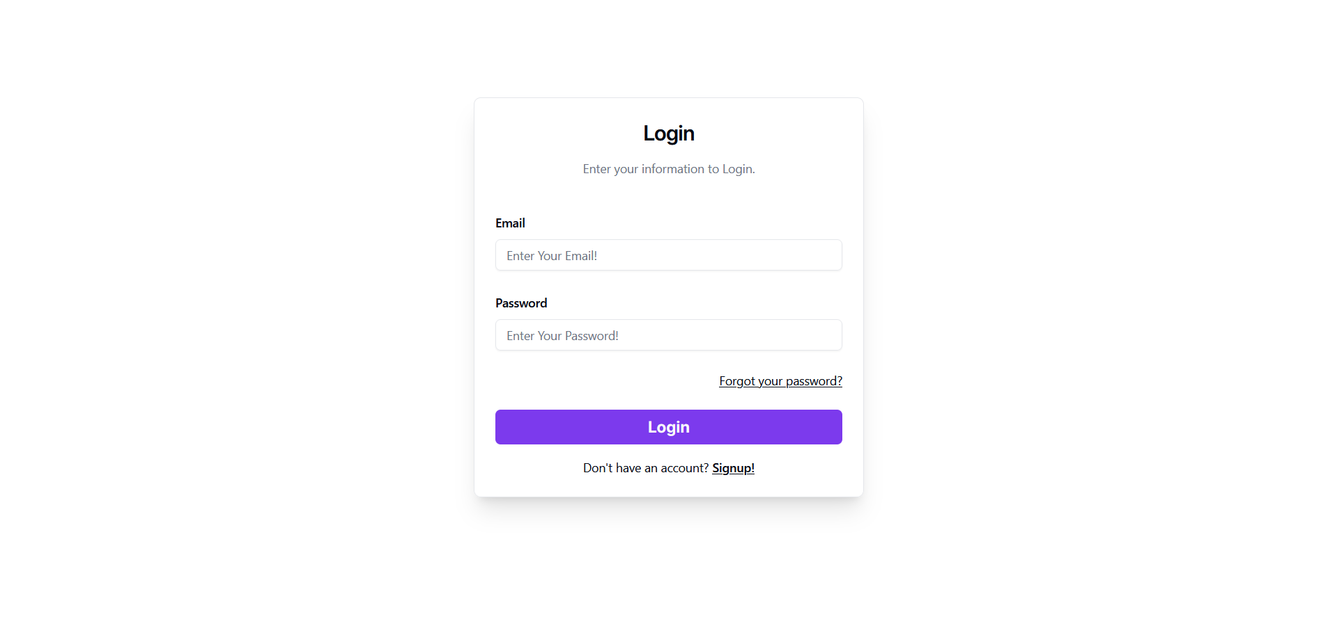

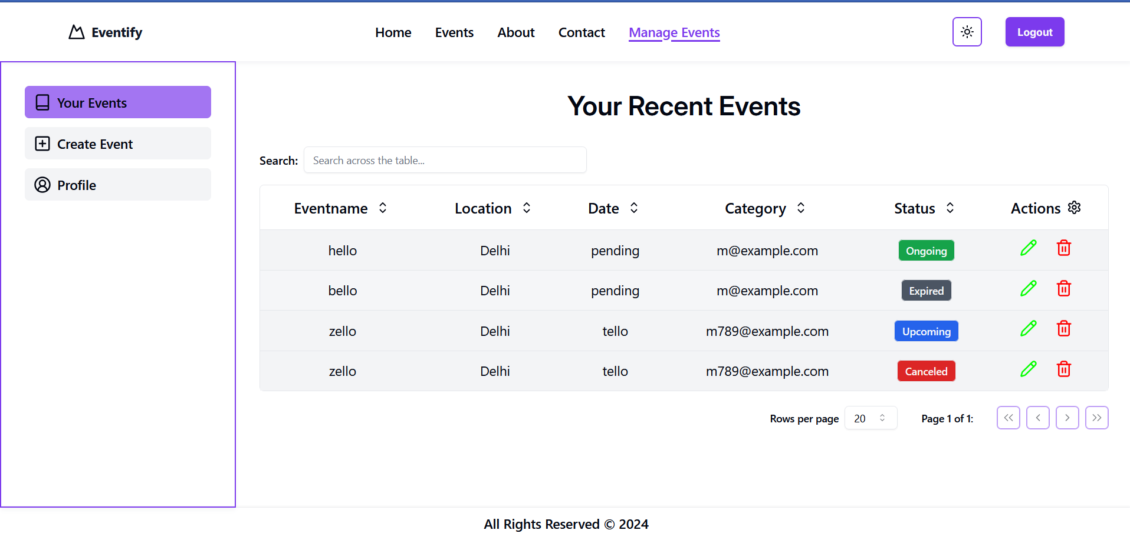

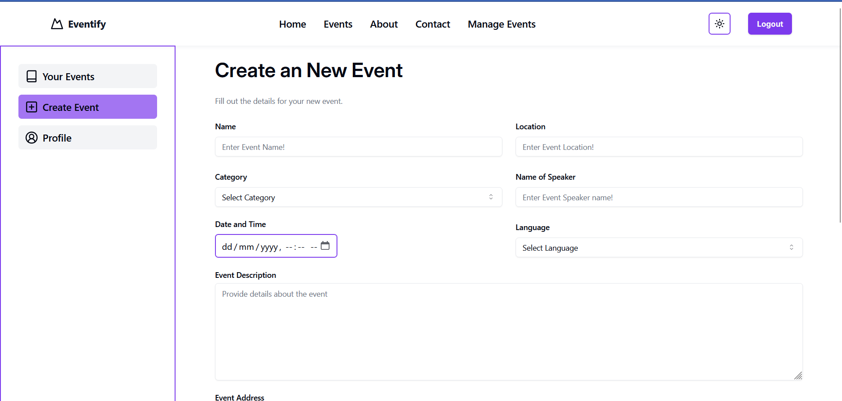

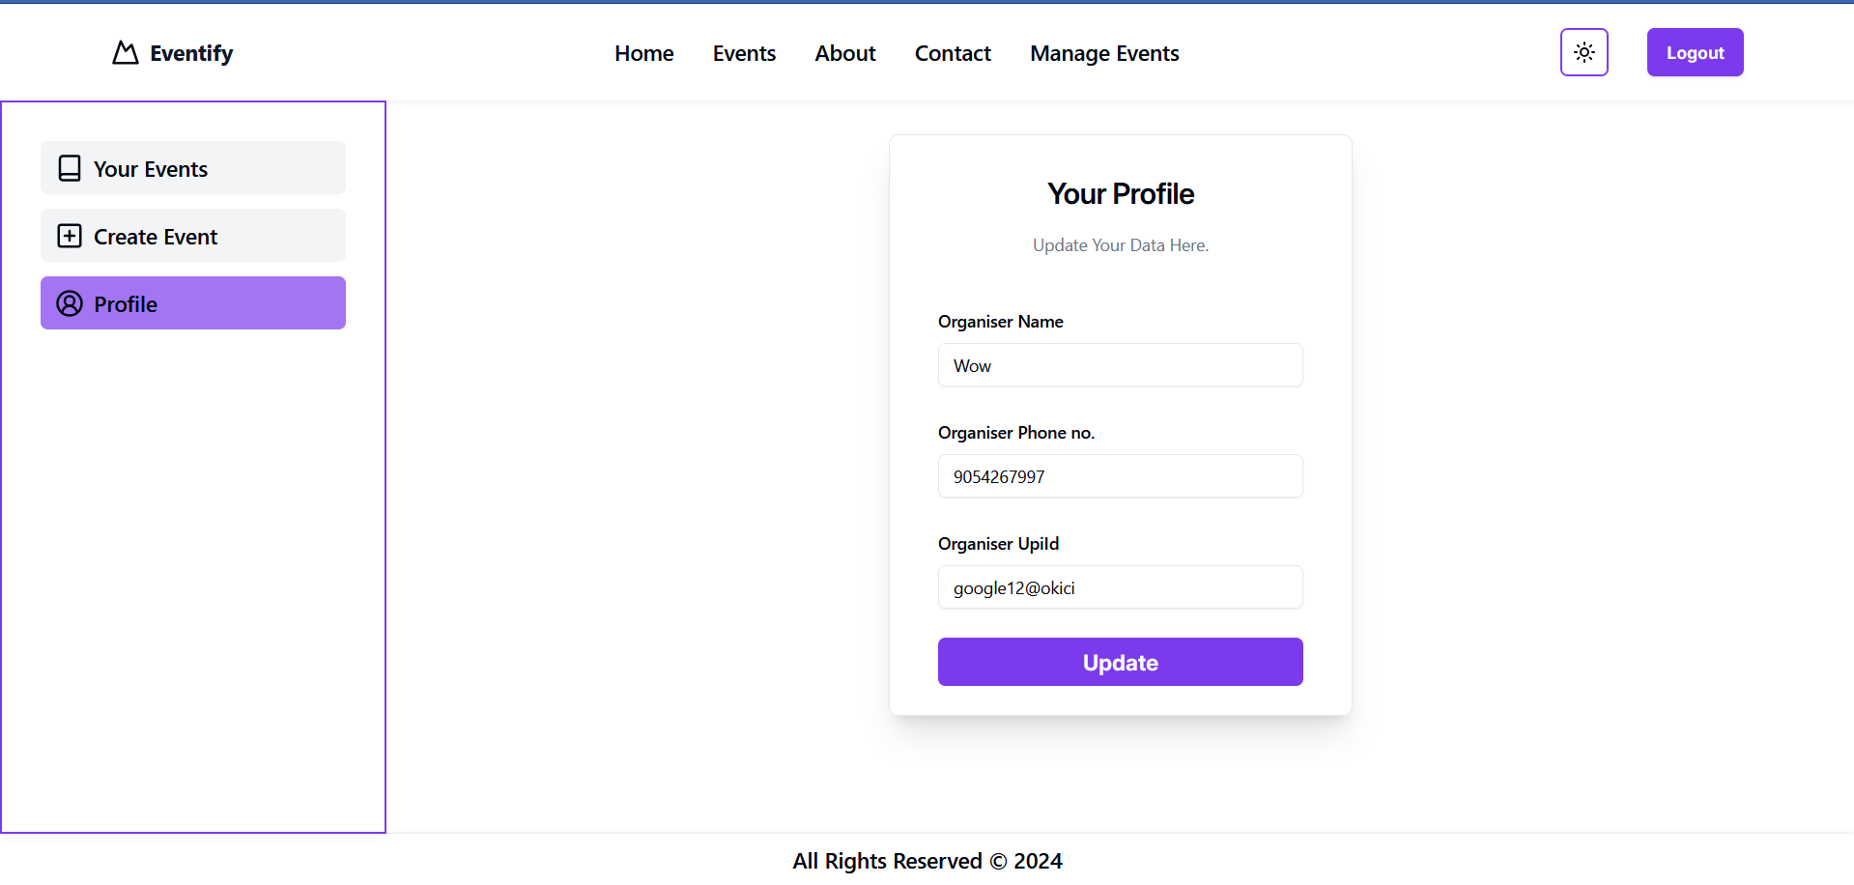

**Admin Side:**



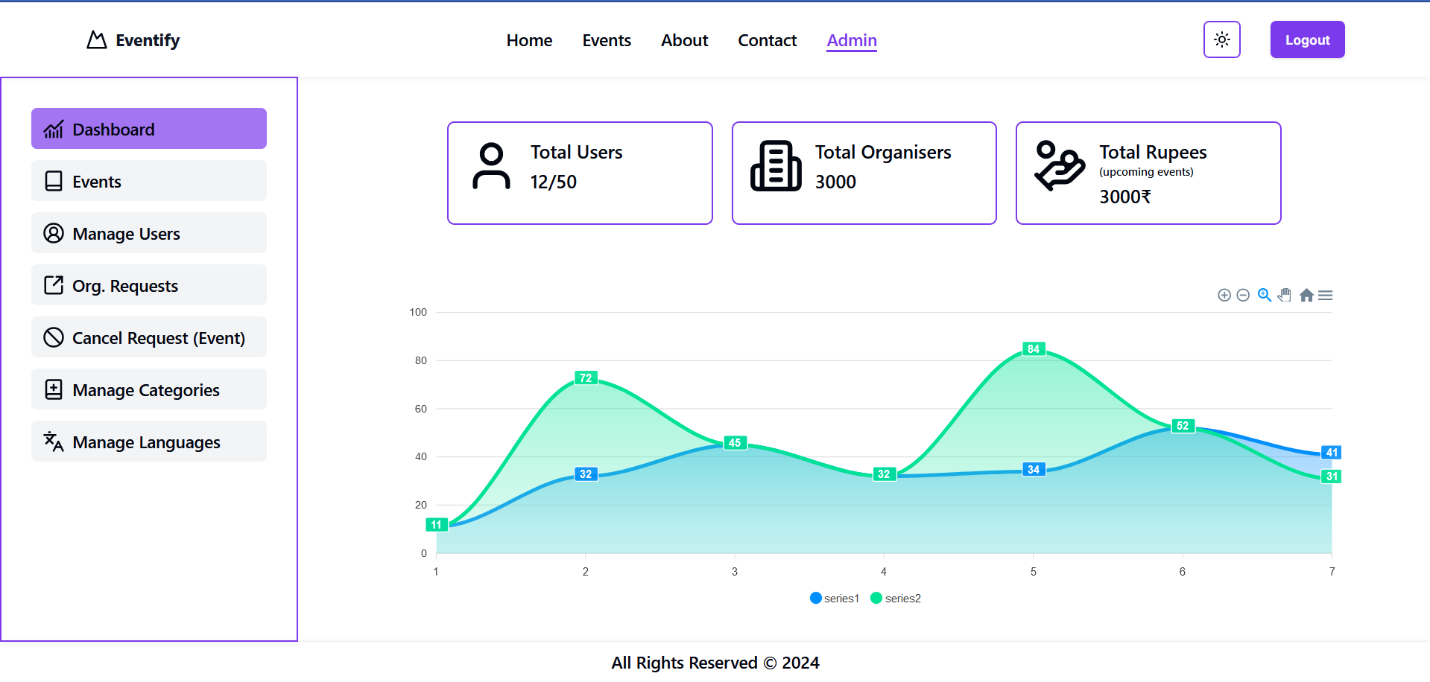

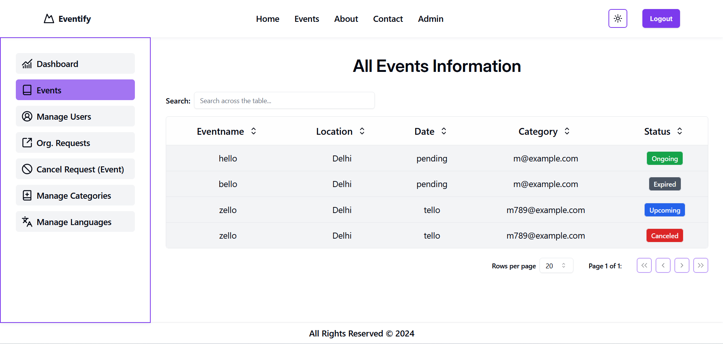

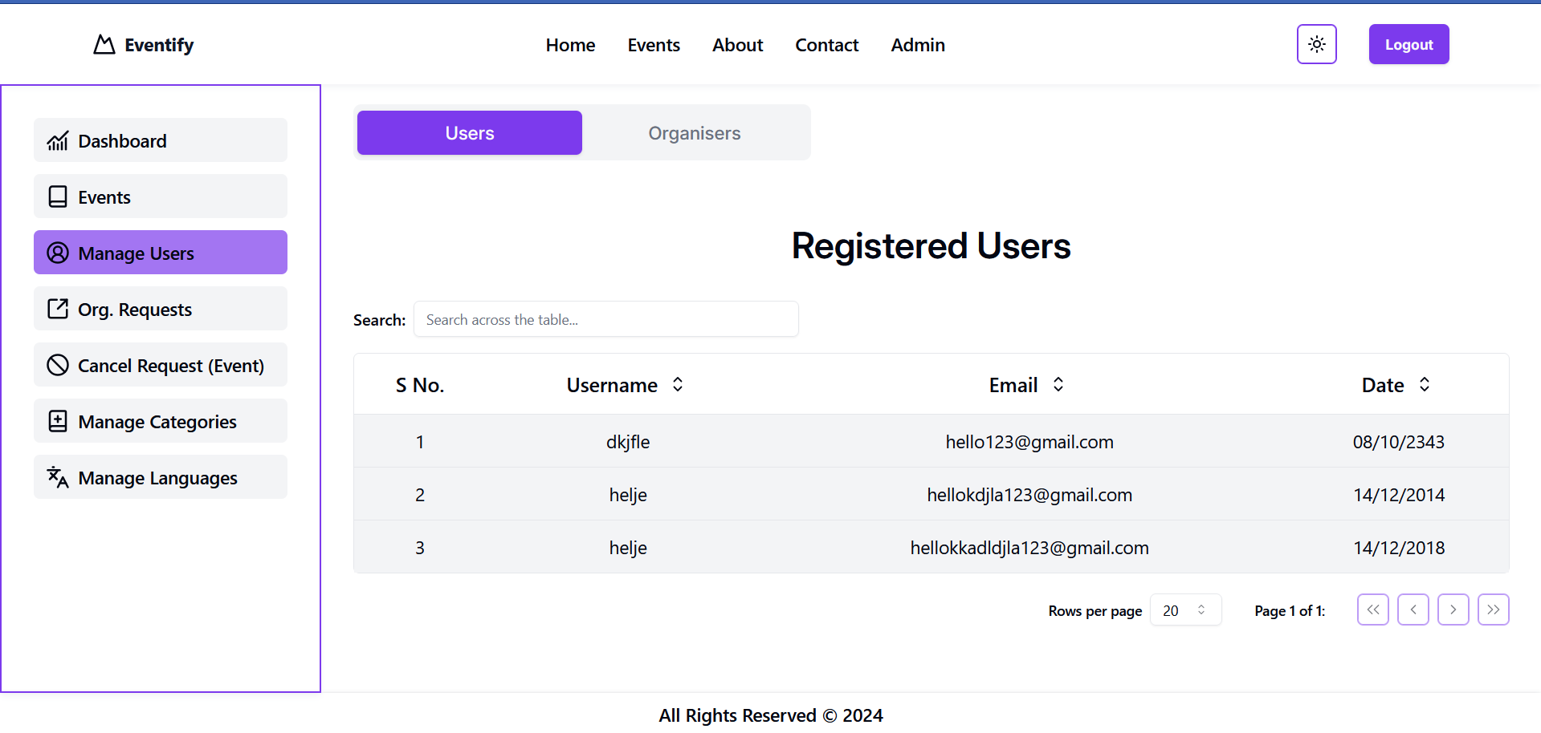

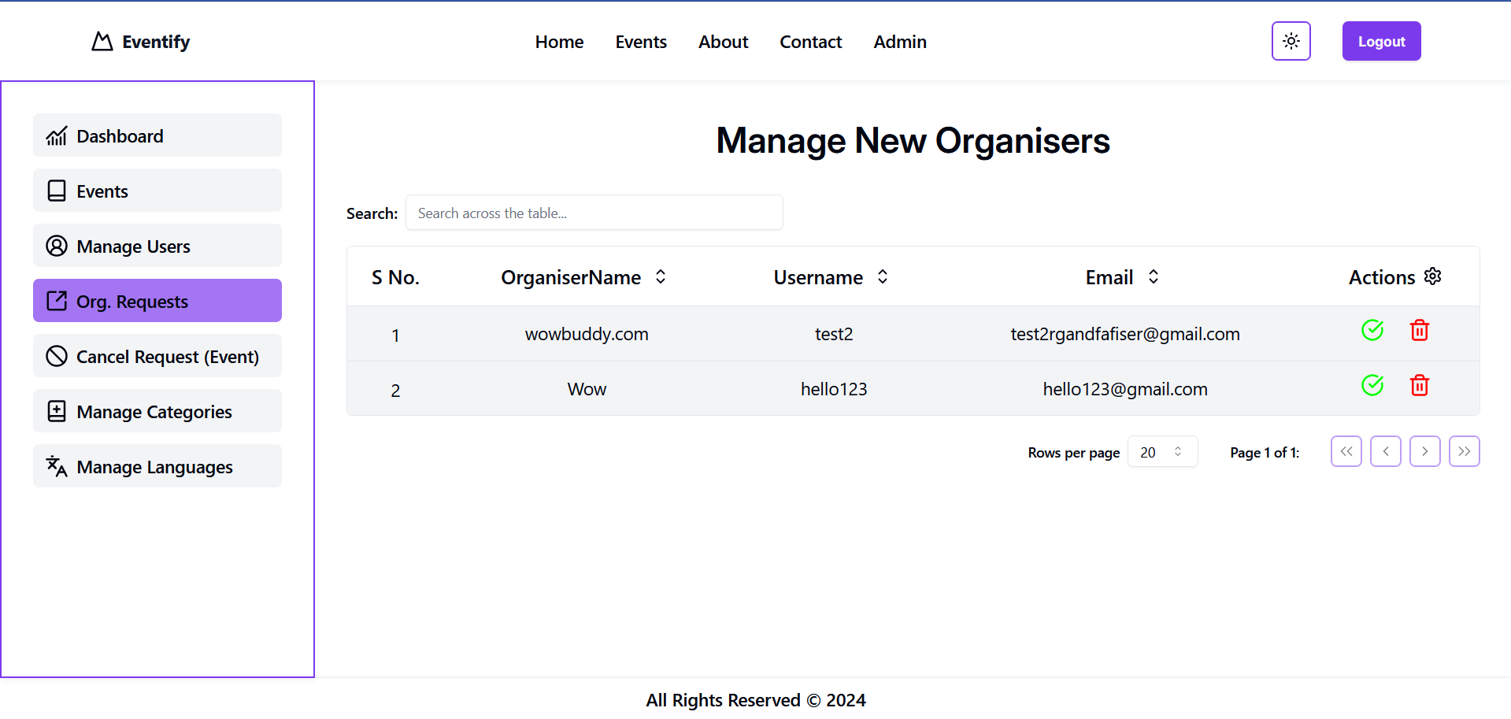

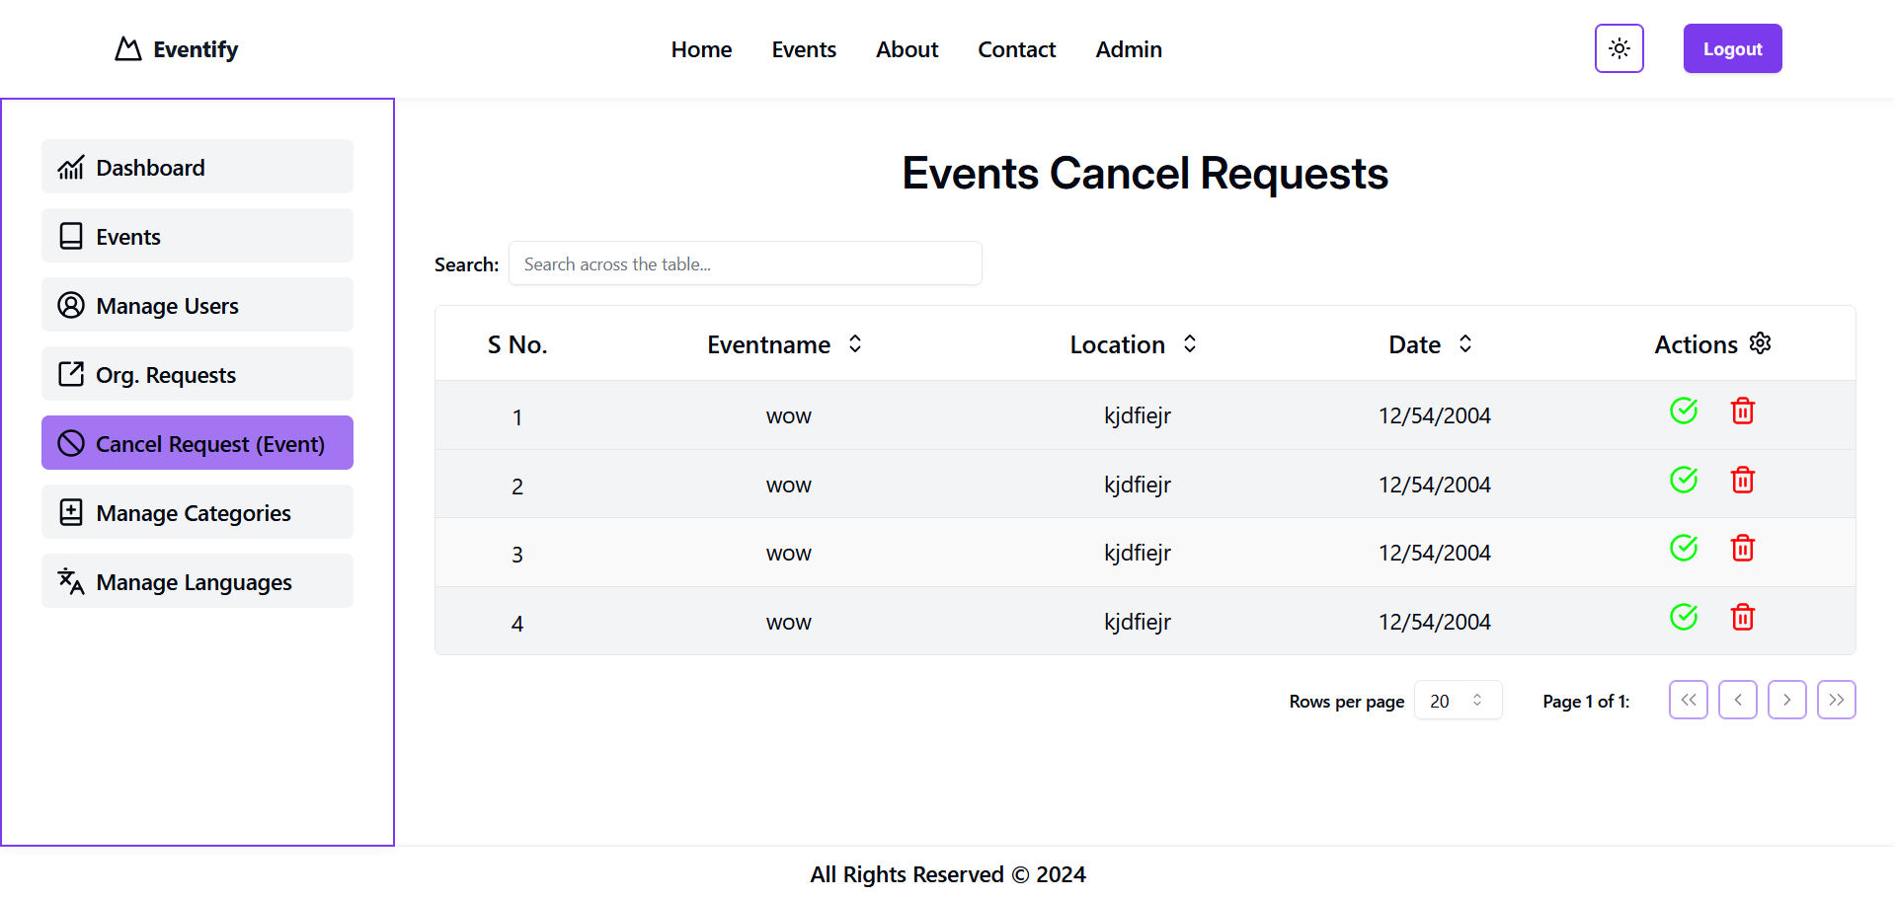

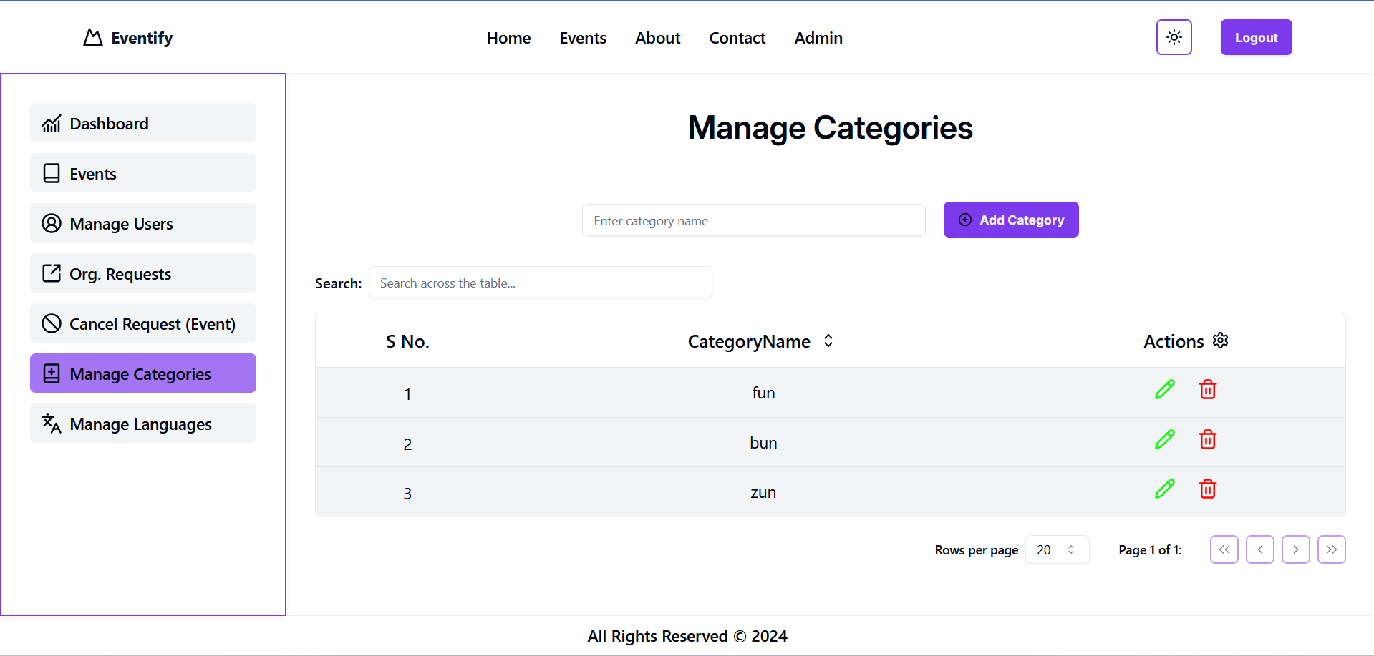

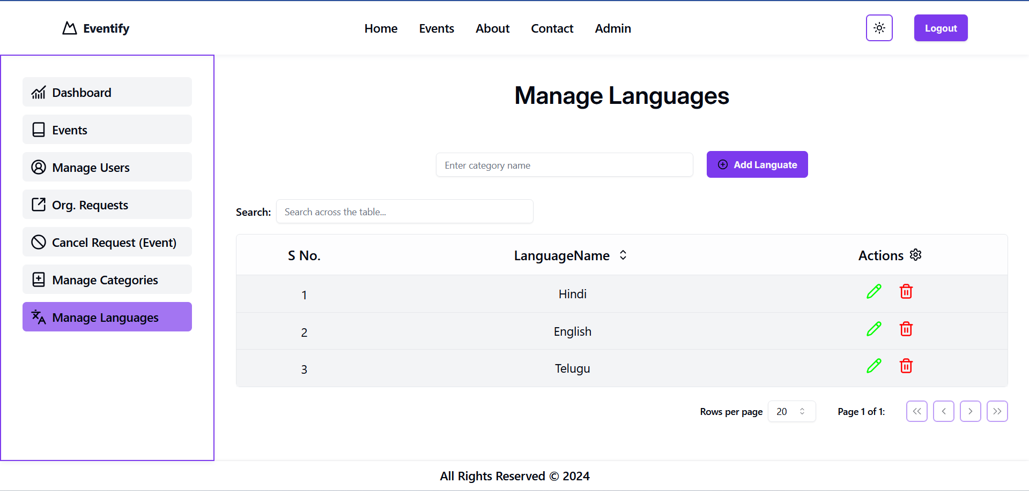

**Conclusion:**

**The event management system, developed using modern web technologies including React.js, Mongodb, and Express.js, successfully meets the core objectives for which it was designed. The system provides a user-friendly platform for event organizers to create and manage events, while allowing users to easily browse event details and register for both paid and free events. The admin panel offers robust control over users, organizers, categories, and languages, ensuring smooth and efficient management of all aspects of the system. This solution streamlines the event management process, making it both efficient and easy to use.**