JSS Mahavidyapeetha

### JSS SCIENCE AND TECHNOLOGY UNIVERSITY MYSURU-570006

Final Year B.E Project Report 2019-2020

## Remote Application for IPTV using DirectFB & VNC

Submitted by

|  |  |  |  |
| --- | --- | --- | --- |
| **Name** | **USN** | **e-mail** | **Phone-no** |
| **geek** | **246** | **@gnubox** | **192** |
| **freak** | **124** | **@gmail.com** | **94** |
| **stud** | **4JC07EC** | **gmail.com** | **94** |
| **stud** | **4JC07EC** | **gmail.com** | **84** |

Submitted in partial fulfilment of the requirement of academic event in BE Under the Guidance of

#### Name

**Professor**

**Dept Of Electronics & Communication**



#### SRI JAYACHAMARAJENDRA COLLEGE OF ENGINEERING MYSURU-570006

JSS Mahavidyapeetha

**JSS SCIENCE AND TECHNOLOGY UNIVERSITY MYSURU-570006**

##### CERTIFICATE

Certified that the project work entitled **Title of Project** carried out by **Arjun Urs J, Krishna B, Manoj R and Prashanth P**, bonafide students of Sri Jayachamara- jendra College of Engineering, Mysuru in partial fulfillment for the award of Bachelor of Engineering in ELECTRONICS & COMMNUNICATION of the JSS Science And Technology University, Mysuru during the year 2019-20. It is certified that all correc- tions/suggestions indicated for Internal Assessment have been incorporated in the final report.The project report has been approved as it satisfies the requirements in respect of Project work prescribed for the degree.

##### Dr. Shankaraiah Professor and Head, Dept of E & C SJCE Mysuru

**Name of Your Guide Designation,**

**Dept of E & C SJCE Mysuru**

**Dr. T. N. Nagabhushan Principal,SJCE Mysuru**

Name of Examiners

1. .............................

2. .............................

3. .............................

##### External Viva

Signature with Date

.............................

.............................

.............................

# Contents

1. Introduction 1

1.0.1 IPTV 1

* 1. Objectives 1

1. Literature Survey 2
   1. section name 2

2.1.1 . . . . . . . . . . . . . . . . . . . . . . . . . . . . . . . . . . . . . 2

1. System Architecture and Methodology 3
   1. Block diagram 3
2. Hardware and Software Components 4
   1. Hardware requirements 4
   2. Software Components 4
3. Implementation and Testing 5
   1. Result Analysis 5
4. Conclusion 6
   1. Advantages and Limitations 6
   2. Future Work 6

References 7

**List of Figures**

5.1 name of fig 5

# List of Tables

5.1 Data test results 5

## Chapter 1

**Introduction**

#### 1.0.1 IPTV

Internet Protocol television (IPTV) is a system through which Internet television services are delivered using the architecture and networking methods of the Internet Protocol Suite over a packet-switched network infrastructure, e.g. the Internet and broadband Internet access networks, instead of being delivered through traditional radio frequency broadcast, satellite signal, and cable television.[1]

### Objectives

* + - .....
    - ....

## Chapter 2

**Literature Survey**

### 2.1 section name

#### 2.1.1

**Chapter 3**

**System Architecture and Methodology**

### 3.1 Block diagram

**Chapter 4**

**Hardware and Software Components**

### Hardware requirements

### Software Components

**Chapter 5**

**Implementation and Testing**

### 5.1 Result Analysis

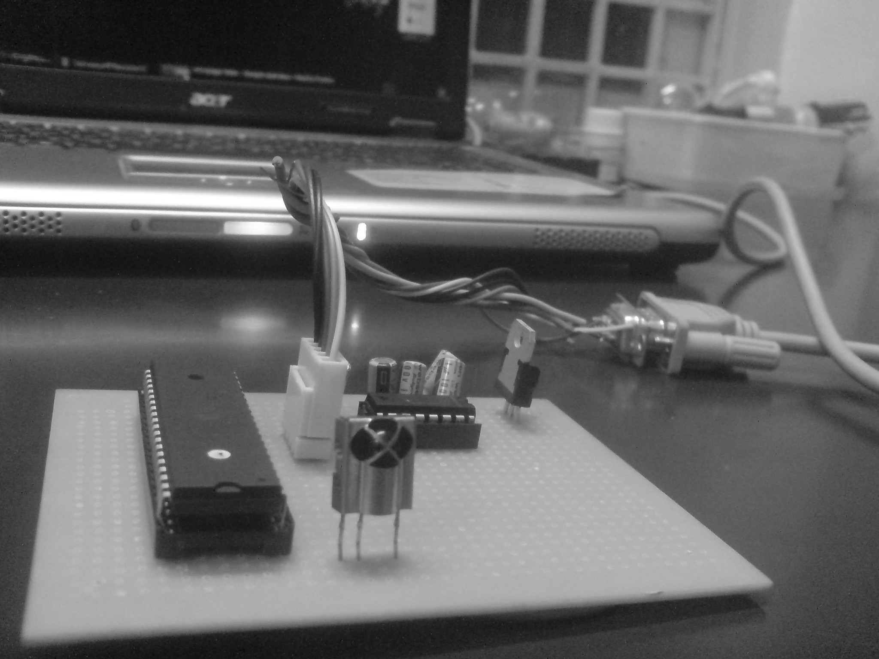

Figure 5.1: name of fig

|  |  |  |
| --- | --- | --- |
| x | y | z |
| a | b | c |

Table 5.1: Data test results

## Chapter 6

**Conclusion**

### Advantages and Limitations

### Future Work

**Bibliography**

* + 1. About IPTV on Wikipedia <http://en.wikipedia.org/wiki/IPTV>
    2. About VNC on Wikipedia [http://en.wikipedia.org/wiki/Virtual_Network_ Computing](http://en.wikipedia.org/wiki/Virtual_Network_Computing)
    3. LibVNC server [http://libvncserver.sourceforge.net](http://libvncserver.sourceforge.net/)
    4. DirectFB documentation <http://elinux.org/DirectFB>
    5. jointSPACE documentation [http://sourceforge.net/apps/mediawiki/ jointspace/index.php?title=Main_Page](http://sourceforge.net/apps/mediawiki/jointspace/index.php?title=Main_Page)
    6. PuTTy on Wikipedia <http://en.wikipedia.org/wiki/Putty>