**FACE MASK DETECTION USING COMPUTER VISION**

SUMANTHA ULLASA PRABHU VIVAN SANJAY ATHREYA

Student Student

JSS SCIENCE AND TECHNOLOGY JSS SCIENCE AND TECHNOLOGY

UNIVERSITY UNIVERSITY

MYSURU 570006 MYSURU 570006

Email: sumanthprabhu2000@gmail.com Email: vivansanjay16@gmail.com

*Abstract-* In this Covid-19 situation, to prevent the spreading of viruses it is necessary to wear the face mask and maintain the social distance. It's not possible to check each and every person physically whether he wears a mask or not. So In this paper we proposed a system in order to prevent the spreading of covid by finding the people who are not wearing a mask in public areas using cameras. Hence this Face mask Detection has been approached using a Sequential Model with 4 layers of Convolution Neural Network. Available approaches consist of following steps 1. Pre-processing 2. Training 3. Classification.

The datasets generally which we have used Consist about 1376 images in which with-facemask has 690 images and without-facemask 686 images and Which is resized to 50*50. Dataset taken from the kaggle website. The face mask recognition model we developed achieves 95% accuracy. This approach will send a mail to the authority section if it finds a person who didn't wear a mask.

I. INTRODUCTION

This Covid-19 virus is one which has not previously been identified in humans. Many precautionary measures have been taken to fight coronavirus. Among them, cleaning hands, maintaining a safe social distance, wearing mask, refraining from touching eyes, nose, and mouth are the main, where wearing a mask is the most important. Many people lost their jobs and income, with no way of knowing when the normality will return. The cases were increasing day by day. Fever, dry cough, tiredness, diarrhoea, loss of taste, and smell are the major symptoms of coronavirus as declared by the World Health Organization (WHO). Covid virus will spread from an affected human to normal human, but can be prevented by using facemask, because the main precaution is to wear facemasks and maintain social distance. Face Mask Detection is a technique to find whether the people have worn a mask or not. This paper approaches the designing of a system to find out whether a person is using a mask or not and informing the corresponding authority in a smart city network. Firstly, CCTV cameras are used to take picture video footage of different public places in the city. From that video footage, facial images are extracted and these images are used to identify the mask on the face. The learning algorithm Convolutional Neural Network (CNN) is used for feature extraction from the images then these features are learned by multiple hidden layers. At the time of writing this paper vaccination was already found.

II. METHODOLOGY

This method is based on a Sequential model with 4 layers of Convolution neural network. This generally has 3 main steps. 1. Image processing 2. Training the Model 3. Classification to find whether the person has worn a mask or not, as shown in *Fig. 2.1*.

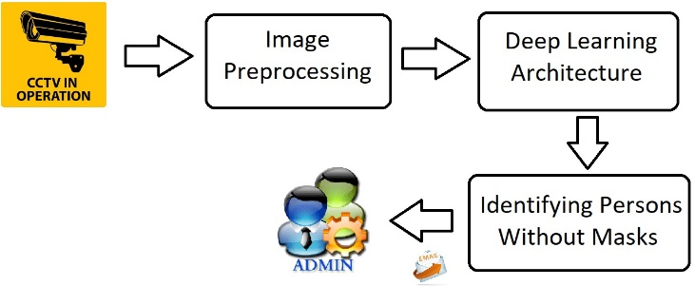

*Fig 2.1: Block Diagram of the proposed system.*

A. Image Pre-processing

The first and foremost step is to take the image and process it for further steps. Here we usually take the images from the CCTV camera; nowadays every smarty city has CCTV installed. The obtained RGB image is then converted to Gray scale Image, as the RGB image has a lot of information which is redundant for this Model. The image is then shaped into 50*50 to maintain uniformity of the input images to the architecture. Further, the Data and Target array, created during the processing are stored in the form of binary file as .npy format.

B. Deep Learning Architecture

Deep learning plays a very important role in Data analysis and Data management. Deep learning learns the important non linear features to train the model. The trained model can be used to predict the unseen images. This architecture of learning that depends on CNN.

i) Dataset Collection:

The Dataset for training and testing the model is obtained from the kaggle. A total of 690 images of people with masks and 686 images of people without a mask is collected. For training purposes, 85% images of each class are used and the rest of the images are utilized for testing purposes. *Fig 2.1* shows some of the images taken for training and testing.

ii) CNN Model

Convolutional Neural Network is a special architecture of artificial neural networks. The learning model is based on CNN which is very useful for image pattern recognition. The network comprises an input layer, several hidden layers and an output layer. The hidden layers consist of multiple convolution layers that learn suitable filters for important feature extraction from the given samples. Like in an image a small part of N*N pixels are taken and convolution of that matrix is found and with the help of filters at last a value is obtained at the end. Hence, now by shifting one more unit we select another n*n matrix and apply the same procedure. The actual process is shown in the *Table I*. Tensor flow and keras are used for the training and testing the model. A sequential model with 4 CNN layers connected to the dense layer with 64 neurons is used in this regard. At the end, 2 neurons with output are used to conclude the presence or absence of mask in the image. Then the model is trained for 50 epoch with validation split of 0.2. The model is then saved and used for the Detection of facemasks.

|  |  |  |  |
| --- | --- | --- | --- |
| Layer | Type | Kernel | Output Size |
| 1 | Conv2D | 32 | 48*48*32 |
| 2 | MaxPooling2D | - | 24*24*32 |
| 3 | Conv2D | 64 | 22*22*64 |
| 4 | Activation | - | 22*22*64 |
| 5 | MaxPooling2 | - | 11*11*64 |
| 6 | Conv2D | 128 | 9*9*128 |
| 7 | Activation | - | 9*9*128 |
| 8 | MaxPooling2D | - | 4*4*128 |
| 9 | Conv2D | 256 | 2*2*256 |
| 10 | Activation | - | 2*2*256 |
| 11 | MaxPooling2D | - | 1*1*256 |
| 12 | Flatten | - | 256 |
| 13 | Dropout | - | 256 |
| 14 | Dense | - | 64 |
| 15 | Dropout | - | 664 |
| 16 | Dense | - | 2 |

*Table I: Architecture of Deep Learning Network*

iii) Informing Authority

The main aim of the proposed system is to find the person who is violating the guidelines by not wearing the mask. The Model identifies whether the input image contains a person without a mask, then an e-mail is sent to the authority along with the person's image. The proposed system uses SMTP library to send the mail and information to authority, thereby facilitating their easy and quick reach to the place of the person without face mask, to take necessary actions.

III. RESULT ANALYSIS

In this approach the dataset is partitioned into training and testing dataset. The dataset comprises 1651 images of which 85% (i.e. 1403 images) are used for training and the remaining 15% (i.e. 248 images) for testing. The developed model is trained for 50 epochs, as, further increase in the number of epochs leads to the Overfitting of the model. Overfitting is that condition of the model in which it imparts unwanted features during the training process, as a result, the model is unable to generalise or fit the unseen data.

The proposed system model has accuracy of 95% with loss 1.8%.

*Fig 3.1 and Fig 3.2* show the accuracy and loss of trained and test model respectively. Clearly, the train and the test graphs are identical i.e. the model predicts unseen data very close to the actual value without any overfitting of trained data.

*Table II* shows the confusion matrix for the testing dataset. The proposed system misclassified 13 samples among 248 samples. The model classified 8 samples as without mask even though it had the presence of mask, and classified 5 samples as with mask but the samples had no presence of mask. Further, the model correctly guessed 235 samples. The area under the ROC curve shown in *Fig. 3.3* (AUC) measures the performance of the binary classifier for all possible thresholds. The value of AUC ranges from 0 to 1. When a model predicts 100% correct its AUC is 1 and when it predicts 100% wrong then its AUC is 0. The AUC achieved from this classifier is 0.9854.

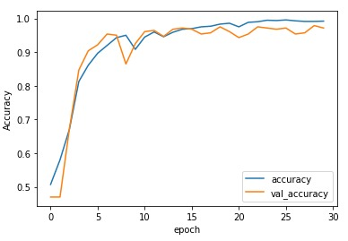

*Fig 3.1: Accuracy of the developed system for training and testing phase*

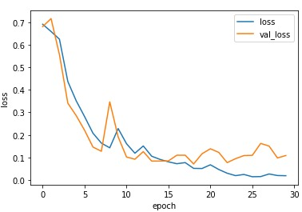

*Fig 3.2: Loss of the developed system for training and testing phase*

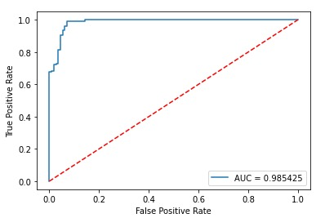

*Fig 3.3: ROC of Classification Network*

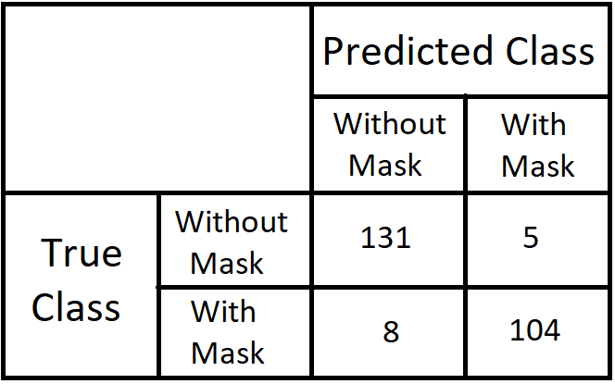

*Table II: Confusion Matrix*

Two parameters are plotted in the ROC curve; one is the true positive rate (TPR) and other is the false positive rate (FPR) measured using (1) and (2) respectively. TPR and FPR are calculated for different threshold and these values are plotted as ROC curve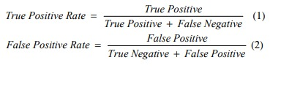

V. CNN MODEL CODE SNIPPET

model=Sequential()

model.add(layers.Conv2D(32,(3,3),input_shape=img_shape))

model.add(layers.MaxPooling2D(pool_size=(2,2)))

model.add(layers.Conv2D(64,(3,3)))

model.add(layers.Activation('relu'))

model.add(layers.MaxPooling2D(pool_size=(2,2)))

model.add(layers.Conv2D(128,(3,3)))

model.add(layers.Activation('relu'))

model.add(layers.MaxPooling2D(pool_size=(2,2)))

model.add(layers.Conv2D(256,(3,3)))

model.add(layers.Activation('relu'))

model.add(layers.MaxPooling2D(pool_size=(2,2)))

model.add(layers.Flatten())

model.add(layers.Dropout(0.5))

model.add(layers.Dense(64,activation='relu'))

model.add(layers.Dropout(0.4))

model.add(layers.Dense(2,activation='softmax'))

*#The Final layer with two outputs for two categories*

adam = tf.keras.optimizers.Adam(0.001)

model.compile(loss='categorical_crossentropy',optimizer=adam,metrics=['accuracy'])

VI. FUTURE IMPROVEMENTS

[1] This model can be further linked with sensors and actuators to avoid the entry of the public into crowded places.

[2] The photo of the person who has violated the norms can be displayed on LEDs, there by create awareness among the public.

VII. CONCLUSION

A four layered Convolution Neural Network is employed to implement this model of face mask detection. The proposed system model is successfully verified for its accuracy of 95% with a loss of 1.8%, with a scope of further improvements. The model can be implemented in wide range of applications, including controlling of crowd in public places such as malls, theatres, multiplexes, restricting the entry of people who do not abide by the norms.

VIII. REFERENCES

[1] L. J. Muhammad, M. M. Islam, S. S. Usman, and S. I. Ayon, “Predictive Data Mining Models for Novel Coronavirus (COVID-19) Infected Patients’ Recovery,” SN Comput. Sci., vol. 1, no. 4, p. 206, Jun. 2020. [6] Bluche, Theodore, accessed 29 November 2000, <http://www.tbluche.com/scan_attend_read.html>

[2] Z. Allam and D. S. Jones, “On the Coronavirus (COVID-19) Outbreak and the Smart City Network: Universal Data Sharing Standards Coupled with Artificial Intelligence (AI) to Benefit Urban Health Monitoring and Management,” Healthcare, vol. 8, no. 1, p. 46, 2020.

[3] M. Jiang, X. Fan, and H. Yan, “RetinaMask: A Face Mask detector,” 2020. [Online]. Available: http://arxiv.org/abs/2005.03950.

[4] M. Gupta, M. Abdelsalam, and S. Mittal, “Enabling and Enforcing

Social Distancing Measures using Smart City and ITS Infrastructures:

A COVID-19 Use Case,” 2020. [Online]. Available:

https://arxiv.org/abs/2004.09246.

[5] J. Won Sonn and J. K. Lee, “The smart city as time-space cartographer in COVID-19 control: the South Korean strategy and democratic control of surveillance technology,” Eurasian Geogr. Econ., pp. 1–11, May. 2020.

[6] R. P. Singh, M. Javaid, A. Haleem, and R. Suman, “Internet of things (IoT) applications to fight against COVID-19 pandemic,” Diabetes Metab. Syndr. Clin. Res. Rev., vol. 14, no. 4, pp. 521–524, Jul. 2020.

[7] J. W. Sonn, M. Kang, and Y. Choi, “Smart city technologies for

pandemic control without lockdown,” Int. J. Urban Sci., vol. 24, no.

2, pp. 149–151, 2020.

[8] R. Jaiswal, A. Agarwal, and R. NEGI, “Smart Solution for Reducing the COVID-19 Risk using Smart City Technology,” IET Smart Cities, vol. 2, pp. 82–88, 2020.

[9] I. S. Cardenas et al., “Telesuit: design and implementation of an immersive user-centric telepresence control suit,” in Proceedings of the 23rd International Symposium on Wearable Computers – ISWC ‘19, New York, NY, USA, 2019, pp. 261–266.

[10] D. Y. Kim, I. S. Cardenas, and J.-H. Kim, “Engage/Disengage: Control Triggers for Immersive Telepresence Robots,” in Proceedings of the 5th International Conference on Human Agent Interaction, New York, NY, USA, 2017, pp. 495–499.